Department of Electronics& Computer Engineering

Mid-Session Test January 2004

EE3052B - MultiMedia Signal Processing

Time allowed 1 Hour Plus 10 minutes reading time

Answer only three out of five questions

Ensure that your registration number is written clearly on the front cover.

1.

- Calculate the CD storage capacity required to store one hour of digital HiFi stereo music sampled at a rate of 44.1 kHz.

Explain the effect of the following operations on a music signal in time and frequency domains.

  - Sampling a continuous-time signal at a rate of 44.1 kHz samples per second.

  - Up-sampling a discrete-time signal, originally sampled at 22.05 kHz, by a factor 1:2 to a new sampling rate of 44.1 kHz.

  - Down-sampling a discrete-time signal, originally sampled at 44.1 kHz, by a factor of 2:1 to a new sampling rate of 22.05 kHz.

State the effects of each of the above three operations on the perceived quality of the audio signal.

[5 Marks]

Answer

(a)

Storage required =2*44100*16*3600/8=635 Mega Bytes

(i)
Sampling an audio signal a 44.1 kHz converts the time signal to a sequence of samples at 44100 samples/second. The effect on the signal spectrum is that the spectrum becomes periodic with a period of 44.1 kHz.

The signal quality remains unaffected.
(ii)
Up-sampling a signal from 22.05 kHz to 44.1 kHz doubles the number of samples per second. But the spectral energy remains unaffected with the maximum signal energy at 11.025 Hz.
The signal quality is unaffected

(iii)
Down-sampling a signal from 44.1 kHz to 22.05 kHz halves the signal duration and the maximum signal energy is reduced from 22.05 kHz to 11.025 kHz.
The signal quality loses some of its high frequency brilliance.

(b)

With the aid of a block diagram, describe how a music signal that is originally sampled at a rate of 48 kHz can be down-sampled to a new sampling rate of 44.1 kHz.

State your choice of the values of the parameters for each stage of the re-sampling process.

State the effect of each stage of the re-sampling process on the spectrum of the signal.
[5 Marks]

Zero-insert the original signal by a factor of 1:441. The result is that the spectrum will be replicated by a factor of 441.

Low pass filter the zero-inserted signal by an FIR filter with a cutoff frequency of 1/480. This will remove spectral images introduced as a result of zero-insertion.

Down sample the filtered signal by a factor of 480:1. This will streach the spectrum to fill the baseband 0 Hz to 22050 Hz.

The signal will lose its bandwidth between 22050 and 24000. Practically this has no consequence for music quality.

2.

The discrete Fourier transform (DFT) equation is given by

$X(k)\text{}=\text{}\sum_{m=0}^{N−1}{x(m)}\text{}e^{−j\frac{2π}{N}\text{km}}$ k = 0, . . ., N−1 Eq (1)

- In the DFT Eq(1) the discrete-time index m corresponds to the time instant mT_{s} seconds, where T_{s} is the sampling period.

Quantify the value of the discrete-frequency index k in terms the sampling frequency F_{s} and the number of samples N used in DFT.

For and N-point DFT write the expressions for calculation of time resolution and frequency resolution and also write the relation between time and frequency resolutions.

State the uncertainty principle in the context of time and frequency resolutions of Fourier transform.

[5 Marks]

Answer

For a sampling period of T_{s}, the sampling frequency is F_{s}=1/T_{s}.

The variable k corresponds to a frequency of kF_{s}/N.

Time resolution =ΔT = NT_{s}

Frequency resolution = ΔF = 1/NT_{s}= F_{s}/N

Relation between time and frequency relations

ΔF =1/ ΔT

The uncertainty principal states that time and frequency resolution cannot be simultaneously increased, however, they can be traded off at one or the other’s expense.

- With the aid of a block diagram list the signal processing stages required in a spectrogram.
[2 Marks]

A music signal with a bandwidth of 20 kHz is to be analysed with a spectrogram.

- Suggest the values of the cut-off frequency for the anti-aliasing filter and the minimum sampling rate F_{s} required.

[1 Marks]

- Calculate the number of DFT input samples required to give a frequency resolution of 50 Hz. Calculate the resulting time resolution.
[2 Marks]

(b) Answer

The main signal processing steps in the design of a spectrogram are:
Signal segmentation and windowing,
Transformation to frequency domain via DFT,
Log magnitude spectrum and stacking vectors in a matrix
Magnitude to colour mapping and display

- Fc=20 kHz, Fs=44.1 kHz.
- N ≥ Fs/Δf

N ≥ 44100/50=882
Δf = 882/44100=20 ms

3.
- Using the inverse Fourier transform methods design a digital low pass finite duration impulse response (FIR) filter with a cut off frequency of 10 kHz to operate at a sampling rate of 40 kHz.
Describe how this filter is made causal and finite duration impulse response.
[5 Marks]

Answer

The ideal low pass filter response is given by
$$H_{d}(f)=\begin{aligned}\left\{1\text{} \text{} \text{}|f|<F_{c} | \right.\end{aligned}$$

Normalised cutoff frequency in radians =2πf_{c}/F_{s}=2π×10000/40000
=π/2.
Cutoff frequency a fraction of Sampling Frequency =f/F_{s}=0.25
Using the window design technique the FIR impulse response is obtained from the inverse Fourier transform as

$$h_{d}(m)=\int_{−\text{.}\text{25}}^{\text{.}\text{25}}{1\text{.}0 e^{j2mπf}\text{df}}$$

we obtain the FIR filter response as

$h_{1}(m)=w(m) ×0\text{.}5 \text{sinc}(0\text{.}5π(m−M/2))$ 0 ≤ m ≤ M

Where M is the filter length. Note for causality the filter impulse response is windowed and delayed.

- Using the low pass filter above as the basic element in a binary-tree structure, construct a filter bank with four equal bandwidths, operating at a sampling rate of 40 kHz.

Sketch a block diagram illustration of the filter-tree and briefly describe the function of each element.
[5 Marks]

Answer
Figure shows a four band filter bank constructed from a low pass filter and delays and down samplers

4.
- A first order digital pre-emphasis filter is given by

$y(m)= x(m)−a x(m−1)$ Eq. (2)

Obtain the z-transfer function of this filter.

Assuming a value of a=0.98 draw its pole-zero and frequency response diagrams.

State the range of values of the parameter a where this filter acts as a pre-emphasis filter.

Give an example of an application of a pre-emphasis filter.

[5 Marks]

Answer

z-transfer function of this filter
$$H(z)= 1−a z^{−1}$$

pole-zero and frequency response diagrams

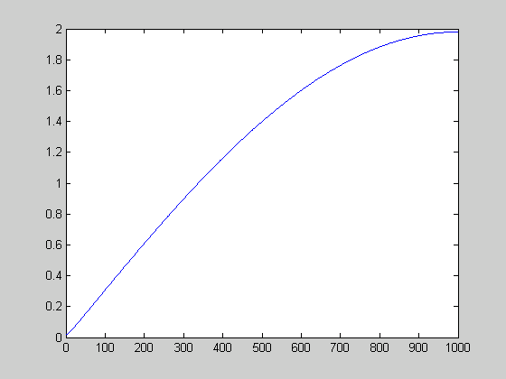

The range of values for pre-emphasis operation (high pass) is: a>0.

Applications in Dolby audio and digital speech processing.

- The equation describing the general form of the z-transfer function of a second order system in polar form is given by

$H(z)= \frac{1−2r_{z}\text{cos}(ϕ_{z})z^{−1}+r_{z}^{2}z^{−2}}{1−2r_{p}\text{cos}(ϕ_{p})z^{−1}+r_{p}^{2}z^{−2}}$ Eq. (3)

Using the transfer function in equation (3) obtain the values of the coefficients r_{z}, $ϕ_{z}$ and $ϕ_{p}$of a second order notch filter for removing a sinusoidal interference with a frequency of 100 Hz. Assume a sampling frequency of 10 kHz.

Sketch the pole-zero diagram and the frequency response of the notch filter.

Explain the effect of varying r_{p} on the frequency response of notch filter.
[3 Marks]
- Calculate the values of coefficients in Equation (3) for which the second order system acts as a digital oscillator operating at 10 kHz and with an oscillation frequency of 1 kHz.
[2 Marks]

$$r_{z}= 1$$
$$ϕ_{z}= \frac{2π}{\text{10000}}\text{100}=0\text{.}\text{0628}$$
$$ϕ_{p}= ϕ_{z}=0\text{.}\text{0628}$$

r_{p} controls the bandwidth
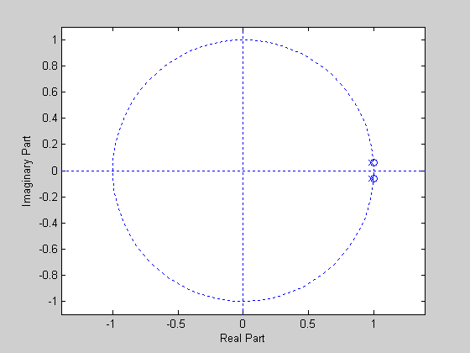
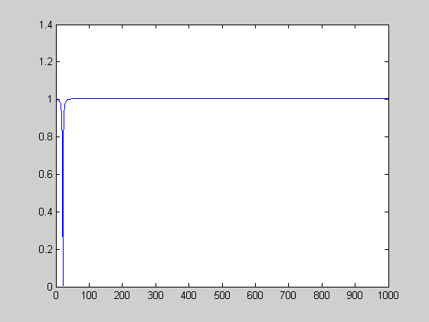

For oscillator we need an all-pole filter.

$r_{z}= 0$

$$r_{p}= 1$$

$$ϕ_{p}=0\text{.}\text{628}$$

5.

The discrete Fourier transform (DFT) equation is given by

$X(k)\text{}=\text{}\sum_{m=0}^{N−1}{x(m)}\text{}e^{−j\frac{2π}{N}\text{km}}$ k = 0, . . ., N−1 Eq (4)

- Using the orthogonality property of the basis functions of Fourier transform, derive the inverse Fourier transform (IDFT) defined as

$x(m)\text{}=\text{}\sum_{k=0}^{N−1}{X(k)}\text{}e^{j\frac{2π}{N}\text{km}}$ m = 0, . . ., N−1 Eq (5)

Explain why orthogonality is a useful property of the basis functions of Fourier transform.

(5 Marks)

Answer

(a) The discrete Fourier transform (DFT) is given by

k = 0, . . ., N−1

- Multiply both sides of the DFT equation by e^{-j2πkn/N} and take the summation as

Using the principle of orthogonality, the inverse DFT equation can be derived as
[5 marks]

Orthogonality implies that the components of a signal in different frequency bands can be processed independent of eachother, this property is used in music coding, graphic equalisers and signal transmission.

  - Explain why the Fourier transform has become the most important tool in signal processing and system analysis.

Give an example of a biological system that employs vibration analysis.

  - Starting from a unit-area rectangular pulse, derive the mathematical definition of the continuous-time impulse function δ(t).

Obtain the DFT of a discrete-time impulse function δ(m) and sketch its spectrum.

Explain the importance of an impulse function in digital signal processing.
(5 Mark)

Answer

(b) Fourier transform is essentially a vibration analysis tool. Most signals that we encounter such as sound and electromagnetic waves are product of vibration at macro or micro level. Other signals such as economic data may also have cyclic nature. The advantages of Fourier transform is its compatability applicability and ease of solution, plus the fact that the sinusoidal basis function are orthogonal.

Human auditory system is an example of the use of frequency and vibration analysis in biological systems.

Consider the unit-area pulse p(t). As the pulse width Δ tends to zero the pulse tends to an impulse. The impulse function is defined as a unit-area pulse with an infinitesimal time width as
$δ(t)=\underset{Δ → 0}{\text{limit}} p(t)=\begin{aligned}\left\{1/Δ\text{}\left|t\right|≤ Δ/2 | \right.\end{aligned}$

The Fourier transform of the impulse function is obtained as
$Δ(f)\text{} =\text{}\int_{−∞}^{∞}{δ(t)e^{−j2π\text{ft}}\text{dt}} = e^{0}\int_{−∞}^{∞}{δ(t) \text{dt}}= 1$ (3.30)
The impulse function is used as a test function to obtain the impulse response of a system. This is because as an impulse is a spectrally rich signal containing all frequencies in equal amounts.

(a) A unit-area pulse, (b) the pulse becomes an impulse as $Δ→0$, (c) the spectrum of the impulse function.

