GAUTENG DEPARTMENT OF EDUCATION
SENIORS CERTIFICATE EXAMINATION

ISIXHOSA ULWIMI LOLUQALA
UHLELO OLUPHAKAMILEYO
(Iphepha Lokuqala)

IXESHA: 3 Iiyure

AMANQAKU: 100
IMÍYALELO

- Yonke imibuzo mayiphendulwe ngesiXhosa.
- Qala icandelo ngalinye kwiphepha elitsha. Umvavanywa uya kulahlekelwa ngamanqaku ngomsebenzi omdaka, nokupela gwenxa amagama.

ICANDELO A

UMBUZO 1

Funda ezi zicatshulwa zingezantsi uze uphendule imibuzo elandelayo

Isicatshulwa A:

“Ndiyibulele ngale mbokotho,” ekhomba.  “Phendula umbuzo. Uyibulalele ntoni?”  “Besingekayityi nokuyitya inyama.”  “Bekutheni?”  “Bekungokuhlwa nje. Asibhaqwanga xa besiyokuba eHobeni, eXhorha.  Kodwa ke ndiyakrokra, madoda, ndikrokrela usibonda lo ikakhulu. Ndis’ ke ndonqen’ ukubuza kuba ndingokaMhlambeli. Umntu ogwexayo nguNtotholwana. Nokuba ungade uphike injalo loo nto, yinyaniso engenakuphikwa naliKula. Kunjalonje nawe lo Hlathi, zingakukhonkotha  izinja ukuba akuziphathel’ ithambo elinenyama.”  Isizathu sokubulala uNtotholwana yintoni?”  Wathundeza ubhityo uLungisile.  “Ndimxelele nosibonda ukuba ndimbulele.” | 5  10

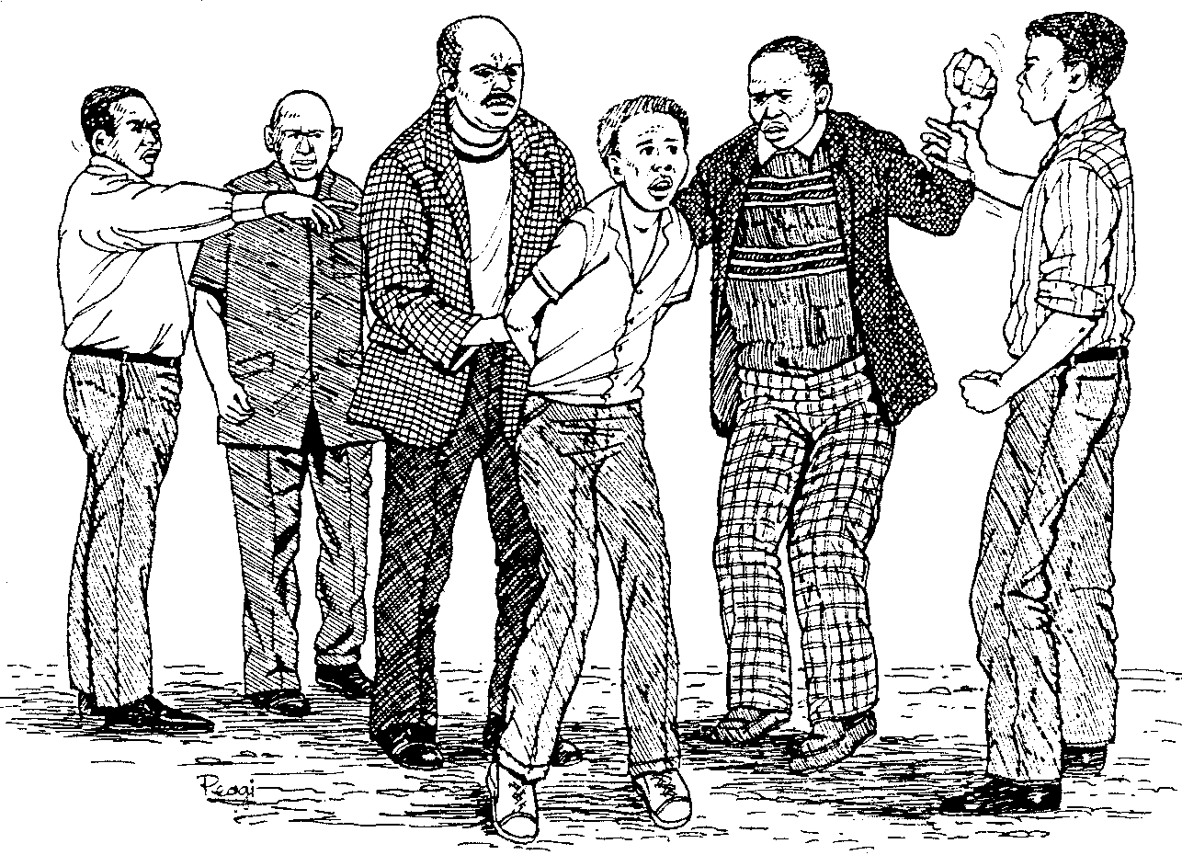  Jambase, khawumyeke ngothotho Iwemibuzo, Ndijongile nje  Ndifumanis’ ukuba uyaphambana lo mfo,” watsho uBangindlela wasemaQwambini kwalapha elalini.  “Hayi khona! Hayi khona!! Makubethwe eli geza! Nisaxoxa ntoni na?” Kwatsho isibhongobhiya, esinguMdendeni sigqwagqweleka ngumsindo, sibhesha, siphethe isikrweqe somnqayimbila esasikade sisithambisa ngehlala umhla nezolo, silungiselela imihla enyembeleke njengalo kanye. Ethetha ngelizwi elityhalwa lifuthe lamaza engqumbo lo mfo watyatyadula esithi:  “Anisaqondi ke nina, madoda, ukuba eli nyangaza lizenza umntu ophambeneyo ngokutyeshela impendulo engqalileyo? Ukuba niyaloyika liyekeleni apha kum; mna ndiza kulibonisa into endibhinqa ngayo ndandule ukuliqongqotha ngesi sikrweqe sakowethu.  Andiloyiki nganto mna, liyekeleni apha kum!” Esitsho nje ke uMdendeni wayephutshuluka okomsila wembulu phakathi kwaloo madoda awayezizinxadanxada, enqanda amahalihali.  “Hayi Tshangisa, hayi Sikhomo, Hayi Mngwevu; musa ukwenjenjalo  kuba akwenjiwa njalo. Musa ukuzizekela isizemazema setyala. Umthetho awungowakho, ngokaRhulumente. Ngako oko ke yiyekele kuye le ndoda, ayohlwaye ngokwakhe,” wavakala emcenga esitsho usibonda, enqand’ ihlahla.  Nyamayipheli, bulela ubukho bala madoda. Sendihlonela nje wona  kodwa ukuba ebengekho, ndifung’ uNomfanelo, isidumbu sakho  ngesidunduluze ecaleni kwesi sikaNtotholwana. Kodwa ndisenomoya wezikhova, kuthi mandikugqebhe ngawo lo mzuzu,” wathi ebengathi uyathotha uMdendeni waqalel’ekuqaleni ukuba nomsindo.  L.S. Ngcangate, Ingwe Emabalabala | 15  20  25  30  35  37

1.1 Yintoni unobangela ukuba uMdendeni abe nomsindo kakhulu? | (2)

1.2 Yayinjani imbonakalo yomsindo awayenawo? | (2)

1.3 Leliphi igama elisetyenzisiweyo kwisixhobo esasiphethwe nguMdendeni? | (2)

1.4 Uthetha ukuthini uBangindlela xa esithi “Jambase khawumyeke ngothotho lwemibuzo”? | (2)

1.5 Nika intsingiselo yala magana alandelayo ngokwendlela asetyenziswe ngayo kwesi sicatshulwa

- isibhongobhiya  - enyembeleke  - watyatyadula | (2)  (2)  (2)

1.6 Kuthetha ukuthini ukuthi wayephutshuluka okomsila wembulu phakathi kwaloo madoda? | (2)

Isicatshulwa B:

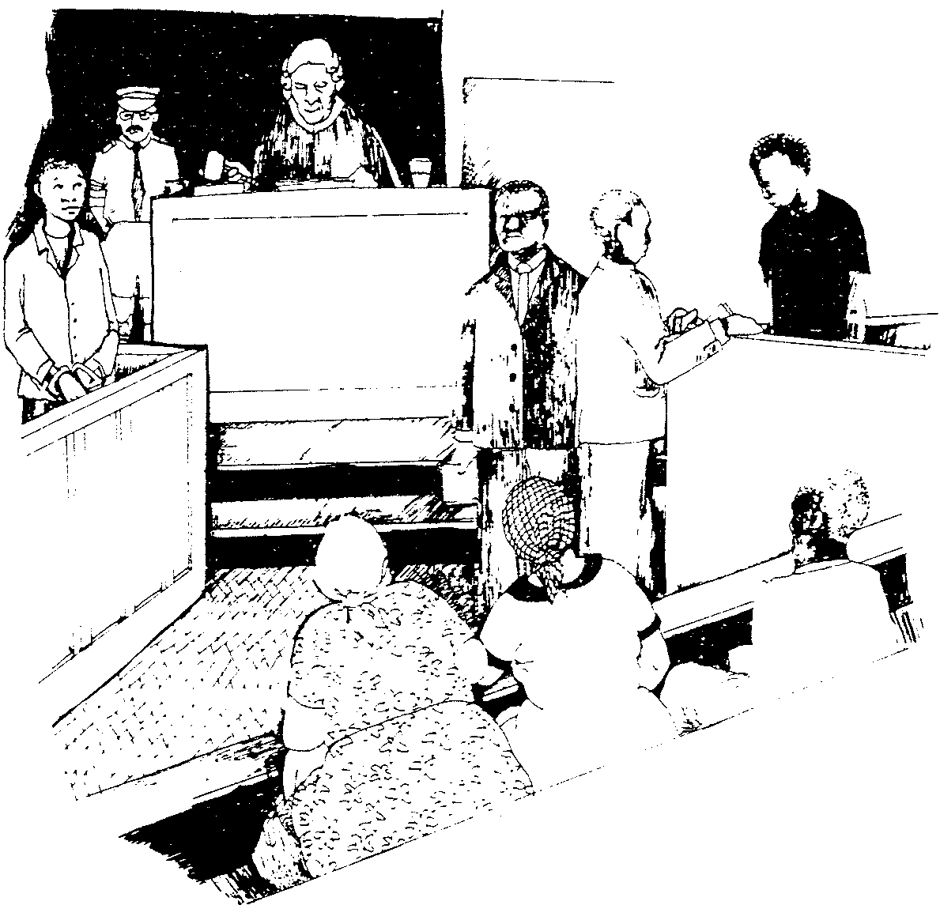  Kwathuleka kwathi cwaka. NeJaji yathula. Akukho ngxolo nakushukuma. Akukho nokhohlelayo. Yathetha iJaji yathi:  “Le nkundla ikufumanisa unetyala Absalom Khumalo lokubulala uJarvis emzini wakhe. Wena Matthew Khumalo nawe Johannes Pafuni inkundla inifumanisa ningenatyala.”  Aba babini behla ngamanqwanqwa baya ngaphantsi. Washiyeka yedwa lo umnye. Wabajonga ngoku bahambayo. Mhlawumbi wayesithi ngentliziyo, sendisele ndedwa.  Ijaji yathetha kwakhona yathi: “Zizathu zini ezingenza le nkundla ikuxolele ukuba uxolelwe. Ndicinge kakhulu ngale nto, kodwa ndoyisakala ukuzifumana. Ewe usemncinane, kodwa sewufikile kwikhabathisi lobudoda. Uya emzini nabalingane bakho ababini, niphatha izikhali ezibi nezibulalayo. Zozibini ezi zikhali ziyasetyenziswa esinye silimaza umntu kakubi, esinye sikhupha umphefumlo. Le nkundla ifanele ukuba ikhusele abantu ukuba bangahlaselwa zizigebenga nokuba zincinane nokuba zidala … | 5  10

Ngako ke andinakho ukuba ndikucelele ukuba uxolelwe.  Ijaji yabhekisa emfaneni yathi, “Kukho nto ongaba ufuna ukuyithetha ndingekasiwisi isigwebo?”  “Ndifuna ukuphinda nje kuphela ndithi ndambulala yena lo mlungu, kodwa ndandingamqondanga…”  Kuthuleke kwathi cwaka enkundleni. Nangona kwakuthe cwaka nje, wavakala umlungu ememeza esithi, “Inzolo enkundleni.” UKhumalo  wafihla ubuso bakhe ngezandla. Wayesele ekuqonda okuzayo. UJarvis uthule, uhlalele phezulu … “Absolom Khumalo, uza kuphindiselwa ejele uxhonywe ngentambo ude ufe. UNkulunkulu abe nenceba kuwe.  (Sibusiso Nyembezi/Alan Paton: Lafa Elihle Kakhulu) | 5

1.7 Kwakutheni eli tyala lalichotshelwe yiJaji? | (2)

1.8 Saba yintoni isigwebo salo mntu ungummangalelwa? | (2)

1.9 Xa ufunda ezi zicatshulwa zibini umxholo wazo uwubona uthetha ngantoni?` | (2)

1.10 Sifanekisozwi sini esisifumana kumhlathi wokugqibela? | (2)

1.11 Bhala igama libe linye endaweni yala mabinzana abhalwe ngqindilili apha ngezantsi:

- Abantu bayayihlonipha indlu yokuthetha amatyala.  - Akazange angene apho kugcinwe khona amabanjwa.  - Bamxhele ngemela izolo wafa. | 2x3=(6)

AMANQAKU ECANDELO A: | [30]

ICANDELO B

UMBUZO 2

Shwankathela esi sicatshulwa ngezivakalisi ezisibonisa unobangela wokugwetywa, nendlela abagwetywe ngayo abo bantu.

Isibhozo samadoda nabafazi ababini bebevele phambi kwenkundla kamantyi apha betyholwa ngokuxhoma amadoda amabini ngentambo kutshanje.
Kwelo qela kugwetywe amadoda amathandathu nabafazi ababini emva kokufunyaniswa benetyala lokuthathela umthetho ezandleni zabo. Isibini samadoda sifunyaniswe singenatyala.
Ngokwengxelo edizwe enkundleni, eli qela lathatha iintonga laya koosiyazi emva kokunyamalala kweenkomo kwilali yaseNtlangaza kwisiThili saseMqanduli.

Igqirha elo lawuchaza ngesipili umhlola, laza lanuka ababini. Aba babini babonakala esipilini bevulela iinkomo ezo zalahlekayo ebuhlanti, ngokutsho kobungqina benkundla.
Emva koko eli qela lathi liyaya, liyaya kwezi nqeberhu zimbini alisanyatheli. Bathatyathwa babotshelelwa ngentambo, baza bajingiswa phezulu endlwini, kusithiwa mabachaze ukuba ziphi na iinkomo.
Esi sibhozo sabantu sithe asalibazisa enkundleni, salivuma ityala zibekwa nje.
Bebonke bagwetywe intlawulo esukela kuma-R50 ukuya kwi-R100 umntu, okanye iintsuku ezingama-20 ukuya kwezingama-40 umntu emnye.
Isibini siphume sitshaya emva kokuba abamangali bexelele inkundla ukuba esi sibini sasikho ngomhla wokuxhonywa kodwa asizange sithabathe nxaxheba.

(Iphephandaba: Intsimbi)

AMANQAKU ECANDELO B: | [10]

ICANDELO C

UMBUZO 3

Funda esi sicatshulwa wandule ukuphendula imibuzo elandelayo

USibanjalo

Eli gama likaSibanjalo yayingegama wayelithiywe kowabo utitshala lo koko wayelizuze kubafundi beso sikolo semfundo ephakamileyo saseTamarha. Wayelithiywe eli gama ngabafundi bebanga lethoba awayebahlohla isiXhosa. Kuninzi lwezikolo kukho inkolo yokuba abafundi beli banga abanto ukuba nenkathazo nemfeketho. Mhlawumbi oku kungunobangela wokuba sukuba bengumxube wabafundi abavela kwizikolo ngezikolo.
Wofika kwezinye izikolo bede baphiwa igama lokuba ngooNotsib’ idyokhwe. Umfo kaLunda into yakwaMawawa, kwaMpinga kwaNtomntwana wayezithembe ngokwenene kulwimi lwenkobe. Wayesithi khona akusingatha eli cala lemigaqo yentetho ubone ukuba unkabi uphothulelwe. Kwakuba ngakumbi ke ukugxininisa nokubeka umnwe akufika kwesi sahluko sezibanjalo. Kulapho walifumana khona ke eli gama likaSibanjalo. Ayengasaziwa amagama akhe okwenyani kuba wawungeva nelali ikhala ngotitshala uSibanjalo. Wawungafika nala maxwebethwana aphuma ngonyezi esikolweni ephekuza ecaleni kweengcelwane elinganisa indlela ahlohla ngayo utitshala lo, uxakwe ukuba ayembona ngayiphi na intunja.
Oku kudunyelwa kukatitshala leli gama kwazenza ezinye iinkewana apho esikolweni zaphelela kule nto kaSibanjalo, ingakumbi abo babefika beze kuqala ibanga lesithandathu.

Yenzeka yona inkinge mhla enye yezi tshuvana yangena idubulekile, kwelo gumbi leetitshala, ngexesha lesidlo sasemini, yathi, ‘Ithi inqununu mandize kuxelela utitshala uSibanjalo ukuba usatsiba kwi-ofisi yabahloli.” Impendulo yaba yintsini eyamtsho waxakeka lowo wayezise umyalezo. Esaxakeke njalo umfo omkhulu nempendulo engadanga wayifumana, kwaphakama omnye wotitshala waqubula esikufuphi isagweba wonda ngomthunywa embuza ukuba ngubani na utitshala uSibanjalo. Waya ngomva emnyango ukhekhe elumkele eso sagweba, phofu esazama ukuchaza.
Kwakuxa athi, “Ngulaa titsh ……………… " ukuvakala kwesithongakazi sokuwa komfundi nenqununu ngaxeshanye. Hayi ke! Kwakrukruthekwa kwagigithekwa kwigumbi leetitshala kubukelwe inqununu ijongise amanqina phezulu umntwana wesikolo engaphezulu.
Zazimtshele yena uSilulami kuba wayengekalifezi nelokuqala ityala esenza elinye nje. Wadomboza apho, etarhuzisa, ecela uxolo, etyhwatyhwa luvalo. Yavuka apho inqununu imthwebeshu sele inyongoba ukuya kwiofisi yayo, ingakhange ilahlekelwe nalelimdaka, imshiya apho loo Silulami esisimo setyuwa. Sada saphuma isikolo eso siganeko singundaba-mlonyeni.

(P.P.N. Dumashe, Umfundi eUnitra)

3.1 Qwalasela ukusetyenziswa kwala magama alandelayo afunyanwa kwesi sicatshulwa singentla. Yenza ke ngoku amaqhalo okanye izaci ngala magama uze unike nentsingiselo ukubonisa ukuba uyawazi ukuba asetyenziswa njani.

3.1.1 isagweba  3.1.2 ukubeka  3.1.3 indlela  3.1.4 umnwe  3.1.5 ityala | 2x5=(10)

3.2 Sebenzisa amaqhalo / izaci ozenzileyo kwizivakalisi uphuhlise ukuba uyayazi intsingiselo yawo. | 1x5=(5)

UMBUZO 4

Kumhlathi wesibini kukho ezi zimnini zilandelayo. Zenzele izivakalisi ngezimnini ezi ubonise ukuba uyayazi intsingiselo yazo. Izivakalisi zakho mazahluke kwezo zikwisicatshulwa.

- lokuba  - kaLundi  - lwenkobe  - yentetho  - sezibanjalo | (5)

UMBUZO 5

5.1 Chaza ukuba kwezi zivakalisi zilandelayo kungani ukuba iceba lishiyiwe.

- Eyona nyama endiyithandayo ngumkhwepha.  - Zintombindini yizani apha.  - Thina maXhosa singabantu abahle.  - Andifuni mntu apha.  - Ndifumene zitapile, zimbotyi nemingqusho. | 1x5=[5]

5.2 Yakha izenzi kwezi ziphawuli, zibizo, zifanekisozwi okanye izibaluli wandule ukuzisebenzisa kwizivakalisi ezifanelekileyo ukubonisa ukuba uyazazi.

- khulu  - mnandi  - myoli  - ncinci  - ivila | 1x5=[5]

UMBUZO 6

6.1 Kumhlathi wesibini umgca wesibini sifumana isibizo “Umfo”. Sebenzisa isiqu sesibizo kunye nezimaphambili zala mahlelo alandelayo 7 no 8 ukubonisa ukuba isimaphambili sinakho ukuyiguqu-guqula intsingiselo yengcambu, usakugqiba wakhe izivakalisi ngazo.

Cwangcisa ngoluhlobo  Isibizo Isivakalisi | (4)

6.2 Njengoko sesenzile ngasentla thabatha kwakhona isiqu sesibizo “Umthi” usisebenzise nezimaphambili zala mahlelo alandelayo 10, 11, 14 ukubonisa ukuba isimaphambili siyayiguquguqula intsingiselo yengcambu. Usakugqiba wakhe izivakalisi ukubonisa ukuba uyaziqonda izinto ezizithethayo.

Cwangcisa ngoluhlobo  Isibizo Isivakalisi | (6)  [10]

UMBUZO 7

Lungisa iziphene othi uzifumane kulo mhlathana.

laa mhla wabambwa wothuka akubona enxibiswa ezamabanjwa ukuze impahla ebeyinxibile ukufika kwakhe ifakwe engxoweni ebomini bakhe wayeqala ukungena entolongweni iinyanga ezintathu zaphela sele ebhitye iingqame zingaphandle wayeyingozi ukuhamb’ oku erhotyoza isangotha siphume sonke iminwe ngathi ziingcingo zaphezu kwento yonke nga wayekhathazeka kakhulu nangexesha langokuhlwa yena wayeyintlekisa ekhwazwa heyi wena mafikizolo unonkonkonko le nto usingxolelayo ngokugukruza ubusuku bonke? | [20]

AMANQAKU ECANDELO C: | [60]

AMANQAKU SELEWONKE: | 100

