Part 11 The s-Block Elements (Book 4, p.74 – 75)

11. (a) CaCO₃(s) $\vec{\text{heat}}$ CaO(s) + CO₂(g)
CaO(s) + H₂O(l) ⎯→ Ca(OH)₂(s)

(b) To raise the pH of soil.

(c) MCO₃(s) $\vec{\text{heat}}$ MO(s) + CO₂(g)
It increases down the group.
The M²⁺ cation polarizes the anion and weakens the C – O bond. This facilitates the decomposition of MCO₃. Going down the group, the cationic size increases and the polarization effect decreases. Hence, it becomes more difficult to decompose MCO₃ down the group.

(d) (i) As M²⁺ cationic size increases down the group, the ionic bonds become weaker. Hence, less energy is needed to break the bonds and a low melting point is expected.
(ii) MgO: as a refractory material.

12. (a) CaCO₃(s) ⎯→ CaO(s) + CO₂(g)

(b) A calcium ion is smaller than a barium ion since it has less filled inner electron shells but the same charge. Hence, calcium ion has a higher charge density and a greater polarizing power. Calcium ion distorts the electron cloud of the carbonate ion to a greater extent than barium ion, so calcium carbonate decomposes more readily and at a lower temperature.

13. When limestone is heated strongly, it decomposes to calcium oxide and carbon dioxide.
CaCO₃(s) ⎯→ CaO(s) + CO₂(g)
When a small amount of water is added, much heat is given out and calcium oxide is converted to calcium hydroxide.
CaO(s) + H₂O(l) ⎯→ Ca(OH)₂(s)
On addition of an excess of water, calcium hydroxide dissolves.
Ca(OH)₂(s) + aq ⎯→ Ca(OH)₂(aq)

14. (a) Ba(s) + 2H₂O(l) ⎯→ Ba(OH)₂(aq) + H₂(g)

(b) The reaction of barium with water is more vigorous than the reaction of calcium with water.
Both barium and calcium are Group II elements. The reactivity of Group II metals with water is related to the relative ease of the metal to donate the outermost shell electrons. Going down the group, as the atomic size increases, the atoms are easier to donate the outermost shell electrons. Since barium is a lower member of Group II metals than calcium, the electrons are loosely held by the nucleus and they lose more easily to water. So barium react with water more vigorously than calcium.

(c) BaCO₃(s) $\vec{\text{heat}}$ BaO(s) + CO₂(g)
(d) Calcium carbonate would decompose more easily.
This is because calcium has higher polarizing power than barium, it distorts the electron cloud of the carbonate ion to a greater extent. Thus, it is less stable and decomposes more easily.

(e) As the solubility of barium sulphate(VI) in water is lower than that of calcium sulphate(VI), we would distinguish between barium chloride and calcium chloride by adding sodium sulphate(VI) solution to form the corresponding sulphate(VI) compounds. n the test tube containing barium chloride, a precipitate would appear shortly after adding sodium sulphate(VI) solution. On the other hand, a precipitate does not appear in the test tube containing calcium chloride after adding sodium sulphate(VI) solution.

15. ΔH_{soln} = ΔH_{hyd} － ΔH_{lattice}
The solubility of compounds depends on both of ΔH_{lattice} and ΔH_{hyd}. For the sulphates of Group II metals, the size of the cations are much smaller than the anion. Therefore, going down the group, the increase in size of cations does not cause a significant change in the ΔH_{lattice}. However, the increase in size of the cations does cause the ΔH_{hyd} to become less and less negative down the group. As a result, the hydration enthalpy of magnesium sulphate is more negative than that of barium sulphate. The change in ΔH_{hyd} is more significant than the change in ΔH_{lattice}. Therefore, the ΔH_{soln} of magnesium sulphate is more exothermic, and hence the solubility of magnesium sulphate in water is much higher than that of barium sulphate.

16. (a) Lithium and calcium

(b) 4Li(s) + O₂(g) ⎯→ 2Li₂O(s)
2Ca(s) + O₂(g) ⎯→ 2CaO(s)

17. 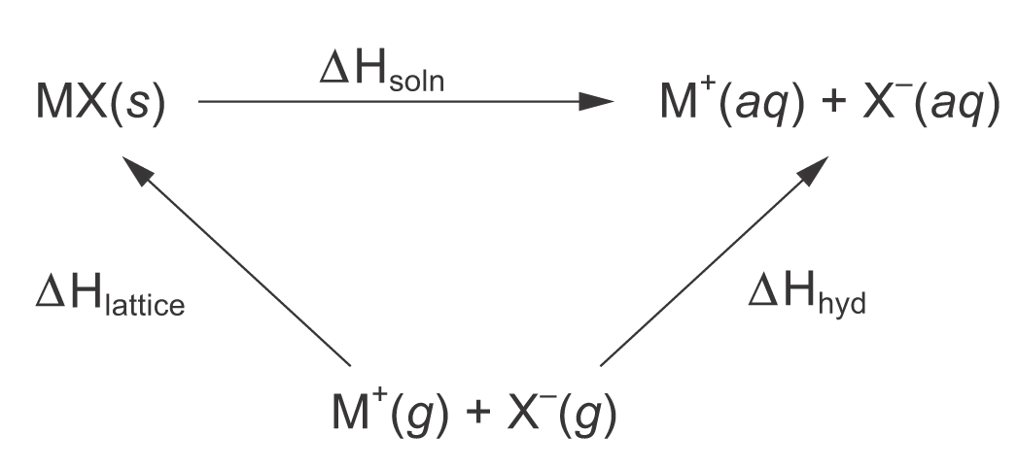

H_{soln} = ΔH_{hyd} － ΔH_{lattice}
For the hydroxides of Group II metals, the sizes of the anion and the cations are of the same order of magnitude. From Mg²⁺ to Ba²⁺, less and less energy is required to break the lattice (i.e. from –2843 to –2228 kJ mol^{–1}). However, the change in ΔH_{hyd} is comparatively small (i.e. from –1920 to –1360 kJ mol^{–1}). Consequently, the ΔH_{soln} becomes more and more negative, and the solubility of the hydroxides of Group II metals increases down the group.

18. (a) Ca(s) + 2H₂O(l) ⎯→ Ca(OH)₂(aq) + H₂(g)

(b) The solubility of the hydroxides of Group II metals increases down the group.
19. (a)
(b) On heating, the compounds are vaporized. The ions are converted to gaseous atoms. The electrons in the gaseous atoms are excited to higher energy levels. When the excited electrons return to their ground state, energy is released in form of light corresponding to the initial excitation. Since the amount of energy is quantized, the flame colour is a characteristic property of elements.

20. (a) Bottle B

(b) The label is correct.
Magnesium ion is small and highly charged, so it has high polarizing power. As it has large polarizing power, it distorts the electron cloud of the carbonate ion to great extent. The compound becomes less stable to heat and decomposes on heating.
MgCO₃(s) $\vec{\text{heat}}$ MgO(s) + CO₂(g)
The colourless gas produced is carbon dioxide.

(c) Dissolve the solid in bottle D into water. Barium hydroxide is more soluble in water than magnesium hydroxide. If the solid does not dissolve or dissolve only slightly in water, it would be magnesium hydroxide. If the solid dissolves in water readily, it would be barium hydroxide.

