FORCES REVISION QUESTIONS
1. Two forces that act on a moving cyclist are the driving force and the resistive force.
(a) The diagram shows a cyclist.
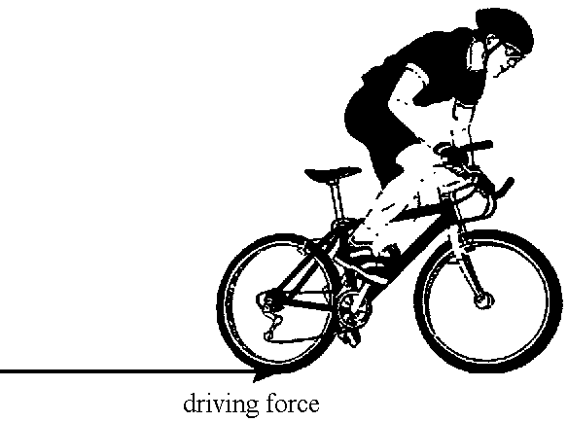
(i) Add an arrow to show the direction of the resistive force.
(1)
(ii) The cyclist is speeding up. Which is the correct statement about these two forces?
A The driving force is greater than the resistive force.
B The driving force is smaller than the resistive force.
C The driving force is the same as the resistive force.
Write the correct answer (A, B or C) in the box.
(1)
(b) The table shows how the distance travelled by a cyclist changes with time.
Distance travelled (m) | 0 | 40 | 80 | 80 | 110 | 140
Time (s) | 0 | 10 | 20 | 30 | 40 | 50

Some of these points have been plotted on the graph.
(i) Complete the graph.
(2)
(ii) Between which TWO times shown on the graph was the cyclist not moving?
Between.......................s and ......................s
(1)

(iii) Between which TWO times shown on the graph did the cyclist have the greatest speed?
Between.......................s and ......................s
Explain your answer.
...........................................................................................................................
...........................................................................................................................
(2)
(Total 7 marks)

2. The mattress of a bed contains springs. The diagrams show the change that takes place when a person lies on the bed.
(a) (i) How do the springs change when a person lies on the bed?
..........................................................................................................................
(1)
(ii) Circle the spring that has the greatest force on it.
(1)
(iii) How can you tell that this spring has the greatest force acting on it?
..........................................................................................................................
(1)
(b) A manufacturer makes a mattress that sags less in the middle when a person lies on it.
Suggest two ways of doing this.
1 .................................................................................................................................
....................................................................................................................................
2 .................................................................................................................................
....................................................................................................................................
(2)
(c) One force acting on the person is the upward push of the springs.
(i) Another force acts on the person.
Draw an arrow on the diagram to show the direction of this force.
(1)

(ii) Use words from the box to complete the sentence.
downward Earth mattress upward
The other force on the person is the ................................................ pull of the
................................................ .
(2)
(Total 8 marks)

3. A sky-diver of mass 70 kg jumps from a plane. The graph shows how the vertical velocity of the sky-diver varies with time. Parts of the graph have been labelled A, B, C, D and E.
(a) At A, the sky-diver has an acceleration equal to the acceleration due to gravity of
10 m/s2. Calculate the resultant force acting on the sky-diver at this instant.
....................................................................................................................................
....................................................................................................................................
....................................................................................................................................
(3)
(b) How can you tell from the graph that in the time period from B to C the resultant force acting on the sky-diver is zero?
....................................................................................................................................
....................................................................................................................................
....................................................................................................................................
....................................................................................................................................
(2)

(c) Describe and explain the motion of the sky-diver from C until he lands at E.
....................................................................................................................................
....................................................................................................................................
....................................................................................................................................
....................................................................................................................................
....................................................................................................................................
....................................................................................................................................
....................................................................................................................................
(4)
(d) A sky-diver, of the same mass, falls from the same height but uses a parachute with a larger surface area. On the grid, sketch a graph to show his motion.
(2)
(Total 11 marks)

4. The diagrams show the forces acting on a ball, attached to an elastic cord, as it falls.
A, B, C and D represent four different times in its fall. The length of each arrow shows the size of the forces.
(a) What is the name of the downward force that causes the ball to fall?
....................................................................................................................................
(1)
(b) Which diagram, A, B, C or D, shows the ball slowing down?
Explain how you can tell.
....................................................................................................................................
....................................................................................................................................
(2)
(c) Explain why the upward force increases as the ball moves from position C to position D.
....................................................................................................................................
(1)
(d) Describe the energy changes taking place as the ball falls to the point where the elastic cord is stretched the most.
....................................................................................................................................
....................................................................................................................................
....................................................................................................................................
(3)
(Total 7 marks)

5. A train accelerates from rest along a straight track.
The graph shows how the train’s velocity changes with time.
(a) (i) How can the distance travelled be determined from a velocity-time graph?
.............................................................................................................................
(1)
(ii) Calculate the distance travelled by the train in the first 15 s.
.............................................................................................................................
.............................................................................................................................
(2)

(b) The mass of the train is 120 000 kg.
Calculate the unbalanced force on the train at 10 s.
.......................................................................................................................................
.......................................................................................................................................
.......................................................................................................................................
.......................................................................................................................................
(4)
(Total 7 marks)

6. Motor vehicles use springs to help to give passengers a smooth ride.
The weight of a vehicle rests on four of these springs, causing them to become compressed.
The table shows how the length of one of these springs changes as the force on it increases.
force (N) | length (cm)
400 | 30.0
1800 | 25.0
4000 | 17.5
4700 | 16.5
6000 | 15.5
7000 | 15.0
(a) Use the grid to draw a graph of length in cm against force in N.
(3)

(b) In normal use the force on each spring is 2400 N.
What is the length of the spring in normal use?
………………………………………………………………………………………
(1)
(c) Explain why the spring cannot be made smaller than 15 cm however big a force is applied.
………………………………………………………………………………………
………………………………………………………………………………………
(2)
(Total 6 marks)

7. The diagram shows the forces on a rally car moving forward along a road.
(a) (i) There are several forces on the rally car.
Complete this sentence using A, B, C, D or E.
The rally car will accelerate forwards if force ………... becomes greater
than force ……....
(1)
(ii) The car weighs 10 000N
Calculate the value of force B.
.......................................................................................................................
(1)

(b) This is a velocity/time graph for a short journey.
The graph has three sections X, Y and Z.
(i) In which section is the car slowing down and stopping?
.......................................................................................................................
(1)

(ii) In which section is the driving force equal to the resistance force?
.......................................................................................................................
(1)
(c) When the car travels at 30 m/s, its braking distance is 90 m.
The highway code says the stopping distance for a car moving at 30 m/s is 110 m.
(i) Explain why the stopping distance is greater than the braking distance.
.......................................................................................................................
.......................................................................................................................
(1)

(ii) Suggest two factors that can increase the braking distance at 30 m/s.
1. .............................................................................................................…...
.......................................................................................................................
2. ..............................................................................................................…..
.......................................................................................................................
(2)
(Total 7 marks)

8. A hot air balloon is tied to the ground by two ropes.
The diagram shows the forces acting on the balloon.

The ropes are untied and the balloon starts to move upwards.
(a) Calculate the size of the unbalanced force acting on the balloon.
State the direction of this force.
....................................................................................................................................
....................................................................................................................................
....................................................................................................................................
(2)

(b) The mass of the balloon is 765 kg. Calculate the initial acceleration of the balloon.
....................................................................................................................................
....................................................................................................................................
....................................................................................................................................
....................................................................................................................................
(3)

(c) Explain how the acceleration of the balloon changes during the first ten seconds of its flight.
....................................................................................................................................
....................................................................................................................................
....................................................................................................................................
....................................................................................................................................
....................................................................................................................................
....................................................................................................................................
(4)
(d) When the balloon is still accelerating, the balloonist throws some bags of sand over the side. Explain how this affects the acceleration of the balloon.
....................................................................................................................................
....................................................................................................................................
....................................................................................................................................
....................................................................................................................................
(2)
(Total 11 marks)

