Cathode rays & electronics

Introduction
This unit will look at the production of cathode rays and their behaviour in electric and magnetic fields. It will look in detail at the use an oscilloscope to measure both AC and DC voltages. A variety of electronic devices such as potentiometers, capacitors, LDRs, thermistors, reed switches and reed relays will be looked at, as will their use in circuits.

Cathode rays
A cathode ray is basically a stream of high-speed electrons. They are produced by a process called thermionic emission. This occurs when a metal is heated to the point where high-energy electrons are able to escape from the surface of the metal. These ‘free’ electrons can be made to flow as a stream, or cathode ray, if a high voltage anode (+ve terminal) is used to attract them.
The easiest way to detect these cathode rays is by making them strike a fluorescent screen. When this happens, the screen glows (usually a green or purple colour).

Deflecting cathode rays
Since a cathode ray is a stream of electrons, it is affected by magnetic or electric fields.
Magnetic field
The two coils X₁ and X₂ are large electromagnets. When turned on, one will become a N-pole and the other a S-pole.
By using Flemings LHR we can predict which way the cathode ray will be deflected -
X₁ X₂ Deflection of beam
N S Downwards
S N Upwards
N.B. The flow of electrons is right to left but conventional current is left to right!!

Electric field
The two plates Y₁ and Y₂ can have a high voltage attached to them, so that one becomes +ve and the other –ve.
The cathode rays will be attracted to the +ve plate (because they are –vely charged) and the ray will be deflected.
Y₁ Y₂ Deflection of beam
+ - Upwards
- + Downwards
the size of the force causing the deflection can be increased by
- A stronger magnetic or electric field
- Larger number of cathode rays

Proving the charge on cathode rays
In this circuit, the ammeter registers a current only when the anode is +vely charged, showing that the cathode rays only hit the anode because they are –vely charged.

The cathode ray oscilloscope
The oscilloscope can be broken down into 3 main areas.
The electron gun The deflecting system The fluorescent screen
The electron gun consists of a heater, a cathode, another electrode called the control grid, and 2 or 3 anodes for accelerating and focussing the beam.
The control grid is –vely charged and controls the number of cathode rays passing through it. In other words it is the ’Brilliance’ or brightness control on the CRO.
The deflecting system has Y plates, which are horizontal parallel plates are used to produce an electrical field that deflects the electron beam vertically. It is to these plates that the ‘external source’ to be tested is applied.
The X plates are vertical parallel plates that produce an electrical field that deflects the electron beam horizontally. They are powered by an internal, controllable source that deflects the cathode rays in a regular manner, called the ‘time base voltage’ (see time base later).
The fluorescent screen is where the cathode rays strike the screen and become visible as dots.

Use of the CRO
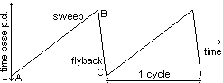The time base control
This is the internal voltage applied to the X plates. It can be used to make the ‘dot’ move across the screen. If this movement is quick enough, then it looks like a continuous line to us. The voltage that is applied is a SAW TOOTH one, as shown here.
The section AB causes the dot to move at a steady speed across the screen. The section BC causes it to ‘fly back’ rapidly to its starting position.
For the use of the ‘time base’ control - see measuring AC voltage.

Measuring DC voltages
If an external DC source is corrected to the Y plates, then the beam can be made to deflect vertically. If the time base is set high enough then we will see this as a deflection of the line.
A No external pd applied, so the line is in the centre of the screen
B + ve DC applied, so the line deflects upwards
C - ve DC applied, so the line deflects downwards
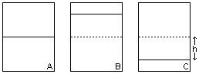The screen is divided into 1cm grids. So by:
i. Calculating the height of the deflection in cm;
ii Using the Vcm^{–1} scale that the scope is set to;
We can calculate the value of the voltage -
eg deflection h = 1cm
voltage gain value = 2Vcm⁻¹
voltage = 2 x 1 = +2V
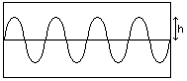Measuring AC voltages
As before, we have to measure the ‘peak value’ (the peak deflection) from the screen and multiply it by the voltage gain value. We can either measure the deflection for a ‘peak’ or a ‘trough’. eg deflection h = 0.5cm
gain = 3Vcm⁻¹
voltage = 3 x 0.5 = 1.5V
Measuring time period and frequency for AC voltages
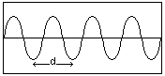As stated before, we can control the ‘time base’ voltage applied to the X plates.
To measure the time period for an AC supply we:
a) Measure the horizontal length of one cycle
b) Record the time base scale
If we multiply this distance by the time base value, we can calculate the time period for the AC supply. eg d = 1.5cm
Time base = 2scm⁻¹
Time period (T) = 1.5 x 2 = 3s
Frequency (f) = 1/T f = 1/3 = 0.33Hz

The potentiometer (potential divider)
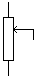This is a device to control the amount of voltage supplied to a component in a circuit. It is very similar to a rheostat in design and usage. It consists of length of wire with a sliding contact. As the contact is slid, the resistance of the circuit changes, because the length of the potentiometer wire used in the circuit varies. Thus the voltage across the component in the circuit can be varied.
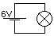
In this circuit the bulb receives all of the 6V across it.
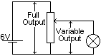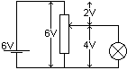
Now any value between 0V and 6V can be given to the bulb, depending upon the position of the sliding contact.

Its main use is as a tone/volume control. In a practical device, the length of wire is circular to reduce space.

The capacitor
This is a device that stores electrical energy by storing electrical charge. The capacitor charges up (stores charge) when the circuit is on. When power is switched off, the capacitor slowly discharges (releases its energy and charge). It can be used as a switch to turn a second circuit on a pre-determined time after the first circuit is off. It is used in ”time delay circuits”

LDRS and Themistor
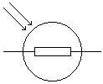LDR (light dependent resistor) is a device whose resistance changes with the amount of light incident upon it. It is termed a transducer as it changes (transduces) light energy into electrical energy.
Light intensity UP Resistance DOWN Current UP

It can be used as a sensor in a circuit. A limit is set to the current that will turn a circuit on. If the light intensity is low then R will be high and I too small to turn the component on. As the light intensity increases, R decreases and I will reach the pre-set limit and the component will operate.

Thermistor
This is another transducer (it changes heat energy into electrical energy). It too can be used like a sensor, as outlined for the LDR.
Temperature UP Resistance DOWN Current UP

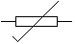

Reed switches & Relays
Reed switches
1. Normally open
It consists of two pieces of thin, flexible metal that overlap. When exposed to a magnetic field the strips become magnetised, attract each other and touch, so the circuit is completed. It can be used as a switch to turn a second circuit on.
2. Normally closed
There is a variation in which the metal strips are in contact at the start. In the presence of a magnetic field they magnetise and repel each other - switching the circuit off.

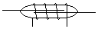Reed relay
It is basically a reed switch with its own electromagnet around it. It behaves exactly as a reed switch (normally open or closed).

Uses of relays / Reeds switches
They are used in low current circuits as switches to turn on or off secondary circuits that carry far larger currents. This allows for greater economy and safety.

Switching circuits
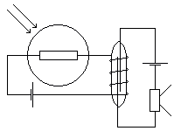

Light sensitive system

eg A Dark Room Alarm

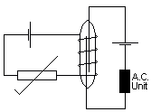

Temperature sensitive system

eg An AC control

or

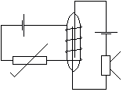 A Fire alarm

Homework p 313: q 2, 4, 5; p 336: q 21, 25.

