Waves Character – Classwork Practice

Section A – Basic Wave Understanding

- Complete the following by replacing the **** with the correct words:
  - If the vibrations of a wave are at right angles to the direction of the wave, it is called a **** wave.
  - If the vibrations of a wave are along the direction of the wave, it is called a **** wave.
  - The wavelength of a wave is the distance between two successive **** (or ****) of a wave.
  - The frequency of a wave is measured in ****.

- A certain sound wave has a frequency of 110 Hz and a wavelength of 3m. What is the speed of sound?

- The time period of a wave (T), is the time taken to complete one complete wave. If the frequency (f) of a wave is 2 Hz, what is its time period?

Section B – Understanding Sound Waves
- A sonar pulse (a sound wave) sent out by a submarine is heard by a dolphin 4 seconds later. If the dolphin is 6km away from the submarine:
  - Calculate the speed of sound in water.

  - The speed of sound in air is 340 m/s. Give one reason why the value you calculated in (a) is different from this value.

  - If the frequency of the sonar pulse is 500 Hz, what is its wavelength in water?

- Look at the following diagram, which shows a graph of a sound wave given by a tuning fork.
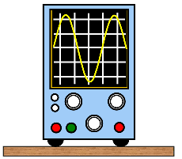
On the following blank traces, draw graphs to show:

  - A sound wave of higher pitch but the same loudness.
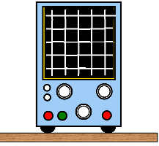
  - A sound wave of the same pitch but louder.

  - A sound wave of a lower pitch and quieter

Section C – Extension Question
- A fishing boat can use sonar to detect a shoal of fish underneath it, by bouncing the sound wave off it. On one occasion, a short pulse of sound waves is emitted from the boat, and the echo from the shoal is detected 0.10 seconds later. The sound waves travel through sea water at 1500 m/s.
  - How far has the pulse travelled in 0.10 seconds?

  - How far below the boat is the shoal of fish?

  - The sound wave has a wavelength of 2cm. What is the frequency of the sonar sound wave?

Waves Character – Homework Questions

- Complete the gaps in the following:
  - A sound wave is longitudinal, which results in it consisting of places of higher pressure (called ****) and places of lower pressure (called ****).
  - Sound cannot travel through a ****
  - The speed of sound in a solid is **** than the speed of sound in air.
  - The pitch of a sound depends on the **** of the sound wave.
  - The loudness of a sound depends on the **** of the sound wave.
- The speed of sound is 340 m/s. If thunder is heard 20 seconds after lightning, how far away is the storm?
- Explain, with the aid of diagrams, what is meant by the following for sound waves:
  - Amplitude
  - Wavelength
  - Frequency
- A flute player produces a note of 300 Hz during a solo. If the speed of sound in air is 340 m/s:
  - How long would it take someone sitting at the back of a concert hall to hear the note, if the distance between the listener and the flute player is 200m.
  - What is the wavelength of the note produced by the flute player?
  - How many compressions would there be in the sound wave between the flute player and the listener (Hint: there will be one compression per wave cycle).

