waves

Introduction
This unit will introduce basic wave theory as well as the usage of ideas of wavefront, frequency, wavelength and amplitude. It will also categorise waves into two types, give the wave equation for calculations and consider reflection, refraction and diffraction of waves.

Waves
A wave is a pulse of energy travelling through a medium, or in some cases, through a vacuum. A wave carries energy from place to place. There are 2 types of wave:

Longitudinal waves Transverse waves
Sound waves Light waves
Water waves
Waves from the EMS

Production of waves using a spring
Transverse waves.
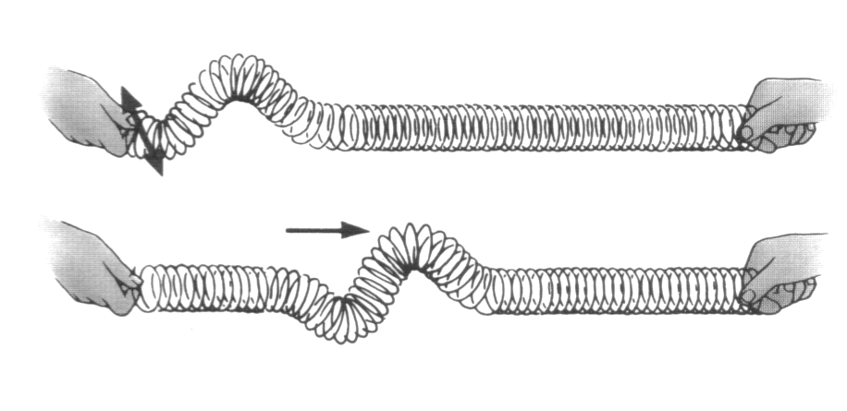
In the diagram one flick, up and down, of the wrist will cause one pulse or wave to travel along the stretched spring.
If the wave is analysed as it travels we can see how the position of one particle changes with time.

Motion of one particle
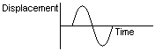
This shows how a single particles position changes with time

The motion of all the particles moving along the spring at any one instant.

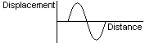This shows how all the particles are moving along the length of the spring at any given instant.

Transverse motion
The motion of any one particle follows the pattern below as one wave passes.

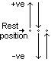The particle first rises to a maximum displacement, then it falls back through the rest position to an equal maximum –ve displacement and then it travels back to its rest position.

The motion of the medium is at 90^{O} to the motion of the wave itself.
This is the definition of a transverse wave.

Longitudinal waves
One sideways motion, back and forth, will cause one wave to travel along the stretched spring.

If the wave is analysed as it travels we can see how the position of one particle changes with time.

Motion of one particle
This shows how a single particles position changes with time

Longitudinal motion
The motion of one particle can be interpreted as that for transverse waves, even though the motion of the particles is side to side rather than up and down.
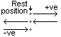
However in this case the motion of the particle is in the same plane as that in which it travels. This is the definition of a longitudinal wave.

naming the parts of a Wave
Frequency The number of waves or complete cycles per second. A measure of the number of waves passing by in one second.
It is measured in Hertz (Hz). 1 Hertz = 1 wave (or cycle) per second. Symbol = f

Amplitude The maximum displacement, either positive or negative, from the rest position. Symbol = a

Wavelength The distance between two points on a wave that are in phase i.e. moving at the same speed in the same direction. Usually seen as the distance between two peaks or two troughs on a wave. Measured in metres. Symbol = λ
Velocity How fast the wave is travelling. Measured in metres. Symbol = v

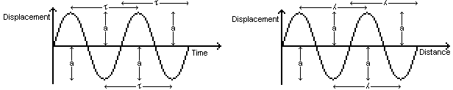Time period The time between two points on a wave which is in phase. In simple terms it is the time between either two adjacent peaks or two adjacent troughs. Measured in seconds. Symbol = τ Note that f = 1 / τ

Phase Two points are in phase when they are in exactly the same position.

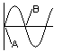These two points (A & B)are not in phase, even though they are both at the rest position.
A is about to move in a +ve direction.
B is about to move in a –ve direction.

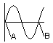These two points are in phase. They are both at the rest position.
They are both about to move in a +ve direction.

Altering waves
Amplitude
The more energy put into a wave the larger the amplitude, so Amplitude ∝ Energy
In the case of the springs, a larger amplitude is achieved by flicking over a larger distance (for transverse waves), or shuffling the spring back and forth over a larger distance (for longitudinal waves). In all cases it is altered at the source of the wave.

Frequency
The faster the spring is moved the more waves per second are created. This is altering the wave at its source.

Velocity
The velocity of a wave can only be altered by altering the medium the wave travels through. (Refraction).

Wavelength
Wavelength changes depend upon changes in frequency and velocity.

Wave equation
v = f λ
v = velocity (ms⁻¹) f = frequency (Hz) λ = wavelength (m)

This equation is applicable to all waves.

Energy losses in waves
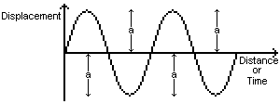In an ideal situation, there are no energy losses as the wave travels. So the height of each peak and trough will remain at a constant maximum level, i.e. each peak and trough will have the same amplitude.

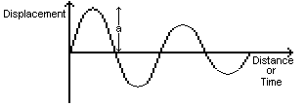In reality, energy is lost as the wave travels. So the height of each peak and trough steadily decreases. Only the first peak shows the original full amplitude.

Examples on page 172, q 3, 4

Water waves
Water waves are examples of Transverse Waves. They can be used to demonstrate the behaviour of all waves. All waves can be: Reflected, Refracted Diffracted.

Wavefronts: As waves are given out from a source, if all the points in phase on each wave are joined up with an imaginary line, then a wavefront has been created.
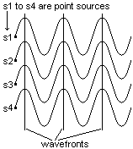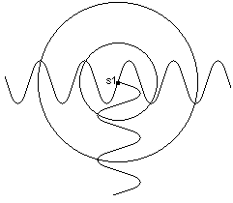Plane wavefront Circular wavefront
In each case the wavefront is at 90^{O}
to the direction of the wave

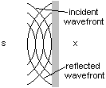Reflection of waves
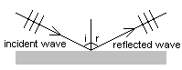

Angle of incidence = Angle of reflection The reflected wavefronts appear
∠ i = ∠ r to come from point X.

When reflection occurs there is no change in velocity (v), frequency (f), wavelength (λ)
or amplitude (a).

Refraction of waves
A wave changes speed as it passes form one medium to another. This change of speed is called refraction. It usually shows itself as a change in direction of the wavefronts.

If the wave travels from a less dense to a more dense medium then the wave slows down, wavelength decreases but frequency is unaltered.
This is seen as a bending of the wave towards the normal.
If the wave travels from a more dense medium to a less dense medium, then the wave speeds up, wavelength increases but frequency is unaltered.
This is seen as a bending of the wave away form the normal.

Combinations of media
Less dense | More dense
Air | Oil
Oil | Water
Air | Glass/perspex
Water | Glass/perspex
Warm water | Cool water
Air | Water
Oil | Glass/perspex

More dense to Less dense
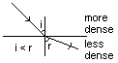
Wave speeds up
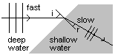Wavelength increases
Frequency remains constant

Less dense to More dense
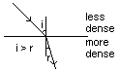
Wave slows down
Wavelength decreases
Frequency remains constant

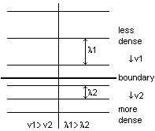Refraction with plane waves at 90^{O} to the boundary

v₁ > v₂ λ₁ > λ₂

The wave is slowed down, but no bending is seen.

The wave, however, has still been refracted.

Homework p 172: q 5, 6, 7, 8.

REFLECTION, REFRACTION

& Diffraction

As the plane wavefronts pass through the hole they are distorted, i.e. bent into circular wavefronts. The wave however does not change velocity, frequency, wavelength or amplitude.
The smaller the aperture the more bending (diffraction) occurs. The closer the wave length is to the size of the aperture, the greater the diffraction.

