FORCES III

Introduction
This final unit on forces will look at the Moment or turning effect of a force and how these forces may be balanced to produce equilibrium. We also define centre of mass and explain how to find it experimentally and show how it affects the stability of any object.

Moments
If we set up an object so that it can pivot (turn), then any forces applied to it will cause it to rotate. In other words there is a turning effect produced by these forces.

The extent of the turning effect depends upon
- the size of the force
- the perpendicular distance between the force and the pivot

This turning effect is known as the Moment of the force, and its units are Nm.

Moment = Force (N) x Perpendicular distance (m)

Examples:
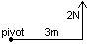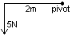

Moment of the force = F x d Moment of the force = F x d
= 2 x 3 = 6Nm = 5 x 2 = 10Nm

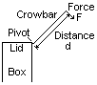
Simple levers, The moment of the applied force is F x d
such as crowbars, This large force is applied via the very
are examples of short distance from the bend in the bar
moments in action. to the point of the bar.

So a force F of 5N applied to a crowbar with d =1m is 5 x 1 = 5Nm.
This force on the lid is over a distance of 2cm (the short bit of the crowbar).
So the force on the lid L is 0.02 x L.
The two forces are equal because the crowbar is rigid, so 0.02 x L = 5.
∴ L = 5 / .02 = 500N.
So using a small force with the crowbar, together with our knowledge of moments, means we can easily apply a very large force to the lid with very little effort to ourselves.

Simple Machines
The principle of moments can be applied to any machine that uses a pivot.

The force used to make the machine work is called the EFFORT.
The object on which the force acts is the LOAD.

On each of the machines below label –
the effort as a force arrow E and
the load as a force arrow F,
the pivot is shown.

Equilibrium
If we consider a stationary beam, which is pivoted, then it must be under the influence of balanced forces; otherwise it would start to move. There are two ways in which forces can move the beam – either vertically or rotationally. For example:
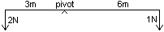
The forces balance because the beam does not move.

In a vertical plane, the pivot must be exerting an upward reaction force on the beam equal to the downward force of the mass of the beam plus the 2n and 1N forces.
In a rotational sense, the 2N and 1N forces must balance because of the distances they are from the pivot, i.e. 2N x 3m = 1N x 6m = 6Nm. The 2N force tries to rotate the beam anticlockwise whilst the 1N force tries to rotate it clockwise. The moments are equal and opposite, 6Nm clockwise and 6Nm anticlockwise.
i.e. the Clockwise Moments = the Anticlockwise Moments.
So, for equilibrium, the vertical forces and the rotational forces must balance.

We can use equilibrium to find an unknown force, or distance, if a beam is known to be in balance because the Clockwise Moments = Anticlockwise Moments.
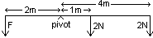Clockwise Moments = (2N x 1m) + (2N x 4m) = 10Nm
Anticlockwise Moments = F x 2m
So, 2 x F = 10
∴F = 10 / 2 = 5N.

Examples
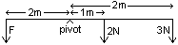

1 What is the force F required to balance the beam?

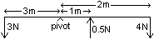
2 Is this system balanced?

3 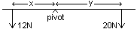For each case, work out if the system is balanced:

a) x = 3m, y = 5m b) x = 5m, y = 3m c) x = 6m, y = 10m d) x = 12m, y = 20m

moments and forces
We have already introduced the idea of a lever as a “magnifier” of force. In any given situation a certain force is required to make something happen – i.e. the force needed to start a screw turning or the force needed to loosen a bolt with a spanner. To provide this force we can either use a large enough force directly, but this is tiring or the force required may be more than we can produce alone, or use some kind of lever to magnify the force which we are able to produce ourselves.
Since the moment depends upon the force and the distance, we can use smaller forces to do the work providing we make the distance from the pivot large enough.

Centre of mass
With all objects we can pretend that their mass is concentrated at one point and that the objects weight acts vertically from that point.
This point is known as The Centre of Mass of the object.
For regular shaped or uniform objects the centre of mass is also the geometrical centre.
For non-uniform objects the centre of mass will be away from the geometrical centre towards the side where the mass is greatest.
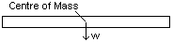
For a regular beam,
the centre of mass is in the centre of the beam.

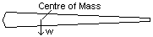For a baseball bat,
The centre of mass is towards the heavy end.

Further examples of moments
So far, looking at moments along beams, we have only considered uniform beams with the pivot at the centre of mass. This means that the moment of the mass is zero because its distance is zero. We now consider beams not pivoted at their centre of mass, so we must take into account the mass of the beam.

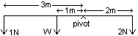If W = 1N, then we can calculate that this beam is in equilibrium because the Clockwise Moments = the Anticlockwise Moments: 2 x 2 = (1 x 1) + (3 x 1)

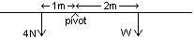
Calculate the weight w of the beam.

Stability
An object is defined to be stable if its centre of mass passes within its base. We can topple an object by tilting it so that is centre of mass acts outside of its base. Hence tilting an object will turn it from being stable to becoming unstable.

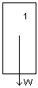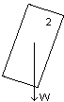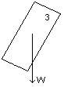 In picture 1, the box sits on its base.
In picture 2, the box is tilted and the right hand
corner acts as the pivot. Because the weight
is still to the left of the pivot, the box will return
to picture 1 if the tilt force is removed.

In picture 3, the box will topple to the right, even if the tilt force is removed, because the weight is now to the right of the corner pivot and its moment has become clockwise, pulling the box further over.

Objects may be made more stable either by
lowering their centre of mass, or by
widening their base.

Forms of equilibrium
There are three forms of equilibrium.
Stable equilibrium occurs when an object which is tilted slightly returns to its original position when the tilting force is removed, like the box in the examples above.

Unstable equilibrium occurs when an object which is tilted slightly does not return to its original position when the tilting force is removed, but instead continues to move and takes up a new, different, position instead.

This is an example of an object in unstable equilibrium. The shape remains in stable equilibrium only as long as there is no horizontal tilting force applied to it.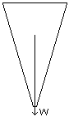
This shape can be balanced upon the narrow top but, clearly, the slightest force will tilt it so that the moment of the centre of mass acts outside the narrow base causing it to topple.
This shape turned upside down would be very stable because a large movement would be necessary to tip it over.

Neutral equilibrium occurs when an object moves without its centre of mass changing its height and the new position of the object is no more or less stable than before. An example of this is a ball rolling on a level surface – there is no one position which is any more stable than any other.

Homework p 106: q 1, 2, 3, 4, 6, 8; p 146: q 7, 8, 9.

Practical on the law of moments
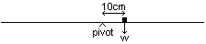Method
- Balance a metre ruler at its centre of mass.
- Place 2 x 100g masses (w) 10cm to the right of the pivot.
- Record this weight and distance.
- Place a 100g mass to the left of the pivot so the ruler balances.
- Record this weight and distance.
- Move w to the right by a further 10cm.
- Move the 100g mass to balance the ruler.
- Record these new weights and distances.
- Repeat 6, 7 & 8 until you can no longer balance the ruler.

Results
Left side of pivot (Anticlockwise) |  |  | Right side of pivot (Clockwise)
Weight | Distance | Moment | Weight | Distance | Moment
N | cm | Ncm | N | cm | Ncm
 |  |  | 200 | 10
 |  |  | 200 | 20

Conclusion
Look at your results for Clockwise and Anticlockwise Moments and write a rule for moments at an equilibrium position.

Finding the centre of mass (gravity) for a plane shape
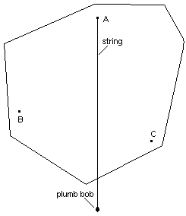Method
- Mark three positions A, B & C on the shape
near its edge and widely spaced apart.
- Suspend the shape from A in such a way
that it is free to swing.
- Suspend the plumb line (string and plumb
bob) from A and allow it to settle.
- Mark the line of the string on the shape.
- Repeat 2, 3 & 4 for positions B and C.

Results
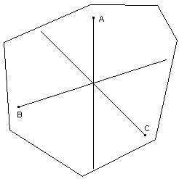

Where the three lines cross is the centre of
mass (or gravity) of the shape

