Kinetic theory

Introduction
This unit looks at the fact that matter is formed from molecules. It also compares the properties and behaviour of these molecules in each state of matter and the effect of temperature. Finally, it explains evaporation and pressure and volume changes in a gas, in terms of the behaviour of these molecules.

BASIC IDEAS
All matter is made up of tiny particles called molecules. The behaviour and properties of these molecules depends upon the state of the matter (which is temperature dependent), volume and pressure.

The States of Matter
There are three states of matter – gas, liquid and solid. The state a particular material is in depends upon its temperature, pressure and volume. For example, at low temperatures matter becomes solid, whilst at high temperatures it turns into gas (unless a chemical change happens, such as burning). We regard all solids as having similar properties regardless of which materials they are composed. This also applies to liquids and gases.

properties of The States of Matter
Solids Definite shape.
Crystalline – the molecules are fixed in place, like students seated in a classroom

Liquids Takes the shape of its container.
Can flow – the molecules can move passed one another like people in a corridor

Gases No fixed shape.
Totally free to move in any direction and will occupy the full volume of its container.

Solids | Liquids | Gases
Molecules are veryclose together | Molecules are further apart but still close | Molecules are very far apart
Molecules vibrate | Molecules vibrate and are free to move past each other as bonds break and remake | Molecules move freely at high speeds
Strong forces between molecules | Weaker forces between molecules | Almost no force between molecules

Forces between Molecules
The forces between the molecules are electric forces. They are made up of attractive forces that try to pull the molecules together and repulsive forces that try to push them apart it they are very close together. In solids these forces are balanced, so the molecules cannot move about much. In liquids and gases the attractive forces are weakened because of the increased distances between molecules due to their increased vibrations.
Solids Since the forces between molecules are strong, the molecules are held closely together and are unable to move (other than by vibration) and therefore solids have definite shape.
Liquids the molecules are able to move over small distances because the forces between the molecules are quite weak, so therefore there is less of a definite shape and the liquid can flow.
Gases The forces between the molecules are weak and the molecules are free to move. There is no definite shape.
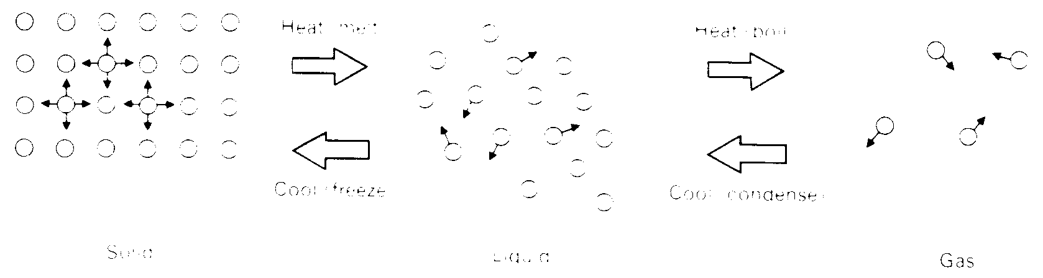
Some of this information can be shown in pictures, which convey the arrangement of molecules in each state.

Temperature and Motion
The average kinetic energy of the molecules in each state is different. They are at different temperatures and possess different amounts of internal energy.
Solids - low average KE - low internal energy
Liquids - higher average KE - higher internal energy
Gases - very high KE - high internal energy
The higher the internal energy, the higher the average KE and the faster they are moving. Heating the molecules raises the internal energy and therefore the average KE. We observe this as a rise in the temperature. The higher the temperature, the faster the molecules in it are moving.

Pressure of a Gas
The molecules of a gas are in constant, random, high-speed motion. This means they will collide with each other. They will also collide with the walls of the container and when this happens the molecules exert a force on the walls. This force acts over the entire wall surface. Since Pressure = Force / Area, then pressure is exerted. Recall that pressure is measured in Newtons/m² or Pascals, Pa.

Changing the Pressure of a Gas
If a gas that is kept at a constant volume is heated, the average KE of the molecules will increase because they will move more quickly. They will collide with the walls of the container more often and with a higher velocity. This means that the force has increased and hence the pressure has increased.
Increased Temperature → Increased Pressure
Decreased Temperature → Decreased Pressure

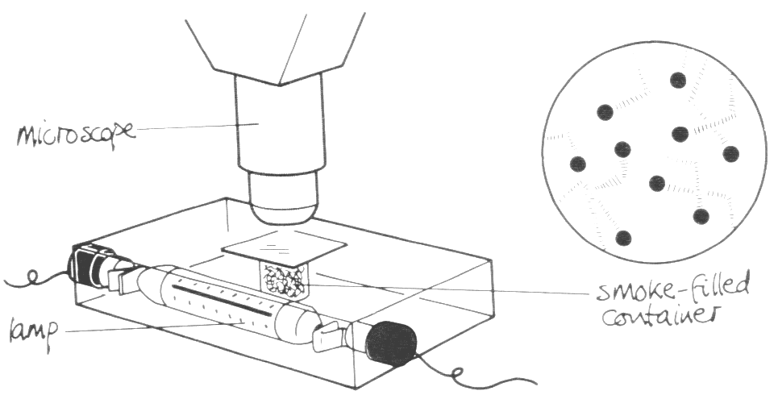Evidence for the Kinetic Theory of Matter

Brownian Motion
When we look through the microscope at the smoke in the container, we see bright specks that seem to jump about. The specks are tiny particles of smoke reflecting the light from the lamp. They are moving about in a jerky manner because much smaller, fast moving, air molecules are continually jostling them.
This supports the Kinetic Theory of Matter because it shows us that the molecules in a gas do move at high speeds, colliding with other particles and the walls of the container.
We can perform a similar experiment with sulphur particles in water. The sulphur will be seen to dance about because the smaller (and faster) water molecules are hitting them.

Changing the Volume of a Gas
If a gas is kept at a constant temperature when it is compressed (volume reduced) by squashing it slowly, then molecules are going to hit the walls of the container more often because they have less room to move about it. So even at a constant temperature, the pressure will increase as the gas volume decreases.
Decreased Volume → Increased Pressure
Increased Volume → Decreased Pressure
This is written as the equation PV = constant, where p = pressure and v = volume
This is usually written as Pressure is inversely proportional to volume for a gas at constant temperature. P ∝ 1 / V (at constant temperature)

Kinetic Theory and Evaporation
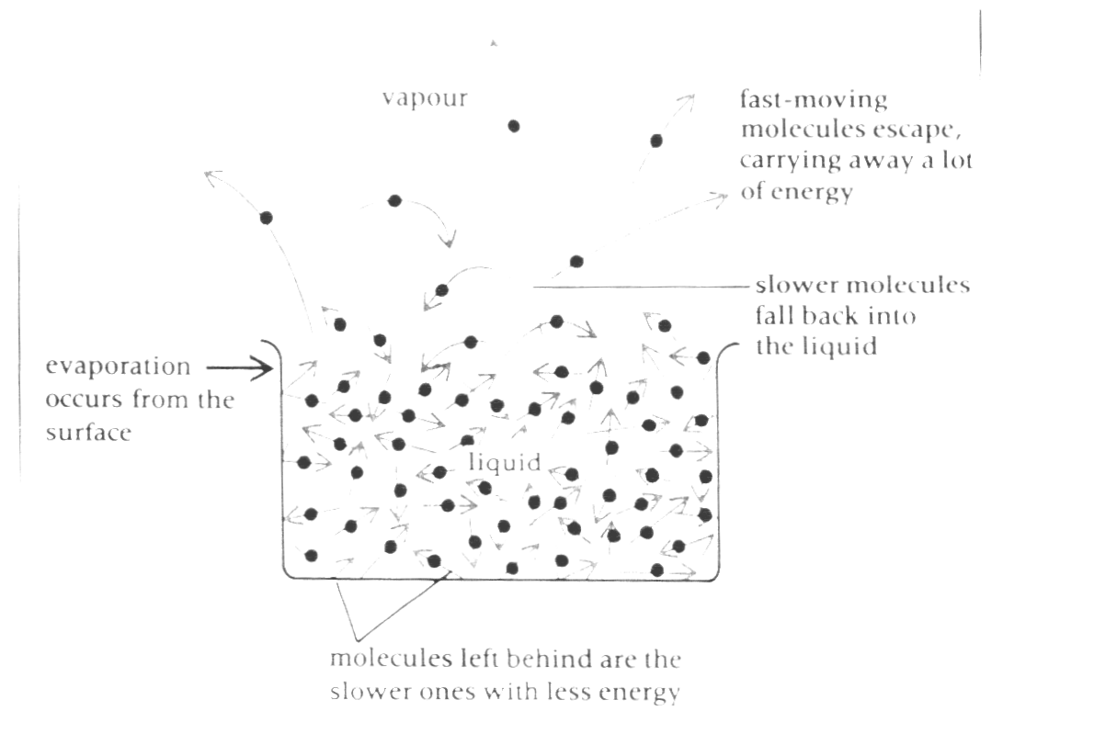In any of the states of matter, not all molecules have exactly the same energy – some have more and some have less than others. This is why we usually talk about the average KE of the molecules. In a liquid, some molecules move faster than others, and at the surface of the liquid some of these faster moving molecules have sufficient energy to overcome the attractive forces of the surrounding surface molecules and leave the liquid to form a vapour. This process is called evaporation. Since it is the more energetic molecules that are leaving the liquid the kinetic energy left behind gets lower as more molecules leave, taking their energy with them. This means that the liquid cools as evaporation takes place.

Factors which affect Evaporation
Evaporation from a liquid occurs at any temperature, but these are the factors that affect how fast a liquid will evaporate:

1 Temperature The higher the temperature of the liquid then the number of molecules with enough energy to leave the liquid will be increased. So an increase in temperature results in higher rate of evaporation.

2 Surface Area The more surface there is for molecules to escape from, then more molecules will reach the surface and leave. So an increase in surface area results in higher rate of evaporation.

3 Wind Any wind will blow away the molecules of vapour formed by the high-energy liquid particles as they leave the surface. This makes more room for other particles to leave. It also stops any of the vapour particles rejoining the liquid as they cool. So an increase in wind results in higher rate of evaporation.

Volatility A volatile liquid is one where the forces of attraction at the surface are weak so those molecules need less energy to leave the liquid and form a vapour. So an increase in volatility results in higher rate of evaporation.

Humidity The more humidity there is, then the more water vapour in the air and

therefore the less room for molecules to evaporate into. So an increase in humidity results in lower rate of evaporation.

The Gas Laws

Pressure and Volume of a Gas at constant Temperature
Suppose we have a gas with a volume V₁ and a pressure P_{1.} If we change the pressure so that the volume can also change, we have.
P₁V₁ = P₂V₂
For example:
What is the pressure of a gas that was originally at 10Pa at a volume of 10m³
but is now at 30m³?
P₁V₁ = P₂V₂
10 x 10 = P₂ x 30
100 = P₂ x 30
P₂ = 100 / 30 = 3.3Pa

NOTE you do not need to learn the other two gas laws, the pressure law or Charles’ law, but you do need to know the full gas law that includes temperature.

$\frac{P_{1}V_{1}}{T_{1}}=\frac{P_{2}V_{2}}{T_{2}}$ where the temperature T must be in Kelvin (centigrade+273)

