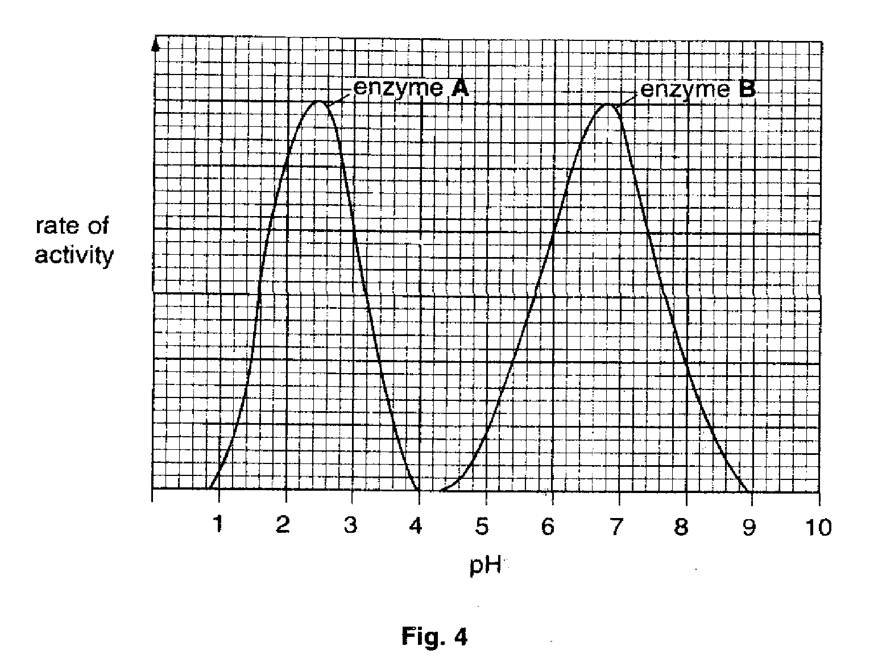
1. Fig. 4 shows the effect of pH on the rate of activity of two digestive enzymes.
(a) (i) The optimum pH for enzyme A is 2.5. Explain what meant by the term optimum pH.

………………………………………………………………………………………………………………..[1]

- What is the optimum pH for enzyme B ?

………………………………………………………………………………………………………………..[1]

- Name an organ in the body in which enzyme A is likely to work efficiently and explain how the low pH is maintained in this organ.

Organ………………………………………………………………………………………………………………………

Explanation………………………………………………………………………………………………………………..

…………………………………………………………………………………………………………………………..[2]

- Enzyme B is amylase.

- What substrate does it act on ?

………………………………………………………………………………………………………………..[1]

- What is the end product of this reaction ?

………………………………………………………………………………………………………………..[1]

(d) The curve plotted for enzyme B was from an investigation carried out at 30 ºC. For enzyme B, draw on the graph the curve you would expect if the investigation was carried out at 20 ºC. [2]

2.
- After chewing food, it is swallowed and then moved to the stomach by peristalsis.

Describe how food is moved to the stomach by peristalsis.

...…………………………………………………………………………………………………………………………..

...…………………………………………………………………………………………………………………………..

...…………………………………………………………………………………………………………………………..

...…………………………………………………………………………………………………………………………..

...…………………………………………………………………………………………………………………………..

...……………………………………………………………………………………………………………………..…[4]

- When food reaches the stomach it is acted upon by a protease. Name the substrate and the end product of this reaction.

Substrate...………………………………………………………………………………………………………………...

End product...…………………………………………………………………………………………………………..[2]

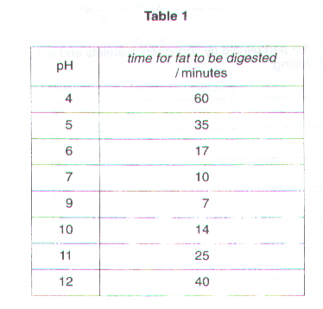
- After leaving the stomach, fat in the food will be acted upon by a lipase. The affect of pH on the activity of such an enzyme was investigated. The results are shown in Table 1.

- Plot these results as a line graph on the grid provided.


- Use your graph to predict how long it would take for fat to be digested at pH 8.

………………………………………………………………………………………………………………..[1]

- Describe and explain the change in the curve between pH 9 and pH 11.

…………………………………………………………………………………………………………………...

…………………………………………………………………………………………………………………...

…………………………………………………………………………………………………………………...

………………………………………………………………………………………………………………..[2]

3. Six identical samples containing a mixture of starch and amylase in water were kept at different temperatures, as shown in Table 2. The time taken for the starch to be digested was measured. The results are shown in the Table.

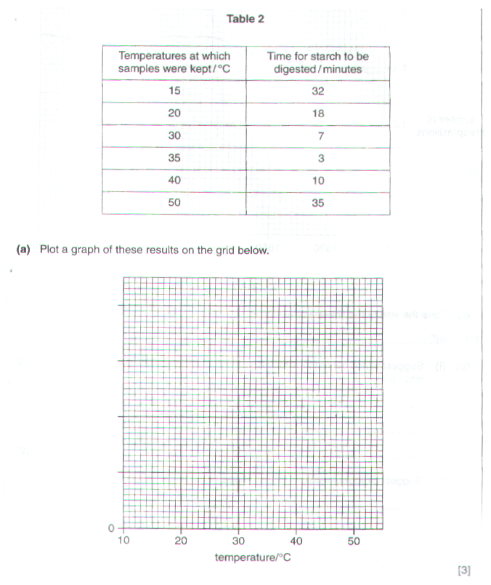

(b) (i) Describe how the time taken for the starch to be digested could be determined.

…………………………………………………………………………………………………………………...

…………………………………………………………………………………………………………………...

………………………………………………………………………………………………………………..[2]

- At which temperature was the starch digested most rapidly?

………………………………………………………………………………………………………………..[1]

- Describe the relationship between temperature and the rate of starch digestion.

…………………………………………………………………………………………………………………...

…………………………………………………………………………………………………………………...

………………………………………………………………………………………………………………..[2]

- Similar samples were set up and kept at 10º C and 60º C. The starch in these samples was not fully digested after an hour. Both of these samples were then kept at 35º C. Suggest and explain the effect of these changes in temperature on starch digestion.

- Sample changed from 10º C to 35º C.

…………………………………………………………………………………………………………………...

…………………………………………………………………………………………………………………...

………………………………………………………………………………………………………………..[2]

- Sample changed from 60º C to 35º C.

…………………………………………………………………………………………………………………...

…………………………………………………………………………………………………………………...

……………………………………………………………………………………………………………..…[2]

[Total: 12]

4. Hydrogen peroxide is a poisonous compound which sometimes forms in living tissues. As a safeguard, substances within the cells are able to break down this compound, releasing molecules of oxygen in the process.

Some plant material was cut into pieces and then ground in a mortar with sand and water. The resulting material was filtered. Fresh pieces of pieces of filter paper were soaked in the filtrate, dried in an oven at 40ºC and then cut into 1cm squares.

Six test-tubes, each containing 30 cm³ of hydrogen peroxide, were placed in water baths at different temperatures. Pieces of the treated filter paper were added to each test-tube. The filter paper sank to the bottom for a while; all the pieces then rose to the surface.

The time taken for the filter paper to float to the surface was noted for each test-tube. The results are given in Table 1.

Table 1

Temperature  / ºC | Time  /seconds
5 | 70
15 | 38
25 | 24
35 | 14
45 | 10
55 | 36

- Construct a graph from the results given in table 1.

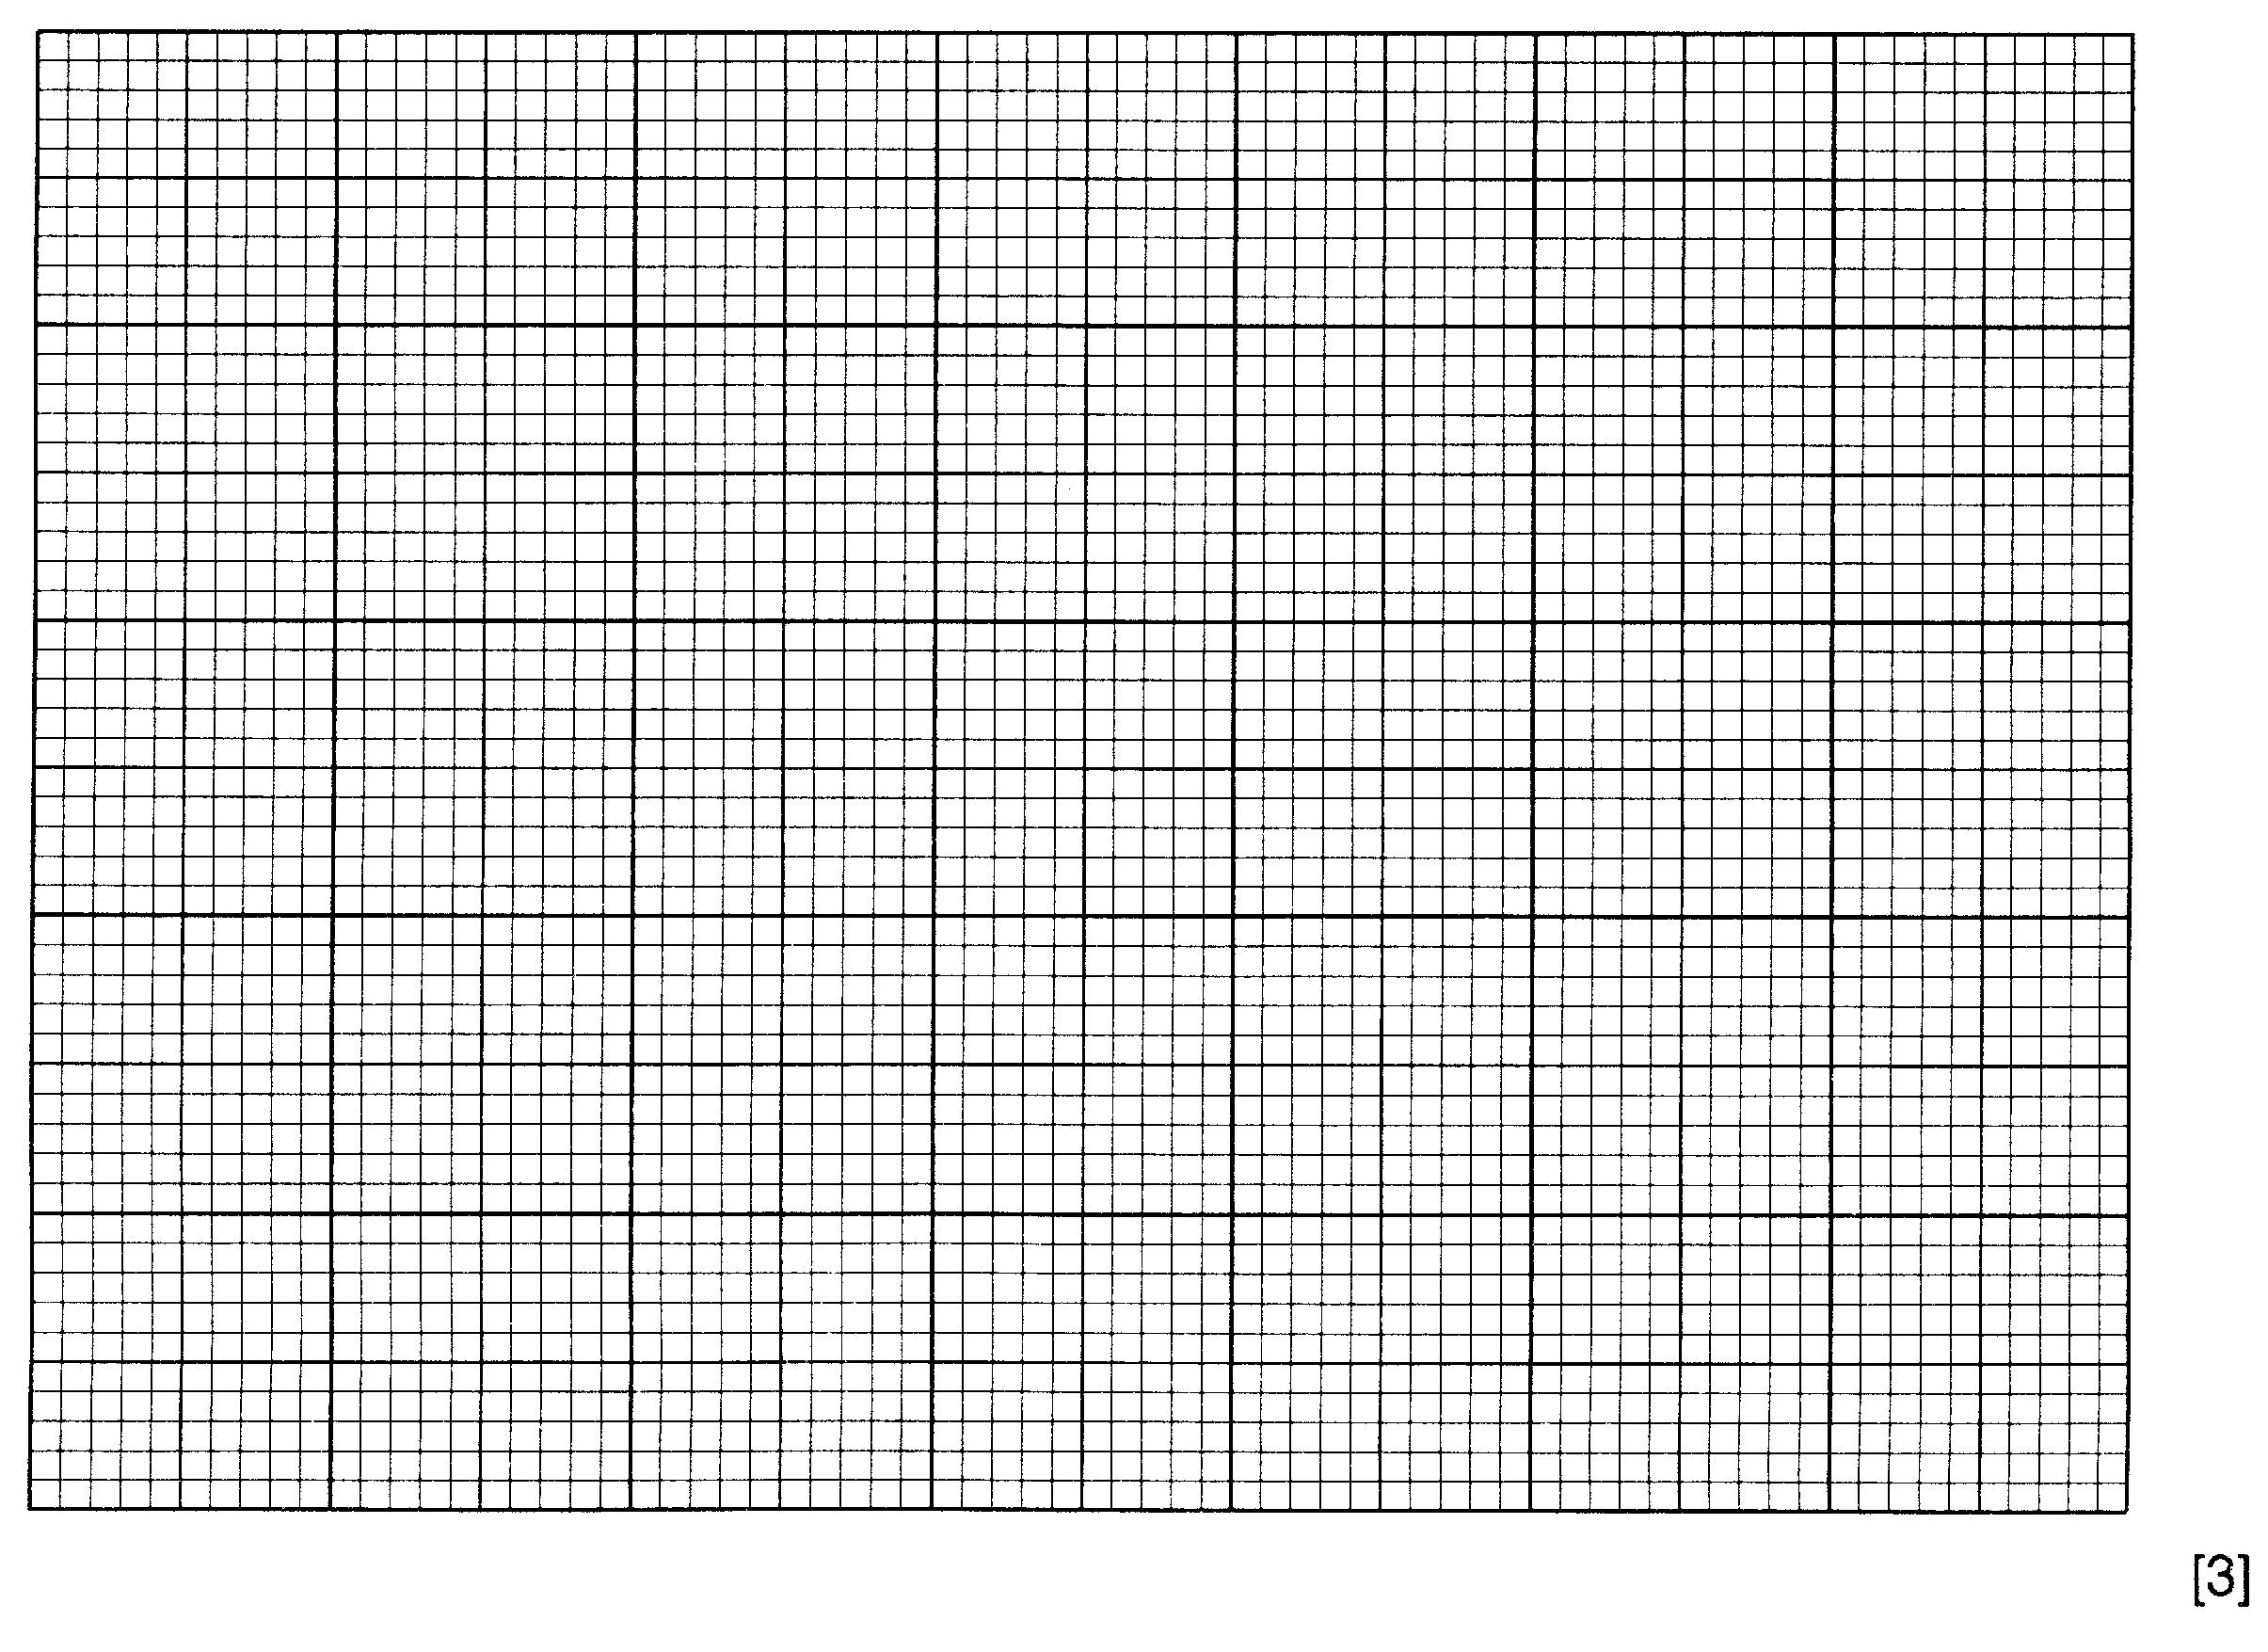
(b) (i) Why were 1. Sand, and 2. Water added to the tissue before grinding?

- sand ………………………………………………………………………………….

…………………………………………………………………………………………….

2. water …………………………………………………………………………………

……………………………………………………………………………………………

- Draw a simple diagram of the apparatus you would use to filter the material after grinding.

- Suggest why the soaked filter paper was not dried more quickly, in an oven at 85 ºC.

…………………………………………………………………………………………………………….

…………………………………………………………………………………………………………[3]

(c) (i) Suggest why the filter paper eventually rose to the surface in each test-tube.

…………………………………………………………………………………………………………….

…………………………………………………………………………………………………………….

…………………………………………………………………………………………………………….

- What additional observation might have been made to confirm your explanation?

…………………………………………………………………………………………………………….

…………………………………………………………………………………………………………[3]

- Suggest why the curve, after falling steadily to the 45 ºC reading, began to rise at 55 ºC.

…………………………………………………………………………………………………………….

…………………………………………………………………………………………………………….

…………………………………………………………………………………………………………[2]

- Curves which usually relate enzyme activity to temperature usually rise to a peak, as shown in Fig. 4.

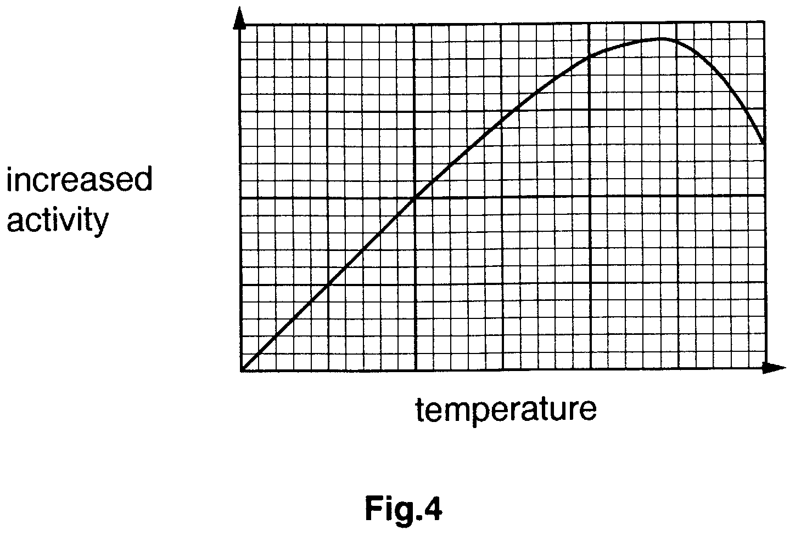

Suggest how the information given in Table 1 might be used to obtain a graph of this type.

…………………………………………………………………………………………………………….

…………………………………………………………………………………………………………….

…………………………………………………………………………………………………………….

…………………………………………………………………………………………………………[1]

