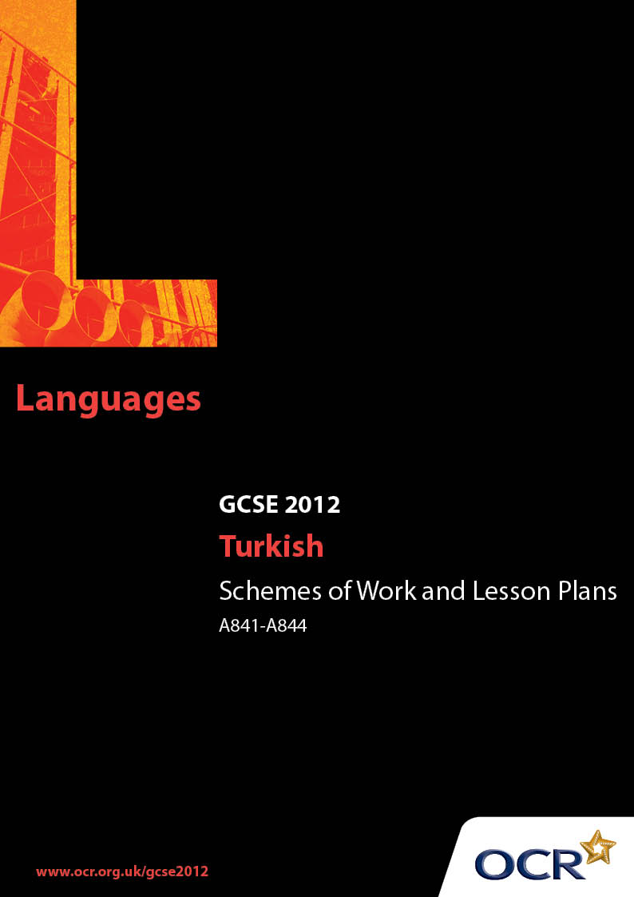

Contents
Contents 2
Introduction 3
Sample Scheme of Work: OCR GCSE Turkish J737 Units A841-A844:
Listening, Speaking, Reading and Writing 5
Sample Lesson Plan: OCR GCSE Turkish J737 Units A841-A844:
Listening, Speaking, Reading and Writing 11

Introduction

Background
OCR has produced a summary brochure, which summarises the changes to Turkish. This can be found at www.ocr.org.uk, along with the new specification.
In addition and in response to reforms announced by the Government and in response to Ofqual mandated changes to GCSEs, unitised assessment of this qualification is being replaced by linear assessment from September 2012. This means that candidates commencing a two year course from September 2012 will take all of their GCSE units at the end of the course in June 2014.
In order to help you plan effectively for the implementation of the new specification we have produced this Scheme of Work and Sample Lesson Plan for Turkish. These Support Materials are designed for guidance only and play a secondary role to the Specification.

Our Ethos
OCR involves teachers in the development of new support materials to capture current teaching practices tailored to our new specifications. These support materials are designed to inspire teachers and facilitate different ideas and teaching practices.
Each Scheme of Work and set of sample Lesson Plans is provided in Word format so that you can use it as a foundation to build upon and amend the content to suit your teaching style and students’ needs.
The Scheme of Work and sample Lesson Plans provide examples of how to teach this unit and the teaching hours are suggestions only. Some or all of it may be applicable to your teaching.
The Specification is the document on which assessment is based and specifies what content and skills need to be covered in delivering the course. At all times, therefore, this Support Material booklet should be read in conjunction with the Specification. If clarification on a particular point is sought then that clarification should be found in the Specification itself.

A Guided Tour through the Scheme of Work

= Innovative Teaching Idea
This icon is used to highlight exceptionally innovative ideas.


= ICT Opportunity
This icon is used to illustrate when an activity could be taught using ICT facilities.

OCR GCSE Turkish J737 Units A841-A844: Listening, Speaking, Reading and Writing
Suggested teaching time | 10-13 hours | Topic | Education and Work
Topic outline |  | Suggested teaching and homework activities |  | Suggested resources | Points to note
Introduction |  | - Describing school: group work  - Labelling the parts of a school  - Discussion about lessons  - Role plays: job application  - Write up your ideas of an ideal job |  |  | - Teacher and students to prepare teaching/ learning materials.
Lesson 1 |  | - Teacher, using a plan of a school on OHT,  shows the areas and teaches vocabulary.  Students label the names of places on the  plan using cue cards.  - A short trip around school: teacher and  students to walk around the school writing  the names of places to create a school plan. |  | - The plan of the school  - OHT  - Pictures  - Dictionaries  - Newspapers  - Video  - Cue cards
Lesson 2 |  | - Class activity: in class students compare each other’s plans by asking directions to some places without showing their plans. (Previous knowledge: preposition of place)  - The teacher to use OHT to show the plan  of the school for the students to check.  - Matching exercise: students to match the places at school with descriptions of what they are used for.  - Teacher introduces the names of the lessons in Turkish using pictures, where possible, or English titles. Students to draw up a timetable, writing the names of the lessons in Turkish. Students to draw up their ideal timetables.  - Information-gap exercise: students use two versions of a timetable with some gaps on it and they fill in the gaps by asking each other questions. (Previous knowledge: the days of the week and time)
Lesson 3 |  | - Listening: Teacher to read out key definitions for major lessons.  - Matching exercise: students to match the Turkish names of the lessons with the definitions.  - Writing: students to work in groups and match subjects to jobs and write reasons for their choice.
Lesson 4 |  | - Reading/Writing/Listening: students to classify the jobs using dictionaries. They match jobs and workplaces. Teacher introduces new vocabulary: what people do at different workplaces.  - Students to read the activities done at work and name the jobs.
Lesson 5 |  | - Speaking: discuss the potential benefits of work experience while still studying at school.  - Writing: students to produce a piece of writing presenting their opinions on the benefits of work experience.
Lesson 6 |  | - Listening for gist: students to listen to a dialogue between two students talking about their favourite lessons, giving reasons.  - Reading: students to read the dialogue and ask each other questions in groups about the dialogue.  - Writing: students to write a paragraph about their favourite lessons.
Lesson 7 |  | - Writing: school activities. In groups, students to list activities at school. Students to write their choice of activities, giving reasons and opinions, after reading a text about the same topic.
Lesson 8 |  | - Reading: (Working in groups of about 4) Students to read the job advertisements in a Turkish newspaper and choose a job. They determine the skills and knowledge needed for the job. They also cut out the ads and stick them on a sheet of paper.  - Speaking: students in groups give a presentation to the whole class pointing out their reasons for choosing the job and listing the skills needed.
Lesson 9 |  | - Listening: students to listen to someone getting more information about a job on the  telephone and to fill in an information  form (gap-fill exercise).
Lesson 10 |  | - Speaking: role play. Students to telephone to get information about a job in the school office. In groups of 3-4: a student telephones the workplace for more information. The rest listen and  take notes for feedback. They then  rotate roles.
Lesson 11 |  | - Listening/Reading: teacher to explain the format of a CV and to circulate a typical example.  - Writing: students to write a simple job application letter and/or a CV.
Lesson 12 |  | - Job interview  - Listening: students to listen to a manager telephoning an applicant about an interview.  - Reading: students to read the dialogue and fill in the missing information while listening.  - Speaking: role play. Students to use the dialogue in pairs.  - Listening: students to watch a video about people’s opinions about their jobs in English  and make notes. Teacher introduces the vocabulary needed in Turkish (adjectives).  - Speaking: students talk about their jobs without mentioning the name of the job while they are being filmed. Teacher shows  the film later and students to  discuss and find out what the job is.
Lesson 13 |  | - A guest comes to class to talk about his/her job. Students to write an email to a friend to give information about the guest’s job and their opinions of the job.

OCR GCSE Turkish J737 Units A841-A844: Listening, Speaking, Reading and Writing

Looking for a job
OCR recognises that the teaching of this qualification will vary greatly from school to school and from teacher to teacher. With that in mind this Lesson Plan is offered as a possible approach but will be subject to modifications by the individual teacher.
Lesson length is assumed to be one hour.

Learning Objectives for the Lesson
Objective 1 | Students to listen for, identify and note main points of a dialogue about jobs
Objective 2 | Students to read and identify main points of job advertisements
Objective 3 | Students to develop their knowledge of vocabulary on job-related topics
Objective 4 | Students to improve their ability to write an email to a friend about a job

Recap of Previous Experience and Prior Knowledge
- Students have already learnt the vocabulary related to jobs, skilIs and knowledge required for a variety of jobs.

Content
Time | Content
5 minutes | Warm-up activity to practise the names of jobs and workplaces. Group work: each group to name a workplace and make a list of the jobs in that workplace. Groups give feedback to each other. Teacher to monitor.
10 minutes | The class discuss the ways of finding jobs and students read newspaper advertisements to choose a job and write down the necessary details. Teacher to ask questions.
5–10 minutes | Teacher to give an information-gap form about the dialogue and students to listen to the dialogue between an employer and a person who wants to get more information about a job. Students fill in the missing information. Teacher to check.
15 minutes | Pair work: students to read the dialogue in pairs and change some of it using different time expressions. Teacher to hand out cue cards to students to prepare them for a role play. Students sit back to back and, using a telephone, do the role play. Teacher to note down general errors without interfering and record the dialogues. Class to listen to the tape and give feedback. Teacher to give feedback.
10 minutes | Students to read an email on OHT and discuss the content. Teacher to ask questions. Then students to write a short email to a friend to give information about the job they are applying for using the email on the OHT as an example.

Consolidation
Time | Content
5 minutes | Students to stick their emails on the board for others to read and give feedback.
10 minutes | Students in groups to create job advertisements for the class paper. Teacher monitors and gives feedback.

