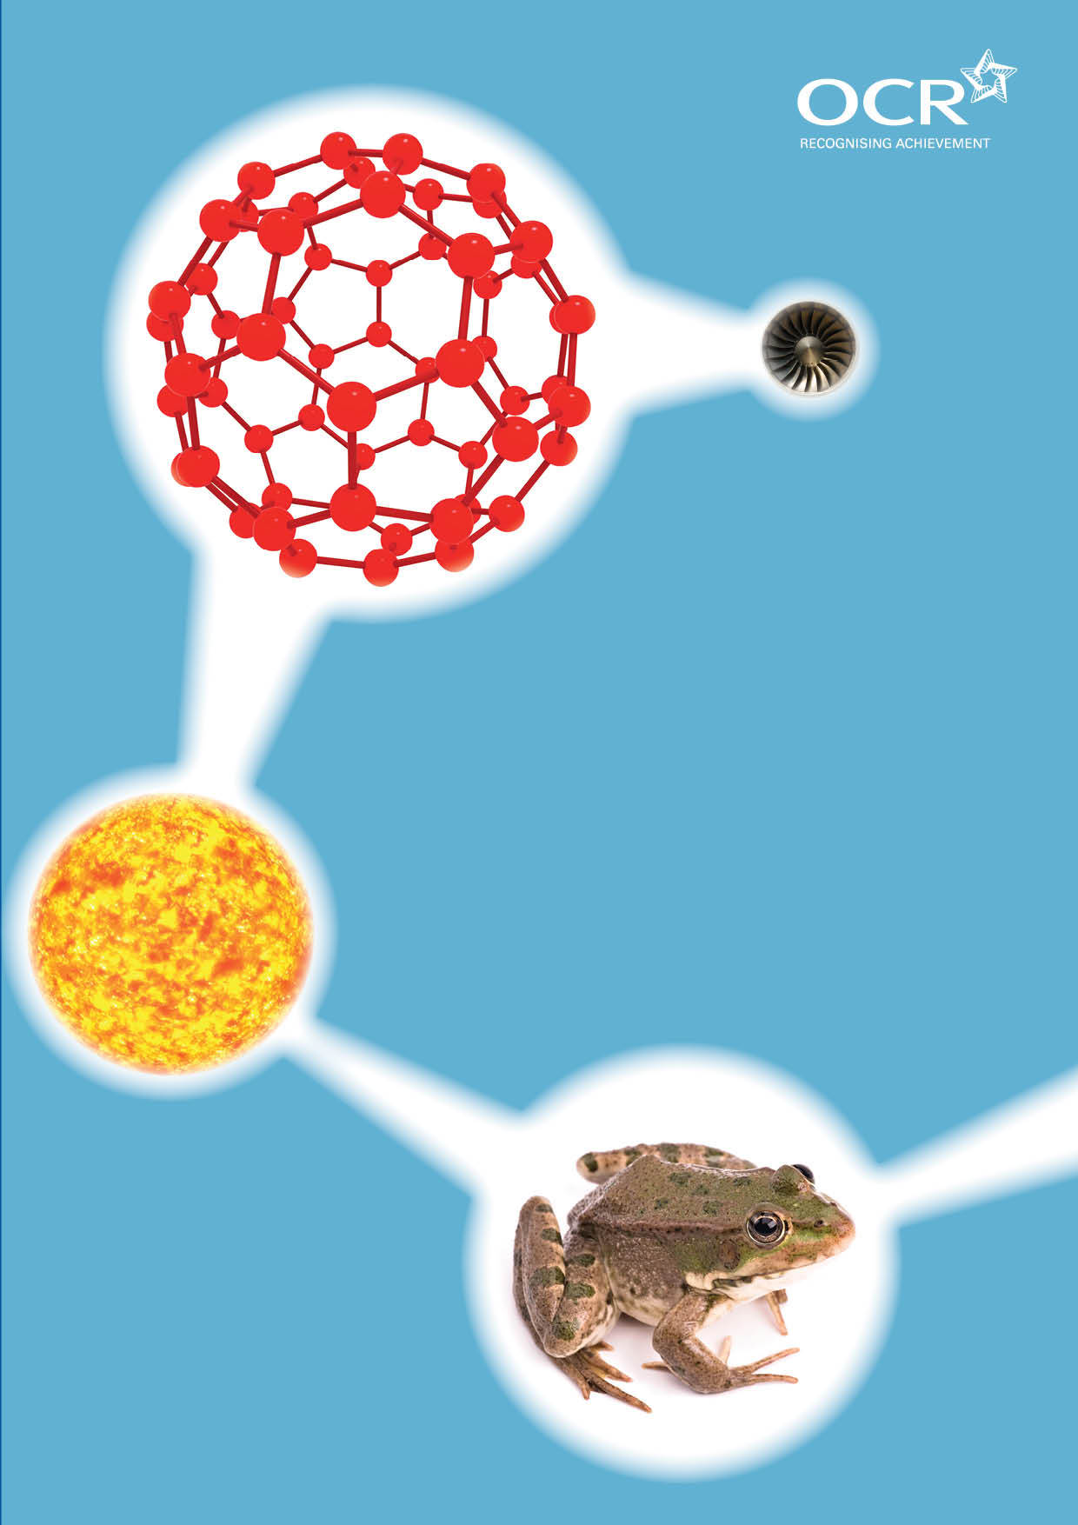
TWENTY FIRST CENTURY SCIENCE SUITE
SCHEMES OF WORK AND LESSON PLANS
P5: Electric circuits
VERSION 1 JULY 2011
Introduction
OCR involves teachers in the development of new support materials to capture current teaching practices tailored to our new specifications. These support materials are designed to inspire teachers and facilitate different ideas and teaching practices. Each Scheme of Work and set of sample Lesson Plans is provided in Word format – so that you can use it as a foundation to build upon and amend the content to suit your teaching style and students’ needs.
The Scheme of Work and sample Lesson plans provide examples of how to teach this unit and the teaching hours are suggestions only. Some or all of it may be applicable to your teaching.
The Specification is the document on which assessment is based and specifies what content and skills need to be covered in delivering the course. At all times, therefore, this Support Material booklet should be read in conjunction with the Specification. If clarification on a particular point is sought then that clarification should be found in the Specification itself. References to the content statements for each lesson are given in the ‘Points to note’ column.


Sample Scheme of Work
GCSE 21st Century Science Physics A J245
Module P5: Electric circuits
Suggested Teaching Time: 13 Hours

Topic outline | Suggested teaching and homework activities | Suggested resources | Points to note
Static electricity | Students carry out a circus of activities to show electrostatic effects, making note of what they see.  Using diagrams, animation or video, explain the key ideas behind all electrostatic effects (objects with similar charges repel, objects with opposite charges attract, electrons are negative, electrons can be transferred from one object to another when objects are rubbed together)  Students explain the effects that they saw during the circus.  Use the Van de Graaff generator to demonstrate more electrostatic effects, and ask students to explain each of the effects in terms of electrons. | Suitable experiments could include:  Rubbing two plastic rods with a cloth, hanging one from a thread, bringing the second rod close to the first, and watching the effect of different rods.  Rubbing a rod and bringing it close to water running slowly from a tap.  Rubbing a rod and bringing it close to scraps of paper or hair.  Various videos or animations exist to show how electrons are transferred. | Van de Graaf generators vary, along with the accessories. Incorrect use can cause shocks, please refer to local risk assessments before using.
Current | Quick quiz on circuit electricity to remind students of KS2 and 3 work and circuit symbols, and to judge the understanding that students have. Speed of subsequent lessons will vary with prior understanding.  Students set up basic circuits with a battery, connecting wires and bulb, and use it to classify materials as conductors or insulators.  Introduce ammeters and how to use them, and the ampere.  Add an ammeter into the circuit, and students vary the current by adding batteries (or using a power pack with a 12v bulb), and note down the current along with observations of the brightness of the bulb.  Use an animation or model to explain what happens in conductors that are connected to power supplies, and why insulators are different. | Quick quiz worksheet or presentation, with red/amber/green cards or mini whiteboards for immediate feedback from class.  Batteries (or power packs), connecting leads, ammeters, bulbs, crocodile clips, various materials (both insulators and conductors).  Animations or video to model the charges in conductors and insulators. | Prior understanding will vary considerably, and many misconceptions may need to be addressed.  Although students are expected to understand that electrons move in metallic conductors, keep the discussion broad to ease understanding of electrolysis for students studying chemistry or additional science.  Emphasise the differences between the symbol for current (I) and the symbol for the ampere (A) and the symbol for an ammeter.

Topic outline | Suggested teaching and homework activities | Suggested resources | Points to note
Potential difference | Set up a series circuit with a bulb, a motor and three 1.5V cells. Add an ammeter in between each component to show that current is not being used up. Pose the question: if nothing seems to be being used up in the circuit, why do the batteries run down?  Show students how to connect a voltmeter in parallel across a component. Introduce the term potential difference.  Students set up the same circuit, but measure the potential difference across each component.  Use the results to discuss what potential difference is: the amount of energy given to or taken from the charges as they move through each component.  Use a physical or thinking model of a circuit to consolidate learning so far.  The class sets up basic one bulb, one cell circuits and they measure the potential difference across the cell and the current in the circuit. They then add more cells in series (and for higher, in parallel) and describe the differences to the values of current and potential difference. | Batteries, bulbs, motors, connecting leads, ammeters, voltmeters.  Physical models that could be used: the Malteser demo: the teacher (a cell) holds a large bag of Maltesers (energy) while the class (charges) standing in a circle. A bulb is represented by a chair that the class have to climb over. The students move around the “circuit” taking a Malteser from the bag, and eating it as they climb over the chair.  Water demo: the cell is represented by a bucket of water, the class hold beakers and move around to a watermill or similar where they pour their water before returning for more.  In both demos, emphasise the fact that charges move around, but are not stored or used up, the energy is taken from the battery and dissipated at the bulb.  Thinking models could use pizza delivery systems or the hot water system in a house.  Discussion can draw out what potential difference and current would be represented by. All models can be extended for series and parallel circuits. | Circuits never behave as expected, so this could be a good point to discuss data and repeatability. “Smoothing” the data by taking averages of the readings at each point by groups can often emphasise the patterns expected.  The difference between EMF and PD is not required for this specification, but students should understand that the potential difference is the work done on or by a given amount of charge between two points.  The formal definition of “joule per coulomb” is not required.

Topic outline | Suggested teaching and homework activities | Suggested resources | Points to note
Resistance | Demonstrate electronic fat analyser. Pose the question: how does it know the amount of fat in the body? Answer: it measures the resistance of the body.  Define resistance, and give the equation:  Students practise the calculations using a worksheet. Or set as homework.  Students set up a basic circuit and measure the resistance of a series of components.  Ask students to measure the resistance of a connecting wire. Use the results to explain why the resistance of connecting wires can normally be ignored.  Split the class in two. One half of the class set up a circuit and vary the voltage across a fixed resistance, and measure the current, producing a graph of current against voltage.  The other half of the class vary the resistance in the circuit and produce a graph of current against resistance for constant voltage.  The two halves of the class report their results and sketch each others’ graphs. | Electronic fat analyser (various types available e.g. www.sourcingmap.com/white-plastic-digital-body-healthy-monitor-fat-analyzer-p-65092.html).  Batteries or power packs, fixed resistors, lamps, motors, ammeters, voltmeters, calculators. The resistance of each component could be pre-measured and the practical work could become a challenge.  Variable resistors or a series of resistors of different values.  Worksheet of resistance calculations for students to practice. | Higher tier students should be able to rearrange the equation.  Knowledge of the resistor colour codes are not required.  It is important to check the experiment to ensure that the results are as expected; too large or small resistances will give difficult to analyse results.

Topic outline | Suggested teaching and homework activities | Suggested resources | Points to note
Power | Students brainstorm everyday meanings of the word “power”. Ask which is more powerful: a torch or a theatre spotlight. Would a spotlight that was flashed on and off be less powerful than a torch that was left on for weeks? No, as power is energy per second or the rate of transfer of energy.  Give students the equation:  Power = voltage x current  (watts, w) (volts, v) (amperes, a)  Higher tier students can explain this equation using the model; the higher the voltage, the more energy transferred. The higher the current, the faster the charge flows, so the faster the energy is “delivered”.  Students measure the power of various different components e.g. the same light bulb at different brightness.  Demonstrate what happens to a wire when a large current is passed through it – it becomes hot, and then starts to glow. Discuss how all resistors lose energy via heat, and that this effect is used in filament lamps to make them glow. Higher tier students should be able to describe this effect in terms of collisions between moving charges and ions in the wires. | Batteries, voltmeters, ammeters, bulbs or components of different power rating.  A piece of resistance wire connected between crocodile clips to a power pack with a variable voltage. This should be done on a heat proof mat.  The sep energy meter could be used during this lesson to good effect. | Students who have studied P3 will have encountered this equation before. Kilowatt hours are used in that unit, and are not expected in P5.  Higher tier students are expected to rearrange the equation.  The formal definition of the watt as a joule per second is not required.  There is opportunity for development of the ability of students to show data graphically.  This lesson could be expanded into a mini investigation into the heat produced by various bulbs by clamping a beaker of water with a thermometer above bulbs of different power ratings caution: this investigation must be properly risk assessed by the teacher.

Topic outline | Suggested teaching and homework activities | Suggested resources | Points to note
LDRs and thermistors | Demonstrate the use of a multimeter to measure resistance.  Divide the class in two.  One half investigates how the resistance of an LDR varies with light intensity by varying the distance to a light source. Students plot a graph of resistance against distance. Alternatively, students could measure the light intensity directly with data logging equipment, and plot a graph of resistance against light intensity.  The other half of the class investigates how the resistance of a thermistor varies with temperature, by suspending a thermistor into a beaker of ice over a Bunsen burner (keeping the wires out of the way by using a clamp stand), and gently heating to melt the ice. Alternatively, students could hold the thermistor into water baths of different known temperatures. They then plot a graph of resistance against temperature.  Students share their results and sketch the graph from the other group.  Introduce the circuit symbols for thermistors and LDRs. Students could play snap or dominos or similar to ensure they know all the electrical symbols required in the specification, and the uses of each of the components. | Multimeters, thermistors, LDRS, heating equipment, ice, beakers, lamps or white LEDs.  Room with reduced lighting will help with LDRs work, or use large cardboard boxes. An alternative arrangement is to use a white LED which can be easily shielded with a long tube made from black paper. The distance between source and LDR can then be varied to vary the light intensity. Using an LED reduces the risk associated with the light bulb getting hot.  Graph paper.  Snap or dominos or similar with circuit symbols, names and/or uses of each component. | There is an opportunity for discussion of positive and negative correlations (names are not required, but understanding of the two types are).

Topic outline | Suggested teaching and homework activities | Suggested resources | Points to note
Series circuits | Students set up series circuits with two (or for higher, more) components and measure the current through each component and the potential difference across each component.  Students summarise their findings. Higher tier students should explain each effect in terms of the work done by or on charges, and the movement of charges.  Higher tier students set up a circuit with a fixed resistor and a variable resistor, LDR or thermistor. They measure the potential difference across each component as the resistance of the variable component is changed, and summarise their findings.  Students measure the resistance of resistors in series (either in a circuit, or using a multimeter), and explain the result in terms of the charges.  Check understanding using “fill in the gaps” exercise, using the specification statements as a starting point. | Batteries, ammeters, voltmeters, multimeters, bulbs, motors, LDRs, fixed and variable resistors, thermistors.  This lesson could be carried out using circuit simulation software such as “crocodile clips”. | The calculation of total resistance of resistors in series and parallel is not required.  The practical skills in this section could be used to build those needed for the investigation controlled assessment.

Topic outline | Suggested teaching and homework activities | Suggested resources | Points to note
Parallel circuits | Students set up circuits with components in parallel with each other.  All students try to find the link between the current in each branch and the current from the battery, and the link between the resistance of the components and the current through each component.  Higher tier candidates measure the potential difference across each component and the battery, and compare the current through each parallel component to a circuit set up with the component on its own.  Higher tier candidates need to be able to explain why the largest current is in the component with the least resistance.  Use analogies (such as queuing for a checkout at a supermarket) to explain why parallel resistors always have a lower total resistance than each resistor on its own.  Students summarise their findings by completing sentences based on the specification statements.  Students compare series and parallel circuits in a summary table showing key features of each. This could be done as a card sort for lower ability students. | Batteries, ammeters, voltmeters, multimeters, bulbs, fixed resistors.  This lesson could be carried out using circuit simulation software such as “crocodile clips”. | The calculation of total resistance of resistors in series and parallel is not required.

Topic outline | Suggested teaching and homework activities | Suggested resources | Points to note
Induction and generators (two hours) | Students visit a series of stations with information or experiments to introduce them to electromagnetic induction.  Bring class together and summarise the findings.  Use an oscilloscope to show that the voltage of a battery does not change (direct current), but the voltage of the mains supply does (alternating current). Point out the difference in the sizes of the voltage; students should know that mains supply in the UK is 230V.  Students can make steam turbines from tin and use steam from boiling water to turn them. Attaching them to motors (using a cork) and the motor to a voltmeter should show that the faster the turbine is turned, the higher the voltage.  Using diagrams, video or computer animation, discuss the composition of a generator, and the factors that are involved in increasing the voltage induced.  Higher tier students should be able to describe how the voltage induced (and current in the external circuit) varies during each revolution. This can be shown using diagrams, experiments or computer animation.  Students watch a video showing how power stations generate electricity and make notes or answer questions. | Induction circus  Written information about power generation.  A wire, attached to an analogue millivoltmeter that can be moved between the poles of a strong magnet.  A magnet on a string that can be dropped into, or pulled out of, a coil of wire, which is attached to a millivoltmeter.  A dynamo attached to a bulb.  Computer animations or video showing induction.  Turbines could be pre-made or students could make their own. Safety risk holding them over boiling water, use a clamp stand and keep wires away from heat.  Video of the workings of power stations. | The right hand rule is not needed, but students should know that the current will reverse if the direction of changes is reversed.  Some older textbooks refer to UK mains supply as 240v. This changed a few years ago.  Testing mains supply is dangerous, it may be better to “mock up” the supply using input from a signal generator. This should not be a class experiment.

Topic outline | Suggested teaching and homework activities | Suggested resources | Points to note
Transformers | Show students a number of examples of devices that use transformers.  Demonstrate how a transformer changes alternating electrical energy into magnetic energy, and then back again, by using a demountable transformer. Higher tier students need to be able to explain this in detail.  Students draw the construction of a basic transformer.  Show that the transformer changes the voltage of alternating current, but not direct current.  Higher tier students need to be able to use the equation:  Higher tier students should carry out practice calculations using this equation.  Foundation tier students could do a survey of transformers, using the information on electrical appliances to write down the input and output voltages and then classify them as step-up or step-down.  Explain the need for alternating current in the national grid: because it is easier to generate, and it can be used with transformers. Explain that high voltages are needed to transmit electricity with low current, thereby reducing the energy lost as heat. Various videos exist showing this. | Every day examples of transformers, e.g. Mobile phones, laptops, electric toothbrushes, inside computers.  Demountable transformer, or computer animations.  Worksheets giving practice calculation questions for higher tier students.  Videos showing the national grid. | The transformer equation is hard to rearrange for most students. Explaining it in terms of ratios is easier under most circumstances.

Topic outline | Suggested teaching and homework activities | Suggested resources | Points to note
Motors | Brainstorm devices that include motors.  Demonstrate how a current carrying wire in a magnetic field experiences a force, if the current is at right angles to the field lines. Demonstrate what happens when the current or magnetic field is reversed.  Draw a coil of wire in a magnetic field, and ask students to predict what will happen to each side of the coil.  Explain the need for a commutator to ensure that the current always flows the same way around the coil of wire.  Students make motors using motor kits.  More able students can vary the number of coils, magnetic field and voltage to judge the effect on the speed of turning (although this is not required by the specification). | Various demonstrations can be used here. The simplest is to hang a wire in between the poles of a strong magnet or kits exist to show the catapult effect.  Kits to make working motors. Various types exist. | The left hand rule is not needed.
Revision and test | Write a series of titles on pieces of A3 paper (e.g. “static electricity”, “series and parallel”, “resistance”). Separate class into groups of students, each with a different colour pen. Each has five minutes to write as much information on one of the sheets of paper, using notes and textbooks. They then pass their sheet of paper on to the next group, adding information to each sheet. Pass the sheets back so that each group has read the notes from all groups. Good quality revision sheets can be scanned and given to students.  Give past paper questions to students to test understanding. | Past paper questions. | The legacy specification papers do not include the 6 mark questions that will exist on the new papers. Examples of these should be included in tests.

Sample Lesson Plan
GCSE 21st Century Science Chemistry A J244
Module P5: Electric circuits

Static electricity
OCR recognises that the teaching of this qualification above will vary greatly from school to school and from teacher to teacher. With that in mind this lesson plan is offered as a possible approach but will be subject to modifications by the individual teacher.
Lesson length is assumed to be one hour.

Learning Objectives for the Lesson
Objective 1 | To know that when two objects are rubbed together they become charged, because electrons are transferred from one object to the other.
Objective 2 | To recall that objects with similar charges repel, and objects with opposite charges attract.
Objective 3 | To explain simple electrostatic effects in terms of attraction and repulsion of charges.
Objective 4 | To recall that electrons are negatively charged.

Recap of Previous Experience and Prior Knowledge
Students will have different experiences of learning about static electricity in Key Stages 2 and 3.

Content
Time | Content
5 minutes | Rub a balloon on a jumper and stick to the wall. Ask students if they know how that works. Tell them that by the end of the lesson they will be able to explain it in detail.
5 minutes | Students copy a table into their books:  Experiment Observation Explanation  1  2 (etc)
15 minutes | Students carry out a number of different experiments showing different electrostatic effects. Examples could include:  - Rubbing two plastic rods with a cloth, hanging one from a thread, bringing the second rod close to the first, and watching the effect of different rods.  - Rubbing a rod and bringing it close to water running slowly from a tap.  - Rubbing a rod and bringing it close to scraps of paper or hair.  For each experiment, students fill in the “observation” column in their books.
10 minutes | Using diagrams, animation or video, explain the key ideas behind all electrostatic effects (objects with similar charges repel, objects with opposite charges attract, electrons are negative, electrons can be transferred from one object to another when objects are rubbed together).  Students make appropriate notes in their books.
10 minutes | Students fill in the third column in their table, explaining each of the experiments in terms of electrostatic effects.  Ask students to read out their explanations. Correct any mistakes, or challenge students to give fuller explanations as necessary.

Consolidation
Time | Content
15 minutes | Show the Van de Graaff generator. Explain how it is constructed, and what happens when it is turned on. (Please refer to local health and safety regulations regarding its use).  Show sparking, and ask students to explain this in terms of movement of electrons. This could lead to a discussion of the dangers of static electricity.  Ask a student to stand on an insulated mat, with one hand on the dome, and to hover one hand over some pieces of paper. Ask the other students to explain the effect in terms of moving charges.  Ask a student to hold both hands on the machine and charge them so that their hair stands on end. Again, ask students to explain the effects in terms of moving charges.  Various other experiments exist. Each time an experiment is done, ask the students to explain it.

