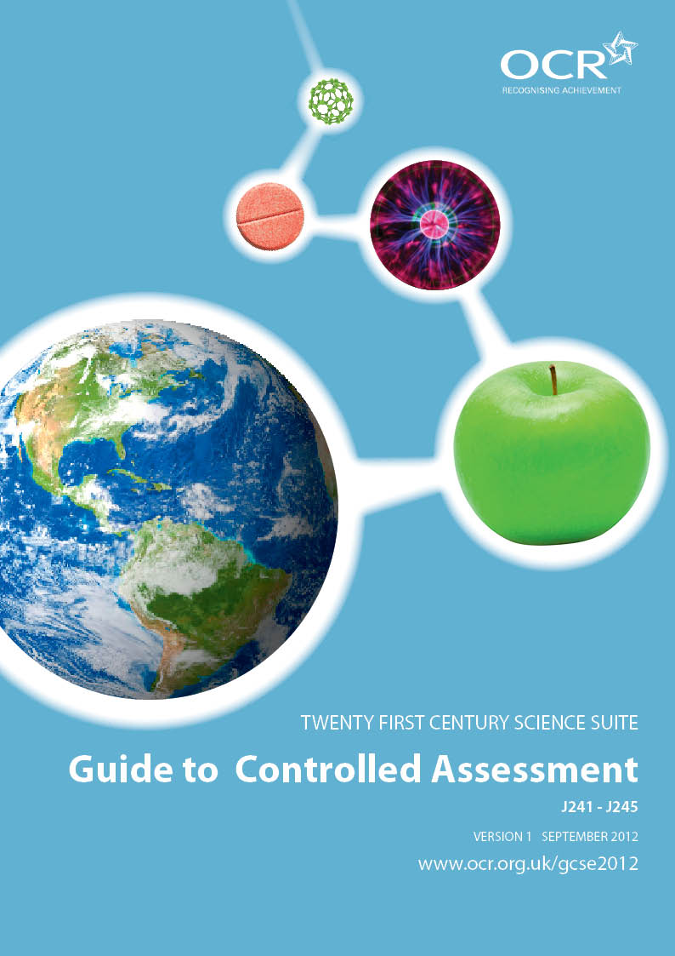
Guide to Controlled Assessment for
GCSE Twenty First Century Science: Science A

This Guide provides information for teachers about how to manage Controlled Assessment. Some of the information is generic and applies to all GCSE subjects and some information provides subject specific guidance. It should be noted that this Guide plays a secondary role to the specification itself. All assessment is based on the specification, and it is this which defines what content and skills need to be covered in delivering the course. At all times, therefore, this Guide should be read in conjunction with the specification.

INDEX
page
Section 1 Introduction 3
Section 2 Summary of Controlled Assessment for GCSE Twenty First 4
Century Science A
Section 3 Getting Ready For Controlled Assessment 8
Section 4 Preparing and Managing a Case Study Task 10
Section 5 Preparing and Managing a Practical Data analysis Task 13
Section 6 Teacher Guidance on Task Marking 16
Section 7 Submitting a Controlled Assessment Task 23
Section 8 Candidate Guidelines for Controlled Assessment 25
Section 9 Frequently Asked Questions 27
Section 10 Guidance on Downloading Controlled Assessment Tasks 32
from OCR Interchange
Section 11 Appendices 39
- Appendix A Marking Criteria for the Case Study 40
- Appendix B Marking Criteria for the Practical Data 42
Analysis
- Appendix C Advice to Centres on Preparation of 44
Sample for Moderation
- Appendix D Glossary of Terms 45
- Appendix E Cover Sheet for Controlled Assessment for 46
GCSE Science A

SECTION 1
INTRODUCTION
Controlled Assessment is a new form of internal assessment. Following a review by QCA, Controlled Assessment has been introduced as part of nearly all new GCSEs, to replace coursework.

Controlled Assessment provides candidates with opportunities to demonstrate skills that are difficult to assess in an examination environment while, at the same time, providing a degree of control appropriate to ensure reliability, authenticity and fairness in candidate assessment.
Levels of control are set and defined by Ofqual for each stage of a Controlled Assessment: task setting (high control), task taking (limited and high control) and task marking (medium control). For each stage, the level of control is set as high as possible for the skills assessed in order to ensure reliability and authenticity.
WHAT ARE THE LEVELS OF CONTROL?
Levels of control (high, medium and limited) define the environment within which each stage of a Controlled Assessment task is undertaken. This includes candidate supervision, teacher support, availability of resources, access to other materials, approximate timings and collaboration between candidates. QCA has produced guidance for each level of control, as follows:
- High control
Candidates work independently under formal supervision. What teacher support is allowed is clearly indicated together with how this should be recorded. Resources available to candidates are specified and the use of materials from other sources is tightly prescribed. Approximate duration of the tasks is defined.
- Limited control
Candidates complete work under limited supervision; this can include working away from the centre without direct supervision. Clear guidance on the requirements of the assessment, including the use of methods and materials from other sources, are clearly specified. Candidates may work with others but must provide an individual response. What teacher support is allowed is clearly indicated together with how this should be recorded. Guidance on appropriate time limits is given.
- Medium control)
Work is internally marked according to the marking criteria, and moderated by OCR.
THE WEIGHTING OF CONTROLLED ASSESSMENT
Weighting of Controlled Assessments is defined by the Ofqual subject criteria for GCSE Science and is set at 25% of the total assessment.

SECTION 2
SUMMARY OF CONTROLLED ASSESSMENT FOR GCSE TWENTY FIRST CENTURY SCIENCE A
The Twenty First Century Science A specification is designed to meet the needs of every citizen through the development of scientific literacy and an awareness of how science works. It provides an understanding of areas where scientific progress is most rapid, and of the interactions which lead to the response by society and individuals to new discoveries and ideas.

The Controlled Assessment tasks are intended to allow students to demonstrate their learning.

There are two tasks for the Controlled Assessment in Science A:

- A Case Study of a topical issue in science

- A Practical Data Analysis task designed as a stepping stone towards the wider range of skills required to carry out an independent, complete investigation, and to give students an appreciation of some of the issues scientists may face in reporting data that may have some uncertainties.

The Case Study provides experience in evaluating evidence provided or reported by others while the Practical Data Analysis focuses on interpretation of students’ own first-hand data.

Each candidate must carry out both tasks. Although the tasks will be set by OCR, the tasks will be presented in a way which leaves some freedom for each centre to vary the approach slightly, to allow for candidates with a range of abilities and interests, and/or for differences in the materials, equipment and facilities that centres have.

The Controlled Assessment process consists of three stages:

STAGE 1: TASK SETTING (HIGH CONTROL)
All Controlled Assessment tasks are set by OCR. Each June, new Controlled Assessment tasks will be made available, two years ahead of the examination series in which they are to be submitted.

STAGE 2: TASK TAKING (LIMITED AND HIGH CONTROL)
Controlled Assessment tasks will take place in distinct phases, with time for research, planning and collection of data (primary and secondary), followed by analysis, evaluation and review.

During task taking, limited control (research and data collection) and high control (task setting, analysis and evaluation of findings) levels are applied. These are summarised below:

 | Limited level of control | High level of control
Conditions under which the task is taken | Candidates can work without direct teacher supervision, and away from the centre. | Candidates must work under direct teacher supervision.
Conditions under which the task is taken | Candidates can work in groups, but must provide an individual response. | Candidates must complete work independently.
Use of resources | Candidates can collaborate to collect information. | The use of information, including material from other sources, is controlled tightly.
Guidance permissible | Information specific to the task can be discussed with the class. | Any guidance given should be generic only.

Timings for carrying out the Controlled Assessment tasks are shown in this Guide and in the specification. Whilst approximate, these timings should be reasonably matched to the allocation of whole lessons. For example, allowing time at the start and end of lessons for setting up and tidying away, an allocation of four, 1-hour lessons could reasonably be matched to an approximate timing of 3 hours.

STAGE 3: TASK MARKING (MEDIUM CONTROL)
Tasks are marked internally and subject to internal standardisation by the centre. The tasks are then moderated externally by an OCR Moderator, in line with Code of Practice requirements.

THE CASE STUDY
The Case Study is designed to enable candidates to demonstrate their skills in evaluating science-related information that they might find in the media. Each year, OCR will provide a choice of three broad topics for the Case Study. The topics chosen will involve some degree of controversy, or disagreement, either about the interpretation of the scientific evidence, or about how individuals or society should respond. OCR will provide some stimulus material – the ‘News Sheet’ – to provide students with a starting point for their study. Candidates will choose a question based on the Case Study material provided in the News Sheet.

The Case Study is designed to encourage research skills in locating and evaluating scientific evidence, claims and opinions in the media and other sources. It provides a motivating context within which candidates can write at length on the question they have researched for themselves, allowing them to demonstrate understanding of all aspects of Ideas about Science, including:
- the importance of good quality data
- differences between correlations and causal relationships
- the status of theories as models to explain observed behaviour
- the ways in which scientific work is published and reported
- considerations of real and perceived risk
- how society interacts with new scientific findings.

The resulting Case Study should not be simply a report of some new discovery, but rather an exercise in comparing opposing views/opinions and using understanding of science to decide on appropriate courses of action.
Each Case Study assesses both scientific knowledge and understanding of the topic, and the ability to apply Ideas about Science (see Appendix B in the specification):
- IaS1: Data: their importance and limitations
- IaS2: Cause-effect explanations
- IaS3: Developing scientific explanations
- IaS4: The scientific community
- IaS5: Risk
- IaS6: Making decisions about science and technology.

In addition to using the News Sheet material, candidates are expected to research text books, the internet and other sources to find secondary data which will help them to evaluate claims and opinions related to the topic. They will consider the information in relation to their own scientific knowledge and understanding, taking into account the quality of supporting evidence as well as the apparent reliability of each source. Finally, they will decide between the claims made and give recommendations for appropriate actions.

The time required to complete a Case Study will be between 3 and 4 hours, with some time for reflection possible between lessons. The final report is produced by the students working under direct teacher supervision. Resources, notes and other materials collected during the research and planning stage may be referred to and used, but prepared text cannot be incorporated directly into the report.

Each year, three new Case Study tasks (corresponding to Biology [Modules B1 – B3], Chemistry [Modules C1 – C3] and Physics [Modules P1 – P3]) will be made available on OCR Interchange, two years ahead of the examination series in which they are to be submitted. It is not necessary for all candidates from a centre to carry out the same task.

THE PRACTICAL DATA ANALYSIS

The Practical Data Analysis task requires candidates to design, carry out, interpret and evaluate an investigative practical activity in which they have been personally involved in collecting first-hand data. The tasks provided will be open-ended and investigative in nature. Each task provides a strong foundation for progression to full-scale individual investigations in Additional Science A, Additional Applied Science or separate Biology A, Chemistry A and/or Physics A.

Each year, OCR will provide a choice of hypotheses to be tested by candidates. The support materials for these will encourage teachers to work with whole class groups to develop practical ways to test the chosen hypothesis.

Science candidates will need to:
- record a risk assessment for the procedures they will use
- write a method for the procedures used
- record and present data collected
- draw evidence-based conclusions
- evaluate the quality of the data collected and review the effectiveness of their practical procedures
- relate their findings to the confidence they have in the hypothesis, and plan for further work.
Each Practical Data Analysis task assesses both scientific knowledge and understanding of the topic, and the ability to apply Ideas about Science (see Appendix B in the specification), in particular:
- IaS1: Data: their importance and limitations
- IaS2: Cause-effect explanations
- IaS3: Developing scientific explanations
- IaS4: The scientific community
- IaS5: Risk.
The time required to complete a Practical Data Analysis task will be approximately 3 hours. The final piece of work is produced in the centre under conditions of high control, which means that candidates work individually under direct teacher supervision. Teachers must be able to authenticate the work and there must be acknowledgement and referencing of any sources used.

It should be noted that, unlike the legacy Practical Data Analysis, it will not be possible to carry back marks to the GCSE Science Practical Data Analysis Task from the Practical Investigations in GCSE Additional Science A, GCSE Biology A, GCSE Chemistry A and GCSE Physics A.

Each year, three new Practical Data Analysis tasks (corresponding to Biology [Modules B1 – B3], Chemistry [Modules C1 – C3] and Physics [Modules P1 – P3]) will be made available, two years ahead of the examination series in which they are to be submitted. It is not necessary for all candidates from a centre to carry out the same task
SECTION 3
GETTING READY FOR CONTROLLED ASSESSMENT
FLOW CHART SHOWING HOW TO RUN GCSE SCIENCE A CONTROLLED ASSESSMENT
Select task to
attempt
from 3 for each of the Case Study and Practical Data
Analysis
Practical
and
research skills
Theory from appropriate modules and
Ideas about Science
Preparation

CASE STUDY
Research and planning
Candidates may work without direct teacher supervision and may collaborate
1.5 – 2 hours
Analysis, evaluation and review
Report writing independently and under high control
1.5 – 2 hours
PRACTICAL DATA ANALYSIS
Collecting data
Practical work under
direct teacher
supervision.
Candidates may collaborate
1 hour
Analysis, evaluation and review
Report writing independently and under high control
1 hour
1 hour
Research and planning
Candidates may work without direct teacher supervision and may collaborate
CHOICE OF CONTROLLED ASSESSMENT TASK

OCR will assume a high level of control in relation to the setting of tasks. The Controlled Assessment unit comprises of two tasks – a Case Study and a Practical Data Analysis. Three task titles will be available for both the Case Study and the Practical Data Analysis, for submission in any given year. Of the three, one will correspond to each of Biology (Modules B1 – B3), Chemistry (Modules C1 – C3) and Physics (Modules P1 – P3).

These tasks have been designed to meet the full assessment requirements of the Controlled Assessment for GCSE Science. Candidates will need to take part in a planned learning programme that covers the underpinning knowledge and skills of the unit.

For each task, centres must choose from the task titles offered by OCR. The tasks will each be specific for submission in one year only.

The same OCR Controlled Assessment tasks must NOT be used as practice material and then as the actual live assessment material. Centres should devise their own practice material using the OCR specimen Controlled Assessment tasks as guidance, if they wish to do so.

WHEN AND HOW TO GIVE CONTROLLED ASSESSMENT TASKS TO CANDIDATES

Controlled Assessment units are only available for assessment in the June examination series. Furthermore, each individual task is only valid for submission in a single examination series. This is clearly marked on the front cover of each task. Tasks submitted for assessment must be appropriate to the examination series in which they are entered. Tasks are not valid for submission in any other examination series.

Controlled Assessment tasks will be available to download from OCR Interchange; teachers without direct access to Interchange should ask their Examinations Officer to download the task materials for them.

Controlled Assessment tasks will be made available from Interchange in June, two years ahead of the valid submission date. This is to enable effective management of practical work preparation and Health and Safety requirements. However, this means that tasks will be simultaneously available for two examination series and care must be taken to ensure that the tasks valid for the required series of submission are selected.

It is the responsibility of the centre to ensure the correct task titles are used depending on when they plan to submit the candidates’ work. The Case Study and the Practical Data Analysis are part of the same unit and must be submitted together.

Controlled Assessment tasks should be given to candidates at an appropriate time following the delivery of the relevant specification content and the teaching of the skills.

SECTION 4
PREPARING AND MANAGING A CASE STUDY TASK

PREPARATION FOR THE CASE STUDY

The Controlled Assessment materials for each Case Study task comprise two documents:
- Information for teachers
- News Sheet.

The ‘Information for teachers’ is confidential to teachers and it is not permitted for candidates to have access to this document. The document provides generic guidance on various aspects of the task, including preparation of candidates, as well as task specific guidance on the underpinning specification content and any specific assessment issues.

The News Sheet is a collection of several articles about a topical issue in science, which will be the basis of the Case Study task. It should only be issued to candidates at the start of the task. Teachers should be aware that the articles included and referenced in the Case Study are correct at the time of release of the Case Study tasks but, particularly with web-based sources, may not be available throughout the time period from release of tasks to submission. In this circumstance, candidates should continue to use the articles provided in the News Sheet. Their assessment will not be affected.
Each of the Case Study tasks provided is related to the content of the GCSE Science A specification, and is therefore based from within Modules B1 – B3, C1 – C3 and P1 – P3. The ‘Information for Teachers’ for any particular task will identify the specific modules relevant to that task. This will enable teachers to plan the best time for candidates to undertake a particular Case Study, to ensure that candidates are familiar with the underlying science knowledge and understanding, including Ideas about Science (see Appendix B in the specification).
Before the assessment begins, centres should make the general requirements of the assessment clear to candidates, and provide learning activities to develop the relevant skills. The Case Study assesses skills in locating and selecting, evaluating and comparing information from different sources in order to decide between conflicting views. As general preparation, therefore, candidates should be given opportunities to develop research skills to find relevant sources of information, and evaluate the quality of these information sources.
Candidates must also be guided on the use of information from other sources to ensure that intellectual property rights and any confidentiality issues are maintained at all times. It is essential that any material directly used from a source is appropriately referenced, and candidates should learn how to reference information sources using one of the accepted conventions.
While, for scientific writing, the Harvard System is usually the preferred convention, candidates may find the use of the Vancouver System more conducive to their referencing of information sources, as it uses a numbering system sequential in the report.

 | Harvard System | Vancouver System
referred to in text | text (author[s], year) | text [numbered reference – 1, 2, 3, etc]
cited in list of references | Author[s] (date). Title of book. Publisher. | 1. Author(s). Title of book. Publisher: Date.
cited in list of references | The references are listed in alphabetical order, according to the authors. | The references are listed in the order in which they are used.

Candidates should be encouraged to write out the URLs of websites in full. If it is not possible to indicate a date of publication of material on a website, then the date the website was accessed should be indicated in the list of references.
Research and planning for the Case Study
(Approximate time: 1.5 - 2 hours)
OCR will set the Case Study task and provide stimulus material, in the form of a News Sheet. The News Sheet contains ‘people’s views’ on a topic, including opposing evidence and/or opinions, and will include a section on the background science involved.
During the phase of candidates’ research and planning, a limited level of control is required, and candidates are permitted to work in collaboration, providing that they can also make an individual response. They can also work without direct teacher supervision and away from the centre, as required.
The assessment period should begin by issuing the News Sheets to the group. The teacher should introduce each topic and allow time for candidates to look through the News Sheet.
The articles provided are designed to raise a variety of issues, and candidates should be encouraged to develop their own titles to study, in consultation with the teacher. The questions chosen by candidates on which to base their case studies should involve some degree of controversy, either:
- in the interpretation of scientific evidence, or
- how individuals or a society should respond to the issue.
Where possible, lessons should be programmed in library rooms or computer suites, where these facilities are available in sufficient number. Often librarians or ICT technicians may be able to provide additional support, but must be made aware of the restrictions which apply to the type and amount of help which can be given.
During this collection of information phase, suitable work folders should be set up for each candidate, in which all resources for use in the report should be kept, making it easier for the teacher to check progress and see where information is coming from. At the discretion of the centre, candidates may take this outside the classroom during the data collection phase. Alternatively, the centre may prefer to keep the files, so that students have to bring in their source material. Teachers should check material that is in and added to the folder.
It is important that candidates opting to produce their reports in an electronic form, such as a word-processed report or electronic presentation, have no unfair advantage in the assembly of the report. So, during this phase, those candidates opting to produce hand-written reports can, for inclusion in their work folder:
- collect information and make notes from textbooks, magazine articles and leaflets
- produce printouts of textual material from the internet
- produce printouts of pictorial material from internet sources, including tables, charts, graphs, pictures and/or explanatory diagrams, along with website addresses (rather than attempting to hand copy these).
During this phase, those candidates opting to produce word-processed reports can, for inclusion in their work folder:
- collect information and make notes from textbooks, magazine articles and leaflets
- produce printouts of textual material from the internet.
- collect textual and visual material from the internet electronically, including tables, charts, graphs, pictures and/or explanatory diagrams, along with website addresses. These should be stored on flash/pen drives, CD-ROM or in a secure location on the school network. Flash/pen drives and CD-ROMs should be stored in candidates’ work folders once the information collection stage is completed.
It is important to note that this phase is concerned with collection of information only, and must not contribute directly to the candidates’ analysis, evaluation and review. So, with the exception of their references and material which is to be incorporated directly and appropriately referenced, during this phase candidates should not begin the compilation of their final reports using prepared text. It is crucial that staff can (and do) make checks on what is stored, both in paper-based and electronic folders.
Analysis, evaluation and review for the Case Study
(Approximate time: 1.5 - 2 hours)
During this phase, a high level of control is required. Candidates will work individually to complete reports under direct teacher supervision.
Resources and notes in the candidates’ work folders, collected in the planning stages, may be referred to and used to compile their report.
Candidates opting to produce hand-written reports can copy textual and visual material collected, either by hand, or by cutting out and sticking material into their final reports. This should be appropriately referenced where applicable.
Similarly, candidates opting to produce word-processed reports can copy and paste textual and visual material into their reports electronically, but must reference this appropriately.
However, it is not permitted for candidates to make use of text that they have prepared themselves involving their own analysis, evaluation and review. Such sections must be written by candidates under conditions of high control, with reference to materials collected previously.
At this stage, candidates are allowed access to the Marking Criteria (see Appendix A), and can be given generic guidance.
If report writing extends over more than one session work, including notes and partially-completed reports together with any electronic data storage devices, must be collected in. In all cases, the teacher must be able to authenticate work submitted for assessment.
Note that candidate work folders, including flash/pen drives, CD-ROMs and other materials, should be retained by the centre until after the issue of results, in case any issues arise, eg request for re-moderation, malpractice enquiries, etc.
SECTION 5
PREPARING AND MANAGING A PRACTICAL DATA ANALYSIS TASK

PREPARATION FOR THE PRACTICAL DATA ANALYSIS

The Controlled Assessment materials for each Practical Data Analysis task comprise two documents:
- Information for teachers
- Information for candidates

The ‘Information for teachers’ is confidential to teachers and it is not permitted for candidates to have access to this document. The document provides generic guidance on various aspects of the task, including preparation of candidates, as well as task specific guidance on the underpinning specification content and any specific assessment issues. It also includes a section for technicians and teachers identifying suggested apparatus for the tasks and any particular issues with carrying out the practical work.

The ‘Information for candidates’ provides an outline of the hypothesis to be tested including some relevant scientific background. It should only be issued to candidates at the start of the task.
Each of the Practical Data Analysis tasks provided is related to the content of the GCSE Science A specification, and is therefore based from within Modules B1 – B3, C1 – C3 and P1 – P3. The ‘Information for Teachers’ for any particular task will identify the specific modules relevant to that task. This will enable teachers to plan the best time for candidates to undertake a particular Practical Data Analysis task, to ensure that candidates are familiar with the underlying science knowledge and understanding, including Ideas about Science (see Appendix B in the specification).
The Practical Data Analysis task requires candidates to take part in an investigative task in which they collect first hand data to test a hypothesis provided in ‘Information for Candidates’.
A scientific hypothesis is a tentative explanation of science-related observations, or some phenomenon or event.
Candidates are required to plan an experiment to test the hypothesis provided, and useful general preparation will involve providing learning activities to:
- understand the word ‘hypothesis’
- consider ways of testing hypotheses
- develop skills in the selection of methods, equipment and techniques to carry out practical investigative work, and
- apply Ideas about Science, in particular (but not limited to):
  - IaS1: Data: their importance and limitations
  - IaS2: Cause-effect explanations
  - IaS3: Developing scientific explanations
  - IaS4: The scientific community
  - IaS5: Risk.
More specific preparation will involve the teaching of the relevant science content (the teaching module concerned is indicated clearly in the Information for Teachers), and scientific techniques and methods appropriate to work in this area.
Research and planning for the Practical Data Analysis
(Approximate time: 1 hour)
This task requires candidates to take part in an investigative task in which they collect first hand data to test a hypothesis. The hypothesis is provided in the document, ‘Information for candidates’.
The hypothesis provided is based on underlying science that is accessible to candidates within the content of GCSE Science A (Modules B1 – B3, C1 – C3, P1 – P3). This science may, at times, be supplemented with specific additional material provided in the ‘Information for teachers’ or ‘Information for candidates’.
For example, the Specimen Assessment Material task for the Practical Data Analysis involves investigating the energy given out when burning different fuels. In this case, supplementary information on the calculation of the energy released from fuels should be provided to candidates, as some might use this in their completion of the task at the required level.
During the research and planning phase, a limited level of control is required, and candidates are permitted to work in collaboration, although they will still need to be able to demonstrate an individual response. They can also work without direct teacher supervision and away from the centre, as required.
The teacher should introduce the topic and remind candidates of the contexts within which they have studied related content and ideas. The hypothesis to be tested may be explained, leading to teacher-led class discussion of what factors should be varied, measured or controlled, and possible ways of doing this. Tasks are sufficiently open-ended to allow a variety of approaches.
The teacher can advise on how the task can be approached, resources and the key components that will contribute to the candidates’ final piece of work. Candidates will then develop a plan to test the hypothesis, including a risk assessment.
If, at the end of this process, some candidates have not produced a method suitable for them to engage fully in the task, or intend to pursue a method that is impracticable or likely to be hazardous, they should be provided with one. In these circumstances, any plan that the candidate has completed should be collected in and stored securely prior to issuing a plan to the candidate. The original plan can then be assessed and appropriate credit given for Strand D. If this is not possible, then the maximum mark awarded to a candidate provided with a method in Strand D will be 1 or 2 marks. Candidates’ work should be annotated to indicate what has happened.
Collecting data for the Practical Data Analysis
(Approximate time: 1 hour)
During the collecting data phase, a limited level of control is required, and candidates are permitted to work in collaboration, but all candidates must be actively involved. Candidates also need to develop their own response in determining how best to collect and record data. Candidates will carry out practical work under direct teacher supervision.
If the nature of the Practical Data Analysis task would require or benefit from this, class data can be pooled at the end of the data collection process.
A suitable work folder should be provided for each candidate, in which notes on their experimental methods, along with data collected and other information, may be kept, making it easier to check progress and see where information is coming from.
It should be noted that it is not permitted for candidates to base the collection of data solely on data from a demonstration, (computer) simulation or secondary data.
Analysis, evaluation and review for the Practical Data Analysis
(Approximate time: 1 hour)
During the analysis, evaluation and review phase, a high level of control is required. Candidates should work individually, under direct teacher supervision, to complete their reports. Ideally, reports should include an introduction to the hypothesis which has been tested. At this stage, candidates are allowed access to the Marking Criteria (see Appendix B), but can be given generic guidance only.
Candidates may incorporate tables of results and graphs that have been prepared previously into their reports. However, it is not permitted for candidates to make use of text that they have prepared themselves involving their own analysis, evaluation and review. Such sections must be written by candidates under conditions of high control, with reference to materials collected previously.
If report writing extends over more than one session work, including partially completed reports and electronic data storage devices, must be collected in. In all cases, the teacher must be able to authenticate work submitted for assessment.
SECTION 6
TEACHER GUIDANCE ON TASK MARKING
GENERIC GUIDANCE ON HOW TO MARK CONTROLLED ASSESSMENT TASKS
The starting points for marking the Case Study and Practical Data Analysis tasks are the relevant Marking Criteria grids, found within Section 5 of the specification. There are separate marking grids for the Case Study and Practical Data Analysis. These contain level descriptors for the skills, knowledge and understanding that the candidate is required to demonstrate. OCR will provide separate exemplification of the application of the marking criteria through real or simulated candidate work, which will help to clarify the level of achievement the assessors should be looking for when awarding marks.
Furthermore, the document ‘Information for teachers’ will provide some specific pointers for individual tasks where particular issues are identified that require further clarification.
Candidates’ progress through the tasks is assessed in three strands for the Case Study and four strands for the Practical Data Analysis, each of which corresponds to a different type of performance by the candidate. Two of the three strands for the Case Study include two different aspects of the work.
Thus, marking is based on a total of nine aspects, each of which is shown as a different row in the grid of marking criteria. For each aspect, a hierarchical set of four marking criteria shows typical performance for candidates working at four different mark levels. This provides a level of response mark scheme where achievement is divided into four non-overlapping bands.
Award of marks in each row of the grid is based on the professional judgement of the teacher and is hierarchical. This means that each of the criteria is considered in turn, working up from the lowest band to the highest band that is fully matched by the candidate’s performance. Once a band has been reached which is not fully matched by the work seen, no higher bands can be considered.
In strand A of the Case Study, each aspect is marked on a scale of 0 – 4 marks. For all other strands of the Case Study and Practical Data Analysis, each aspect is marked on a scale of 0 – 8 marks, with each of the four bands covering a range of two marks: 1–2, 3–4, 5–6 and 7–8. Within each two-mark band, the higher mark is available where the performance fully matches the criterion for that mark band (and all preceding, lower mark bands). The lower mark is awarded where the candidate has partially, but not fully, matched this criterion and has exceeded the criteria in the preceding, lower mark bands.
Where there is no evidence of engagement with an aspect of the work, or if the response is not sufficient to merit award of one mark, a mark of zero is awarded for the aspect.
This method of marking can be used even where there is wide variation in performance between different aspects of the work. Weak performance on one aspect need not limit marks in other aspects.
In strand E of the Practical Data Analysis, two alternative routes to credit are provided. One row of criteria is used for investigations where the candidate uses graphical display or charts to reveal patterns in the data. The other row is used where the candidate has used statistical or algebraic methods to identify patterns. Only the row which gives the highest mark is counted. However, the requirements of the hierarchical mark scheme can be satisfied by crossing from one row to the next to demonstrate continuous progression through this strand.
The level awarded in each aspect is recorded on a marking grid, which also serves as a cover sheet if the work is called for moderation.
The total for the assessment is the sum of all the aspect marks, giving a maximum possible mark of 64 (32 for the Case Study and 32 for the Practical Data Analysis).
INTERPRETATION OF THE CONTROLLED ASSESSMENT MARKING CRITERIA
THE CASE STUDY
Strand A: Finding sources of information (0-4 marks)
Aspect A(a)
Here candidates should show an awareness of sources of information, including their own notes as well as text books or encyclopaedias, and the internet. Credit will be given for selection of appropriate material from the available resources, rather than indiscriminate copying. It will also be given for judgement shown in selecting from sources which allow comparison of a variety of different opinions or views of the topic. Candidates will be expected to use numerical data, in addition to textual information, to put forward evidence. Good work in this aspect will be characterised by the ability of the candidate to adapt and re-structure information to suit the purpose of their study.
Candidates working at lower levels will not use information sources beyond those included in the News Sheet (for 1 mark); those using an additional relevant information source should be awarded 2 marks.
To be awarded 3 marks, candidates should select and use information and/or data that represent conflicting views of a topic.
Coverage of this range of views and opinions should be balanced for the award of 4 marks.
Please note that candidates should not submit their research notes and printouts as part of their reports or appendices to them.
Aspect A(b)
All information sources should be credited, and it should be clear where each piece of information has come from, in the text, and in a list of references.
The level of detail contained in the list of references will increase as a candidate moves between one and four marks.
For 1 mark, links for some sources will be indicated, but these will not be fully detailed; referral to textbooks, for instance, may be limited to a title, and website references to a home page.
For candidates awarded 2 marks, most sources will be identified, though detail will be similarly limited.
For candidates to proceed to 3 marks, reference to nearly all sources should be made in sufficient detail to locate the information in the source material. Direct quotations from books (the convention is to acknowledge these in single quotation marks) or direct quotation of speech (in double quotation marks) should also be acknowledged. At this level, candidates should comment on the validity of the information sources used.
Candidates awarded 4 marks should cite books and articles according to one of the accepted conventions, and websites should provide the full URL (not just the homepage), and record the publication date or, where this is not possible, the date the website was accessed. Credit is given for being selective in choosing only relevant material. Working at this level, candidates should show that they have considered the reliability of sources by evaluating the status of the authority providing the source material, the ownership of the information (is it being quoted by the original author, or by another source?), and justifying their selection or rejection of information on this.
Strand B: Quality of understanding of the science content of the Case Study (0-8 marks)

Quality of written communication will be assessed in this strand, alongside the science content. Note that to achieve 2, 4, 6 or 8 marks, the candidate has to fully satisfy the relevant descriptor on both science and any Quality of Written Communication (QWC) marks within the relevant two-mark band.

In many or most candidates, levels of science and QWC will be assessed to be in the same two-mark band. In instances where marks do not fall in the same two-mark band, centres should continue to carefully follow the procedure for applying the marking criteria. This requires that the highest band that is fully matched by the candidate’s work is identified initially. To be fully matched, both the science and the QWC must be fully met in this marking band, and all preceding marking bands. Once the highest band that is fully matched is identified, consideration can then be given as to whether this descriptor is, in fact, exceeded so that the next highest marking band is partially achieved. If this is the case, then the lower mark in the next marking band might be appropriate. Thus, for example, a candidate with a rather variable standard of spelling, punctuation and grammar who has used some scientific terms (matching QWC of level 3-4) who has reviewed the evidence and scientific knowledge to understand the issues studied can still achieve a mark of 5 for this strand.
When assessing candidate work for this strand, it is helpful for centres to first develop their judgement about the science knowledge related to the Case Study in question and the amount of science expected at each mark level.
Candidates working at lower levels will use limited science to answer the question which forms their Case Study. This will range from just superficial reference to science, and limited use of scientific vocabulary at the 1-2 mark level, to a basic outline of the main scientific ideas, using some relevant scientific terms, for 3-4 marks.
For 5-6 marks, candidates will review evidence from the information sources used, demonstrating a use of scientific knowledge required to understand it. Specialist scientific terms will be used in the Case Study. Information will be effectively organised at this level, and candidates’ use of spelling, punctuation and grammar should be sound.
For 7-8 marks, candidates should use detailed scientific knowledge to analyse and interpret the evidence they have collected. At this level, some candidates may wish to go beyond what they have been taught in class and, if they find, and apply correctly, theory which is not directly within the specification but relevant to the Case Study, this can help to raise their mark. Credit should not, however, be given to uncritical reproduction of large amounts of theory from texts. The report will be comprehensive, relevant and logically-sequenced, and will make full use of appropriate scientific terminology. At this level, there will be few, if any, grammatical errors.
Strand C: Conclusions and recommendations (0-8 marks)
Aspect C(a)
In this aspect, candidates should balance the evidence they have collected for each different view of the topic. They evaluate the claims and opinions they have studied.
Candidates working at the 1-2 mark level will have reported some information found, but this is not organised in relation to different views; there may be little or no appreciation of which side of the case these support.
At the 3-4 marks, candidates will classify or group evidence into ‘for’ and ‘against’, and there will be some structure to the report; for instance, with the use of sub-headings to organise work.
For 5-6 marks, the evidence is discussed to compare how it supports or refutes different views. Candidates will make comparative comments about the quality of evidence and organise information effectively.
For 7-8 marks, the quality of evidence supporting each view is considered critically. Candidates may consider the design and scale of research studies, the level of agreement between authors, and the ways in which the quality of research data or other information can be assessed, eg by peer review and/or by reproducibility of results. Candidates should draw on the language and ideas of IaS 2, 3 and 4 to help them.
Aspect C(b)
Candidates working at lower levels will draw conclusions without linking them to evidence for 1-2 marks. For 3-4 marks, the conclusion given is based on the extent to which the evidence presented in the report is supported by scientific evidence.
For 5 marks and above, the conclusion should be supported by recommendations for future action.
For 7-8 marks, limitations of candidates’ conclusions are discussed. Alternative recommendations will be made, based on different interpretations of the evidence. Credit will be given for discussion of the perceived benefits and associated risks of any proposed actions and an appreciation that different groups may be affected in different ways. Candidates will find it helpful to refer to the language and ideas of Ideas about Science, particularly IaS 5: Risk, and IaS 6: Making decisions about science and technology.
Candidates may indicate what further research may help to decide between the alternatives.
THE PRACTICAL DATA ANALYSIS TASK
Strand D: Choice of methods, techniques and equipment (0 – 8 marks)
Candidates’ choice of equipment and techniques will depend upon the contextualisation of the task by centres and choices made by candidates.
For 1-2 marks, the candidate will provide a description of the techniques and equipment selected, and show that some data have been collected, but without the control necessary to ensure repeatable results. These candidates will make a simple comment about taking care when handling equipment, chemicals or biological material, but without linking this to the appropriate risks.
Candidates who have been provided with a method because they have failed to fully engage in the task, or have intended to pursue a method that is impracticable or likely to be hazardous, will be working at this level (or below), if there is no secure evidence of the candidate’s own plan that can be assessed. However, if the candidate’s own plan was collected in and stored securely prior to issuing a method, credit may be awarded as appropriate to the candidate based on the available evidence. In either of these situations, the centre should add the appropriate annotation to the candidate’s report.
For 3-4 marks, candidates will comment on their choice of techniques and equipment. They will show some understanding for the need for repeating measurements, but repeats made may be inadequate.
These candidates will identify the hazards involved with the use of equipment, chemicals or biological material.
For 5-6 marks, candidates will use, and describe, techniques and equipment to collect an appropriate range of good quality data. They will make regular repeats or alternative checks for reliability.
Having identified significant risks, candidates working at this level will suggest some precautions to minimise these.
For 7-8 marks, candidates will justify the choice of method, range of values, equipment and range of values to collect high quality data.
Candidates will produce a ‘full’ and ‘appropriate’ Risk Assessment. A Risk Assessment that is full includes all the potential hazards, even if these are considered of minimal risk, and in the case of a chemistry-based experiment, a consideration of products made as well as reactants. Ways in which risks are minimised should be fully identified.
An ‘appropriate’ Risk Assessment is one where a true assessment of the hazards and risks is made to the chemicals, material or equipment used. For example, the hazard and risk cited for an acid should correspond with the specific concentration being used.
Strand E: Revealing patterns in data (0 – 8 marks)

In strand E, two alternative routes to credit are provided to allow access to a wider range of activities. The upper row of the marking criteria for Strand E relates to graphical display, and the lower row to a numerical or statistical analysis of the data.

For assessing the quality of graphical display the use of a spreadsheet package to draw graphs does not preclude the award of higher marks, as some skill is required to draw a graph of appropriate scientific validity. Hand-drawn graphs and computer generated graphs are therefore assessed on exactly the same criteria. However, centres should note that graphs which are printed out at very small size, with incomplete labelling, or with only partial grids or no grid, cannot score 8 marks. Furthermore, graphs joined point-to-point, or with an inappropriate line of best fit, by the software will score no more than 5 marks. To avoid this pitfall, it is suggested that centres advise candidates to add a line of best fit to their points electronically, or hand-draw their own line of best fit on the graph after it has been printed out.

Candidates working in the lower mark ranges will record and display data in simple bar charts or histograms. Note, however, that analysis of data from categoric independent variables can lend itself to statistical analysis, and may therefore be awarded marks in higher ranges along the alternative route of numerical or statistical analysis (see below).

Candidates working in the 3-4 mark range will draw line graphs, but at this level, there will be some errors in scales, plotting, or in drawing a line of best fit.

Well-drawn line graphs, with appropriate lines of best fit, or more complex charts such as species distribution maps can score up to six marks.

For 7-8 marks, candidates should indicate the spread of data on their graphs. This could include the addition of accurately drawn range bars or displaying data in scatter graphs. Alternatively, 7-8 marks can also be awarded for the inclusion of clear keys for plots of multiple data sets on common axes.

The alternative route is used to award credit for numerical or statistical analysis of data. At the 1-2 marks level, no calculations are expected, with the conclusions drawn in Strand G based on the selection of individual results.
Simple calculations done correctly, e.g., the calculation of means, can be awarded 3-4 marks.
Mathematical comparisons of results will be made at the 5-6 mark level, while for 7-8 marks, candidates will describe inverse relationships, or carry out calculations of gradients of graphs, or statistical analyses. Statistical methods could include, but may not be limited to, the student’s t-test for comparing the means calculated from sets of data, or the chi-squared test for comparing observed and predicted results. The use of statistical packages to make calculations, rather than carrying these out longhand, need not preclude the award of the highest marks, provided the exercise is carried out with understanding.
At 7-8 marks, statistical methods could also include the derivation and designation of quartiles and the construction of box and whisker plots on candidates’ graphs to show the spread of data.
Where candidates have progressed through the marking criteria across both rows, the row that gives the highest mark is counted. However, the requirements of the hierarchical mark scheme can be satisfied by crossing from one row to the next. This can occur where analysis of results provides opportunities to address criteria for both graphical and statistical analysis, in a complementary fashion. The mark awarded should then be the highest that can be reached by counting across the two rows in a continuous route of progression. For example, a candidate that has drawn a good, scientific graph (route 1), but has failed to indicate the range of data used to produce the graph, may still enter the 7-8 mark band if they have calculated the gradient of the graph (route 2).
Strand F: Evaluation of data (0 – 8 marks)
In this strand, candidates should show consider the spread of values in the data collected and awareness of limitations imposed by the apparatus and techniques.
At the 1-2 mark level candidates may state that their results are ‘accurate’ or repeatable (where a set of readings that they have collected shows good concordance between repeats) but do this without referring to their data.
Candidates will identify outliers in their set of results, or on their graphs, or justify a claim that there are no outliers, at the 3-4 mark level.
For 5-6 marks, candidates will extend this by assessing the accuracy and repeatability of their results from the spread of data. They should indicate and describe how they can recognise an outlier resulting from a measurement or from experimental error.
For 7-8 marks, variation in data should be considered in terms of its repeatability. At this level the spread of data and the presence of outliers should be linked to relevant limitations in procedures used, and/or linking these to measurement or experimental errors.
Strand G: Reviewing confidence in the hypothesis (0 – 8 marks)
Quality of written communication will be assessed in this strand, alongside the science content.
In this strand, referring to patterns, trends of correlations in data, candidates will assess how well the available data support the hypothesis, by reference to, or explanation, using the appropriate science.
In the 1-2 mark range, it is likely that patterns, trends or correlations in data will be non-quantitative, and/or candidates will simply state that the hypothesis provided is supported (it is ‘correct’ or ‘proven’). There will be little use of scientific vocabulary, and frequent errors on spelling, punctuation and grammar.
For 3-4 marks, candidates will discuss whether trends or correlations support the hypothesis provided. Candidates will do this using some reference to science, and using some scientific terms.
In the 5-6 mark range, candidates will explain the extent to which patterns in the data support the hypothesis. They will use relevant science to draw conclusions and may suggest how the hypothesis could be modified to better account for these. The report will be organised effectively, and use specialist scientific terms appropriately. Spelling, punctuation and grammar will be sound.
For 7-8 marks, candidates should suggest extra data that could be collected to improve confidence in their hypothesis. This may involve suggestions for parts of the range over which more data could be collected, or, on the basis of elaboration or modification of their hypothesis, the testing of other factors that might be involved. The candidate will make full and effective use of scientific terminology. The report will be comprehensive, relevant and logically sequenced, with few, if any, grammatical errors.
SECTION 7
SUBMITTING A CONTROLLED ASSESSMENT TASK

ANNOTATION OF CANDIDATE WORK
The Code of Practice for GCSE Examinations requires teachers to show how the marks for internally assessed work have been awarded. One convenient way of meeting this requirement is by hand-written annotation on each candidate’s work. At the least this should consist of a shorthand reference to the appropriate Aspect or Strand, with an indication of the mark level, at the appropriate point in the work where the award of the mark is evidenced, eg A(b)4 or F3. Annotations are particularly helpful where assessment decisions may not be immediately apparent, and in these cases a brief explanation will help moderators to support centre marks.
INTERNAL STANDARDISATION AND RECORDING OF MARKS
When marking work, it is important that internal moderation takes place within the centre to ensure that the same standards are being applied by all the members of staff. This should ensure that marks submitted from the centre form a single, coherent order of merit. If there are differences in the way in which the marking criteria have been applied by different teachers, this can lead to a significant violation of this order. As a result, moderators may require centres to re-mark the work of all candidates at short notice.
Centres should provide a brief report for moderators, outlining details of internal standardisation processes, with the requested sample of work
Final marks awarded should be recorded on the cover sheet (Appendix E). This should be secured to the front of each piece of work using a treasury tag.
STORAGE OF SCRIPTS
When the task and its associated marking are complete the scripts should be stored securely. In addition to samples being requested during moderation, samples of work may also be required for Enquiries about Results.
AUTHENTICATION
The Ofqual Code of Practice for the conduct of GCSE examinations requires that every teacher involved in the internal assessment of Controlled Assessment ensures that each piece of assessed work can be authenticated with confidence as being the work of the candidate who submits it. This is particularly important when candidates have undertaken some of their work not under the direct supervision of the teacher or have been working in groups.
A Student Authentication Form is available for use internally. Teachers must complete a Centre Authentication Form to confirm that all work submitted is that of the candidates.
A teacher may have some residual concerns about the extent to which the response does not represent the work of a particular candidate. For example, there may be evidence that too much help has been given or that a candidate has simply copied work directly from another candidate. In such circumstances, that piece of work should not be counted for assessment purposes and the candidate should undertake another Controlled Assessment task.
If teachers do discover cases of deliberate plagiarism this should be dealt with using the centre’s own disciplinary procedures.
If malpractice is not discovered by the centre but is later suspected by a moderator then OCR’s malpractice procedure will be implemented. If there has been malpractice then penalties will be applied to all candidates involved.
MODERATION
A sample of a centre’s assessed Controlled Assessment tasks will be externally validated by a moderator appointed by OCR. The moderator will review a sample of the judgements made by the teachers at the centre to ensure that these are correctly aligned to common standards. The judgements made by the teachers will be adjusted, if necessary, to conform to the agreed standards.
Each teacher involved in the preparation of candidates is required to sign a Centre Authentication Form which must be included in the material sent to the moderator.
The marks awarded for the Controlled Assessment should be submitted to OCR by 15th May in the year for which the task is dated. A sample will be selected based on the number of candidates entered, but will be up to a maximum of 25 from each centre. The sample will be across the whole range of marks. Centres will need to send this sample to the moderator within a specified time period.
The internal standardisation of judgements made by all the teachers involved in the marking of candidates for the Controlled Assessment is vital. The marks awarded by a centre will form a single order of merit. The centre must provide evidence that steps have been taken to ensure that each of the teachers is using a common interpretation of the marking criteria.
If a moderator experiences difficulties in validating the judgements made fro the initial sample of work requested from a centre, then additional samples may be required.
The candidates’ work will be returned after moderation and detailed comments on the overall quality of the work submitted will be available to the centre at the time the results are issued.
CONTROLLED ASSESSMENT TASK SECURITY
It is the responsibility of the centre to ensure that downloaded Controlled Assessment Task titles and candidates’ scripts are stored securely. Any breach in security must be reported to OCR as soon as possible by submitting a written report (a blank report form is available on Interchange) from the Head of Centre to the OCR Quality and Standards Division detailing the circumstances, the candidates concerned and any action taken.
Candidates’ scripts for all completed Controlled Assessment must be stored securely and be available for moderation.
Candidate absence at the time of assessment
If a candidate is absent from a centre when an assessment is carried out, the Controlled Assessment task may be set at an alternative time provided that the centre is satisfied that security has been maintained by keeping all materials secure.
Unexpected circumstances
If an unexpected problem (such as a fire alarm or other circumstance beyond the teacher’s control) occurs while a Controlled Assessment task is taking place, the task may be resumed subsequently provided the teacher is satisfied that no candidate is likely to have been unfairly advantaged.
SECTION 8
CANDIDATE GUIDELINES FOR CONTROLLED ASSESSMENT
These guidelines are available as a separate document for use by candidates during completion of the task.
THE CONTROLLED ASSESSMENT TASK
The task titles for this subject are set by OCR and changed every year.
Task taking

Research, planning and data collection
Once you have been given the task title, you will have time to do the research and data collection and make notes which you will use later when you write up the task. Your teacher will tell you how much time you will have and will give you advice on how and where you will gather data and/or where you will find resources (for example the library or the internet).
Things to think about and remember:
- how will you approach the task – you can discuss this with your teacher
- make a plan of how you will spend the time you have for research/data collection. This way, you can make sure that you have time to cover everything you want to do. This plan may be useful to refer back to you when you are writing up the task
- make sure that you keep a record of where all the information you want to use comes from. This will allow you to include references in your report and a references list when you write up the task
- think about how you will use your research or the data that you have collected to respond to the task. It may be helpful to make a basic plan so that you can check you have all the information that you need
- make sure that you have all the information that you collected in your work folder since you will not have access to resources other than your notes when you write up the task.
During your research and data collection, you can talk to your teacher about the task and ask them for advice. You can also work with other candidates and share ideas about the task with them.
How much teacher support can I expect?
During your work for Controlled Assessment you must produce work and evidence independently. However, your teacher will be able to give you some advice, support, guidance and feedback before you start writing your report. The amount will vary depending upon the type of task you are doing.
You must make your own judgements and draw your own conclusions, but your teacher will:
- offer advice about how best to approach a task
- offer guidance on the way you work in groups so that you all have an opportunity to tackle your tasks
- offer advice to help your research if this is appropriate
- monitor your progress to make sure your work gets underway in a planned and timely manner
- help ensure that your work meets the specification requirements.
The support given by your teacher will be to make sure you understand what it is you have to do. Your teacher will not be allowed to provide model responses for you or work through your responses or outcomes in detail.
What can I expect in the supervised sessions?
This is where you will complete the task by analysing and evaluating the data that you have collected and the research that you have done. Depending on the type of task, this analysis and evaluation of findings may take a variety of forms. You will have already discussed with your teacher which format is suitable for the task that you are doing.
This part of the task has to be completed under controlled supervised conditions. This means that all of this stage of the task has to be completed within school time and supervised by your teacher or another invigilator.
Things to think about and remember:
- the analysis and evaluation of findings is the part of the work that you will be assessed on
- make sure that you include all the relevant information from your notes
- the written report must be your own work
- if you quote from another source (for example a book or the internet) you must acknowledge this properly.
You will have access to all the notes that you made during the research and data collection period. You will not be allowed to take in a draft or final version of your analysis and evaluation however, as this part of the work needs to be completed under controlled conditions.
It may take more than one session to write up your findings. At the end of each session your teacher will collect in your work and your notes. They will give these back at the start of the next session.
It is a good idea to prepare a detailed plan of what you are going to do, with timings, so that you complete everything in the time available.
SECTION 9
FREQUENTLY ASKED QUESTIONS

When and where can teachers and candidates access the Controlled Assessment materials?

Controlled Assessment tasks can only be accessed from OCR Interchange. Access to OCR Interchange for science teachers can be organised through the school’s examinations officer.

New tasks are uploaded to Interchange in June of each year. The newly uploaded tasks will be for submission two years later. Tasks for submission in the coming year will have been there for a year already.

Candidates can only access the tasks through their teachers. This should only occur when the task is being started.

When can Controlled Assessments be taken?

The Controlled Assessment tasks should be submitted for the June series of the year clearly indicated on the front cover of the task. They can be taken at any time, convenient to the centre, after they appear on the OCR Interchange web site. This should, of course, be synchronised with the teaching of the appropriate module. Furthermore, some tasks, for instance, fieldwork or work with plants, may also be seasonal.

Each Controlled Assessment task is allocated to a specific June examination series. Marks awarded for that assessment must be submitted to OCR before May 15th in that examination year; they are not valid in any other year. There are always Controlled Assessments for both the current year and the subsequent year available on interchange, so care must be taken to select one for the correct year.

How long is each Controlled Assessment task valid for?

Each Controlled Assessment task is valid for submission in one examination year only

A Controlled Assessment task can be completed at any time in the two years prior to the submission date. However, the marks can only be submitted in the assessment year stated on the front cover of the task.

There are always two years of tasks available on OCR Interchange.

Can candidates select which Controlled Assessment task to do?

There is nothing to prevent a centre allowing candidates to select the task from those available for the required examination series, although this may not be practicable for the majority of centres.

Different teaching groups within a centre could do different tasks.

When should I do the Controlled Assessment?

The timing of the Controlled Assessment is entirely up to the centre within the period between the release of a task on OCR Interchange and the examination series for which the task is valid. However, timings should take account of the need:

- for candidates to have studied the modules and Ideas about Science relevant to the Controlled Assessment task
- for candidates to have gained the necessary skills
- to allow enough time for marking and internal standardisation before the 15th May, which is the deadline for submission of centre marks to OCR.

Can any preparation work be done out of the classroom?

Yes, in the research and planning stages in conditions of limited control, at the discretion of the centre. Materials collected and added to work folders during this phase should be checked by the teacher.

Can any work for submission be done out of the classroom?

No part of the Controlled Assessment that is subject to high control can be worked on out of the classroom. This includes report writing, although referenced materials which are to be incorporated directly into the report such as diagrams and quotations, can be collected in advance into candidates’ folders.

Is there a minimum or maximum time that can be spent on the assessments?

Approximate times are provided for the different phases of the Controlled Assessment tasks and are indicated in Section 5 of the specification. These can be reasonably matched to the timings of whole lessons. For example, allowing time at the start and end of lessons for setting up and tidying away, an allocation of four, 1-hour lessons could reasonably be matched to an approximate timing of 3 hours.

Furthermore. the times indicated can be divided between lessons, as appropriate. The Case Study should take between 3 and 4 hours, and the Practical Data Analysis between 3 and 4 hours. The completion of a particular stage of the task need not involve consecutive lessons, and some time for reflection can be allowed in between.

If tasks take more than one session then work should be collected in and stored securely until re-issued for the next lesson.

Where can the Mark Schemes be accessed?

The Marking Criteria for the assessment of the candidate work are found in Section 5 of the specification, and are repeated in Appendices 1 and 2 of this Guide. These are generic criteria for the Case Study and Data Analysis.

Do Controlled Assessment tasks have to be completed under examination conditions?

It is not necessary to administer any part of the tasks under examination conditions. The analysis, evaluation and review stages of the Controlled Assessment task are, however, under a high level of control and must be under direct teacher supervision, whether in a classroom or laboratory, to prevent collusion between candidates. Research, planning and collection of data stages are under limited control.

It is not necessary for different groups of candidates working on the same Controlled Assessment tasks in one centre to carry these out all at the same time.

Can Controlled Assessment units be re-sat?

Change to 'Under the current 100% terminal rules, no resits of any units are permitted.'

However, where candidates perform badly on a particular task they can attempt a different task available in the same examination series, and the better mark can be submitted to OCR. This does not constitute a re-sit. It is never permitted for a candidate to attempt the same task again.

Who marks Controlled Assessment tasks?

The Controlled Assessment tasks are marked by the centre and internally standardised. Once marks are submitted to OCR, a sample of work is requested by OCR and sent for moderation.

If the assessment tasks change each year will I have to organise new practical work each year?

Yes. The tasks will change each year, and so it will not be possible to repeat the same practical year after year.

Is it possible for candidates to work together?

Candidates will be able to work together during any phase of a Controlled Assessment task that is subject to limited control. This includes research, planning and collection of primary data. However, each candidate will need to provide an individual response.

Can teachers provide resources for candidates to use in the Case Study?

Teachers, librarians and ICT staff can provide resources for the Case Study from which candidates can make selections, such as a library box, but the onus is on candidates working at higher levels to collect their own resources.

For the Practical Data Analysis, can candidates be given a list of equipment to choose from?

Yes. Teachers may also display equipment for candidates to look at, but this should include a range of apparatus of varying suitability so that candidates can make meaningful choices.

In the Practical Data Analysis, can candidates be given a method to work from?

If candidates intend to pursue a method that is impracticable, or likely to be hazardous, they can be issued with a method. In these circumstances the plan that candidates have completed should be collected in and stored securely prior to issuing a method. Candidates can then be credited for their initial plan in Strand D when the work is marked. If this is not possible, then the maximum mark the candidate can be awarded for Strand D will be 1 or 2 marks. In either of these circumstances, the candidate’s work should be annotated to show what has happened.

In the Practical Data Analysis, what happens if a candidate is absent for the phase where they have to make choices about methods, techniques and equipment?

It is possible that this phase may extend over more than one lesson, so on their return, the candidate can engage in the process.

If the candidate is absent for longer than this, they may resume work at the appropriate stage. However, it may be preferable for them to carry out an alternative task on another occasion at the discretion of the centre.
In Controlled Assessments, can a writing frame be issued to candidates?

Providing that writing frames are generic, and therefore appropriate for any task, these may be used. However, they must not prompt candidates to make decisions or present work in particular ways that are worthy of credit in their own right. Writing frames are likely to limit performance for higher attaining candidates.

Can candidates use ICT?

Yes, candidates can use ICT to compile their reports according to the guidelines indicated in this document. It is essential that candidates using ICT should have no unfair advantage over those opting to handwrite reports. Under conditions of high control, access to the internet and candidates’ own network areas must be disabled. Candidates must not be able to access previously prepared work other than that specifically permitted and collected in earlier phases of the Controlled Assessment, eg tables of results, graphs, diagrams, quotations attributed to sources, and reference lists. All of these can also be used by candidates writing reports by hand and pasting directly into their reports.

Can candidates use computer software, such as Microsoft Excel, to draw graphs?

Yes. Such graphs will be marked on the same criteria as hand-drawn graphs and can therefore give access to full marks. However, if a candidate is to draw a graph of sufficient quality using such software, they will need to be very proficient in its use. Common pitfalls include reproducing the graph at an inappropriately small size, failing to include gridlines, plotting incorrect lines of best fit and omitting appropriate titles for the axes.

Can tasks be modified, either by teachers or candidates?

The Controlled Assessment tasks are set by OCR. This is under high control.

However, it is possible for tasks to be contextualised to take account of local circumstances and the interests and abilities of the candidates concerned. Nevertheless, the Controlled Assessment will still need to match both the marking criteria and the set tasks, and if there is any doubt concerning this, confirmation should be sought from OCR.

In addition, the nature of the Controlled Assessment tasks already provides scope for candidate choices.

In the Case Study, for instance, candidates choose a question that interests them to research based on the stimulus material provided.

Similarly, for the Practical Data Analysis, tasks are sufficiently open-ended to allow a variety of investigative approaches by the candidate, and to allow for candidates of different abilities and interests, or for differences in the materials, equipment and facilities at different centres.

Can we provide students with the marking criteria during their analysis, evaluation and review? Can we use ‘student-speak’ versions?

The OCR Marking Criteria can be provided during this period of high level of control.

If using centre-devised ‘student-speak’ marking criteria, the centre must ensure that these are a correct interpretation of the marking criteria, and do not give undue guidance to candidates.

All marking must be against the OCR marking criteria.

Can teachers give any feedback to students during Controlled Assessment phases under high level of control, eg analysis, evaluation and review stages?

Teachers may give generic, informal feedback while the task is being completed but may not give guidance specific to the task or indicate what candidates need to do to improve their work.

Does OCR provide definitions of scientific terms, such as ‘accuracy’ and ‘precision’, in its guidance?

An excellent overview of these, and other scientific terms, can be found in the publication:
ASE-Nuffield (2010). The Language of Measurement. Terminology used in school science investigations. ASE Nuffield.

A selection of definitions consistent with this publication are presented in Appendix D of this Guide.

Furthermore, OCR-endorsed publications by Oxford University Press and Collins give detailed sections on Controlled Assessment.

Can candidates start a Controlled Assessment task before Year 10?

Yes, there are no restrictions on the year in which Controlled Assessment tasks can be started. However, consideration will need to be given to the intended year of submission for the Controlled Assessment. This will affect which year’s tasks you select. Furthermore, you will also need to ensure that candidates have been taught the appropriate module content and Ideas about Science, as well as having developed the necessary skills, before the candidates attempt the Controlled Assessment.

I have candidates with physical disabilities that make practical work impossible. Can these candidates be given teacher data?

Such candidates can either have an assistant to perform the experiments under their direction, or can use the data from another candidate. The use of teacher data is not allowed. If candidates use data from another candidate they will be unable to access the marks for this skill quality.

Can candidates have scribes or amanuenses if needed?

Yes, access arrangements are exactly the same as for written examinations.

Can candidates bring in a word-processed list of references from home?

Yes, this is an example of the kind of material that can be produced under conditions of limited control and brought into the high control part of the assessment. What is not permitted is incorporation of prepared text covering analysis, evaluation or review into reports produced under high control.

Can candidates redraft their written reports?

No re-drafting of reports is permitted outside conditions of high control. However, while under direct teacher supervision candidates can continue to amend and edit the reports that they are writing. Teachers cannot provide specific feedback on candidates’ drafts or indicate what improvements need to be made.

Can candidates share their results for the Practical Data Analysis task?

Candidates are allowed to work together under conditions of limited control and this can include sharing primary data that they have collected. However, all candidates must make an individual response and therefore have contributed to collecting at least some of the data for themselves.
SECTION 10
GUIDANCE ON DOWNLOADING CONTROLLED ASSESSMENT TASKS FROM OCR INTERCHANGE

Before you start
Controlled Assessment materials will be available to download from OCR Interchange from June 2011.
In order to use OCR Interchange for the first time, you will need to register your centre by returning the Interchange Agreement. This can be downloaded from the OCR website at http://www.ocr.org.uk/interchange
In addition, you will need to be assigned the ‘Tutor / Teacher’ Interchange role to access Controlled Assessment materials. Your Interchange Centre Administrator can assign this for you, as follows:
    - select ‘Admin’ in the left-hand menu
    - select ‘Manage centre users’ from the pop-up menu that appears
    - select the relevant username
    - select the 'Roles' tab
    - select the role of 'Tutor teacher' on the left-hand side of the screen
    - click the '>' button to move the role across to the right-hand side of the screen
    - click the 'User' tab
    - click 'Add'.
Please note that it could take up to 20 minutes for the new role to take effect.
STEP 1 - LOG INTO INTERCHANGE
Click on the following link https://interchange.ocr.org.uk
Enter your log in details
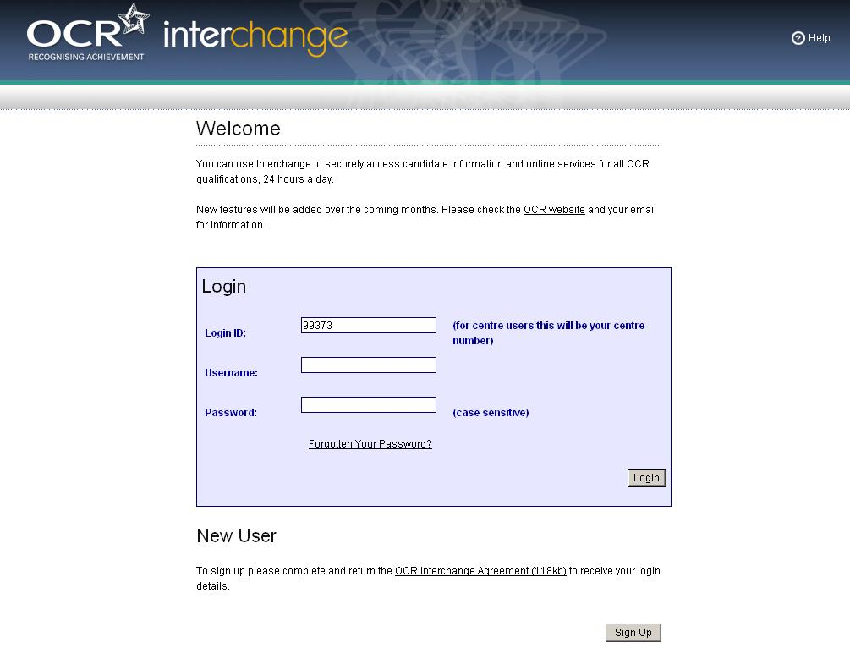

STEP 2 – PROCEED TO CONTROLLED ASSESSMENT TASKS
Click on ‘Coursework and tests’
Click on ‘Controlled Assessment materials’
If you are unable to see either of these menu items then it is likely that you do not have the ‘Tutor / teacher’ role assigned to you – please refer to the start of Section 10.
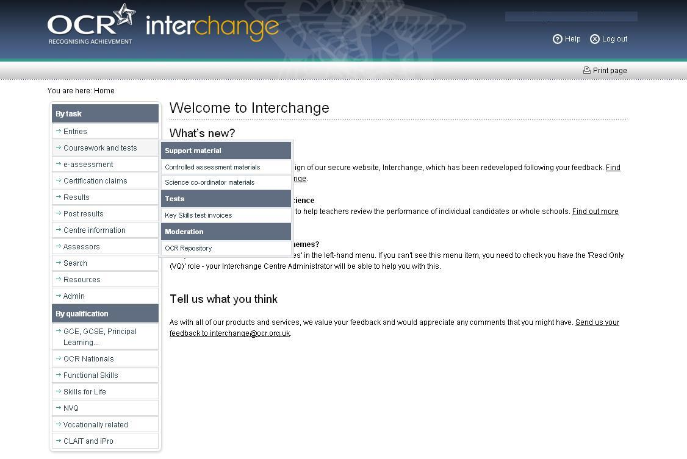

STEP 3 – SEARCH FOR MATERIALS
You can search for materials by unit code. Enter the unit code and click on the ‘search’ button.
Or, you can search for materials by subject information by selecting from the ‘drop down’ options.
All available documents will be displayed below the search.
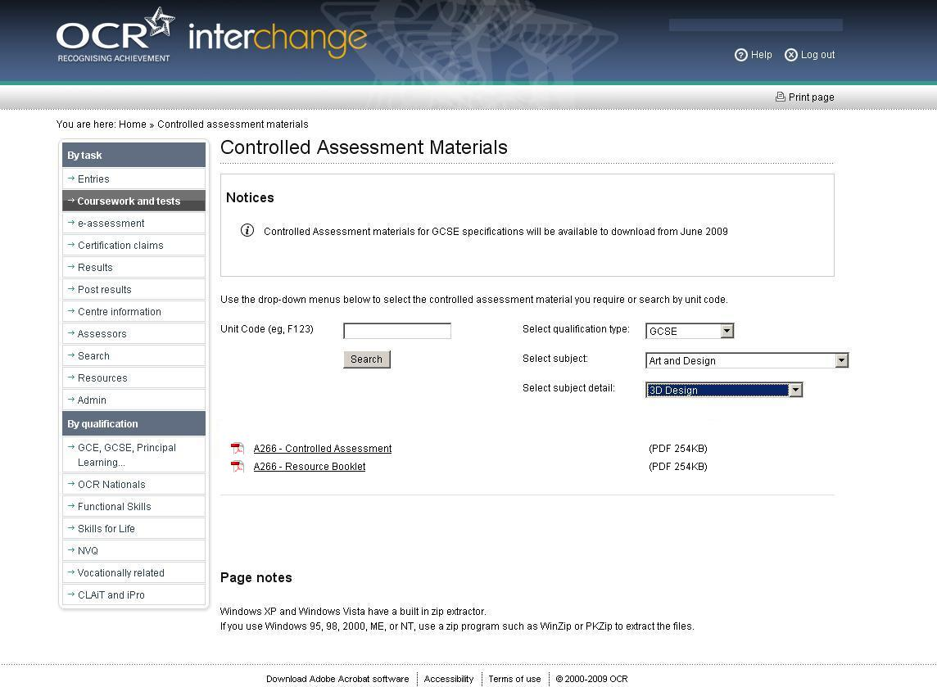

STEP 4 – OPEN MATERIALS
Click on the document link, the document will open in your browser
Click on ‘Save As’ to save to a location of your choice.

STEP 5 – TROUBLESHOOTING
If you search for an invalid unit code, the following error message will be displayed.
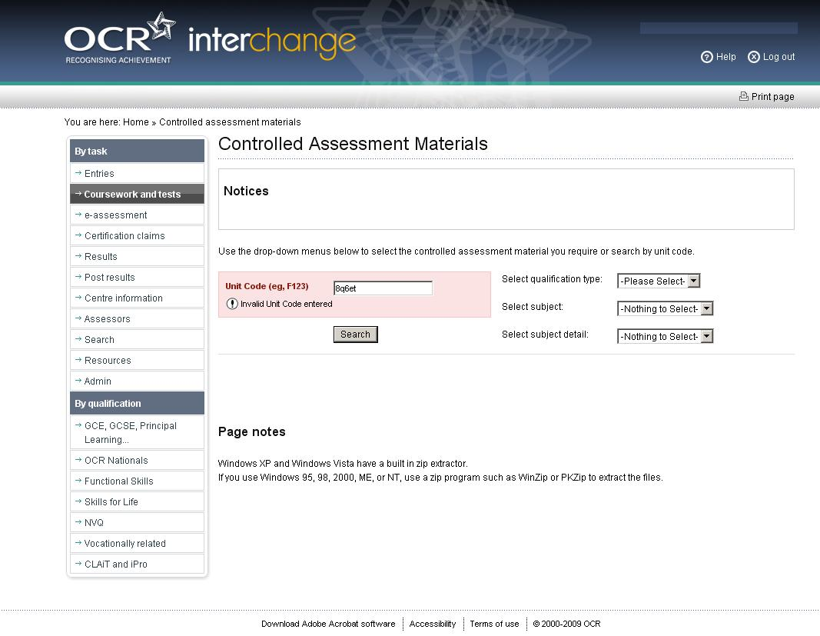

If you search for a valid unit code but there is no document currently available, the following message will be displayed.

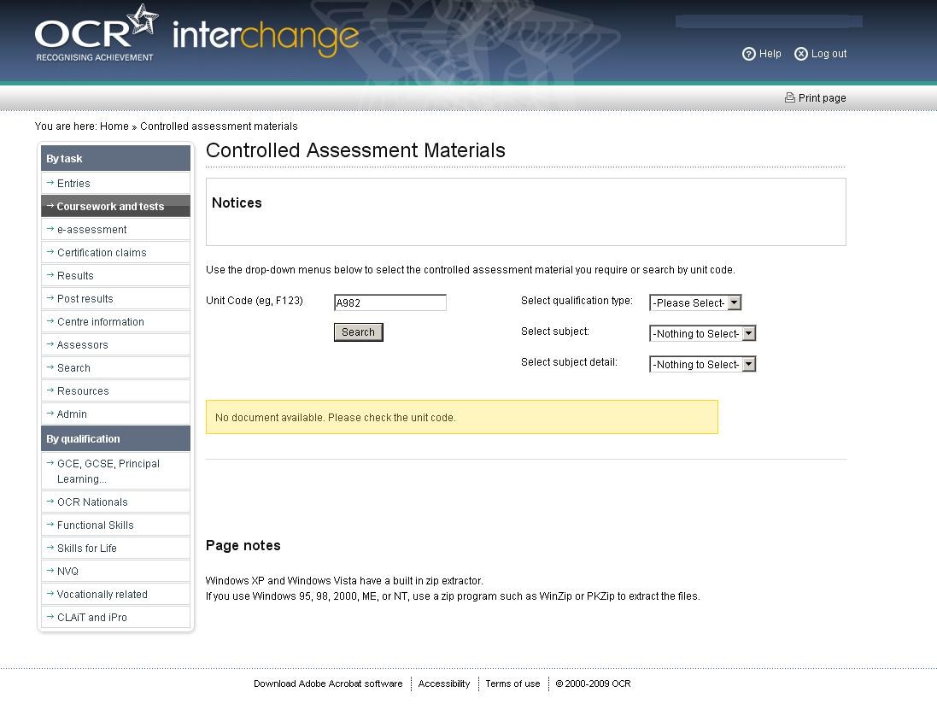

If you search via the ‘drop down’ menus but there is no document currently available, the following message will be displayed.
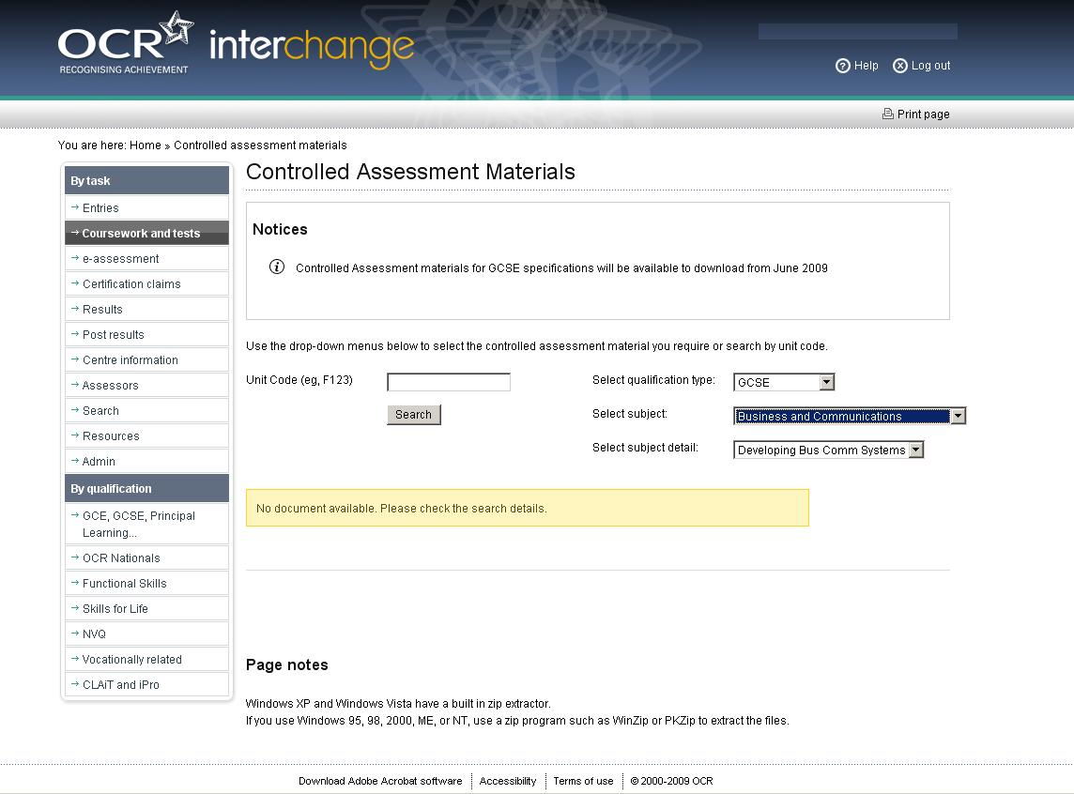

SECTION 11
APPENDICES
APPENDIX A: MARKING CRITERIA FOR THE CASE STUDY
Extracted from the specification for GCSE Science A

APPENDIX B: MARKING CRITERIA FOR THE PRACTICAL DATA ANALYSIS
Extracted from the specification for GCSE Science A
APPENDIX C: ADVICE TO CENTRES ON PREPARATION OF SAMPLE FOR MODERATION

Centres are advised that before submitting marks to OCR they should:
- internally standardise the marking of all teachers involved
- check that all total marks are correct
- check that marks have been correctly transferred to the MS1 or electronic alternative (eg EDI or OCR Interchange).
The centre will receive an email request for the sample of candidates’ work required by the moderator. It is therefore essential that centres ensure that OCR is updated if the contact email address (usually an email account that the examinations officer accesses) changes. Prior to submission of marks OCR will contact centres to confirm that the email address held for moderation purposes is correct; it is essential that centres respond to these requests for confirmation.
Work to be submitted as part of the moderation sample should be checked to ensure that annotation is sufficient, and that a correctly completed cover sheet has been attached to the front of each piece of work.
Treasury tags should be used for fastening the pages of coursework, including the cover sheet. together. The use of plastic wallets is not considered suitable.
The sample, with the Centre Authentication Form, should be sent to the moderator by the date requested. Centres are advised to include details of how internal standardisation has been carried out. It is also helpful to include a contact email address for the Head of Science in case the moderator needs to clarify anything.
APPENDIX D: GLOSSARY OF TERMS

These definitions are consistent with The Language of Measurement: Terminology used in school science investigations, ASE (2010), ISBN 978 0 86357 424.

Term | Definition | Notes
accuracy | how close a reading is to the true value | a measurement result is considered accurate if it is judged to be close to the true value
anomaly (outlier) | value in a set of results that is judged not to be part of the inherent variation | a result which does not agree with other results in the data set  eg result which lies well off the line of best fit
dependent variable | variable which is measured when ever there is a change in the independent variable
independent variable | variable which is deliberately changed by the person in the planning of the experiment
control variable | variables other than the independent and dependent variables which are kept the same
precision | a quality denoting the closeness of agreement between (consistency, low variability of) measured values obtained by repeated measurements | how close the agreement is between measured values
range (of a variable) | the maximum and minimum values of the independent or dependent variables
repeatability | precision obtained when measurement results are produced in one laboratory, by a single operator, using the same equipment under the same conditions, over a short timescale | how close (precise) values are when repeated by the same person with the same equipment
reproducibility | precision obtained when measurement results are produced by different laboratories (and therefore by different operators using different pieces of equipment) | how close (precise) values are when repeated by different people using different equipment
resolution | smallest change in the quantity being measured (input) by a measuring instrument that gives a perceptible change in the indication (output) | smallest change in a value that can be detected by an instrument
uncertainty | interval within which the true value can be expected to lie, with a given level of confidence or probability | the likelihood of a measurement falling close to the true value  a big range in the measurements of the dependent variable implies a high level of uncertainty  use of range bars helps to show the level of uncertainty
validity (of experimental design) | suitability of the investigative procedure to answer the question being asked
valid conclusion | a conclusion supported by valid data, obtained from an appropriate experimental design and based on sound reasoning

Appendix E Cover Sheet for Controlled Assessment for GCSE Science A


GCSE

Science A

OCR GCSE J241 Twenty First Century Science Unit A144

Coursework Cover Sheet for Practical Data Analysis and Case Study

Examination Series: | June | 2 | 0

Centre No: |  |  |  |  |  | Centre Name:

Candidate No: |  |  |  |  |  | Candidate Name:

Put ticks in the boxes (one per row) to indicate the mark matched by the candidate’s work for each aspect of performance.
Record the mark awarded for each strand, the total for the Case Study and the Practical Data Analysis, and the final total marks.
The Additional Notes are available for further record-keeping, including internal standardisation and comments, if required.
A completed copy of this form must be attached to the work of each candidate in the sample requested by the moderator.

Case Study |  |  |  |  |  | Title:
Centre Marks |  |  |  |  |  |  |  |  |  |  |  |  | Additional Notes
Strand | Aspect | 0 | 1 | 2 | 3 |  | 4 | 5 | 6 | 7 | 8 | Mark
A | a
A | b
B
C | a
C | b
Mark for the Case Study (Max = 32)

Practical Data Analysis |  |  |  |  |  | Title:
Centre Marks |  |  |  |  |  |  |  |  |  |  |  |  | Additional Notes
Strand | Aspect | 0 | 1 | 2 | 3 |  | 4 | 5 | 6 | 7 | 8 | Mark
D
E | (i)
E | (ii)
F
G
Mark for the Practical Data Analysis (Max = 32)

Total Mark for Unit A144 (Max = 64)

