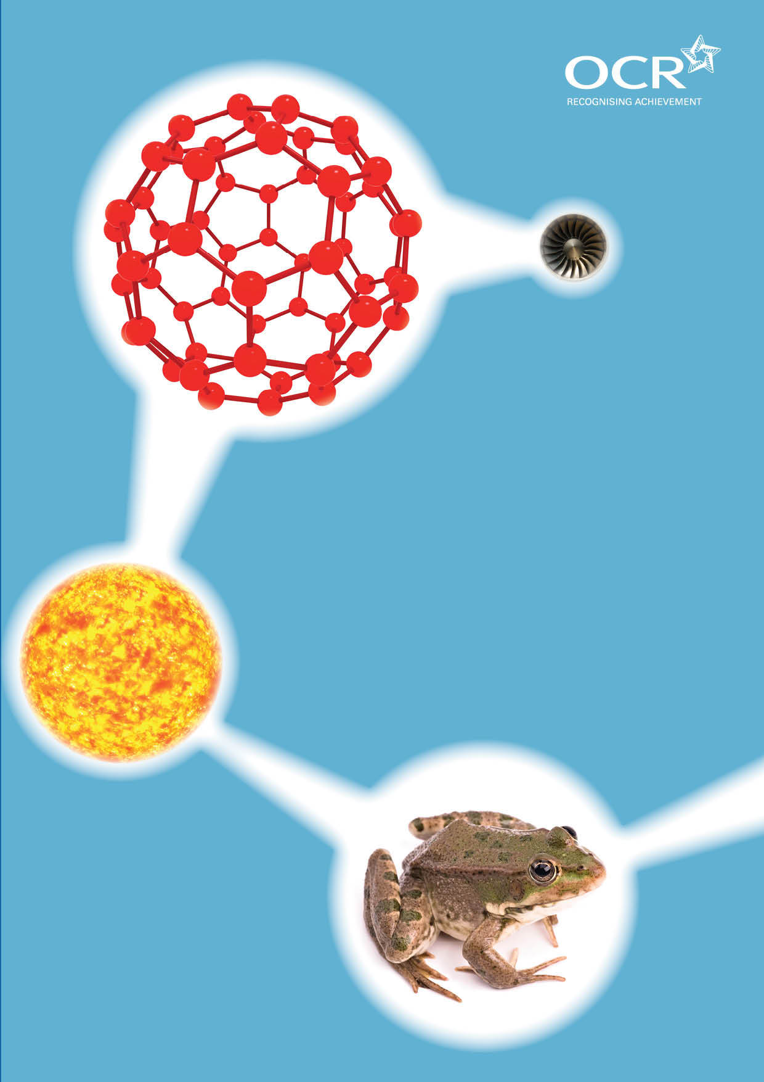
TWENTY FIRST CENTURY SCIENCE SUITE
SCHEMES OF WORK AND LESSON PLANS
P3: Sustainable energy
VERSION 1 AUGUST 2011
Introduction
OCR involves teachers in the development of new support materials to capture current teaching practices tailored to our new specifications. These support materials are designed to inspire teachers and facilitate different ideas and teaching practices. Each Scheme of Work and set of sample Lesson Plans is provided in Word format – so that you can use it as a foundation to build upon and amend the content to suit your teaching style and students’ needs.
The Scheme of Work and sample Lesson plans provide examples of how to teach this unit and the teaching hours are suggestions only. Some or all of it may be applicable to your teaching.
The Specification is the document on which assessment is based and specifies what content and skills need to be covered in delivering the course. At all times, therefore, this Support Material booklet should be read in conjunction with the Specification. If clarification on a particular point is sought then that clarification should be found in the Specification itself. References to the content statements for each lesson are given in the ‘Points to note’ column.


Sample Scheme of Work
GCSE 21st Century Science Physics A J245
Module P3: Sustainable energy
Suggested Teaching Time: 13 Hours (12 x 1 hour lessons, plus 1 hour for revision / consolidation activities)

Topic outline | Suggested teaching and homework activities | Suggested resources | Points to note
1 Understanding the importance of electricity | Students discuss the electrical device they have used already that day.  List is made on the board of all the uses of electricity.  Students then imagine a blackout and how this would affect their everyday lives. They should write a story about their day replacing every electrical item with something else. Candles for lights etc.  Show a video of how close this is to becoming reality C21 videos from previous scheme of SOW.  Students are shown how to keep an energy diary writing down all of the items they use and for how long.  Homework to keep an energy diary for a week, then follow this up with an energy diary for a week when they try to reduce their electricity usage. . | There are lots of commercially available videos on Black outs or electricity generation running out. | It is worth installing all the animations from this website. Some are referred to in this scheme of work.  http://phet.colorado.edu/  Specification links:  P3.1.1. understand that the demand for energy is continually increasing and that this raises issues about the availability of energy sources and the environmental effects of using these sources  P3.1.2. recall the main primary energy sources that humans use: fossil fuels (oil, gas, coal), nuclear fuels, biofuels, wind, waves, and radiation from the Sun  P3.1.3. understand why electricity is called a secondary energy source  P3.2.1. understand that electricity is convenient because it is easily transmitted over distances and can be used in many ways

Topic outline | Suggested teaching and homework activities | Suggested resources | Points to note
2 Where does our electricity come from? | Build on the video from the last lesson (possibly show it again), to illustrate the variety of electrical generation methods in this country,  Demonstrate or show an animation of how each of the main generation methods work.  Discussion about the pros and cons of these – this should be at a basic level and build on KS 3 knowledge. Should summarise how each method works and add the main benefits and the main draw backs. This is more scene setting than going into a great deal of detail. | Multi media science school have a good animation for all types including a block diagram and the energy flows in each. | Specification links:  P3.1.4. understand that power stations which burn fossil fuels produce carbon dioxide which contributes to global warming and climate change  P3.3.3. describe advantages and disadvantages of different energy sources, including non-renewable energy sources such as:  a. fossil fuels  b. nuclear  and renewable energy sources such as:  c. biofuel  d. solar  e. wind  f. water (waves, tides, hydroelectricity)  g. geothermal  [P3.3.4. interpret and evaluate information about different energy sources for generating electricity, considering:  a. efficiency  b. economic costs  c. environmental impact  d. power output and lifetime.  P3.3.5. understand that to ensure a security of electricity supply nationally, we need a mix of energy sources.]

Topic outline | Suggested teaching and homework activities | Suggested resources | Points to note
3 How much do I use (KWatts)? | Explanation of how the electric companies work out bills. A real electric bill could be used,  The idea of kWh is introduced as the “unit” of electrical power.  Circus of activities using old electric meters that measure in kWh and have a spinning dial, students plug in different electrical device to these and time how long it takes for the dial to rotate once.  Students should note that some items use electrical energy more quickly than others.  Students refer to their energy diary to calculate their own usage and kWh and also the cost.  The students can practice calculations on working out the cost of using different rated items for different times. All calculation should be in kWh. | Old electricity meters, variety of household appliances, such as stereos, computer, hair dryer, kettle iron etc.  Electricity bills  www.edfenergy.com/products-services/for-your-home/my-account/understanding-your-electricity-bill.shtml#content | Specification links:  P3.1.10. calculate the cost of energy supplied by electricity given the power, the time and the cost per kilowatt hour  P3.1.11. interpret and process data on energy use, presented in a variety of ways  P3.1.7. use the following equation to calculate the amount of energy transferred in a process, in joules and in kilowatt hours:  energy transferred = power × time  (joules, J) (watts, W) (seconds, s)  (kilowatt hours, kWh) (kilowatts, kW) (hours, h)

Topic outline | Suggested teaching and homework activities | Suggested resources | Points to note
4 How much do I use (Joules)? | Introduce the idea of a joule as a unit of energy. A joule is much smaller than a kWh.  Use data loggers to measure the energy usage of different items in joules.  Students should compare the values with the kWh and suggest a reason that kWh are used in bills and joules are used in science. | (Data logger software varies widely, so check the suppliers’ associated support worksheets)  Data loggers and joule meters | Specification links:  P3.1.5. understand that when electric current passes through a component (or device), energy is transferred from the power supply to the component and/or to the environment  P3.1.6. recall that the power (in watts, W) of an appliance or device is a measure of the amount of energy it transfers each second, ie the rate at which it transfers energy  P3.1.7. use the following equation to calculate the amount of energy transferred in a process, in joules and in kilowatt hours:  energy transferred = power × time  (joules, J) (watts, W) (seconds, s)  (kilowatt hours, kWh) (kilowatts, kW) (hours, h)  P3.1.8. use the following equation to calculate the rate at which an electrical device transfers energy:  power = voltage × current  (watts, W) (volts, V) (amperes, A)  P3.1.9. understand that a joule is a very small amount of energy, so a domestic electricity meter measures the energy transfer in kilowatt hours.

Topic outline | Suggested teaching and homework activities | Suggested resources | Points to note
5 Efficiency? What a waste! | Remind students of last lesson and the use of different devices to transfer energy form one form to another.  Students draw Sankey diagrams with realistic values for the devices used. These could be measured / estimated or looked up on the internet.  Values are then given to the students for a variety of devices, from which they work out the efficiency.  These efficiency Sankey diagrams could be used as a display in a local community centre or school hall to highlight the need to improve the efficiency of the devices we use.  Many commercial questions available or you could use past papers / make them up yourself. | www.schoolsnet.com/pls/hot_school/sn_revision.page_pls_revision_detail?x=&p_rev_id=134&p_res_type_id=8  UK Electricity supply mix 2009  http://www.scribd.com/doc/23034584/sankey-diagrams | Specification links:  P3.1.12. interpret and construct Sankey diagrams to show understanding that energy is conserved  P3.1.13. use the following equation in the context of electrical appliances and power stations:  efficiency =  energy usefully transferred × 100%  total energy supplied  Candidates will be expected to consider / calculate efficiency as a decimal ratio and as a percentage  P3.1.14. suggest examples of ways to reduce energy usage in personal and national contexts.

Topic outline | Suggested teaching and homework activities | Suggested resources | Points to note
6 Generating electricity- why electricity? | Why is electricity used so widely? Class discussion.  Refer back to the story they wrote about their life without electricity (lesson 1). Carry out this activity is you didn’t do it previously.  [Students then imagine a blackout and how this would affect their everyday lives. They should write a story about their day replacing every electrical item with something else. Candles for lights etc.]  Highlight the easy of generating electricity on a large scale, delivering it to all the houses in the country and also how versatile it is – powers almost everything you can imagine needing.  Out of school opportunity to survey the impact of power generation on the local environment, including visual, noise and pollution effects. Could be a class visit or homework activity. |  | Specification links:  P3.2.1. understand that electricity is convenient because it is easily transmitted over distances and can be used in many ways  P3.2.2. recall that mains electricity is produced by generators  P3.3.2. understand that the choice of energy source for a given situation depends upon a number of factors including:  a. environmental impact  b. economics  c. waste produced  d. carbon dioxide emissions

Topic outline | Suggested teaching and homework activities | Suggested resources | Points to note
7 Magnetic induction | Demonstrate a magnet moving in and out of a coil of wire.  Highlight the key points about the direction of the current and the orientation of the magnet, the size of the voltage induced related to the speed of motion, and the fact it must be moving.  Use dynamos on a bike wheel or a hand cranked generator to show how much effort is required to produce a small amount of energy!  Student could build their own generators – Westminster kits in reverse.  Possible visit to a wind turbine, or local power station to highlight the workings of the generator. | Coil of wire and magnets demonstration.  http://phet.colorado.edu/en/simulation/faraday  There are lots of animations to show the workings of a generator.  www.generatorguide.net/howgeneratorworks.html  http://phet.colorado.edu/en/simulation/generator | Specification links:  P3.2.2. recall that mains electricity is produced by generators  P3.2.3. understand that generators produce a voltage across a coil of wire by spinning a magnet near it  P3.2.4. understand that the bigger the current supplied by a generator, the more primary fuel it uses every second  P3.2.6. label a block diagram showing the basic components and structures of hydroelectric, nuclear and other thermal power stations

Topic outline | Suggested teaching and homework activities | Suggested resources | Points to note
8 How do we make it spin? | Introduce the variety of ways that the spinning motion required to turn the generator is produced.  Students should become familiar with block diagrams of all the thermal power station types, wind and hydroelectric power stations and wave “turbines”.  Diagrams can be used.  Simulations via Multi media science school or flash on the web.  Possibility of making a model power station using a kettle. | There are plenty of clips on youtube that can help here if you haven’t got any commercially available ones.  www.energyquest.ca.gov/projects/geothermal-pp.html | Specification links:  P3.2.5. understand that in many power stations a primary energy source is used to heat water; the steam produced drives a turbine which is coupled to an electrical generator  P3.2.11. understand that many renewable sources of energy drive the turbine directly eg hydroelectric, wave and wind  P3.2.6. label a block diagram showing the basic components and structures of hydroelectric, nuclear and other thermal power stations

Topic outline | Suggested teaching and homework activities | Suggested resources | Points to note
9 Nuclear | Remind the students that nuclear is a thermal type of power station and that the heat comes from nuclear decay.  Explain the process using previous lessons simulations  Watch a video about the pros and cons of nuclear power.  Focus on waste, contamination vs irradiation.  Use news footage of Fukushima nuclear power station  Demonstrate ionising nuclear radiation, alpha beta gamma demonstration | http://phet.colorado.edu/en/simulation/nuclear-fission  Refer to CLEAPPS guidance regarding the safe use of radioactive isotopes in a school laboratory. | Specification links:  P3.2.7. understand that nuclear power stations produce radioactive waste  P3.2.8. understand that radioactive waste emits ionising radiation  P3.2.9. understand that with increased exposure to ionising radiation, damage to living cells increases eventually leading to cancer or cell death  P3.2.10. understand the distinction between contamination and irradiation by a radioactive material, and explain why contamination by a radioactive material is more dangerous than a short period of irradiation from the radioactive material

Topic outline | Suggested teaching and homework activities | Suggested resources | Points to note
10 How do we get it? | Demonstrate the power lines using suitable very low voltage and low voltage transmission line with nichrome wire.  Discuss the role of the transformer (equation not needed here)  Losses in the power lines discussion.  Homework: Explain the last lessons of this topic will be independent research in groups. This should allow students to bring in useful articles form newspapers, book and websites for the start of the presentations. |  | Although the transformer equation is not introduced until module P5.4, this lesson is an opportunity to provide more detail on how transformers work, building on students’ knowledge of em induction from lesson 7.  Homework task opportunity to develop research skills towards Case Study activity (GCSE Science only).  Specification links:  P3.2.12. interpret a Sankey diagram for electricity generation and distribution that includes information on the efficiency of energy transfers  P3.2.13. recall that the mains supply voltage to our homes is 230 volts  P3.2.14. understand that electricity is distributed through the National Grid at high voltages to reduce energy losses.

Topic outline | Suggested teaching and homework activities | Suggested resources | Points to note
11 so what should we decide? (lesson 1 of 2) | The few lessons of this topic are devoted to the students choosing a situation that they then explore the power options for.  There are many possible situations, City rural and remote village in the jungle and then domestic, school /office and national decisions  The students are required to work in small groups to solve the energy problem at one location - the teacher should ensure that all the situations are covered across the class.  Presentations to the rest of the group should take place and the best ones may go forward in to a year group competition.  Each solution should address the following issues, | Internet access  Text book / library  Use the specification links listed to the right with the groups to ensure that all aspects are covered, possibly over a number of presentations. | Specification links:  P3.3.1. discuss both qualitatively and quantitatively (based on given data where appropriate), the effectiveness of different choices in reducing energy demands in:  a. domestic contexts  b. work place contexts  c. national contexts  P3.3.2. understand that the choice of energy source for a given situation depends upon a number of factors including:  a. environmental impact  b. economics  c. waste produced  d. carbon dioxide emissions  P3.3.3. describe advantages and disadvantages of different energy sources, including non-renewable energy sources such as:  a. fossil fuels  b. nuclear  and renewable energy sources such as:  c. biofuel  d. solar  e. wind  f. water (waves, tides, hydroelectricity)  g. geothermal  (continued)

Topic outline | Suggested teaching and homework activities | Suggested resources | Points to note
11 so what should we decide? (lesson 1 of 2) (continued) |  |  | P3.3.4. interpret and evaluate information about different energy sources for generating electricity, considering:  a. efficiency  b. economic costs  c. environmental impact  d. power output and lifetime.  P3.3.5. understand that to ensure a security of electricity supply nationally, we need a mix of energy sources.

Topic outline | Suggested teaching and homework activities | Suggested resources | Points to note
12 so what should we decide? (lesson 2 of 2) | During the presentations the students should be making a note of the benefits and draw backs of the following Fossil fuel use, nuclear, renewable, considering the efficiency, economic costs, environmental / health impacts power output and lifetime of the solution.

Topic outline | Suggested teaching and homework activities | Suggested resources | Points to note
13. Revision and test | Students look through the spec statements in “student Speak” and highlight the ones they are unsure of.  They then revisit these areas of the topic using mind maps and posters.  This could lead to a presentation to the rest of the class and also the competition of a past paper question on this area of the spec. | Past paper materials from OCR  Either exam quest or use their website.  http://www.ocr.org.uk/qualifications/type/gcse_2011/tfcs/physics_a/documents/index.html

Sample Lesson Plan
GCSE 21st Century Science Chemistry A J244
Module P3: Sustainable energy

Understanding the importance of electricity
OCR recognises that the teaching of this qualification above will vary greatly from school to school and from teacher to teacher. With that in mind this lesson plan is offered as a possible approach but will be subject to modifications by the individual teacher.
Lesson length is assumed to be one hour.

Learning Objectives for the Lesson
Objective 1 | Recall the main primary energy sources that humans use: fossil fuels (oil, gas, coal), nuclear fuels, biofuels, wind, waves, and radiation from the Sun
Objective 2 | Understand why electricity is called a secondary energy source
Objective 3 | Understand that electricity is convenient because it is easily transmitted over distances and can be used in many ways
Objective 4 | Understand that the demand for energy is continually increasing and that this raises issues about the availability of energy sources and the environmental effects of using these sources

Recap of Previous Experience and Prior Knowledge
Joule and energy production at KS3.
KS3 electricity production.

Content
Time | Content
5 minutes | Starter task – students make a list of all the items they have used that day that run on electricity.
10 minutes | Teacher takes feedback, highlighting the wide range and versatility of the devices that run on electricity.  Introduce the next task on writing a story about a life or day without electricity. This could be approached as a black out, or living in a remote village possibly in a jungle or desert.
15-20 minutes | Students write their story. This could become a longer activity with students reading out their stories, or producing a presentation, video, or cartoon strip of their day/ life without electricity.
15 minutes | C21 videos from previous specification ipack give a good sense of how close this scenario really is. This should lead to a discussion on how electricity is produced, and our reliance on it.  The teachers should draw out the idea that electricity is a secondary source, relying on other primary sources, all of which have positive and negative aspects.
10 minutes | Explain how to keep an energy diary over the course of the following week / month. This should include, the power rating of each item used, the time used for each day. The total usage time for the week/ month.

Consolidation
Time | Content
10 minutes | Highlight the previous learning at KS3 about different methods of electricity generation and ask students a series of questions to gauge previous learning. This should draw out the main methods of generation and possibly some more obscure and regionally specific methods. If there is time question students about the positive and negative aspects of each primary source of power to generate electricity.

