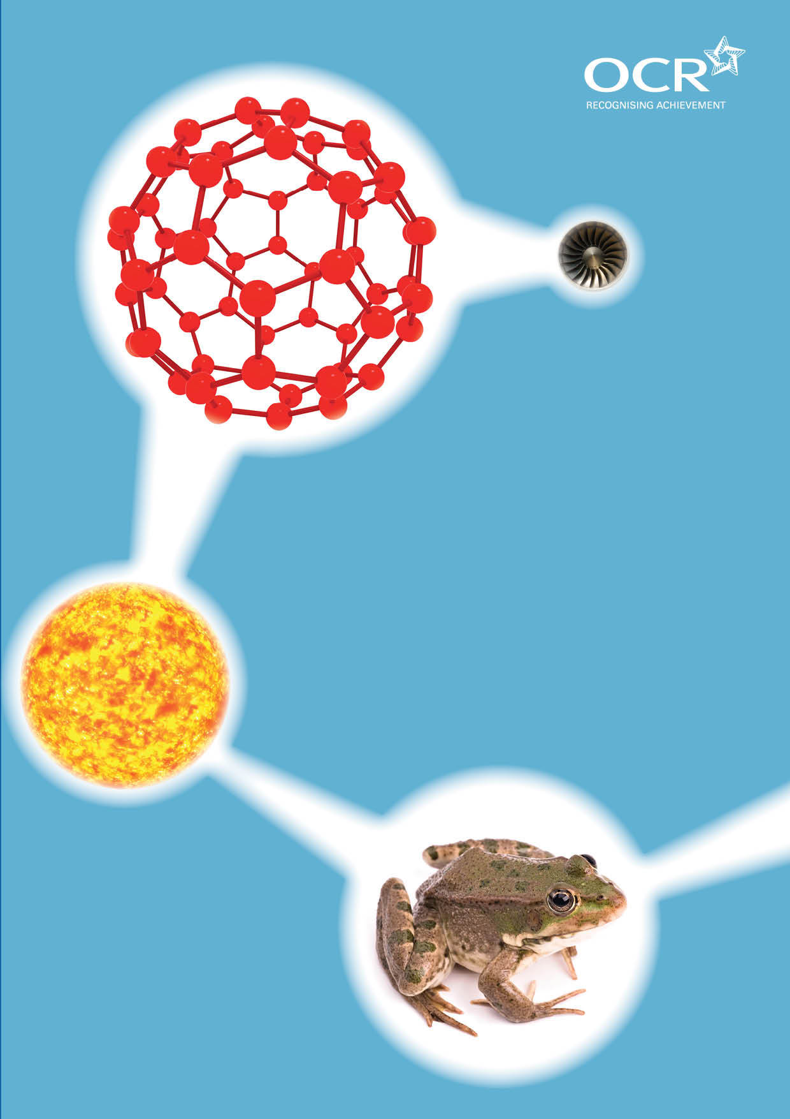
TWENTY FIRST CENTURY SCIENCE SUITE
SCHEMES OF WORK AND LESSON PLANS
P2: Radiation and life
VERSION 1 AUGUST 2011
Introduction
OCR involves teachers in the development of new support materials to capture current teaching practices tailored to our new specifications. These support materials are designed to inspire teachers and facilitate different ideas and teaching practices. Each Scheme of Work and set of sample Lesson Plans is provided in Word format – so that you can use it as a foundation to build upon and amend the content to suit your teaching style and students’ needs.
The Scheme of Work and sample Lesson plans provide examples of how to teach this unit and the teaching hours are suggestions only. Some or all of it may be applicable to your teaching.
The Specification is the document on which assessment is based and specifies what content and skills need to be covered in delivering the course. At all times, therefore, this Support Material booklet should be read in conjunction with the Specification. If clarification on a particular point is sought then that clarification should be found in the Specification itself. References to the content statements for each lesson are given in the ‘Points to note’ column.


Sample Scheme of Work
GCSE 21st Century Science Physics A J245
Module P2: Radiation and life
Suggested Teaching Time: 13 Hours

Topic outline | Suggested teaching and homework activities | Suggested resources | Points to note
1. Models of radiation | Discussion about how light travels.  Use ray boxes and mirrors to show reflection (class practical).  Students should trace the path of the light and explain how it reaches its final destination. | Use ray boxes and mirrors to trace the path light takes from one place to another. Students should appreciate that light doesn’t leave the eye and hit anything but leaves an object to enter the eye.  Discuss the speed of light and how it travels from one place to another.  Use a laser to show you can’t see a beam of light unless there is something for it to reflect off – chalk dust or an aerosol will work. | Recap of KS3 to see things we can either reflect light from them, they give out light,, or light is scattered from them  Specification links:  P2.1.1. interpret situations in which one object affects another some distance away in terms of a general model of electromagnetic radiation:  a. one object (a source) emits radiation  b. the radiation travels outwards from the source and can be reÀ ected, transmitted or absorbed (or a combination of these) by materials it encounters  c. radiation may affect another object (a detector) some distance away, when it is absorbed  P2.1.2. understand that light is one of a family of radiations called the electromagnetic spectrum  P2.1.3. understand that a beam of electromagnetic radiation transfers energy in ‘packets’ called photons

Topic outline | Suggested teaching and homework activities | Suggested resources | Points to note
2. Photons | Introduce the idea that light travels as photons with increasing energy linked to increasing frequency  Students investigate the intensity of light at increasing distance | Multimedia science school / sunflower demonstration www.rm.com/shops/rmshop/ product.aspx?cref=pd952460&srcurl=/mss  Data loggers and light sensors.  Graphs to show the inverse square law for more able students. Possible investigation as preparation for controlled assessment. | Specification links:  P2.1.4. understand that the higher the frequency of an electromagnetic radiation, the more energy is transferred by each photon  P2.1.5. list the electromagnetic radiations in order of the energy transferred by each photon, or in order of frequency:  radio waves, microwaves, infrared, red visible light violet, ultraviolet, X-rays, gamma rays  P2.1.6. recall that all types of electromagnetic radiation travel at exactly the same, very high but finite, speed through space (a vacuum) of 300 000 km/s  P2.1.7. understand that the energy arriving at a square metre of surface each second is a useful measure of the strength (or ‘intensity’) of a beam of electromagnetic radiation  P2.1.8. understand that the energy transferred to an absorber by a beam of electromagnetic radiation depends on both the number of photons arriving and the energy of each photon  P2.1.9. understand that the intensity of a beam of electromagnetic radiation decreases with distance from the source and explain why, in terms of the ever increasing surface area it reaches and its partial absorption by the medium it travels through.

Topic outline | Suggested teaching and homework activities | Suggested resources | Points to note
3. Faster vibrations more energy | Poster/ display work on the regions of the EM spectrum to show frequency and energy uses and risks (wavelength could also be included for completeness but not on the Specification so not examined here | Students present the knowledge they have so far on a poster. This should include the frequency, the energy carried and possibly the wavelength of the radiation.  www.youtube.com/watch?v=cfxzwh3kade&feature=related | Try to have a source, a detector and an approximate value for each region of the EM spec. eg the eye of the bee can see UV, emitted from the sun, the pit viper can “see” in infra red. Ranges of values for frequency (and energy and wavelength for completeness)  Specification links:  P2.1.2. understand that light is one of a family of radiations called the electromagnetic spectrum  P2.1.3. understand that a beam of electromagnetic radiation transfers energy in ‘packets’ called photons  P2.1.4. understand that the higher the frequency of an electromagnetic radiation, the more energy is transferred by each photon  P2.1.5. list the electromagnetic radiations in order of the energy transferred by each photon, or in order of frequency:  radio waves, microwaves, infrared, red visible light violet, ultraviolet, X-rays, gamma rays  P2.1.6. recall that all types of electromagnetic radiation travel at exactly the same, very high but finite, speed through space (a vacuum) of 300 000 km/s

Topic outline | Suggested teaching and homework activities | Suggested resources | Points to note
4. Dangerous radiation | The more energy radiations have, the greater the risk they pose.  Investigation into which sun screens are the best.  Discussion on the use of X-Rays even though they can be harmful.  Research in to harmful effect of X-rays and how regulation plays a part in reducing risk. Find out why we are only allowed one chest X-ray every 6 months or so. | Investigation into sun creams and how  UV can be prevented from causing harm  Use ultra violet beads that change colour in UV rays or UV nail varnish. Test various sun screens with different SPF factors. | Discuss the ideas of risk, perceived and actual risk, regulation – should fewer than 16 be banned from sun beds?  Stress the idea of fair testing and allow students the freedom to change their methods to make them more reliable /fair.  There is a possibility for ground work here into correlation and/ or cause, possible controlled assessment topic.  Specification links:  P2.1.10. understand that some electromagnetic radiations (ultraviolet radiation, X-rays, gamma rays) have enough energy to change atoms or molecules, which can initiate chemical reactions  P2.1.11. recall that high energy ultraviolet radiation, X-rays and gamma rays can cause ionisation  P2.1.12. understand that the electromagnetic radiations which are ionising are those with high enough photon energy to remove an electron from an atom or molecule (ionisation).  P2.2.11. recall that physical barriers absorb some ionising radiation, for example: X-rays are absorbed by dense materials so can be used to produce shadow pictures of bones in our bodies or of objects in aircraft passengers’ luggage, and radiographers are protected from radiation by dense materials such as lead and concrete.

Topic outline | Suggested teaching and homework activities | Suggested resources | Points to note
5. Harm by Heating | Discussion about microwaves and safety  How heating causes harm to living cells.  Demonstrate the safety features of the microwave  Microwave demo using marshmallows or chocolate in the microwave to show hot spots and what could happen if the microwaves leak out. | There are various experiments (http://www.scienceinschool.org/2009/issue12/microwaves) that can be done using a microwave oven that will demonstrate the harmful heating effect and the useful heating effect.  Bring up the fact that mobile phones and WiFI connections use microwaves to transfer information. | BE very careful not to encourage dangerous experiments at home as most students will have access to microwave ovens.  Specification links:  P2.2 1. understand that the heating effect of absorbed radiation can damage living cells  P2.2.2. relate the heating effect when radiation is absorbed to its intensity and duration  P2.2.3. understand that some people have concerns about health risks from low intensity microwave radiation, for example from mobile phone handsets and masts, though the evidence for this is disputed  P2.2.4. understand that some microwaves are strongly absorbed by water molecules and so can be used to heat objects containing water  P2.2.5. understand that the metal cases and door screens of microwave ovens reÀ ect or absorb microwave radiation and so protect users from the radiation  P2.2.6. recall that some materials (radioactive materials) emit ionising gamma radiation all the time  P2.2.7. understand that with increased exposure to ionising radiation, damage to living cells increases eventually leading to cancer or cell death

Topic outline | Suggested teaching and homework activities | Suggested resources | Points to note
6. Mobile Phones and microwaves | Research work into mobile phone correlation and cause with phone use and brain cancer - possible controlled assessment opportunity.  Microwave detectors are interesting for finding mobile phones that are switched on!  There are various experiments with mobile phones you could try. Can you ring a mobile phone when it is inside the microwave oven (make sure the oven is unplugged!) We are coming back to this later in the module. | Possible case study type work on mobile phones, damage they cause and correlation and cause, | This is a good place to practise controlled assessment skills.

Topic outline | Suggested teaching and homework activities | Suggested resources | Points to note
7. Uses of the EM spectrum | Recap the Electromagnetic spectrum  Other uses of Spectrum – add to the posters made previously in the module  Research using Internet and text books | There are some very good EM Spectrum Videos available  www.youtube.com/watch?gl=gb&v=kfs5qn0wn2o  Try to use videos to highlight the IR cameras used in police camera action type programmes and heat seeking fire fighters.  You Tube has a good selection. | Specification links:  P2.1.4. understand that the higher the frequency of an electromagnetic radiation, the more energy is transferred by each photon  5. list the electromagnetic radiations in order of the energy transferred by each photon, or in order of frequency:  radio waves, microwaves, infrared, red visible light violet, ultraviolet, X-rays, gamma rays  6. recall that all types of electromagnetic radiation travel at exactly the same, very high but finite, speed through space (a vacuum) of 300 000 km/s  P2.4. 1. understand that electromagnetic radiation of some frequencies can be used for transmitting information, since:  a. some radio waves and microwaves are not strongly absorbed by the atmosphere so can be used to carry information for radio and TV programmes  b. light and infrared radiation can be used to carry information along optical ¿ bres because the radiation travels large distances through glass without being significantly absorbed  2. recall that information can be superimposed on to an electromagnetic carrier wave, to create a signal

Topic outline | Suggested teaching and homework activities | Suggested resources | Points to note
8. Warming the earth | Why we would die with out the atmosphere.  Keeps us warm / protects us from radiations  Use similar research to that in P1 about the planets, but focus on their temperatures.  Highlight the reducing temperature as they get further away from the sun – spot the outlier!  Investigate Venus and suggest what might cause this increase in temperature.  Students can create a video or play or assembly to show other year groups how important he atmosphere really is. | http://solarsystem.nasa.gov/eyes/index.html is a very powerful website to look into the solar system in more detail. Requires installing unity player and enquires a little time to get to grips with.  www.bbc.co.uk/science/space/solarsystem has some very useful interesting and inspiring film clips about the solar system, including clips from Prof Brian Cox’s wonders of the solar system series.  http://nineplanets.org/history.html  Protection from radiations link to UV and X-Ray investigation earlier in the chapter.  Research in the library and on the internet.  Possible video cameras required. | Specification links:  P2.2.8. understand that the ozone layer absorbs ultraviolet radiation, emitted by the Sun, producing chemical changes in that part of the atmosphere  P2.2.9. understand that the ozone layer protects living organisms from some of the harmful effects of ultraviolet radiation  P2.2.10. recall that sun-screens and clothing can be used to absorb some of the ultraviolet radiation from the Sun

Topic outline | Suggested teaching and homework activities | Suggested resources | Points to note
9. Carbon cycle 1 | Give the students the basic outline of the carbon cycle – this could be a presentation, discussion or handout.  Demonstrate the carbon cycle.  Photosynthesis,  making oil and coal,  burning  respiration,  dissolving via various experiments in the lesson.  Get the students to highlight the processes that move carbon from one form to another.  The students should understand the story of carbon atoms inside someone they admire.  Depending on their ability and if they have completed P1, students should be given a starting point as either the big bang, the dinosaurs, Coal or oil, or wood.  They then have to trace the carbon atom from the starting point to being breathed out by the person they admire | These should be brief demonstrations or a circus of experiments that students can look at and either know where the carbon is going from and to or have to research it them selves. | This activity could include respiration, Photosynthesis, combustion,  Specification links:  P2.3.7. interpret simple diagrams representing the carbon cycle  P2.3.8. use the carbon cycle to explain:  a. why, for thousands of years, the amount of carbon dioxide in the Earth’s atmosphere was approximately constant  b. that some organisms remove carbon dioxide from the atmosphere by photosynthesis (eg green plants) and many organisms return carbon dioxide to the atmosphere by respiration as part of the recycling of carbon  c. why, during the past two hundred years, the amount of carbon dioxide in the atmosphere has been steadily rising  P2.3.9. recall that the rise in atmospheric carbon dioxide is largely the result of:  a. burning increased amounts of fossil fuels as an energy source  b. cutting down or burning forests to clear land  P2.3.10. understand that computer climate models provide evidence that human activities are causing global warming.

Topic outline | Suggested teaching and homework activities | Suggested resources | Points to note
10. Green house effect | Demonstrate greenhouse effect comparing air, CO₂ and methane filled plastic bottles  Use infra red sensitive cameras to demonstrate thermal radiation from every day objects  Use models to demonstrate the increase in temperature against CO₂. Correlation and cause can be discussed here especially with reference to the clearly understood mechanism for the warming taking place.  Consequences and problems of the changes in climate. | 3 x 2L transparent plastic bottles each containing a thermometer, and different gases.  Could use webcam with IR filter removed, or video / photographs from the internet.  The BBC has a clear development line for the climate model used.  http://news.bbc.co.uk/1/hi/sci/tech/6320515.stm  This can be used to show how important climate model as are.  Using the knowledge students gained last lesson, they should discuss the effect of climate change and what people, and governments can do to slow it down. | Specification links:  P2.3.1. understand that all objects emit electromagnetic radiation with a principal frequency that increases with temperature  P2.3.2. recall that the Earth is surrounded by an atmosphere which allows some of the electromagnetic radiation emitted by the Sun to pass through  P2.3.3. recall that this radiation warms the Earth’s surface when it is absorbed  P2.3.4. understand that the radiation emitted by the Earth, which has a lower principal frequency than that emitted by the Sun, is absorbed or reflected back by some gases in the atmosphere; this keeps the Earth warmer than it would otherwise be and is called the greenhouse effect  P2.3.5. recall that one of the main greenhouse gases in the Earth’s atmosphere is carbon dioxide, which is present in very small amounts  P2.3.6. recall that other greenhouse gases include methane, present in very small amounts, and water vapour  P2.3.11. understand how global warming could result in:  a. it being impossible to continue growing some food crops in particular regions because of climate change  b. more extreme weather events, due to increased convection and larger amounts of water vapour in the hotter atmosphere  c. Flooding of low lying land due to rising sea levels, caused by melting continental ice and expansion of water in the oceans.

Topic outline | Suggested teaching and homework activities | Suggested resources | Points to note
11. Communications | How we can use radio wave  Adding signals to waves brief discussion of FM  Digital - conversion, decoding diagrams  Compare analogue and digital | Audacity (free download http://audacity.sourceforge.net/ on a computer projected on a white board) to show a carrier wave, the information signal and how one is modulated onto the other.  Repeated copying of an analogue signal on the board followed by a repeated copying of a digital signal on the board. | Once the first copy has been drawn, cover over the original, then have a student copy each subsequent copy, ensuring you rub out all the previous copies but not the original – this remains hidden.  At the end compare the final 8th copy to the original. The analogue should be very different whilst the digital one is far clearer.  Specification links:  P2.4. 1. understand that electromagnetic radiation of some frequencies can be used for transmitting information, since:  a. some radio waves and microwaves are not strongly absorbed by the atmosphere so can be used to carry information for radio and TV programmes  b. light and infrared radiation can be used to carry information along optical fibres because the radiation travels large distances through glass without being significantly absorbed  P2.4.2. recall that information can be superimposed on to an electromagnetic carrier wave, to create a signal  P2.4.3. recall that a signal which can vary continuously is called an analogue signal.  P2.4.4. recall that a signal that can take only a small number of discrete values (usually two) is called a digital signal  P2.4.9. understand that an important advantage of digital signals over analogue signals is that if the original signal has been affected by noise it can be recovered more easily and explain why

Topic outline | Suggested teaching and homework activities | Suggested resources | Points to note
12. Images and sound | Play a sound sampled at a low rate 20bps and then a CD 128 or more bps.  Why does one sound better then the other  Storing information is easier, as is manipulating it - size matters! Compression and how we can get all this information onto an ipod | Research files sizes and image/ sound quality. Students should use the internet to find images of differing size and then compare their quality and download times. | Specification links:  P2.4.5. recall that sound and images can be transmitted digitally (as a digital signal)  P2.4.6. recall that, in digital transmission, the digital code is made up from just two symbols, ‘0’ and ‘1’  P2.4.7. understand that this coded information can be carried by switching the electromagnetic carrier wave off and on to create short bursts of waves (pulses) where ‘0’ = no pulse and ‘1’ = pulse  P2.4.8. recall that when the waves are received, the pulses are decoded to produce a copy of the original sound wave or image  P2.4.10. recall that the amount of information needed to store an image or sound is measured in bytes (B)  P2.4.11. understand that, generally, the more information stored the higher the quality of the sound or image  P2.4.12. understand that an advantage of using digital signals is that the information can be stored and processed by computers

Topic outline | Suggested teaching and homework activities | Suggested resources | Points to note
13. Revision and test | Students look through the specification statements and highlight the ones they are unsure of.  They then revisit these areas of the topic using mind maps and posters.  This could lead to a presentation to the rest of the class and also the competition of a past paper question on this area of the spec. | Past paper materials from OCR  Either exam quest or use their website.  http://www.ocr.org.uk/qualifications/type/gcse_2011/tfcs/physics_a/documents/index.html

Sample Lesson Plan
GCSE 21st Century Science Chemistry A J244
Module P2: Radiation and life

Models of radiation
OCR recognises that the teaching of this qualification above will vary greatly from school to school and from teacher to teacher. With that in mind this lesson plan is offered as a possible approach but will be subject to modifications by the individual teacher.
Lesson length is assumed to be one hour.

Learning Objectives for the Lesson
Objective 1 | Interpret situations in which one object affects another some distance away in terms of a general model of electromagnetic radiation:  a) one object (a source) emits radiation  b) the radiation travels outwards from the source and can be reflected, transmitted or absorbed (or a combination of these) by materials it encounters  c) radiation may affect another object (a detector) some distance away, when it is absorbed.
Objective 2 | Understand that a beam of electromagnetic radiation transfers energy in ‘packets’ called photons.

Recap of Previous Experience and Prior Knowledge
Key stage three work on reflection, refraction and dispersion.

Content
Time | Content
5 minutes | Starter activity of “how can we see things” on the board.  Students discuss this with a partner for 2 minutes and make 3 points to report back to the class.  Take the feedback from students to get an idea of where they are in their learning and what misconceptions they have.
10 minutes | Teacher describes and demonstrates the experiment using ray boxes and mirrors, and glass blocks to show how light travels in straight lines from one place to another.
5-10 minutes | Students carry out the reflection experiment and trace diagrams into their books. (extension could be to investigate the angles of incidence and reflection for a plane mirror and/or curved mirrors)  Students begin to explain how light travels from one place to another.
15 minutes | Pose the question ‘so how can you see the bulb?’ Take feedback.  Students should be introduced to the photon model of packets of energy that trigger a response in your eye. This allows us to see luminous objects,  Pose the question ‘what about non-luminescent objects?...and coloured objects?’
10 minutes | Turn all of the lights out and black out the room (if possible). This should lead to the idea of reflected light if they didn’t already know.

Consolidation
Time | Content
10 minutes | Use a laser to show that light reflects off non-shiny objects so we can see the light from the laser on a screen. However, can we see the beam? Spray an aerosol or use talcum powder to reveal the beam of the laser. Explain this allows the beam to be reflected into your eye so the photons which make up the light beam are diverted from hitting the screen/wall into your eye so you can see it!  Recap the models of radiation showing a diagram on the board or the screen. Emphasis should be placed on the Source → journey→detector model in the specification.  Homework could be how can we see the sun, stars, planets and moons,. Include a diagram with your explanations.

