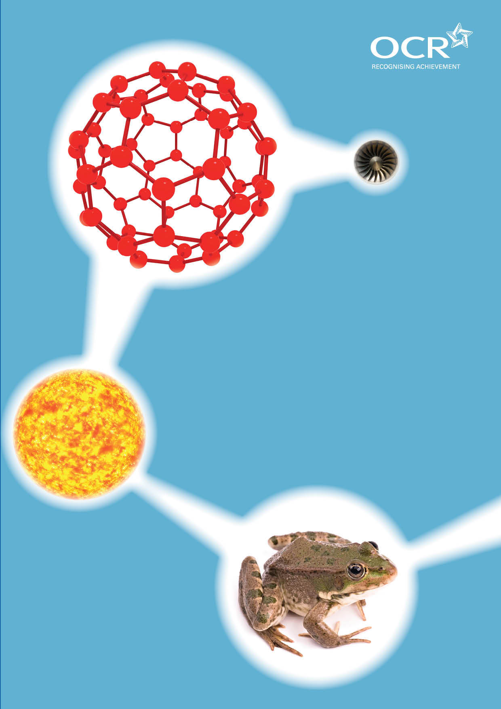
TWENTY FIRST CENTURY SCIENCE SUITE
SCHEMES OF WORK AND LESSON PLANS
C3: Chemicals in our lives
VERSION 1 JULY 2011
Introduction
OCR involves teachers in the development of new support materials to capture current teaching practices tailored to our new specifications. These support materials are designed to inspire teachers and facilitate different ideas and teaching practices. Each Scheme of Work and set of sample Lesson Plans is provided in Word format – so that you can use it as a foundation to build upon and amend the content to suit your teaching style and students’ needs.
The Scheme of Work and sample Lesson plans provide examples of how to teach this unit and the teaching hours are suggestions only. Some or all of it may be applicable to your teaching.
The Specification is the document on which assessment is based and specifies what content and skills need to be covered in delivering the course. At all times, therefore, this Support Material booklet should be read in conjunction with the Specification. If clarification on a particular point is sought then that clarification should be found in the Specification itself. References to the content statements for each lesson are given in the ‘Points to note’ column.


Sample Scheme of Work
GCSE 21st Century Science Chemistry A J244
Module C3: Chemicals in our lives

Suggested Teaching Time: 13 Hours

Topic outline | Suggested teaching and homework activities | Suggested resources | Points to note
Origins of minerals in Britain and rock cycle revision  (2 hours) | Recap the rock cycle to include the shape of grains. Build on knowledge from KS3. Use the one of the animations as a recap of the information. Students complete diagram of the rock cycle.  Plate tectonics and the movement of minerals across the earth’s surface. Provide diagrams of constructive and destructive plate boundaries. Use video to help.  Review geology of Britain, identifying where, when and how coal, limestone and salt were formed. “The present is the key to the past”. Discussion that these raw materials are no longer being formed. Samples of coal, limestone and salt can be shown to students if available.  Pupils could write a newspaper report on a recent geological event e.g. tsunami, earthquake, volcanic eruption etc.  Discussion of how sedimentary rocks show evidence of the conditions under which they formed. These include;  - Fossils  - Shape of water borne grains compared to air blown grains  - Presence of shell fragments  - Ripples from the sea or river bottom. | www.theteacherscorner.net/printable-worksheets/make-your-own/crossword/crossword-puzzle.php  Crossword of rock cycle keywords.  www.geolsoc.org.uk/gsl/site/gsl/lang/en/page3892.html this is an animation from the geological society.  www.phschool.com/atschool/phsciexp/active_art/rock_cycle/index.html this is a rock cycle animation from Pearson’s.  www.bgs.ac.uk/education/geology_of_britain/home.html this is a geological map of Britain provided by the British Geological Society.  www.schooltube.com/video/3a9041f685c9707b9359/science-on-a-sphere-plate-tectonics-and-paleo-animation this is an animation of the movement of plates on the Earth’s surface.  www.planete-energies.com/content/coal/formation.html# this site has a very good animation/video of coal formation.  www.bbc.co.uk/learningzone/clips/formation-of-carboniferous-limestone/4701.html this video is excellent and shows limestone formation. | C3.1.1  C3.1.2  C3.1.3  C3.1.4  C3.1.5  C3.1.6  C3.1.7  IaS 3 (Developing Scientific Explanations)

Topic outline | Suggested teaching and homework activities | Suggested resources | Points to note
Why is salt so important?  (1 hour) | Discuss the reasons salt is an important resource. This could be done as a marketplace activity where a student becomes an expert in one area then passes the information to other groups in the class. Discussions should include:  The name and formula of the salt.  Use of sodium chloride in the food industry.  What government departments regulate in the food industry and how?  What are the implications of eating too much salt?  Identify that the method of extraction depends on the intended use.  Use of salt to treat icy roads in winter.  Discuss the risks of eating too much salt. e.g. high blood pressure sufferers need to reduce salt intake.  Homework activity to compare salt from different manufacturers of crisps or different flavours from the same manufacturer. | www.saltsense.co.uk/ this website has some excellent information on history of salt extraction, uses, health issues etc. | ICT based lesson for students to research these issues using the website given would work well.  C3.2.1  C3.2.2  C3.2.3  C3.2.4  C3.2.6  C3.2.7  C3.2.8  C3.2.9  IaS 5(Risk)
How is salt extracted?  (1 hour) | Discuss the different methods of mining salt. Provide students with diagram of solution mining. Animation could help understanding here.  Debate can be set up here to look at the idea of a theoretical mine to be set up in the local area. Appoint a chair of the panel, students to act as the company wanting to set up the mine to put forward the benefits and local residents to object to the mine. Key discussions need to include the environmental impact of mining salt.  Students could investigate the speed or rate of dissolving of salt at different temperatures. | www.absorblearning.com/media/attachment.action?quick=ue&att=2178  This is an animation on solution mining.  http://www.saltinstitute.org/production-industry/production-technologies/evaporated-salt-refined-salt/solution-mining this is the salt institute website. Some excellent information and diagrams. | Opportunity to develop skills towards Case Study activity (GCSE Science only)  C3.1.7  C3.2.2  C3.2.3  C3.2.5  IaS 6(Making Decisions)

Topic outline | Suggested teaching and homework activities | Suggested resources | Points to note
Why do we need alkalis?  (1 or 2 hours) | Class practical of ph scale. Students to recall the use of the ph scale to identify acids and alkalis  Recall neutralisation reactions. This can be done as a practical (combined with practical above). Discussion of use of alkalis to neutralise stomach acid.  Discussion of traditional sources of alkalis.  Discuss the traditional uses of alkalis such as binding dyes to cloth, converting fats and oils to soap and glass manufacture.  Both soap and glass can easily be made in the lab to allow practical aspects here. Safety is essential in both of these practical activities.  Recall that alkalis are they used for neutralise acids such as stomach acid. | Universal indicator.  Various acids and alkalis of a range of strengths to cover PH scale.  www.madehow.com/volume-2/soap.html this website gives information about how soap was manufactured from the 19th century.  www.madehow.com/volume-2/stained-glass.html this website gives information about the making of stained glass.  www.gpi.org/glassresources/education/sustainabilityrecycling/section-23-raw-materials.html this is a good website about glass and the components that make up glass  www.practicalchemistry.org this is good website for the methods of making soap and glass. | C3.1.7  C3.3.1  C3.3.2  C3.3.4  C3.3.6  Opportunity to develop skills towards Practical Data Analysis / Investigation tasks
Reactions of alkalis  (1 hour) | Students should carry out reactions of soluble carbonates to produce salts.  Students should carry out reactions of soluble hydroxides and carbonates with acid to produce salts.  Complete word and symbol equations for the reactions carried out. | Carry out the reactions below:  Acid + metal carbonate  Acid + metal hydroxide | C3.3.3  C3.3.5
Dealing with waste products from important reactions  (1 hour) | Discuss how older methods of manufacturing some products led to waste materials being produced and how these processes have been refined to reduce waste.  Discussion of how we have used the waste chemicals to produce other products to ensure they are safe. These points could be turned into a competition for students to devise their own methods of how waste can be made safe, recycled or used as a feedstock for other processes. | www.waste-management-world.com/index/display/article-display/364860/articles/waste-management-world/volume-10/issue-3/features/building-a-sustainable-process-industry.html this website has some good information. It is advanced but key points could be picked out. | C3.3.6  C3.3.7  C3.3.8
Electrolysis  (1 hour) | Carry out a demo of the electrolysis of brine.  Use of the products of the electrolysis of brine (NaOH, Cl₂ and H₂).  Environmental impact that may occur from the large scale production of brine. | http://scienceaid.co.uk/chemistry/applied/electrolysis.html this is a good diagram of the electrolysis of brine.  http://chemed.chem.wisc.edu/chempaths/genchem-textbook/electrolysis-of-brine-991.html this is a good website for information on electrolysis of brine. | C3.3.9  C3.3.14  C3.3.15  C3.3.16  C3.3.17

Topic outline | Suggested teaching and homework activities | Suggested resources | Points to note
Uses of chlorine  (1 hour) | Use of chlorine in drinking water as a major contribution to public health.  Advantages and disadvantages of chlorine. | www.buzzle.com/articles/chlorine-uses.html this website has good information on chlorine. | C3.3.10  C3.3.11  C3.3.12  C3.3.13  IaS 5(Risk)  Opportunity to develop skills towards Case Study activity (GCSE Science only)
Risk assessments  (1 hour) | Discussion of general risk assessments and what organisations around the world do to regulate the use of chemicals in food. Discussion of how we assess the risk a chemical poses?  Group discussion on how much data is available to judge the risk of chemicals. Discuss the size of data sets and the length of time the information has been collected for.  Discuss the problems of the persistence of the chemicals in the food chain. Students could carry out independent research here. | http://ec.europa.eu/health-eu/my_environment/chemical_risks/index_en.htm this is the EU portal to looking at chemical risks in food.  www.who.int/foodsafety/chem/en/  This is the world health organisation website with lots of information about chemicals in food. | C3.4.1  C3.4.2  IaS 5(Risk)  Opportunity to develop skills towards Case Study activity (GCSE Science only)
Polymers  (1 hour) | Group discussion of polyvinylchloride (PVC) as a polymer containing chlorine as well as hydrogen and carbon.  Use of plasticisers to modify the properties of polymers such as PVC and that they can leach out into the surroundings and be harmful. | www.plasticisers.org/ this website has lots of useful information about plasticisers. | C3.4.2  C3.4.3  C3.4.4
Life cycle assessment  (2 hour) | Life cycle assessment of a product from the collection of the raw material to the disposal of the product. | http://lca.jrc.ec.europa.eu/lcainfohub/introduction.vm this is an excellent website with diagrams and comprehensive information. | C3.4.5  C3.4.6

Sample Lesson Plan
GCSE 21st Century Science Chemistry A J244
Module C3: Chemicals in our lives

Properties of polymers and their uses
OCR recognises that the teaching of this qualification above will vary greatly from school to school and from teacher to teacher. With that in mind this lesson plan is offered as a possible approach but will be subject to modifications by the individual teacher.
Lesson length is assumed to be one hour.

Learning Objectives for the Lesson
Objective 1 | Recall the properties of a variety of polymers
Objective 2 | Describe how the property of a polymer is related to its uses.
Objective 3 | Explain why synthetic polymers are commonly chosen rather than natural polymers for a wide range of materials and relate this to their properties.

Recap of Previous Experience and Prior Knowledge
Prior Knowledge should include; the types of rocks, their formation and the weathering and erosion that takes place as part of the rock cycle. They should also be aware of the existence of plates on the Earth’s surface that move to create mountain ranges and the reasons for earthquakes.

Content
Time | Content
10 minutes | Students create a mind map of all the key words they remember about the rock cycle. These should include; sedimentary, metamorphic, igneous, weathering, erosion, transportation, deposition, burial, compaction, intrusive and extrusive.
10 minutes | Show the animation from the link below (or similar animation). www.geolsoc.org.uk/gsl/site/GSL/lang/en/page3892.html  Get the students to add more information to their concept map for the rock cycle as they watch the animation through. Discuss any matter arising.
10 minutes | Students could be shown samples of intrusive and extrusive igneous rocks to allow discussion of size of grains or crystals of this type of rock and how the rate of cooling relates to the size of the grain within the rock. (If samples are not available pictures could be used)
10 minutes | Show the short animation below (or similar animation) to describe how the plates have moved, giving Britain its constituent minerals.  www.schooltube.com/video/3a9041f685c9707b9359/Science-on-a-Sphere-Plate-Tectonics-and-Paleo-Animation
10 minutes | Show the animation below about the formation of coal as an example of how a specific mineral formed. Again discuss any matters arising, particularly why this mineral is no longer being formed and is therefore referred to as a non-renewable resource.  www.planete-energies.com/content/coal/formation.html#

Consolidation
Time | Content
10 minutes | Rock cycle crossword. The following website can be used to generate a crossword with answers. It is very easy to use and allows you to print the worksheets out. There are pre-made crosswords or you can make your own to suit your teaching group. http://www.theteacherscorner.net/printable-worksheets/make-your-own/crossword/crossword-puzzle.php

