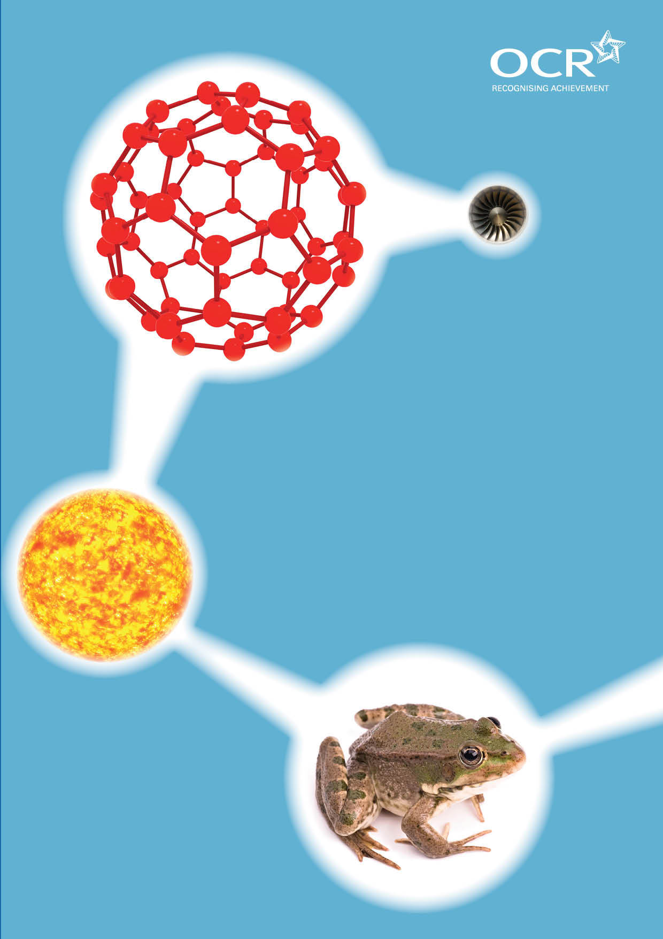
TWENTY FIRST CENTURY SCIENCE SUITE
SCHEMES OF WORK AND LESSON PLANS
P1: The Earth in the Universe
VERSION 1 AUGUST 2011
Introduction
OCR involves teachers in the development of new support materials to capture current teaching practices tailored to our new specifications. These support materials are designed to inspire teachers and facilitate different ideas and teaching practices. Each Scheme of Work and set of sample Lesson Plans is provided in Word format – so that you can use it as a foundation to build upon and amend the content to suit your teaching style and students’ needs.
The Scheme of Work and sample Lesson plans provide examples of how to teach this unit and the teaching hours are suggestions only. Some or all of it may be applicable to your teaching.
The Specification is the document on which assessment is based and specifies what content and skills need to be covered in delivering the course. At all times, therefore, this Support Material booklet should be read in conjunction with the Specification. If clarification on a particular point is sought then that clarification should be found in the Specification itself. References to the content statements for each lesson are given in the ‘Points to note’ column.


Sample Scheme of Work
GCSE 21st Century Science Physics A J245
Module P1: The Earth in the Universe
Suggested Teaching Time: 13 Hours

Topic outline | Suggested teaching and homework activities | Suggested resources | Points to note
1. What do we know about the place of the earth in the universe:  The solar system 1 | True false quiz on solar system  Discussion about the relative size of objects in the solar system. Try to develop a sense of scale of the size of the solar system.  Model the solar system using various sized objects to scale.  Pupils work in groups to produce a presentation (electronic or paper based) on a type of object in the solar system (comet, moon planet sun asteroids)  [Possible alternative approach is looking at the historical development of the understanding of the solar system.] | http://science.nationalgeographic.com/science/space/solar-system is an easy web site to use and get basic data and some good images. Easy to use interface and controls don’t require any downloads.  Could use the wonders of the solar system BBC documentary from march 2011 by Brian Cox  http://solarsystem.nasa.gov/eyes/index.html is a very powerful website to look into the solar system in more detail. Requires installing unity player and enquires a little time to get to grips with. | The KS3 work on the solar system tends to focus on the planets and their composition as well as how the planets move.  Opportunities to develop mathematical skills, and consider the role of models in science.  Specification links:  P1.1.1. recall that the Earth is one of eight planets moving in almost circular paths round the sun which, together with other smaller objects orbiting the Sun (asteroids, dwarf planets, comets) and moons orbiting several planets, make up the solar system  P1.1.2. describe the principal differences between planets, moons, the Sun, comets and asteroids, Including their relative sizes and motions  P1.1.3. understand that the solar system was formed over very long periods from clouds of gases and dust in space, about five thousand million years ago  P1.1.6. put in order and recall the relative sizes of: the diameters of the Earth, the Sun, the Earth’s orbit, the solar system, the Milky Way, the distance from the Sun to the nearest star, and the distance from the Milky Way to the nearest galaxy

Topic outline | Suggested teaching and homework activities | Suggested resources | Points to note
2. What do we know about the place of the earth in the universe:  Solar system 2 | Discussion followed by a time line of the development of the solar system generated by groups of students.  Look at and discuss / present computer models of the solar system.  Pass the light from the sun through a spectroscope to show how we can analyses the spectra from stars. | http://www.bbc.co.uk/science/space/solarsystem/sun_and_planets/sun  has some very useful interesting and inspiring film clips about the solar system, including clips from Prof Brian Cox’s wonders of the solar system series.  spectroscope (see http://www.practicalphysics.org/ for alternative methods)  http://nineplanets.org/history.html | Specification links:  P1.1.7. understand that all the evidence we have about distant stars and galaxies comes from the radiation astronomers can detect  P1.1.4. recall that the Sun is one of thousands of millions of stars in the Milky Way galaxy  P1.1.3. understand that the solar system was formed over very long periods from clouds of gases and dust in space, about five thousand million years ago

Topic outline | Suggested teaching and homework activities | Suggested resources | Points to note
3. Stars and galaxies 1 | Video of the life and death of star.  Discuss the fact that the sun will run out of energy and “die” in about 5 billion years  The life cycle of a star. Students use images of stars, gas clouds, black holes supernovae, and nebulae, to produce a display of the life cycle of a star.  Discussion about the size of the universe, highlighting the scale of the universe and massive distances involved. Define a light year  Calculations around the distances to stars and galaxies in light years  Flame tests to burn different chemical and look at the spectra produced through a hand held spectra scope. Link this to how we know what stars | www.bbc.co.uk/programmes/b00rf172#clips has clips from the wonders of the solar system  www.bbc.co.uk/science/space/solarsystem/  Use distances students know and convert into the time it takes light to travel. How long would lit take light to travel to London, Australia, the moon the sun Proxima Centauri http://en.wikipedia.org/wiki/list_of_nearest_stars | Opportunities to develop Mathematical Skills  Opportunities to develop Practical Skills  Specification links:  P1.1.5. recall that there are thousands of millions of galaxies, each containing thousands of millions of stars, and that all of these galaxies make up the Universe  P1.1.8. recall that light travels through space (a vacuum) at a very high but finite speed, 300 000 km/s  P1.1.9. recall that a light-year is the distance travelled by light in a year  P1.1.15. understand that the source of the Sun’s energy is the fusion of hydrogen nuclei  P1.1.16. understand that all chemical elements with atoms heavier than helium were made in stars

Topic outline | Suggested teaching and homework activities | Suggested resources | Points to note
4. Stars and Galaxies 2 | Parallax measurement on a school field or playground.  Measure the level of light given off by a lamp or ray box. Plot distance against intensity and show we can measure the distance to stars if we know their brightness at a given distance.  Use the spectra and the distance to stars to explain red shift. | http://eaae-astronomy.org/wg3-ss/workshops/triangulation.html this website gives the general idea but a more specific work sheet will be needed.  Data loggers and light meters | Opportunities to develop Practical Skills  Opportunities to develop Mathematical Skills  Specification links:  P1.1.10. understand that the finite speed of light means that very distant objects are observed as they were in the past, when the light we now see left them  P1.1.11. understand how the distance to a star can be measured using parallax (qualitative idea only)  P1.1.12. understand how the distance to a star can be estimated from its relative brightness  P1.1.13. understand that light pollution and other atmospheric conditions interfere with observations of the night sky  P1.1.14. explain why there are uncertainties about the distances of stars and galaxies with reference to the nature and difficulty of the observations on which these are based and the assumptions made in interpreting them  P1.1.17. understand that the redshift in the light coming from them suggests that distant galaxies are moving away from us  P1.1.18. understand that (in general) the further away a galaxy is, the faster it is moving away from us.

Topic outline | Suggested teaching and homework activities | Suggested resources | Points to note
5. Stars and galaxies 3 | Balloon demonstration of expanding universe.  Fusion in stars produced the spectra and this is what tells us what stars contain. After some discussion and / or research students can write a short presentation about how they are made of star dust. | Video of Doppler shift (see You Tube) of sound during relative motion. Link this to Doppler shift of light from stars.  This is shown in most physics texts including OUP Physics C21 GCSE | Specification links:  P1.1.19. understand how the motions of galaxies suggests that space itself is expanding  P1.1.20. recall and put in order the relative ages of the Earth, the Sun, and the Universe  P1.1.21. recall that scientists believe the Universe began with a ‘big bang’ about 14 thousand million years ago  P1.1.22. understand that the ultimate fate of the Universe is difficult to predict because of difficulties in measuring the very large distances involved and the mass of the Universe, and studying the motion of very distant objects.

Topic outline | Suggested teaching and homework activities | Suggested resources | Points to note
6. What do we know about the Earth and how it is changing:  The changing Earth 1 | Follow on from the formation of the solar system in the first section to present the evidence of the structure of the earth.  Present the story of continental drift.  Students use a text book and the internet to research the scientific battle between Wegner and the establishment. They should include the evidence, (data) and the explanations of the same evidence as an example of how science works. | There are various text book s that cover this work | This is the place to tackle the How science works developing scientific theories, IAS strand  Specification links:  P1.2.1. understand how rocks provide evidence for changes in the Earth (erosion and sedimentation, fossils, folding)  P1.2.2. understand that continents would be worn down to sea level by erosion, if mountains were not being continuously formed  P1.2.3. understand that the rock processes seen today can account for past changes  P1.2.4. understand that the age of the Earth can be estimated from, and must be greater than, the age of its oldest rocks, which are about four thousand million years old  P1.2.5. understand Wegener’s theory of continental drift and his evidence for it (geometric ¿ t of continents and their matching fossils and rock layers)  P1.2.6. understand how Wegener’s theory accounts for mountain building  P1.2.7. understand reasons for the rejection of Wegener’s theory by geologists of his time (movement of continents not detectable, too big an idea from limited evidence, simpler explanations of the same evidence, Wegener an outsider to the community of geologists)

Topic outline | Suggested teaching and homework activities | Suggested resources | Points to note
7. The changing Earth 2 | Students look at the evidence and form their own conclusion backed up with evidence. There is a possibility of having a class debate on the competing theories.  Use an animation or cut and stick exercise to consolidate Wegener’s explanation.  Seafloor spreading creates new land leading to magnetic strips in the ocean floor. | There are lots available on line eg www.exploratorium.edu/origins/antarctica/ideas/gondwana2.html  Demonstration using a biscuit broken into two, floating on syrup in a glass beaker heated from beneath with a Bunsen burner.  Magnetic pattern in pins from OUP materials C21 | Specification links:  P1.2.7. understand reasons for the rejection of Wegener’s theory by geologists of his time (movement of continents not detectable, too big an idea from limited evidence, simpler explanations of the same evidence, Wegener an outsider to the community of geologists)  P1.2.8. understand that seafloor spreading is a consequence of movement of the mantle (convection due to heating by the core)  P1.2.9. recall that seafloor spread by a few centimetres a year  P1.2.10. understand how seafloor spreading and the periodic reversals of the Earth’s magnetic field can explain the pattern in the magnetisation of seafloor rocks on either side of the oceanic ridges.

Topic outline | Suggested teaching and homework activities | Suggested resources | Points to note
8. Earthquakes 1 | Discuss a recent earthquake event and the destruction it causes.  Explanation of tectonic movement: ask students to work in groups to give an assembly on how mountain building, volcanoes, earthquakes and tsunamis are caused.  Assemblies could be given to whole school or year group, this may include animations of earthquakes etc. | News cast footage available on –line eg  Warning; distressing images - www.youtube.com/watch?v=ketof15q3lc&feature=relmfu  http://news.bbc.co.uk/1/hi/4126809.stm  Brick quake demonstrations – These could be videoed during the lesson, and then shown during the assembly | This could be a video task, a power point presentation or a Photostory 3 presentation. www.microsoft.com/windowsxp/using/digitalphotography/photostory/default.mspx  Opportunities to develop Practical Skills  IAS looking for correlations and then finding a causal link.  Specification links:  P1.2.11. understand that earthquakes, volcanoes and mountain building generally occur at the edges of tectonic plates  P1.2.12. understand how the movement of tectonic plates causes earthquakes, volcanoes and mountain building, and contributes to the rock cycle  P1.2.13. recall that earthquakes produce wave motions on the surface and inside the Earth which can be detected by instruments located on the Earth’s surface

Topic outline | Suggested teaching and homework activities | Suggested resources | Points to note
9. Earth quakes 2 | Continuation of assembly preparation from lesson 8.  Plot recent earthquakes on a world map to look for patterns around tectonic plate boundaries. Then add volcanoes to the map and compare with presence / absence of mountains. | http://earthquake.usgs.gov/earthquakes/recenteqsww/quakes/quakes_all.php shows the location of the most recent quakes  This could be done using a shared public map on google maps so all the students can contribute to large work map of all earthquakes. – more data leads to a clearer more reliable pattern. | Specification links:  P1.2.11. understand that earthquakes, volcanoes and mountain building generally occur at the edges of tectonic plates

Topic outline | Suggested teaching and homework activities | Suggested resources | Points to note
10. Waves 1 | Revision of waves at KS3 to show relationships of frequency to wavelength and amplitude to loudness (intensity). Project the wave if possible onto a large screen. Ask students to provide the sound. Each student should be asked to make the trace have a longer /shorter wavelength or a bigger / smaller amplitude. The students have to work out if this means making a louder / quieter, higher/lower sound than the last  Use a Slinky demonstration to explain the transverse / longitudinal waves. Then ask students to line up. They then have to show the difference between eh 2 types of wave by either moving forwards or sideways to propagate the wave. | Use USB microphone and audacity (http://audacity.sourceforge.net/) on a computer projected on a white board or use an oscilloscope and microphone.  Slinky or rope  www.youtube.com/watch?v=rbuhdo0azdu  www.youtube.com/watch?v=movz2enjb8m&feature=related | Depending on the group this could be a written exercise  If you ask the students to stand still in a line and just move when the person next to them moves, the transverse waves propagate well. The longitudinal wave requires the students to gently knock into each other to propagate the wave. In each case it should be noted that no matter is transferred – the students them selves do move a long distance they only vibrate on the spot.  Specification links:  P1.2.20. recall that the frequency of waves, in hertz (Hz), is the number of waves each second that are made by the source, or that pass through any particular point  P1.2.21. recall that the wavelength of waves is the distance between the corresponding points on two adjacent cycles  P1.2.22. recall that the amplitude of a wave is the distance from the maximum displacement to the undisturbed position  P1.2.23. draw and interpret diagrams showing the amplitude and the wavelength of waves  P1.2.15. describe the difference between a transverse and longitudinal wave  P1.2.16. understand how differences in the wave speeds and behaviour of P-waves and S-waves can be used to give evidence for the structure of the Earth  P1.2.17. in relation to waves, use the equation:  distance = wave speed × time  (metres, m) (metres per second, m/s) (seconds, s)

Topic outline | Suggested teaching and homework activities | Suggested resources | Points to note
11. Waves 2 | Evidence of the structure of the earth using the propagation of P and S waves differently through different media.  Calculations using the differing speeds of P and S waves. | www.exploratorium.edu/faultline/activezone/slides/pswaves-slide.html | Opportunities to develop Mathematical skills

Topic outline | Suggested teaching and homework activities | Suggested resources | Points to note
12. Waves 3 | Show waves of increasing frequency and observe the wavelength  Students make a note of the frequency and the wavelength.  These should be plotted to show the inverse relationships between the 2 variables. Then plot the inverse relation ship to get a straight line.  Use the gradient to work out eh speed. | GCP have a calculations book for Physics GCSE  Most Physics texts have wave equation calculations.  Either as a standing wave on a string or via an oscilloscope attached to a speaker via a signal generator that tells you the frequency.  Students with access to computers can use a spreadsheet application for this (excel) | Opportunities to develop mathematical Skills  Specification links:  P1.2.14. recall that earthquakes produce:  a. P-waves (longitudinal waves) which travel through solids and liquids  b. S-waves (transverse waves) which travel through solids but not liquids  P1.2.18. draw and label a diagram of the Earth to show its crust, mantle and core  P1.2.19. recall that a wave is a disturbance, caused by a vibrating source, that transfers energy in the direction that the wave travels, without transferring matter  P1.2.17. in relation to waves, use the equation:  distance = wave speed × time  (metres, m) (metres per second, m/s) (seconds, s)  P1.2.24. use the equation:  wave speed = frequency × wavelength  (metres per second, m/s) (hertz, Hz) (metres, m)  P1.2.25. understand that for a constant wave speed the wavelength of the wave is inversely proportional to the frequency.

Topic outline | Suggested teaching and homework activities | Suggested resources | Points to note
13. Revision and test | Students look through the spec statements in “student Speak” and highlight the ones they are unsure of.  They then revisit these areas of the topic using mind maps and posters.  This could lead to a presentation to the rest of the class and also the competition of a past paper question on this area of the spec. | Past paper materials from OCR  Either exam quest or use their website.  http://www.ocr.org.uk/qualifications/type/gcse_2011/tfcs/physics_a/documents/index.html

Sample Lesson Plan
GCSE 21st Century Science Chemistry A J244
Module P1: The Earth in the Universe

The Solar System
OCR recognises that the teaching of this qualification above will vary greatly from school to school and from teacher to teacher. With that in mind this lesson plan is offered as a possible approach but will be subject to modifications by the individual teacher.
Lesson length is assumed to be one hour.

Learning Objectives for the Lesson
Objective 1 | recall that the Earth is one of 8 planets moving in almost circular paths round the Sun which, together with other smaller objects orbiting the Sun (asteroids, dwarf planets, comets) and moons orbiting several planets, make up the solar system
Objective 2 | describe the principal differences between planets, moons, the Sun, comets and asteroids including their relative sizes and motions
Objective 3 | understand that the solar system was formed over very long periods from clouds of gases and dust in space, about five thousand million years ago
Objective 4 | put in order and recall the relative sizes of: the diameters of the Earth, the Sun, the Earth’s orbit, the solar system, the Milky Way, the distance from the Sun to the nearest star, and the distance from the Milky Way to the nearest galaxy

Recap of Previous Experience and Prior Knowledge
From KS3 Programme of Study: the environment the Earth and universe/ astronomy and space science provide insight into the nature and observed motions of the sun, moon, stars, planets and other celestial bodies. This includes the planets and their order form the sun. Remind the students that gravity plays a large role in the solar system!

Content
Time | Content
5 minutes | True false quiz on solar system hand written or use an electronic voting system with the class.  This will need to include some basic KS 3 ideas and also some more common misconceptions such as evidence for alien life the orbital paths of various bodies in the solar system.  Students will use the True False quiz as the basis for what to include in their presentation. So it should be tiered and have some easily accessible statements and some that are far more challenging.
10 minutes | Discussion about the relative size of objects in the solar system. If the sun was 1m across how far away would we be and how big would our planet be?  Use a video or animation to show the relative scale of the universe. Many are available on you tube. Also via the BBC iPlayer and website.

Time | Content
5-10 minutes | Model the solar system using various sized objects to scale. This website will calculate the size of objects you need given the diameter of the object you are using for the sun. http://www.exploratorium.edu/ronh/solar_system/
25 minutes | Pupils work in groups to produce a presentation (electronic or paper based) on a type of object in the solar system (comet, moon planet sun asteroids). This will require access to the flowing resources. GCSE Physics or Science Text books, internet.  http://science.nationalgeographic.com/science/space/solar-system is an easy web site to use and get basic data and some good images. Easy to use interface and controls don’t require any downloads.  http://solarsystem.nasa.gov/eyes/index.html is a very powerful website to look into the solar system in more detail. Requires installing unity player and enquires a little time to get to grips with.  http://www.bbc.co.uk/science/space/solarsystem/sun_and_planets/sun has some very useful interesting and inspiring film clips about the solar system, including clips from Prof Brian Cox’s wonders of the solar system series.  http://nineplanets.org/history.html

Consolidation
Time | Content
15 minutes | Students present their work in groups to the whole class. Audience of classmates have to fill in a sheet summarising the learning taken place in the lesson including the true false questions from the start of the lesson. Ensure this sheet covers the learning outcome for the lesson. This may need to take place in the next lesson depending on the speed of the class and the extent of the task.
Homework | Find out which planets were discovered last and why this might be.  Find out which object in the solar system would be the best for sustaining life

