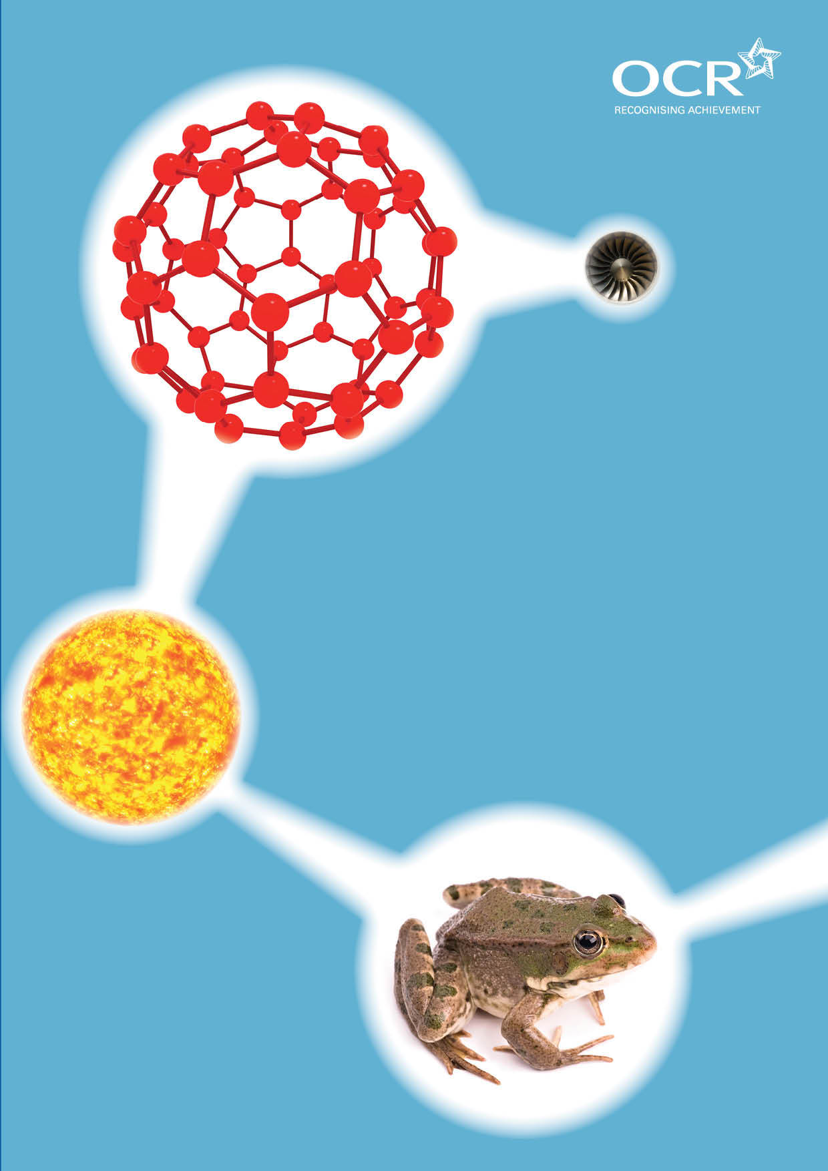
TWENTY FIRST CENTURY SCIENCE SUITE
SCHEMES OF WORK AND LESSON PLANS
C2: Material choices
VERSION 1 JULY 2011
Introduction
OCR involves teachers in the development of new support materials to capture current teaching practices tailored to our new specifications. These support materials are designed to inspire teachers and facilitate different ideas and teaching practices. Each Scheme of Work and set of sample Lesson Plans is provided in Word format – so that you can use it as a foundation to build upon and amend the content to suit your teaching style and students’ needs.
The Scheme of Work and sample Lesson plans provide examples of how to teach this unit and the teaching hours are suggestions only. Some or all of it may be applicable to your teaching.
The Specification is the document on which assessment is based and specifies what content and skills need to be covered in delivering the course. At all times, therefore, this Support Material booklet should be read in conjunction with the Specification. If clarification on a particular point is sought then that clarification should be found in the Specification itself. References to the content statements for each lesson are given in the ‘Points to note’ column.


Sample Scheme of Work
GCSE 21st Century Science Chemistry A J244
Module C2: Material choices

Suggested Teaching Time: 12 Hours

Topic outline | Suggested teaching and homework activities | Suggested resources | Points to note
Polymer properties and uses  (1 hour) | Students to look at a circus of polymer materials and describe the properties of those materials. Try to think of a different material that could be used instead e.g. cork for bottle stopper, paper bags etc. Discuss the advantages and disadvantages of using such materials. Students then complete a table with headings – object, use, properties needed for use, materials it could be made of (natural and man-made).  Identify natural polymers and synthetic polymers. Compare the properties of the two types of polymers used for a specific job and what properties of the synthetic polymer makes it more suitable for the use.  Discussion of materials uses for specific jobs that involve polymers e.g. window frames – why do we use uPVC rather than wood in most window frames manufactured today.  Homework activity: Complete a survey of plastic objects at home. Students to look up the markings on the polymers and make a table of object, its use and the type of polymer. | Circus of polymer materials to help property analysis.  Polyamide – toothbrush bristles.  Polycarbonate – mobile phone case, CDs and DVDs.  Polyester – bottles for fizzy drinks.  Polythene – carrier bags and food bags.  Polypropylene – crisp and sweet packets.  Cotton – piece of material.  Silk – piece of material.  http://science.howstuffworks.com/plastic.htm this link contains a video on the discovery of plastics.  www2.chemistry.msu.edu/faculty/reusch/virttxtjml/polymers.htm this web page has a table of polymers and properties – very comprehensive! | C2.1.1  C2.1.2  C2.1.3  C2.1.4  C2.2.1  C2.2.2  C2.2.3  C2.2.13

Topic outline | Suggested teaching and homework activities | Suggested resources | Points to note
Measuring polymer properties  (2 hours for the practical activities and collection of data and 1 hour for the discussion of the ideas about science and data) | Carry out practical to measure the tensile strength of polymers by safely hanging weights from each of the polymers being tested. How many masses can the polymer hold before breaking? This can be differentiated for foundation and higher students. Foundation could investigate the mass needed to break the handles of a carrier bag, whereas higher students could use different fibres such as wool, cotton, nylon, synthetic wool etc.  Carry out measurements of stiffness by attaching polymer to a surface, such as a bench by using a G clamp. Different polymer rulers can be compared to wooden and metal rulers. Carefully add weights to the end of the ruler and measure the extent of the bend. | 0.1N and 1N masses.  G clamp.  Variety of polymer rulers.  Wooden ruler.  Metal ruler.  Metre ruler for measurement.  Variety of thread like materials such as wool, cotton, nylon, synthetic wool.  Carrier bags.  www.pslc.ws/macrog/kidsmac/property.htm this web page has information of the types of properties we can investigate with polymers. | C2.1.1  C2.1.2  C2.1.3  C2.1.4  IaS 1 (Data)  Opportunity to develop skills towards Practical Data Analysis / Investigation tasks  Discussion here should also cover:  The need for repeated measurements  Range of results  Identifying outliers  Calculation of mean  The best estimate.
What is a hydrocarbon?  Why is crude oil an important raw material?  (2 hours) | Explanation that a hydrocarbon is a substance that contains only hydrogen and carbon atoms.  Discuss the fact that crude oil is a collection of mainly hydrocarbons of different lengths that can be separated by a process called fractional distillation. Use animation to show the separation of the oil. This could be modelled using students of different heights with a height restriction for students to get through each fraction.  Demonstrate the distillation of inky water. This shows the separation of 2 liquids of different boiling points and can be used as further discussion of fractional distillation.  Discussion of how the forces between the molecules increases with the length of the chain and how that relates to the melting and boiling points of the fractions of the crude oil. | http://science.howstuffworks.com/environmental/energy/oil-refining4.htm this has an animation of fractional distillation.  E-chalk can be used for fractional distillation and hydrocarbons.  http://e2bn.skoool.co.uk/content/keystage4/chemistry/pc/lessons/uk_ks4_oil_products/h-frame-ie.htm this is an excellent interactive lesson with animations of fractional distillation and polymerisation.  Distillation apparatus.  Inky water. | C2.2.4  C2.2.5  C2.2.7  C2.2.8  C2.2.9  C2.2.10  C2.2.11

Topic outline | Suggested teaching and homework activities | Suggested resources | Points to note
How can we make polymers?  (1 to 2 hours) | Discussion and use of Molymods to show how monomer molecules can be added together to form a polymer. This process is called polymerisation. It also allows us to change the chemical properties of the polymer to suit the purpose.  This can also be modelled by students by using the idea that as individuals they are monomers but when they join hands the become a polymer. You can add a coloured sticker to some monomers to change the properties, e.g. add a green sticker to show chlorine added to produce PVC.  Discussion of how changing the side groups of the monomer changes the properties of the polymer (this can also be used to discuss the energy needed to separate polymer chains and the effect of branching etc.). | Molymods  www.tvo.org/iqm/plastic/animations.html#  This website has an animation to show how addition polymerisation works.  www.chemistryland.com/polymerplanet/polymers/polymertutorial.htm  This webpage has lots of information about polymerisation as well as polymer properties. | C2.2.6  C2.2.12  C2.3.1  C2.3.2  C2.3.3  C2.3.4  PVC is revisited in module C3, looking at risks and benefits of using plasticizers
How can we modify polymers?  (1 hour) | Use of Molymods to show how increasing the length of the molecule will increase the amount of energy needed to separate them from each other.  Use plastic beads and spaghetti to simulate the addition of plasticizers to allow polymer molecules to slide past each other more easily therefore demonstrating that these increase the flexibility of the polymer.  Use blue-tack or glue with spaghetti to simulate how cross-linking can increase the rigidity of the polymer as the molecules are in fixed positions. | Spaghetti or art straws.  Small plastic beads.  Blue-tack or glue.  www.bbc.co.uk/schools/gcsebitesize/science/21c/materials/molecstructpropertiesrev2.shtml this web page shows diagrams of cross-linking.  www.studydoctor.co.uk/site/?page_id=914 this web site has a worksheet for a lesson on plasticizers and cross-linking that contains clear diagrams. | C2.3.1  C2.3.2  C2.3.3  C2.3.4
What is nanotechnology  (1 hour) | Explain the term ‘nano’ as x10⁻⁹ of a metre and relate this to the size of atoms.  Discuss the fact that nanoparticles occur naturally, by accident and by design.  The nanoparticles show different properties compared to their larger particles of the same material due to their larger surface area. | www.vega.org.uk/video/programmeset/12  This is a series of videos about carbon nanotubes.  http://science.howstuffworks.com/nanotechnology.htm  This is a video about the scale and uses of nanoparticles. | C2.4.1  C2.4.2  C2.4.3  C2.4.4

Topic outline | Suggested teaching and homework activities | Suggested resources | Points to note
How can nanoparticles be modified?  (2 hours) | Discuss examples of uses of nanoparticles  - Use of silver particles to give fibres antibacterial properties.  - Use of nanoparticles to strengthen sports equipment.  Discuss the implications of using nanoparticles as they may have harmful effects on the environment. As this is a relatively new technology there are concerns that the effects have not been fully tested. Group activities and discussions can be used here to investigate the possible risk versus the reward of using the nanoparticles. | www.qmed.com/mpmn/blog/17998/surface-modified-silver-nanoparticles-could-enhance-therapeutic-applications this website has information about the use of silver nanoparticles.  www.azonano.com/details.asp?articleid=1041 this website contains information about silver nanoparticles being used in bacterial resistant materials.  www.nanoandme.org/nano-products/sports-and-leisure/ this website has information about nanoparticles in sport.  http://copublications.greenfacts.org/en/nanotechnologies/l-2/6-ealth-effects-nanoparticles.htm this website is a useful source to begin a discussion on the possible harmful effects of nanoparticles. | C2.4.5  C2.4.6  IaS 2 (Cause-effect explanations)

Sample Lesson Plan
GCSE 21st Century Science Chemistry A J244
Module C2: Material choices

Properties of polymers and their uses
OCR recognises that the teaching of this qualification above will vary greatly from school to school and from teacher to teacher. With that in mind this lesson plan is offered as a possible approach but will be subject to modifications by the individual teacher.
Lesson length is assumed to be one hour.

Learning Objectives for the Lesson
Objective 1 | Recall the properties of a variety of polymers
Objective 2 | Describe how the property of a polymer is related to its uses.
Objective 3 | Explain why synthetic polymers are commonly chosen rather than natural polymers for a wide range of materials and relate this to their properties.

Recap of Previous Experience and Prior Knowledge
No prior knowledge of polymers is expected.

Content
Time | Content
5 minutes | Students use white boards draw a mind map about what they currently understand by the word ‘polymer’.
15 minutes | Students move around the classroom to look at the polymer samples that are set out in a circus around the room. For each material they should name the item and the polymer it is made from.
10 minutes | Discuss in pairs what each item could have been made from or what would you have used before polymers were discovered. e.g. Sandwiches would have been wrapped in brown paper rather than put into plastic food bags. Feedback to the group.
10 minutes | Introduce Key words for the properties of polymers. Students should discuss their suggested definitions in pairs and feedback to the group so a group definition can be arrived at. Words should include; flexible, stiffness, density, hardness, brittle, strength (tensile and compression)
10 minutes | Define natural polymers as polymers that occur in plants such as cotton, rubber etc. and animals such as the silk from silk worms verses the synthetic polymers that are generated from crude oil products. Discuss the sustainability of crude oil as a raw material for synthetic polymers.

Consolidation
Time | Content
10 minutes | Keyword splat  Put the keywords and polymer names on the board. Two students are called to the board. Teacher reads out a definition or question and each student has to cover (or splat) the word they think is being described or which word is the answer to the question. After a couple of attempts swap students and continue to play. This needs questions or definitions to be planned carefully.

