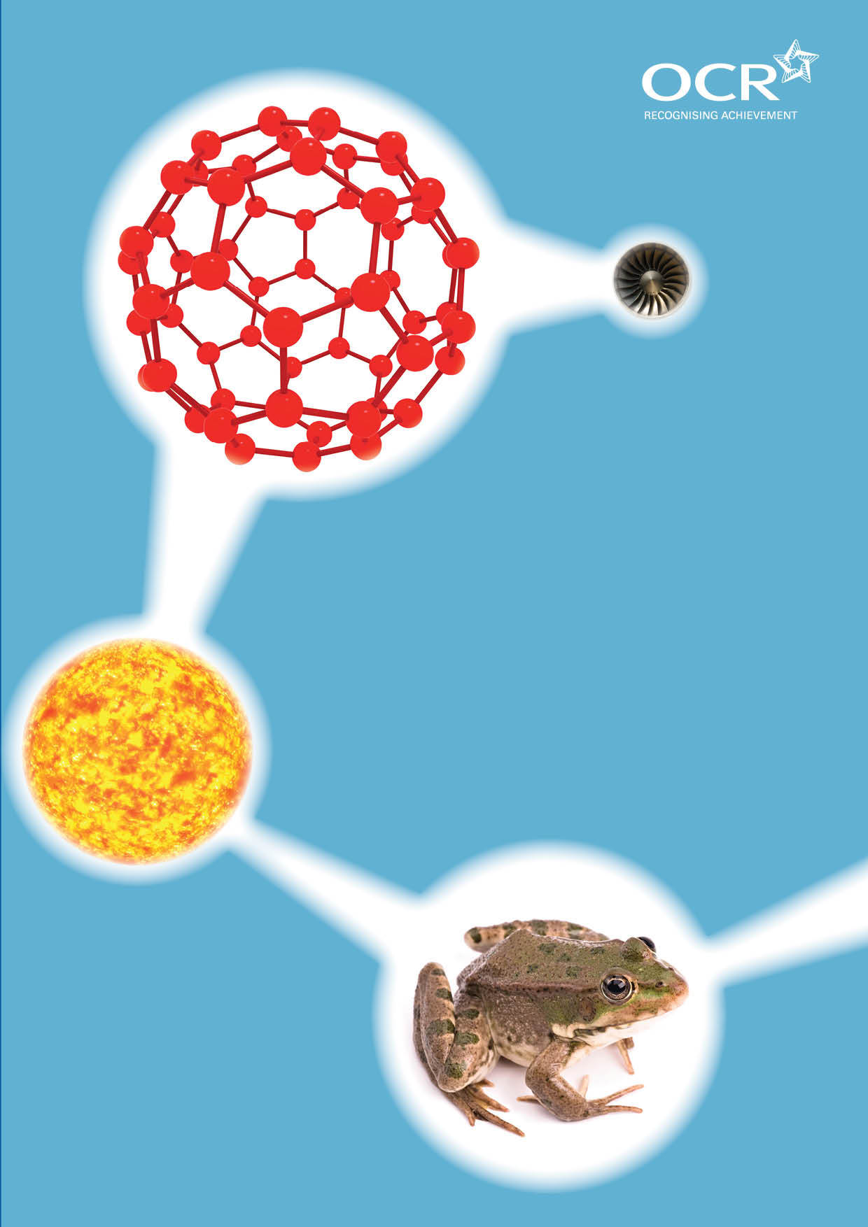
TWENTY FIRST CENTURY SCIENCE SUITE
SCHEMES OF WORK AND LESSON PLANS
C6: Chemical synthesis
VERSION 1 JULY 2011
Introduction
OCR involves teachers in the development of new support materials to capture current teaching practices tailored to our new specifications. These support materials are designed to inspire teachers and facilitate different ideas and teaching practices. Each Scheme of Work and set of sample Lesson Plans is provided in Word format – so that you can use it as a foundation to build upon and amend the content to suit your teaching style and students’ needs.
The Scheme of Work and sample Lesson plans provide examples of how to teach this unit and the teaching hours are suggestions only. Some or all of it may be applicable to your teaching.
The Specification is the document on which assessment is based and specifies what content and skills need to be covered in delivering the course. At all times, therefore, this Support Material booklet should be read in conjunction with the Specification. If clarification on a particular point is sought then that clarification should be found in the Specification itself. References to the content statements for each lesson are given in the ‘Points to note’ column.


Sample Scheme of Work
GCSE 21st Century Science Chemistry A J244
Module C6: Chemical synthesis
Lesson 1: Importance of synthesis and the techniques involved

Suggested Teaching Time: 2 Hours

Topic outline | Suggested teaching and homework activities | Suggested resources | Points to note
Importance of synthesis and the techniques involved | Students create a mind map of the different chemicals that exist in our world and how students think they are manufactured. Examples should include; food additives, fertilisers, dyestuffs, paints, pigments and pharmaceuticals.  Revision and discussion of the techniques involved in the synthesis of chemicals e.g. Dissolving, filtration, evaporation, crystallisation and drying (or use of a desiccator) these techniques can be carried out as a demo or class practical.  Introduce the main process of combinatorial chemistry and how thousands of chemicals may be synthesised before one useful product is identified. (see video on RSC website)  Discussions should also include the need for purity of chemicals produced and how this might be monitored and tested.  Homework to investigate how one group of chemicals is made. e.g. What is the process for making a paint or a medicine. Students can be directed to websites and given guidance on presentation, such as power point presentation or poster. | http://resources.schoolscience.co.uk/exxonmobil/index.html this website has a virtual tour of the Fawley Oil Refinery. It can be used as an example of an industrial process. The site is easy to use  http://www.bbc.co.uk/schools/gcsebitesize/science/add_ocr/chemical_synthesis/techniquesrev1.shtml this web page gives a clear outline of the processes of chemical synthesis.  http://www.bbc.co.uk/schools/gcsebitesize/science/add_ocr/chemical_synthesis/techniquesrev2.shtml this web page describes the techniques involved in synthesis.  http://www.netsci.org/science/combichem/feature02.html this web page gives a definition of, and information on, combinatorial chemistry.  http://www.rsc.org/education/teachers/resources/alchemy/index2.htm this is an excellent site with lots of useful information and videos.  Class practical – separation of sand and salt mixture using dissolving salt, separating sand out through filtration and then re-crystallisation of salt. | ICT suite can be used for students to explore the industrial process.  It is important when discussing purity and analytical experiments, that the ideas about science are discussed. The need for several measurements or a range of measurements, as well as repeated measurements to eliminate outliers, can be clarified here.

Lesson 2: Formulae

Suggested Teaching Time: 1 Hour

Topic outline | Suggested teaching and homework activities | Suggested resources | Points to note
Formulae | Constructing formulae from ions using cards of different sizes to help. Students can be given a table of ions and asked to construct a series of formulae from the information provided (higher tier).  Students can be provided with a table of ions and asked to construct the formulae of compounds, given their names (and vice versa) this can be done as a homework activity. | Cards of different elements  Group 1 metals 5cm by 2cm  Group 2 metals 5cm by 4cm  Aluminium 5cm by 6cm  These should be one colour to represent positive ions.  Group 7 5cm by 2cm  Group 6 5cm by 4cm  These should all be the same colour but different to the positive ions  The boxes have to be equal depth for the formula to work. Also include oh- and other polyatomic ions.  http://www.docbrown.info/page01/elcpdmix/elecmdmix3.htm this is a very useful page with good diagrams which can be used to help students.

Lesson 3: Relative formulae masses and percentage yields

Suggested Teaching Time: 1 Hour

Topic outline | Suggested teaching and homework activities | Suggested resources | Points to note
Relative formulae masses and percentage yields | Use the periodic table to identify the atomic mass of elements in a formula. Calculate relative formula mass of a list of common compounds such as Cl₂, H₂, N₂, O₂, HCl, HNO₃, H₂SO₄, NaOH, NaCl, Na₂CO₃, NaNO₃, Na₂SO₄, KCg, MgCl₂, MgO, Mg(OH)₂, MgCO₃, MgCl₂, MgSO₄, CaCO₃, CaCL₂ and CaSO.  Discuss how the relative formula mass can be used to work out reacting quantities in a chemical reaction. Carry out such calculations. (higher tier)  Calculate the percentage yield of a process. Students should be given the actual and theoretical yields. Use the formula;  Percentage yield = actual yield x 100  theoretical yield  These calculations can be practised using a homework sheet. | Calculators  Periodic tables  http://www.ewart.org.uk/science/patterns/pat13.htm this website has a set of questions to try . This could be done as a class or individually.  http://scienceaid.co.uk/chemistry/fundamental/chemicalequations.html this webpage has information about relative formula masses as well as equations.  http://www.docbrown.info/page04/4_73calcs.htm this is the index page for chemical calculations. Very useful.  http://www.docbrown.info/page04/4_73calcs06rmc.htm this is an example of the calculations that can be performed with reacting masses (not using moles).

Lesson 4: Hazards and state symbols

Suggested Teaching Time: 1 Hour

Topic outline | Suggested teaching and homework activities | Suggested resources | Points to note
Hazards and state symbols | Standard hazard symbols. Student to play a pairs game to match hazards with the symbol.  Students could then match the symbols to some common lab substances. Discussion of more complicated symbols such as oxidising agent maybe required.  Explain the use of state symbols of (s), (l), (g) and (aq). The symbol (aq) relates to a solution. This can be done as a demo e.g. Copper sulphate dissolved in water to make copper sulphate solution.  Homework – identify hazard symbols that are present on household chemicals | http://www.ngfl-cymru.org.uk/vtc/ngfl/science/103_new/asc1/hazardsymbol.htm this website gives a clear definition of each symbol.  Collection of hazard symbols on card  Definitions of hazard symbols on card.  http://www.chem4kids.com/files/matter_states.html reminder about states of matter.  http://www.onlineschools.org/resources/kidsmatter/ this website has links to other useful sites as well as definitions of states of matter. | The symbol (aq) needs to be introduced carefully as there are often misconceptions here.

Lesson 5: pH scale

Suggested Teaching Time: 1 Hour

Topic outline | Suggested teaching and homework activities | Suggested resources | Points to note
pH scale | Recall pH scale and the uses of the pH scale using universal indicator solution (this should be revision from KS3).  Class practical to test pH of household chemicals and lab acids and alkalis. Use a variety of indicators and if available a pH meter to show different methods for identifying acids and alkalis. | http://staff.jccc.net/pdecell/chemistry/phscale.html this website has a clear pH chart with examples of household chemicals as well as useful information.  Collection of household chemicals such as; bleach, washing powder/liquid, soap, toothpaste, lemon juice, vinegar, cola etc.  Universal indicator and chart.  Litmus paper/indicator and chart.  pH meter and data logger if available.
Lesson 6: Neutralisation reactions and naming salts

Suggested Teaching Time: 1 Hour

Topic outline | Suggested teaching and homework activities | Suggested resources | Points to note
Neutralisation reactions and naming salts | Recall that when an acid reacts with an alkali in appropriate quantities this is a neutralisation reaction and a salt is formed. Class practical to react metals, metal oxides, metal hydroxides and metal carbonates. Any one of these reactions can be done as a demo to show the formation of a salt and the neutralisation reaction.  Students should construct the general equations to show formation of salts from reactions with acids and various metal based compounds e.g.  acid + metal oxide → salt + water etc.  Discuss the underlying reaction of hydroxide ions with hydrogen ions to produce water.  Explain that acidic compounds produce aqueous hydrogen ions when they are dissolved in water and that alkalis produce aqueous hydroxide ions when they are dissolved in water. | http://www.elmhurst.edu/~chm/vchembook/183neutral.html this website has some simple experiments that are effective in the classroom for looking at neutralisation and how these reactions are used in everyday life.  Hydrochloric acid  Magnesium ribbon cut into 1cm portions  Magnesium oxide  Magnesium hydroxide  Magnesium carbonate  Universal indicator and chart

Lesson 7: Titrations and calculations

Suggested Teaching Time: 2 Hours

Topic outline | Suggested teaching and homework activities | Suggested resources | Points to note
Titrations and calculations | Demo titration method with water to show the procedure. Discussion of the need to repeat the process to ensure reliability and ideas behind this about data.  Students then carry out an acid-base titration and then process the data to find the concentration of the unknown.  Perform titration calculation to find the concentration of the unknown substance. (the term moles is not expected to be used) | Burette  Glass pipette and filler  Conical flask  Funnel  Hydrochloric acid  Sodium hydroxide  Indicator such as methyl orange or phenolphthalein  White tile  http://www.mpcfaculty.net/mark_bishop/titration.htm this site gives some info about procedure and calculations.  http://www.dartmouth.edu/~chemlab/techniques/titration.html this site has a pictorial description of titration procedure. Beware – American so spelling of some words is incorrect e.g. ‘Buret’ instead of ‘Burette’.  http://www.practicalchemistry.org/experiments/titrating-sodium-hydroxide-with-hydrochloric-acid,129,ex.html this is a practical guide to carrying out a titration.

Lesson 8: Rate of reaction and collision theory

Suggested Teaching Time: 3 Hours

Topic outline | Suggested teaching and homework activities | Suggested resources | Points to note
Rate of reaction and collision theory | Identify the factors affecting the rate of chemical reactions.  Discuss methods of following a reaction such as collecting gas, recording a loss in mass, change in volume, time taken for a colour change etc.  Demo reactions where main factors are changed and identified;  - Surface area – change the size of marble chips (calcium carbonate) reacting with acid (e.g. Hydrochloric acid) and follow reaction by change in mass or collection of gas.  - Concentration – change concentration of one reactant such as sodium thiosulfate reacting with hydrochloric acid. Record the time taken for a black cross on paper to disappear.  - Temperature – choose either of the above reactions and change only the temperature of the reactants to show the effects on the rate.  - Catalysts – the effect of lowering the activation energy by providing an alternative pathway for the reaction to occur. Decomposition of hydrogen peroxide using MnO₂ or catalase (in liver).  Students can model each factor in the classroom (or playing field). Students are particles. Students are given a fixed space to move around for 30 seconds. In this time they should count how many times they collide with other students. To ensure safety the students should walk slowly and keep their arms by their sides. Depending on the students you could get them to close their eyes and turn twice before heading off in a random direction. This can then be adapted to show different concentrations (more or less students take part) and temperature (move faster or slower). Each time students count the collisions they make in the given time and discuss. | Demo reactions where main factors are changed and identified;  Surface area – change the size of marble chips (calcium carbonate) reacting with acid e.g. Hydrochloric acid  Concentration – change concentration of one reactant such as sodium thiosulfate reacting with hydrochloric acid  Catalyst – use hydrogen peroxide reacting with manganese dioxide. This can be done on a large watch glass as bubbling is evident. On a separate watch glass a small piece of liver can have hydrogen peroxide added to it. This also allows the comparison or chemical and biological catalysts. .  http://www.chemguide.co.uk/physical/basicrates/introduction.html this webpage has information about the collision theory. This can be used to extend students and contains information about Maxwell-Boltzmann distribution curves.  http://www.chem4kids.com/files/react_rates.html a very clear and concise website for the collision theory and rates of reaction.  http://www.richardanderson.me.uk/keystage4/gcsechemistry/m3ratesofreaction.php this webpage has some animations on the lower part of the page. Clear and helpful for lower ability students to visualise the changes to collision frequency. | This can be done as an extended set of lessons depending on the ability of students.  Each of the reactions can be done as either demonstrations or a class practical. They can be combined into a couple of lessons or extended, depending on the interest and ability of the students.
Lesson 9: Endothermic and exothermic reactions

Suggested Teaching Time: 1 Hour

Topic outline | Suggested teaching and homework activities | Suggested resources | Points to note
Endothermic and exothermic reactions | Discuss energy changes of breaking bonds. This can be modelled using molymods. Students need to put energy in to pull the models apart. This is much more difficult than putting models together. Relate this to breaking bonds being an endothermic process. Compare this to making bonds releasing energy being exothermic.  Introduce energy level diagrams. Students should sketch an energy level diagram to show the change in energy of a reaction. This should include how a catalyst effects the activation energy or energy needed for the reaction to start by bonds being broken.  Carry out basic reactions for students to feel changes in temperature e.g. Magnesium in acid will produce an exothermic reaction but dissolving ammonium nitrate in water is an endothermic process. | http://www.gcsescience.com/rc24-energy-level-diagram.htm below the initial adverts of the site is a clear energy level diagram and explanation.  http://www.docbrown.info/page03/3_51energy.htm this webpage has lots of information and shows both overall endothermic and exothermic diagrams.  Thermometer  Hydrochloric acid  Magnesium ribbon in 1cm portions  Ammonium nitrate  Molymods

Sample Lesson Plan
GCSE 21st Century Science Chemistry A J244
Module C6: Chemical synthesis

he importance of chemical synthesis
OCR recognises that the teaching of this qualification above will vary greatly from school to school and from teacher to teacher. With that in mind this lesson plan is offered as a possible approach but will be subject to modifications by the individual teacher.
Lesson length is assumed to be one hour.

Learning Objectives for the Lesson
Objective 1 | Identify the large number of chemicals that are processed in the world today
Objective 2 | Recall the process of synthesis of a chemical from conception to production
Objective 3 | Describe the scales used in the synthesis process from micrograms on test plates to kilograms in pilot plants
Objective 4 | Describe some of the techniques that can be used in the lab to synthesise an inorganic compound

Recap of Previous Experience and Prior Knowledge
No prior knowledge chemical synthesis is expected although some knowledge of techniques such as dissolving, filtering, crystallisation and evaporation should exist from Key Stage 3.

Content
Time | Content
5-10 minutes | Students to create a mind map of the different chemicals that exist in our world. They should try to categorise or classify the chemicals into different groups. e.g. Aspirin or Calpol would be pharmaceuticals. This is designed to be a tool for stimulating a discussion so can be done in pairs or small groups.
10 minutes | In pairs students should be given the name of a technique used in the lab. (dissolving, filtering, crystallising, evaporation and drying) They should draw a diagram and give 2 key points about the process. Students feedback to the class. This is revision from Key Stage 3, with the exception of drying by use of a desiccator or oven. These pairs may need a little more support in this activity.
10-15 minutes | Use the website http://www.rsc.org/Education/Teachers/Resources/Alchemy/index2.htm  Choose ‘combinatorial chemistry’ from the menu then click video. This video is just over 6 minutes but gives some excellent information about chemical processes of today and discusses the scales the chemicals are produced in before they reach the final product.  Students should make notes on the key ideas from the video.
20 minutes | Separate students into groups. Each group should discuss how they would carry out a synthesis in the lab. This could be done as a flow chart. They need to logically think about the steps. The ideas of a risk assessment and working out reacting quantities maybe new concepts that will need introducing and discussing. A writing frame or outline of the 7 stages in the process could be provided to aid students as this is new concepts and potentially difficult.  (Students should have a clear set of statements from 6.2.1 a to g in the specification, by the end of the activity). Groups could present their findings to the class.

Consolidation
Time | Content
10 minutes | Students return to their mind maps from the beginning of the lesson and add details such as techniques and scales used.  This is also a good opportunity to use a loop activity as there are lots of questions to pose here as lots of new material has been covered.

