MOMENTS & STABILITY
1. (a) Draw a diagram of a metre ruler and mark on the diagram the position of the ruler’s centre of mass.
(b) How could you experimentally confirm this?
2. Why should the centre of mass of a racing car be as low as possible?
3. Complete: For a ruler to be balanced the total clockwise moments must be the same as…..
4. A person opens a door by pulling a handle with a force of 150N. If the handle is 70cm away from the door hinge what turning effect is applied by the person?
5. The diagram below shows a balanced see-saw.
Child A
Child B
Distance A
Distance B

Complete the table below for each combination of balanced children.
 | Child weights (N) |  | Distances (m)
 | A | B | A | B
(a) | 150 | 300 | 3
(b) | 400 | 300 |  | 4
(c) |  | 300 | 2 | 3

CIRCULAR MOTION
6. (a) What is the affect of centripetal force on the motion of a body?
(b) Give two different examples of centripetal force.
7. How does the centripetal force acting on an object change if the:
(a) the speed of the object decreases
(b) the radius of the object’s circular path increases
(c) the mass of the object decreases

SATELLITE AND PLANETARY MOTION
The table below shows some planetary data:
Name | Orbit radius (km) | Orbit period (days)
Earth | 150 million | 365
Jupiter | 779 million | 4 333
Mars | 228 million | 686
Mercury | 57 million | 88
Neptune | 4504 million | 60 190
Saturn | 1429 million | 10 760
Uranus | 2871 million | 30 685
Venus | 108 million | 225
8. Which planet:
(a) has the longest ‘year’
(b) is nearest to the Sun
(c) has an orbital period of about 30 years
9. The circumference of a circle is given by: C = 2πR.
(a) Use data from the table to calculate the orbital speeds of Earth and Jupiter.
(b) Which planet moves the quickest?
(c) Why are your calculations inaccurate?
10. Explain why gravity is necessary in order for us to have satellites.
11. (a) State two uses of geostationary satellites.
(b) A satellite has an orbital period of 24 hours but it is not geostationary. Explain how it might be moving.

OPTICS
12. (a) Draw a diagram showing how a plane mirror forms an image.
(b) What are the properties of this image?
13. Draw a ray diagram showing how a convex lens can be used as a magnifying glass.
14. An object of size 2cm is placed 10cm away from a convex lens of focal length 5cm. Draw a ray diagram to predict the size and properties of the image formed.
15. State a use of a convex mirror.
16. (a) What is meant by ‘dispersion’?
(b) Draw a diagram showing how a prism refracts light. Mark on your diagram the position of the red and violet light rays produced.
17. Complete the table below:
 | Height of |  | Magnification
 | image | object | Magnification
(a) |  | 2 cm | 3 x
(b) | 4 cm |  | 0.5 x
(c) | 15 cm | 0.015m

SOUND
18. Draw a diagram to explain what is meant by the ‘wavelength’ of a sound wave.
19. The diagram below shows a sound wave might be displayed on an oscilloscope. If the horizontal scale is 10 milliseconds per square calculate the period and frequency of the sound wave.
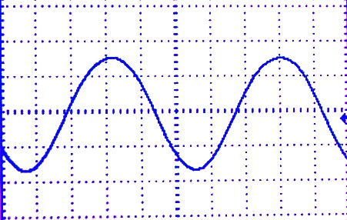

20. What is the typical frequency range of hearing of a human?
21. How does a sound change if the wave it is made up of is increased in amplitude while at the same time being decreased in frequency?
22. What is meant by the ‘quality’ of a sound?

ULTRASOUND
23. What is different about ultrasound compared with ordinary sound?
24. What are the advantages of using ultrasound over X-rays for pre-natal scanning?
25. Use the equation: speed = distance / time to determine the distance to a reflecting surface if a pulse of ultrasound, of speed 1500 m/s is received back from this surface 1.5 seconds after it was transmitted.

THE MOTOR EFFECT
26. How does a moving coil loudspeaker produce a sound wave?
27. Complete the following sentences:
When a current carrying wire is placed inside a __________ field it will experience a force that is proportional to the magnitude of the _________, the strength of the magnetic field and the length of the __________ inside the field. This force will also be ___________ when the conducting wire is at an angle of _________ degrees to the magnetic field direction.
Give two uses of the force experienced by a current carrying conductor in a magnetic field.
28 (a) What is a split-ring commutator?
(b) Why is it needed in a DC electric motor?
(c) Why does an AC motor not need one?

ELECTRICAL GENERATORS
29. How can the current produced in a coil when a magnet is moved in and out of it be:
(a) increased; (b) reversed in direction
30. Below is a diagram of a device used to generate electricity.
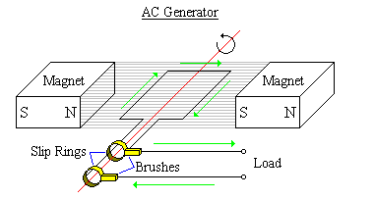
X
(a) Is it an AC or DC generator?
(b) What are the devices labelled ‘X’?
(c) Justify your answer to part (a)
(d) Sketch a graph showing how the potential difference supplied by this generator varies in time.

TRANSFORMERS
31. Draw a labelled diagram of a step-up transformer.
32. Where in the National Grid system would you expect to find:
(a) A step-down transformer
(b) A step-up transformer
33. Why do transformers need AC to work?
34. Use the transformer equation to complete the table below.
 | Primary Coil |  | Secondary Coil
 | Volts (V) | Turns | Volts (V) | Turns
(a) | 230 | 300 | 23
(b) | 230 | 400 |  | 800
(c) |  | 1000 | 12 | 200
(d) | 50 |  | 150 | 900
(e) | 230 |  | 4.6k | 20 000

STARS & GALAXIES
35. (a) What is a galaxy?
(b) What is the name of our galaxy?
(c) Why was it given this name?
36. Complete the following sentences:
The Sun is one of the stars in our galaxy which contains many billions of ________. The Andromeda Galaxy is just visible to the naked eye and is one of at least a _______ galaxies in the Universe .
37. Outline the future history of the Sun.
38. Name the nearest star to Neptune.
39. (a) List the following life-stages of a star like the Sun starting from the earliest.
planetary-nebula; main-sequence; red-giant; white-dwarf; proto-star; nebula
(b) A more massive star than the Sun may have different final stages. What are these?
(c) a black hole
40. Why does the Sun not collapse under its own weight?
41. How does the Sun produce energy?
42. How where each of the following elements probably formed in the Universe?
(a) oxygen
(b) uranium
(c) hydrogen
43. Why do we believe that we are made out of the remnants of an older star or stars?

