Efficiency of an electric motor simulation
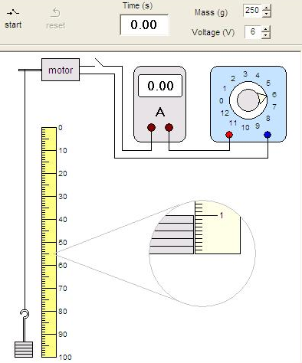
[Demo set up using a joulemeter – M67]

1. On your desktop:
Open the Science folder
– then Science Investigations 2 (NOTE the 2!)
– then select ‘Physics’ – then select ‘Motors’.
You should see a display like that opposite:

2. Note the effect of pressing the ‘start’ and
‘reset’ buttons. Try to time how long it takes for
the mass to be lifted up by 100 cm.

3. The electrical energy in joules supplied to the
motor is equal to:
the time (in seconds) multiplied by
the electric current (in amps) multiplied by
the voltage of the power supply.

4. What are these values initially when raising the
mass of 250g up by 100cm?
Time = _____________ seconds
Current = ______________ amperes
Power supply voltage = __________ volts
Electrical energy supplied = _______________ joules
Note: Remember the computer has a calculator!

5. The gravitational potential energy in joules gained by the mass is equal to
the mass in grams divided by one hundred.
So in the initial case this is 250g / 100 = 2.5J.

6. The efficiency of the motor is equal to: gravitational potential energy gained by the mass
electrical energy supplied to the motor
Calculate the efficiency of the motor.

Motor efficiency when raising a mass of 250g = _________

7. Using EXCEL to produce a results table repeat the above to find the efficiency of the motor when raising masses of: 50g to 450g.
Note: You may have to increase the power supply voltage!

8. Use EXCEL to plot a line graph of Motor efficiency (y-axis) against Mass lifted (g) (x-axis).
You may prefer to hand draw a graph for this.

9. With what mass is the efficiency maximum? __________________________________

10. Suggest some ways in which the electrical energy supplied to the motor is being wasted.
_________________________________________________________________________
_________________________________________________________________________
_________________________________________________________________________

11. With the original settings (mass = 250g; power supply = 6V) investigate the effect of using a different power supply voltage on the motor’s efficiency.

