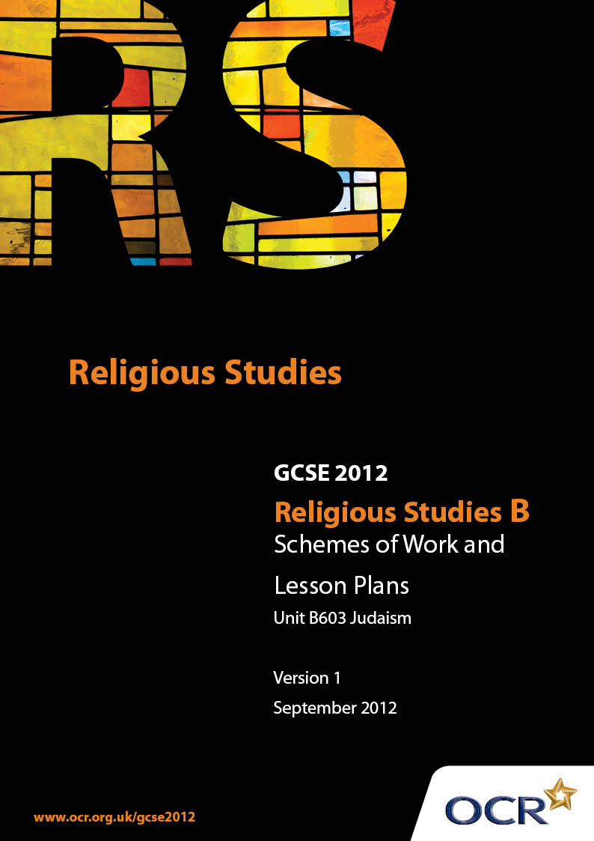

Contents
Introduction 3
Sample Scheme of Work: Unit B603: Ethics 1: Relationships, Medical Ethics, Poverty and Wealth (Judaism) 5
Sample Lesson Plan: Unit B603: Ethics 1: Relationship, Medical Ethics, Poverty and Wealth (Judaism) 14

Introduction

Background
Following a review of 14 – 19 education and the Secondary Curriculum Review, the Qualifications and Curriculum Authority (QCA) has revised the subject criteria for GCSEs, for first teaching in September 2009. This applies to all awarding bodies.
The new GCSEs have more up-to-date content and encourage the development of personal, learning and thinking skills in your students.
We’ve taken this opportunity to redevelop all our GCSEs, to ensure they meet your requirements. These changes will give you greater control of assessment activities and make the assessment process more manageable for you and your students. Controlled assessment will be introduced for most subjects.
From September 2012 assessment tasks may be undertaken at any point between release of the task and the examination series for which the task must be submitted. Centres must ensure that candidates undertake a task that is valid for submission in the year in which the candidate intends to submit it.
OCR has produced a summary brochure, which summarises the changes to Religious Studies. This can be found at www.ocr.org.uk, along with the new specification.
In order to help you plan effectively for the implementation of the new specification we have produced these Schemes of Work and Sample Lesson Plans for Religious Studies. These Support Materials are designed for guidance only and play a secondary role to the Specification.

Our Ethos
OCR involves teachers in the development of new support materials to capture current teaching practices tailored to our new specifications. These support materials are designed to inspire teachers and facilitate different ideas and teaching practices.
Each Scheme of Work and set of sample Lesson Plans is provided in Word format – so that you can use it as a foundation to build upon and amend the content to suit your teaching style and students’ needs.
The Scheme of Work and sample Lesson plans provide examples of how to teach this unit and the teaching hours are suggestions only. Some or all of it may be applicable to your teaching.
The Specification is the document on which assessment is based and specifies what content and skills need to be covered in delivering the course. At all times, therefore, this Support Material booklet should be read in conjunction with the Specification. If clarification on a particular point is sought then that clarification should be found in the Specification itself.

A Guided Tour through the Scheme of Work

= Innovative Teaching Idea
This icon is used to highlight exceptionally innovative ideas.


= ICT Opportunity
This icon is used to illustrate when an activity could be taught using ICT facilities.

Unit B603: Ethics 1 (Relationships, Medical Ethics, Poverty and Wealth) (Judaism)
Suggested teaching time | 14 hours | Topic | Human Relationships
Topic outline |  | Suggested teaching and homework activities |  | Suggested resources | Points to note
Roles of Men and Women in the Family |  | - Write a ‘Parenting’ Magazine for Jewish families. Include advice, articles about issues of concern to Jewish families, and a problem page  - Compile diary entries, blogs or video diaries of Jewish mothers and fathers commenting on their family lives  - Create a guidebook for families new to a synagogue, explaining the expectations for men and women  - Visit a local synagogue, or invite someone from the synagogue, to discuss the roles of men and women in the Jewish Community |  | - ‘Rugrats’ DVDs  - http://jewishfamily.com/  - http://www.boardofdeputies.org.uk/file/FamilyLifeCustoms.pdf | - On-line resources will need to be previewed before use
Marriage and Marriage Ceremonies |  | - Create an Audio Commentary to a video of a Jewish Wedding Ceremony  - Create the Order of Service for a Jewish Wedding Ceremony. Include notes in each part of the ceremony to explain what is going on to any guest who is not Jewish  - Design an advice leaflet for couples setting out on their married life. Feature the Jewish teachings about married life, and explain how this should be put into practice in 21st Century Britain |  | - Wedding videos can be found on YouTube. Download using RealPlayer, and convert using VLC or “Free Video Converter” (all free software). Windows Movie Maker can be used to edit the video, and add an audio commentary. Students will need to use a microphone – the type used for internet phone calls can be bought for less than £5!
Divorce |  | - Choose a storyline from a TV Soap, film or book. The story should include some sort of marital difficulty. Apply the Jewish teaching to the situation – stage the Rabbinical hearing which would issue the Get  - Create letters (or blog-posts) from Jewish men and women who are experiencing difficulties in their marriages. Write answers as though from a Rabbi giving the official Jewish teaching about resolving the difficulties |  | - http://www.jonathanginsburg.net, or search for Jewish Divorce on YouTube  - http://www.boardofdeputies.org.uk/file/FamilyLifeCustoms.pdf
Sexual Relationships and Contraception |  | - Design a series of lessons on Contraception suitable for Year 10, featuring the Jewish teachings on artificial contraception  - Make a video (similar to the ‘Silver Ring Thing’ videos) putting forward Jewish beliefs about Sexual Relationships |  |  | - If video making equipment is unavailable, teachers can create a storyboard blank, and students can plan the video on paper. http://www.open.ac.uk/crete/movingwords/pdf/storyboard.pdf

Unit B603: Ethics 1 (Relationships, Medical ethics, Poverty and Wealth) (Judaism)
Suggested teaching time | 14 hours | Topic | Religion and Medical Ethics
Topic outline |  | Suggested teaching and homework activities |  | Suggested resources | Points to note
Attitudes to abortion |  | - Note the various interpretations of the Jewish teachings on the sanctity of life in a mind map – refer the teachings to relevant quotations  - Apply the teachings to case studies (real or invented). Create an agony aunt style article outlining the advice from Jewish authorities in each case  - Role play scenarios where abortion is being discussed – students should include Jewish teaching, both orthodox and progressive, in their discussions  - Watch excerpts from ‘The Cider House Rules’ and “Vera Drake’. Write summaries of the two stories as though Dr Larch and Vera were Jewish |  | - Relevant textbooks  - Dvds of Cider House Rules and Vera Drake | - Internet resources that campaign for and against abortion often feature distressing images
Attitudes to Fertility treatment |  | - Write a speech that could be delivered by a Jewish member of the House of Lords outlining the Jewish community’s views on Fertility Treatment  - Watch excerpts from ‘Maybe Baby’ – rewrite the story to reflect the views of a Jewish couple |  | - DVD of ‘Maybe Baby’. This is a ‘15’ DVD. So be careful which excerpts you use.
 |  | - Watch appropriate clips from films such as ‘Gattaca’, ‘The Island’ or ‘Attack of the Clones’. Use to provoke discussion about cloning as a technology. Stage a parliamentary debate on cloning, with one student taking the part of a Jewish MP |  | DVDs of ‘Gattaca’, ‘The Island’ and ‘Star Wars Attack of the Clones’. This is a ‘15’ DVD. So be careful which excerpts you use.
Attitudes to Euthanasia and Suicide |  | - Create a scrapbook of recent news stories that feature Euthanasia. Write a commentary on each story from the point of view of a Jewish person  - Prepare a guidebook of Jewish attitudes to Euthanasia suitable for distribution by a GP to patients’ families  - Research the Jewish Hospice Movement  - Create a fundraising brochure for a local Jewish Hospice, making clear its Jewish background and principles |  | - Consult websites such as http://www.ohrami.org
Using Animals in Medical Research |  | - Prepare a table of Jewish teachings that could be used to support and oppose vivisection  - Research Jewish attitudes to animals. Apply this to the question of medical research using animals |  |  | - Internet resources that campaign for and against the use of animals in medical research often feature distressing images

Unit B603: Ethics 1 (Relationships, Medical Ethics, Poverty and Wealth) (Judaism)
Suggested teaching time | 14 hours | Topic | Religion Poverty and Wealth
Topic outline |  | Suggested teaching and homework activities |  | Suggested resources | Points to note
Religious views of wealth and of the causes of hunger, poverty and disease |  | - Use Red Nose Day resources to write an article (or a page for the School website) for the School Newsletter explaining the problem of poverty  - Use clips from the Business News, Economics programmes or other related material. Consider ethical issues such as Child Labour. Discuss appropriate ways to make money. Apply Jewish teachings to the discussions  - Prepare publicity material for a Jewish version of Comic Relief, explaining its motives  - Research Jewish Charities working to alleviate suffering in the UK and abroad |  | - BBC iPlayer  - Fair Trade videos on YouTube  - ‘Blood, Sweat and T-Shirts’ Video  - Some students may also be studying Economics, and will perhaps be able to bring some expertise to this topic
Concern for others |  | - Carry out a survey of local news stories, looking for stories involving hardship or other need  - Create a leaflet called ‘Gemilut Hasadim’, that could be used by a local synagogue to encourage its members to become involved in caring for the community  - Interview a representative of the local Jewish community about the Synagogue’s provision for the disadvantaged  - Watch the discussion between the boys in the film ‘Millions’ to prompt a discussion about the best way to help people who are disadvantaged |  | - Local press and internet sites  - DVD ‘Millions’
The uses of money |  | - Make a leaflet that explains Tzedakah.  - Design a series of posters campaigning for a Jewish Charity  - Make a list of relevant references to Jewish teaching about the use of money  - Discuss Economics and Business stories from the news in the light of Jewish Teachings |  | - Some students may also be studying Economics, and will perhaps be able to bring some expertise to this topic
Moral and immoral occupations |  | - Use a Careers website to compile a list of jobs. Assess each one for its suitability for a Jewish person. Explain with reference to the relevant Jewish Teachings  - Summarise the Shabbat laws and teachings. Apply them to the world of work. Create a guidance booklet helping Jewish people to keep the Shabbat laws at work

Unit B603: Ethics 1 (Relationships, Medical Ethics, Poverty and Wealth) (Judaism)

A Jewish Marriage Service
OCR recognises that the teaching of this qualification above will vary greatly from school to school and from teacher to teacher. With that in mind this lesson plan is offered as a possible approach but will be subject to modifications by the individual teacher.
Lesson length is assumed to be one hour.

Learning Objectives for the Lesson
Objective 1 | To Describe the sequence of events that form the Jewish marriage service.
Objective 2 | To Explain the significance of the events.
Objective 3 | To develop techniques appropriate to answering a GCSE Question
Objective 4 | To develop knowledge of the technical terms associated with the Marriage service

Recap of Previous Experience and Prior Knowledge
- Students will have completed the unit of work on the Roles of Men and Women in the Family

Content
Time | Content
5 minutes | Display a picture of a prominent “couple” that are unmarried, but who live together. Explain that they share mortgage, bank accounts &c. Pose the question “Why bother getting married”. Discuss secular British ideas about marriage.
5 minutes | Using an appropriate textbook, note the different stages of the wedding service. Give each stage a title and note what happens for each one.
10 minutes | Show a video clip (or clips) of a wedding service without comment. Allow the students to identify which stage they are viewing. Match words in the textbook to the service in the video(s).
25 minutes | Create an Order of Service booklet (using a Desktop Publishing program, or more traditional means). Include quotations, rather than the complete text, and add notes to explain the significance of each stage for non-Jewish guests

Consolidation
Time | Content
10 minutes | “Describe a Jewish Wedding Service” – allow students 10 minutes to answer the question. The teacher can either mark students’ answers “on the fly” with oral feedback on improvements, or return marked at the next lesson.
5 minutes | Display up to five “technical terms” from the Jewish service (e.g. Sheva Berachos). Students should write their understanding of the meaning. Alternatively, distribute the terms on cards, with meanings on separate cards, allowing the students to try to match terms with meanings.

Unit B603: Ethics 1 (Relationships, Medical Ethics, Poverty and Wealth) (Judaism)

Jewish Attitudes to Abortion
OCR recognises that the teaching of this qualification above will vary greatly from school to school and from teacher to teacher. With that in mind this lesson plan is offered as a possible approach but will be subject to modifications by the individual teacher.
Lesson length is assumed to be one hour.

Learning Objectives for the Lesson
Objective 1 | To describe Jewish attitudes to abortion
Objective 2 | To explain Jewish responses to specific situations and case studies
Objective 3 | To discuss specific cases in the light of Jewish teaching

Recap of Previous Experience and Prior Knowledge
- Students will have made notes on the Jewish teachings using an appropriate textbook.

Content
Time | Content
5 minutes | Students should list reasons why a woman might seek to have a pregnancy terminated. Collate a class list of reasons.
10 minutes | For each reason listed in the Starter activity, invent a “back story” to create a case study. This can be done individually, or in groups (one group for each case study). Share stories at the end of the activity. They can then discuss each case study, giving a personal response for each situation.
15 minutes | Discuss each one, applying both personal opinion (in the light of the starter activity) and Jewish teachings (from notes taken from a previous lesson). Students can write panels for both case study and responses to create a wall display.
15 minutes | Watch clips from ‘The Cider House Rules’ and ‘Vera Drake’. Discuss how the main characters would respond in the situations featured in the films if they were Jewish. Summarise the discussion in writing.

Consolidation
Time | Content
10 minutes | Give students 10 minutes to answer the question “Abortion is never Justified” Do you agree…? The teacher can either mark the question as the students are working (giving oral feedback for students to respond to instantly) or collect the work in to return for the next lesson.
5 minutes | Students should raise “thumbs up” or “thumbs down” to show their support (or otherwise) for a series of statements pre-prepared and read out by the teacher. The teacher can challenge individual students to justify their vote.

Unit B603: Ethics 1 (Relationships, Medical Ethics, Poverty and Wealth) (Judaism)

Moral and Immoral Occupations
OCR recognises that the teaching of this qualification above will vary greatly from school to school and from teacher to teacher. With that in mind this lesson plan is offered as a possible approach but will be subject to modifications by the individual teacher.
Lesson length is assumed to be one hour.

Learning Objectives for the Lesson
Objective 1 |  | To describe the impact of Jewish values and beliefs on a person’s choice of job and on their professional conduct
Objective 2 |  | To explain Jewish reasons a Jewish person might have for choosing one job over another.
Objective 3 | To discuss the Sunday Trading debate in the light of Jewish Shabbat laws.

Recap of Previous Experience and Prior Knowledge
- Students will have studied the impact of the Mitzvot on a Jewish person’s choice of job, perhaps through an examination of a Careers Database.

Content
Time | Content
5 minutes | Show a clip of a Bush Tucker trial from the ITV Show ‘I’m A Celebrity…’ Pose the question “What would you do for money?” Discuss a Jewish response to the question.
10 minutes | Use an appropriate Textbook or other resource to make notes on the Shabbat Law and the various interpretations and applications of the law.
10 minutes | Apply the teachings researched to the database of jobs from a previous lesson. If computers are available, this can be done through a Careers website. Make a list of the ways in which specific jobs may be affected by the Shabbat laws.
20 minutes | Design a careers leaflet for Year 9 or 11 students, outlining the Shabbat Law and its interpretations and explaining how to choose a job that will be compatible with the observance of Shabbat. If computers are available, this could be done using a Desktop Publishing programme.

Consolidation
Time | Content
10 minutes | Give students 10 minutes to answer the question “The Shabbat laws are impractical and out of date” Do you agree…? The teacher can either mark the question as the students are working (giving oral feedback for students to respond to instantly) or collect the work in to return for the next lesson.
5 minutes | Students should carry out a “personal audit” – how would the Shabbat laws affect them? Discuss the outcomes of the audit, and make sure that comments are related clearly to Jewish teachings.

