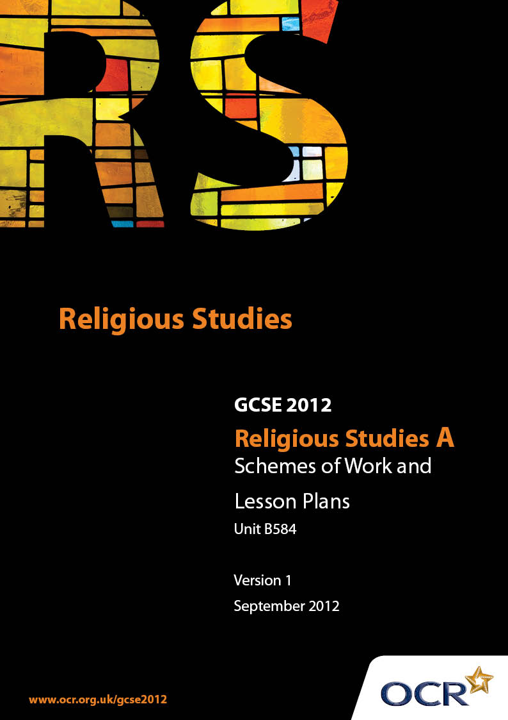

Contents
Introduction 3
Sample Scheme of Work: Unit B584: Christian Scriptures 2 (Luke) 5
Sample Lesson Plan: Unit B584: Christian Scriptures 2 (Luke) 21

Introduction

Background
Following a review of 14 – 19 education and the Secondary Curriculum Review, the Qualifications and Curriculum Authority (QCA) has revised the subject criteria for GCSEs, for first teaching in September 2009. This applies to all awarding bodies.
The new GCSEs have more up-to-date content and encourage the development of personal, learning and thinking skills in your students.
We’ve taken this opportunity to redevelop all our GCSEs, to ensure they meet your requirements. These changes will give you greater control of assessment activities and make the assessment process more manageable for you and your students. Controlled assessment will be introduced for most subjects.
From September 2012 assessment tasks may be undertaken at any point between release of the task and the examination series for which the task must be submitted. Centres must ensure that candidates undertake a task that is valid for submission in the year in which the candidate intends to submit it.
OCR has produced a summary brochure, which summarises the changes to Religious Studies. This can be found at www.ocr.org.uk, along with the new specification.
In order to help you plan effectively for the implementation of the new specification we have produced these Schemes of Work and Sample Lesson Plans for Religious Studies. These Support Materials are designed for guidance only and play a secondary role to the Specification.

Our Ethos
OCR involves teachers in the development of new support materials to capture current teaching practices tailored to our new specifications. These support materials are designed to inspire teachers and facilitate different ideas and teaching practices.
Each Scheme of Work and set of sample Lesson Plans is provided in Word format – so that you can use it as a foundation to build upon and amend the content to suit your teaching style and students’ needs.
The Scheme of Work and sample Lesson plans provide examples of how to teach this unit and the teaching hours are suggestions only. Some or all of it may be applicable to your teaching.
The Specification is the document on which assessment is based and specifies what content and skills need to be covered in delivering the course. At all times, therefore, this Support Material booklet should be read in conjunction with the Specification. If clarification on a particular point is sought then that clarification should be found in the Specification itself.

A Guided Tour through the Scheme of Work

= Innovative Teaching Idea
This icon is used to highlight exceptionally innovative ideas.


= ICT Opportunity
This icon is used to illustrate when an activity could be taught using ICT facilities.

Unit B584: Christian Scriptures 2 (Luke)
SUGGESTED TEACHING TIME | 1-2 HOURS |  | TOPIC | THE NATURE OF GOD
Topic outline |  | Suggested teaching and homework activities |  | Suggested resources | Points to note
Jesus’ teaching on prayer (Luke 11 1-13) |  | - What do you think prayer is? Students to suggest. List of types of prayer on board. Link student suggestions to the types of prayer  - Students produce a questionnaire on prayer and collect responses. Bar chart on different types of prayers  - ICT – research famous prayers  - Write a prayer for someone who is old/ill/taking part in something special etc. Students to suggest  - Importance of prayer as a means of communication with God  - Research the ‘Western’ or ‘Wailing’ Wall in Jerusalem where many Jews go to pray and place a prayer wish between the stones. Write a prayer wish to put in the wall. Homework  - Using the Lord’s Prayer write down each of the sentences explaining what each part means. Pass to a partner and ask them to write down what they think it means |  | - OCR endorsed textbook  - These could be written on a scroll  - http://www.essortment.com/all/wailingwall_r  sef.htm  - www.inisrael.com/tour/jer/vt_western_  wal.htm  - Copy of The Lord’s prayer on Interactive Whiteboard/OHP/sheets
The Parables of the lost sheep and the lost coin (Luke 15: 1-10)  The parable of the lost son. (Luke 15: 11-32) |  | - Why do people tell important things in stories? What is the difference between a parable and an allegory?  - Make an acrostic using the word ‘parable’  - Explain the parables to someone who does not know about parables using simple language or a modern day approach  - Cloze passage either on Interactive whiteboard for whole class or on sheets for individual work  - The parables were simple stories usually taken from everyday life. Give students a range of everyday things – rocks, seeds, wine bottle etc and ask them to write a parable  - Supply pictures of the parables and ask the students to pick one, explain the meaning and what it is about – Growth of the Kingdom of God/God’s mercy/God’s judgement  - In groups write a playlet explaining the parable  - Produce a booklet for a small child telling a parable. Needs to be simple and colourful |  | - Everyday items supplied to stimulate creative writing in the form of a parable | - All biblical passages can be copied into resources from www.biblegateway.com

Unit B584: Christian Scriptures 2 (Luke)
Suggested teaching time | 1-2 hours | Topic | The kingdom of God
Topic outline |  | Suggested teaching and homework activities |  | Suggested resources | Points to note
The Parable of the Sower (Luke 8:1-15)  The parable of the great banquet (Luke 14:15-24)  The lamp of the body (Luke 11: 33-36)  The narrow door (Luke 13:22-30) |  | - For a parable to be meaningful it needs to be in three stages – listen, understand and reflect. Teacher led discussion on what these key terms mean  - Analysis of the parables – using the three key terms. What do they mean? What do you understand by the parable? etc. Similarities and differences  - Draw a storyboard for the Parable of the Sower explaining each part. Why did Jesus use these examples?  - Some of the parables are similes; some are symbols; some are comparisons. Examine the different types of parable that Jesus used. Why were all parables not of the same format? etc  - ICT – students could research what life was like in Jesus’ time and why it was necessary for him to get his message about the Kingdom of God across in this way |  | - Bible passages – NIV/ on Whiteboard/OHP/sheet  - A worksheet could be constructed to enable students to chart the similarities and differences between the parables

Unit B584: Christian Scriptures 2 (Luke)
SUGGESTED TEACHING TIME | 1-2 HOURS | TOPIC | CHRISTIAN DISCIPLESHIP
TOPIC OUTLINE |  | SUGGESTED TEACHING AND HOMEWORK ACTIVITIES |  | SUGGESTED RESOURCES | POINTS TO NOTE
The faith of the centurion (Luke 7: 1-10) |  | - Look at Isaiah 61:1-2 – What did Jesus say right at the beginning of his Ministry? What were evidence of?  - Different types of miracle- healing the sick, raising people from the dead, casting out demons and power over nature
The cost of being a disciple (Luke 14: 25-33) |  | - Explain dunameis (Greek-miracle) contrast with semeia -signs (used in John’s Gospel)  - Why did Jesus choose the disciples? Friendship – why did you choose your friends or did they choose you? Why did Jesus choose ordinary men? Students to write a list of twelve of their friends and why they chose them – what special qualities do they have?  - Write down the differences between being a follower of Jesus and being a follower of e.g. a pop star/band/ a football team etc  - ICT research a fanclub – if Jesus had been alive today do you think he would have had a fan club? Design a web page for Jesus’ fan club  - Research the symbols that each  disciple has |  | - Internet search engine could be used to facilitate this | - ICT  - Web page design
Peter disowns Jesus (Luke 22:54-62) |  | - Write a profile for one of the disciples  - Write a letter from one of the disciples to his family explaining his reasons for following Jesus  - Peter disowned Jesus – was this the right thing to do?  - Following the prophecy Isaiah 53: 3-4, 8 – the Songs of the Suffering Servant  - Draw the story of the betrayal in pictures using speech bubbles for the characters involved |  | - Extracts from Isaiah could be put on screen (Interactive whiteboard) | - www.biblegateway.com

Unit B584: Christian Scriptures 2 (Luke)
SUGGESTED TEACHING TIME | 2-4 HOURS | TOPIC | CHRISTIAN LIFE
Topic outline |  | Suggested teaching and homework activities |  | Suggested resources | Points to note
Wealth  The Parable of the rich fool (Luke 12: 13-21)  The rich ruler (young man) (Luke 18: 18-30)  The widow’s offering (Luke 21: 1-4) |  | - Put teachings about wealth and other sayings to do with money onto cards – sorting exercise – which are real teachings?  - Using a shop catalogue give out slips of paper with an amount on and which people the students have to buy gifts for. Give different amounts to different students. What would they buy?  - Does having more money make the task harder or easier? Is it necessary to have a great deal of money?  - Explain the saying ‘you can’t take it with you when you die’ |  | - Shop catalogues  - Make fake money/cheques etc | - This could be extended to household bills that need paying/need for food etc  - Citizenship link to cost of buying illegal substances/ crime
Women  At the home of Martha and Mary (Luke 10: 38-42)  Jesus anointed by a sinful woman (Luke 7: 36-50) |  | - Extended writing on why Jesus told stories about how people use wealth  - Historical background to women in Old Testament times; marriage, society, education, religion  - What do we learn about Luke from his references to women?  - Write a letter from a woman who was a witness to the resurrection to a friend telling what she felt when she saw the empty tomb  - Breaking down of barriers by Jesus who reacted openly to women and broke down the barriers of sex, race etc. to enable the Kingdom of God to come |  | - Research – internet search engine
The Resurrection (Luke 24:1-12) |  | - Research the role of women in the Church today. What would you say to someone who said that women should not be ordained – use examples from the gospel in your answer  - Devise a short play about the ‘Case of the missing body’  - Extended writing – why were the women visiting the tomb?  - Who were the two men? Do you think they were angels? Research different types of angel. Do people still believe in angels?  - Why is the Resurrection so important? Look at 1 Corinthians 15:14  - Jesus came to proclaim the Kingdom of God which was not a political state but the role of God in people’s lives. Luke shows that Jesus preached equality. How is equality shown in the world today? |  | - Internet search engine
Outcasts |  | - How does Luke show that prejudice was shown to Jesus? Draw a spidergram with prejudice at the centre. Show all the times that prejudice was shown to Jesus  - Design a ‘wanted’ poster for Jesus written by the Jewish leaders. Include all the things that Pharisees and Scribes said about Jesus
The man with leprosy (Luke 5: 12-16) |  | - Jesus healed people with leprosy, a contagious disease. How do people treat others with terrible diseases such as HIV? How did Princess Diana help people? How did she show others compassion? Find out what President Clinton said about the way she helped people with HIV/AIDS
The parable of the Good Samaritan (Luke 10: 25-37) |  | - Explain the relationship between sin and illness in Jesus’ time. Is it the same today? Do people become ill because they have committed a sin?  - What is special about the parable of the good Samaritan? What does this show? Is hate a good thing? Write a modern day version of the good Samaritan  - Written work: The story of the good Samaritan is important for Christians today because…………’
Zacchaeus the tax collector (Luke 19: 1-10) |  | - "He has gone to be the guest of a 'sinner.' "What does this show of the nature of Jesus? Who would you consider to be a sinner today? How would you support them? Write a letter to someone in authority supporting your choice of ‘sinner’
A crippled woman healed on the Sabbath (Luke 13: 10-17) |  | - Why is this story so important? What is special about the Sabbath? How does Luke show this?  - Jesus said ‘the Son of Man is Lord of the Sabbath’ – what does this show about Jesus’ attitude to the Sabbath?  - Should the Sabbath be a day of rest? Devise a questionnaire about working on the Sabbath? Compile your results into a bar chart  - ‘Sunday is the day of worship and it is important to have time to rest and worship God’. Do you agree? In a table explain how this would affect people who have to work on the Sabbath – pilots, nurses, doctors, etc
Suffering  The rich man and Lazarus (Luke 16: 19-31) |  | - Lazarus was a beggar who went to heaven, but the rich man went to the world of the dead. How does this show that God was rewarding the outcast? Research people who help outcasts as Jesus did – Tear Fund, Cicely Saunders, Lighthouse etc. How do these people/organisations help those in need?

Unit B584: Christian Scriptures 2 (Luke)
SUGGESTED TEACHING TIME | 1 HOUR | TOPIC | THE HOLY SPIRIT
TOPIC OUTLINE |  | SUGGESTED TEACHING AND HOMEWORK ACTIVITIES |  | SUGGESTED RESOURCES | POINTS TO NOTE
The Holy Spirit  The events of Pentecost (Acts 2 :1-15, 37-41) |  | - When Jesus ascended into Heaven he promised that power from God would come down to them. How did Jesus keep his promise. Write an eye-witness account based on Acts 2:2-4  - Draw a flame to represent the Holy Spirit. Around the flame write words to describe the effect the Holy Spirit had on the disciples  - Worksheet with sentences from the text jumbled up. Students to put the words into the correct order  - The Holy Spirit was a gift from God. What gift would you like to receive and why. No material things allowed. Perhaps compassion, love, the gift of healing etc. could be used  - Research the seven gifts of the Holy Spirit in the Christian tradition, and spiritual gifts from the Pentecostal tradition |  | - Worksheet with candle on. Word list  - ICT – use of Internet search engine

Unit B584: Christian Scriptures 2 (Luke)

Teachings of Jesus through a study of Luke
Jesus as Messiah: Lord
The Birth of Jesus and the visit of the shepherds Luke 2: 1-20
OCR recognises that the teaching of this qualification above will vary greatly from school to school and from teacher to teacher. With that in mind this lesson plan is offered as a possible approach but will be subject to modifications by the individual teacher.
Lesson length is assumed to be one hour.

Learning Objectives for the Lesson
Objective 1 | Students to understand how Luke shows the promise of a future king through the birth of Jesus.
Objective 2 | Students to appreciate ‘peace’ as an important aspect of Jesus’ birth
Objective 3 | Students to be able to analyse the significance of the birth of Jesus.

Recap of Previous Experience and Prior Knowledge
- Students to recap on why the birth of Jesus in humble surroundings is significant.

Content
Time | Content
5 minutes | Quick discussion on why do people give gifts at Christmas? Explanation that Jesus was God’s gift to mankind.
10 minutes | Read The birth of Jesus and the visit of the shepherds Luke 2:1-20 explain that it does not matter when Jesus was born (celebrated at Christmas) but the fact that it was God’s son. Using v 14 ‘Glory to God in the highest and on earth peace to men on whom his favour rests’ (NIV) ask students to jot down a few examples of why peace is important to us today.
5-10 minutes | Video clip from ‘Jesus of Nazareth’ on birth of Jesus.
20-25 minutes | Read ‘Christmas in the trenches’ by John McCutheon (on screen for all to see?) Briefly explain the background to the war and the difficulties facing the troops. Students to write a letter home to a loved one explaining what happened and why the situation of the truce happened in such an arena of horror, fear and death.
5 minutes | Question and answer session on the meaning of peace as the students perceive it using their examples from earlier.

Consolidation
Time | Content
5 minutes | Students to give one example of something they have learnt in the lesson that they did not know before.
5 minutes | Short closing discussion: Jesus’ birth bringing peace into the world, and how it can be used to facilitate peace today.

