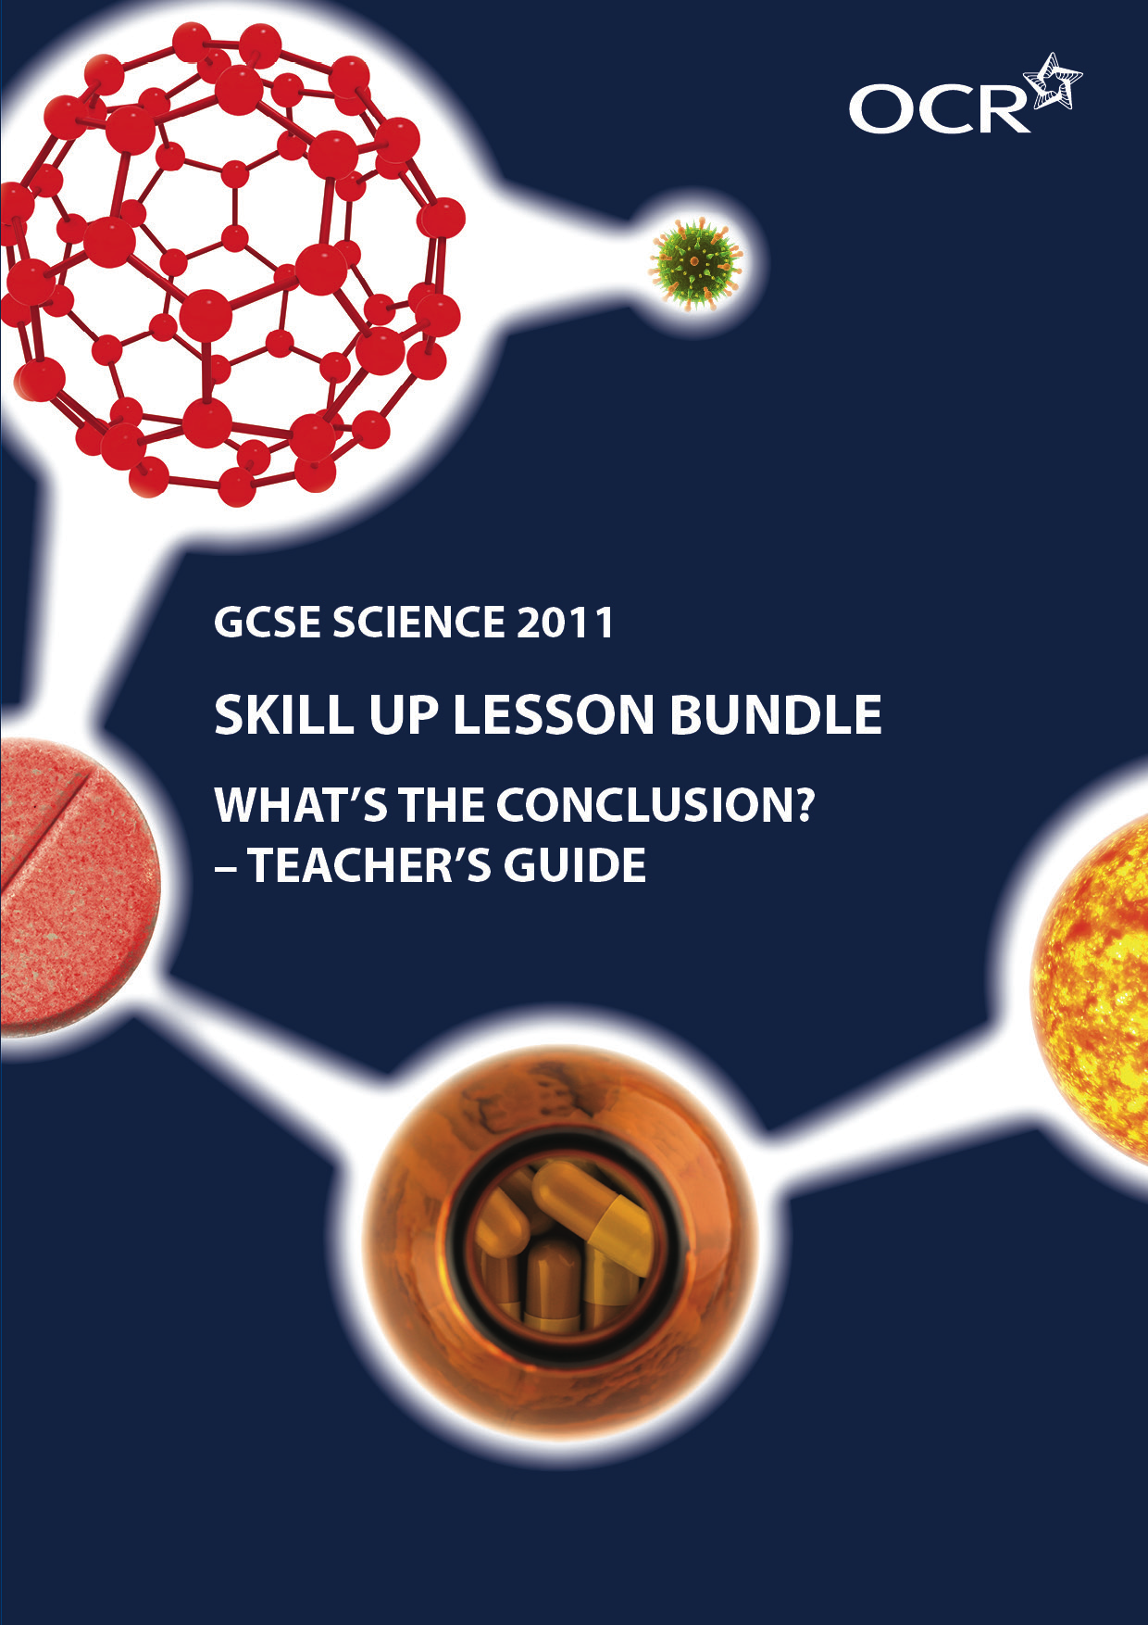
What’s the conclusion?
Teacher’s Guide

Summary
OCR has worked with the Centre for Science Education to produce three sets of teaching resources linked to our GCSE Science specifications.

These lesson bundles comprise of a guide for teachers, student worksheets and a Powerpoint presentation.

The Teacher’s Guide, which is this document, sets the scene and give you an exemplar lesson plan to adapt and use.

The student worksheets can be printed off or used electronically as part of the lesson, in conjunction with the Powerpoint presentation, as you see fit.
This skill development activity is set for: OCR GCSE in Science B J261. Understanding Ourselves B1e Drugs and You
Science A J241. Keeping healthy B2.3 Misuse of drugs
This set of resources is a skill teaching activity set in an engaging, topical context to teach the process of ‘drawing conclusions’ (see objectives below). Students become investigative journalists on a story about caffeinated alcoholic beverages (CABs). Sales are booming. Their fans claim they let you party for longer because caffeine counteracts the effects of alcohol. But is their hypothesis correct? The activity uses a flowchart tool, to break down and make visible the process of coming to a reasoned conclusion.

Learning objectives
The main focus is to address ‘Developing students’ skills to support achievement in GCSE sciences’, strand 5:
1) (Low demand) Explain how a conclusion is based on the scientific evidence which has been collected.
2) (Standard demand) Determine the level of confidence for a conclusion based on scientific evidence and describe how further predictions can lead to more evidence being obtained.
3) (High demand) Identify and critically analyse conflicting evidence, or weaknesses in the data, which lead to different interpretations, and explain what further data would help to make the conclusion more secure.
To address content from the specification, there is an extra objective.
4) (Science B B1e) Recall that alcohol is an example of a depressant, so it slows brain activity and caffeine is an example of a stimulant so it increases brain activity. Some students will be able to explain their mode of action.
(Science B B2.3) Understand that the misuse of drugs (eg alcohol) can have an adverse effect on health

CONTENT
Time | Stage | Activity
10 min | Engage  Students are introduced to Buzz, their new role and discuss how to test the maker’s hypothesis. | Slides 3-5  Stills from an advertisement for a new energy drink: Buzz.  Slide 6  Welcomes the students to their task as an investigative journalist working on a new episode of ‘Media Watch’ and outlines the claim of the makers: that because Buzz contains a mixture of alcohol and caffeine, it keeps you alert.  Slide 7  A starter activity. Show the first 3 statements and ask students to discuss how they think Buzz works and come up with a hypothesis. This task also enables discussion about what the terms ‘stimulant’ and ‘depressant’ mean. Then reveal the final statement – the maker’s hypothesis.  Slide 8  Students discuss in pairs what tests they could carry out and what evidence they could collect to see if this hypothesis was correct. There is room on the slide for their ideas to be added onto the board.
20 min | Explore  Students study the evidence collected by the scientists. | Slide 9 and 10.  This introduces the task.  Slide 11  This slide shows the tests that the scientists will carry out. Ask students to respond with their predictions for the results of the tests if the hypothesis is correct.  Students then work in pairs using SS1a or SS1b to look at the evidence produced from the experiments carried out by the scientists.  Slide 12 contains a question to help focus the students when looking at the graphs. They should copy this down so they can refer to it during whilst studying the graphs as you may wish to go back to displaying slide 11 as the students analyse the results.  Optional: Show the class an example of what a reaction time test entails by trying an: Online reaction test .  NB: This task is differentiated. SS1a is for the less able. SS1b is for the more able.
10 min | Explain  Students discuss their findings | Initiate a discussion with the students on what they decided about the evidence: what did the results show? Do they back up their original prediction based on the hypothesis that the effects of alcohol can be cancelled out by caffeine?  They should answer that yes – both graphs back up the prediction so the conclusion is that drinking Buzz has no affect on reaction times and hand-eye coordination. You may wish to discuss the slight discrepancy with the hand-eye coordination results and possible problems with the methodology e.g. was enough time left between drinking the drink and taking the tests? Optional: SS8 Is a flow chart that you may wish to go through with the students to help them organise their thoughts. SS9 is for teacher reference and shows the route the students should take through the flow chart.
20 min | Evaluate  Students write up a storyboard for the programme. | Students then begin to use SS2 to write out their story-board for the programme. They should fill in the first part ‘the tests’. Note that the pen symbol indicates a place on the flowchart.  They should find that both pieces of evidence back up the prediction that drinking both alcohol and caffeine together results in no significant changes to reaction times and hand-eye coordination. The makers of Buzz seem to be correct in their hypothesis.  Slide 13  Brings the task back to whether drinking Buzz means that people are safe to drive. Is this a good message to send out to the viewers of the television programme?  Ask students for their initial thoughts on this.  Optional: Show the class an example of what the hazard perception test entails by showing them (or letting them try) the hazard perception test video .  Then ask students to work in pairs again and study the evidence on SS3a or b.  Introduce the flowchart on SS4. This leads the students through how to judge how confident they are in their conclusion. Students use all of the evidence they have (results from all three tests) and the flowchart to write out their final assessment.  Briefly discuss with the class what overall conclusion have they come to: is it OK to drink Buzz and drive?  You may wish to discuss with the students that when the evidence does not support any of the predictions, the hypothesis will be rejected. This was intentionally left out of the flowchart in order not to introduce too much complexity and reduce its usefulness as a learning tool.  They should see from the results of the hazard perception test that drinking Buzz makes people less aware of hazards whilst driving. It is important to note here that the law for drink-driving is only concerned with blood alcohol levels.  Students complete SS2.
15 mins | Extend *  Students judge a conclusion in a new context. | Students use the flowchart on SS4 to carry out the task on SS6 which enables them to judge confidence in a conclusion made from the results of some fictional experiments to see if eating broccoli can prevent cancer.  A teaching guide (SS7) is provided.

* As homework or part of a subsequent lesson

Skillup activity OCR created by the upd8 team © OCR 2012. Teachers and others who download this material may use it freely within their institution. For any other usage consult OCR. OCR are not responsible for any revision that may be made to the material after it has been downloaded.

7990733828
1/12

