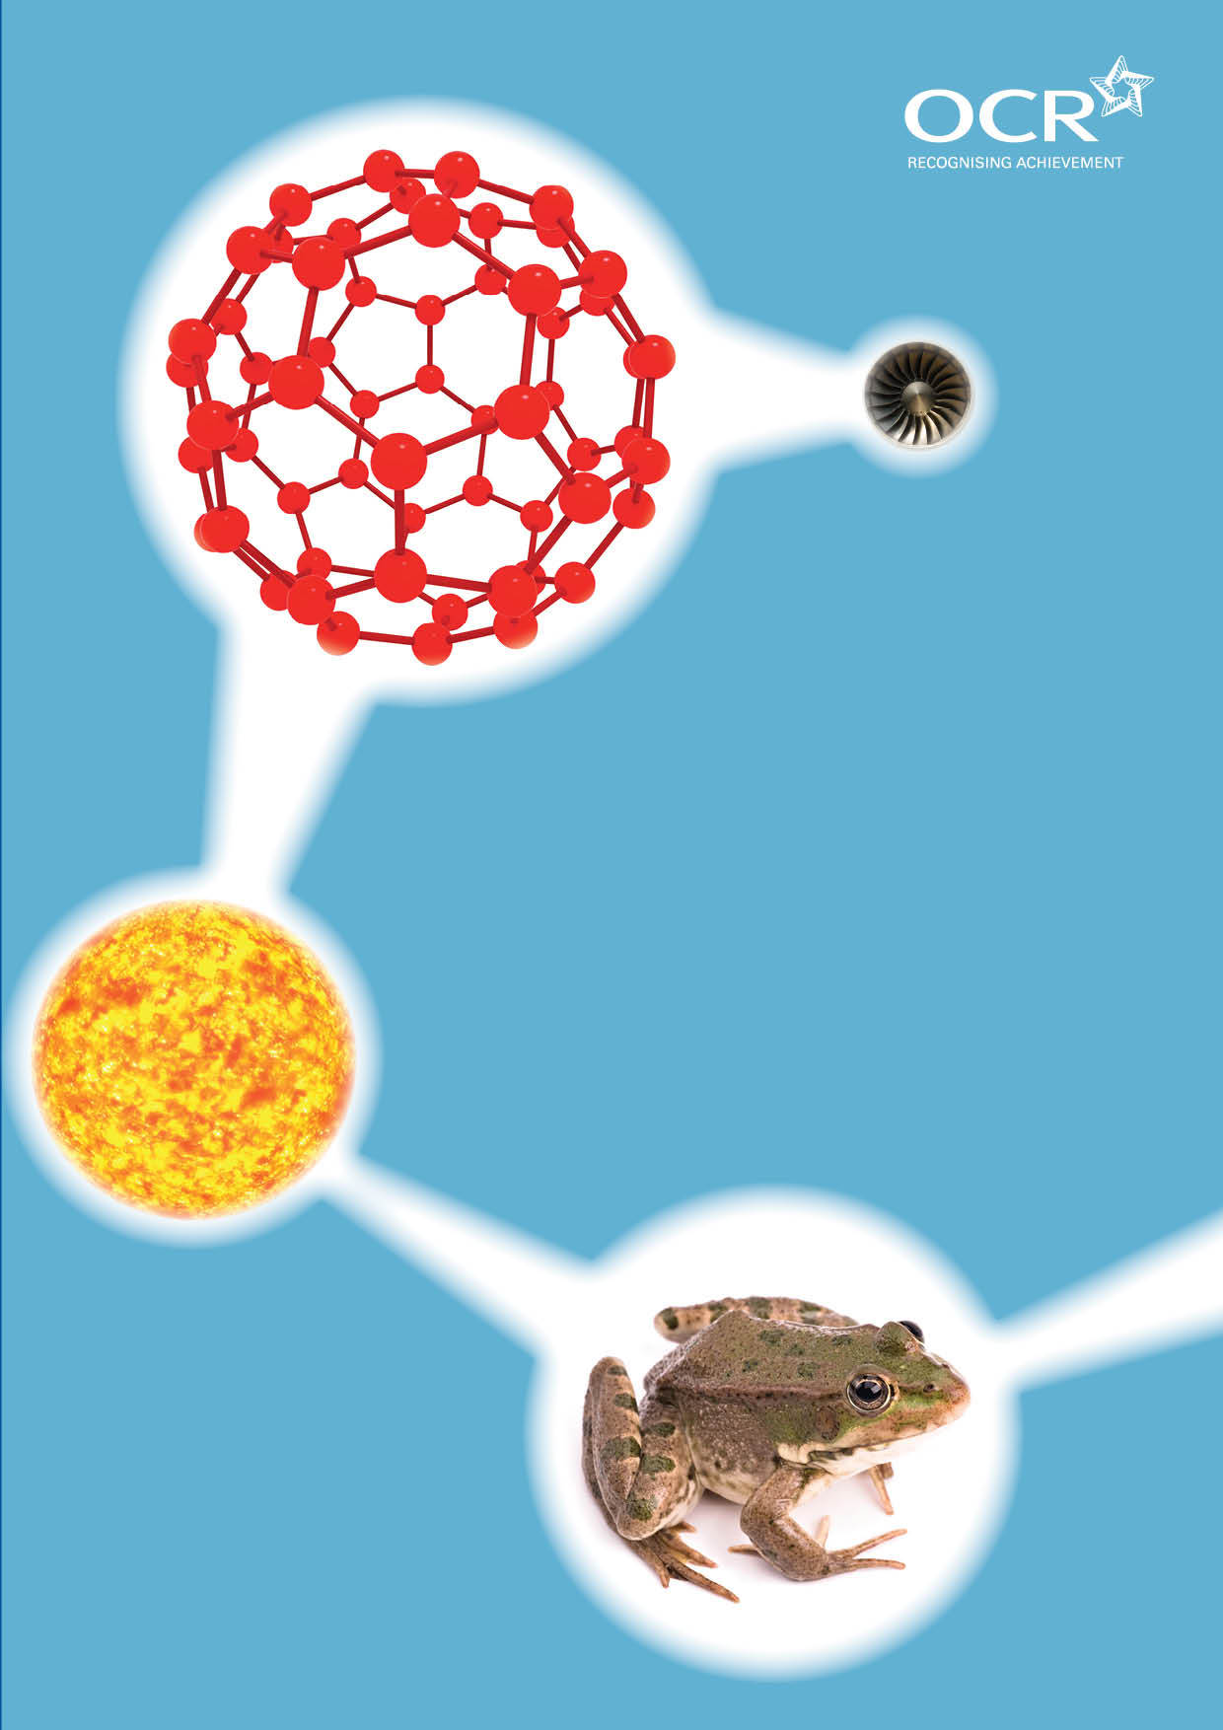
TWENTY FIRST CENTURY SCIENCE SUITE
SCHEMES OF WORK AND LESSON PLANS
P6: Radioactive materials
VERSION 1 JULY 2011
Introduction
OCR involves teachers in the development of new support materials to capture current teaching practices tailored to our new specifications. These support materials are designed to inspire teachers and facilitate different ideas and teaching practices. Each Scheme of Work and set of sample Lesson Plans is provided in Word format – so that you can use it as a foundation to build upon and amend the content to suit your teaching style and students’ needs.
The Scheme of Work and sample Lesson plans provide examples of how to teach this unit and the teaching hours are suggestions only. Some or all of it may be applicable to your teaching.
The Specification is the document on which assessment is based and specifies what content and skills need to be covered in delivering the course. At all times, therefore, this Support Material booklet should be read in conjunction with the Specification. If clarification on a particular point is sought then that clarification should be found in the Specification itself. References to the content statements for each lesson are given in the ‘Points to note’ column.

Sample Scheme of Work
GCSE 21st Century Science Physics A J245
Module P6: Radioactive materials
Suggested Teaching Time: 13 Hours

Topic outline | Suggested teaching and homework activities | Suggested resources | Points to note
Radioactive materials | Brainstorm radioactivity, to establish student’s current understanding (which is likely to be negative and influenced by cartoons)  Show the students a Geiger Muller tube with counter. Explain what causes it to click. Show that it clicks fast when held over a source of radiation.  Hold the equipment over a series of different materials and count the number of decays per minute.  Students plot bar graphs of the data, adding a line across the graphs to represent the background count rate.  Discuss the data: is the data reliable enough to decide which materials were naturally radioactive?  Students plot pie charts of sources of background radiation, emphasising which sources are natural. | Geiger Muller tube and rate counter.  Beta or gamma source.  Various everyday substances are naturally radioactive, for example coffee, low sodium salt, bananas, granite.  Graph paper.  Protractors and compasses.  Calculators.  Tables of information about background radiation.  There is a clip called “nuclear energy our misunderstood friend” in The Simpsons, episode 3 of season 1, which could be used to discuss the difference between reality and cartoon depictions. | Throughout this unit, local health and safety procedures for handling radioactive materials must be followed. In particular, students under the age of 16 should not handle radioactive materials.  Students are expected to be able to plot bar and pie charts.  “corrected count rate” is not specifically mentioned on the specification.  If time and/or resources allow, students could measure the radioactive decay from a number of samples of the same material, and calculate the mean and range of the data.
Atomic Structure | Use a computer animation or video to show the relative sizes of atoms to everyday objects.  Describe the composition of atoms, with a nucleus, made of protons and neutrons, surrounded by electrons.  Higher tier: discuss isotopes, giving carbon-12 and carbon-14 as examples.  Students make atomic model mobiles from wire, string and plasticine. Higher tier candidates could be given a particular element and asked to create the element from only the details on the periodic table. | Video clips or animations showing relative size of atoms (e.g. the second half of “powers of ten” on YouTube).  Various computer programs exist for “building” atoms given details of element and atomic number / atomic mass.  Materials for making mobiles of atoms. An alternative to this is atomic earrings, using very fine wire, string, and small beads, with earring hooks.  Higher tier candidates would benefit from a worksheet looking at the different atoms in terms of the numbers of protons, neutrons and electrons, possibly for homework. | Electron shells are not required for this unit.  In schools where different teachers teach sciences, students may have been taught atomic structure already in Chemistry. Ability to use the periodic table to predict the structure of atoms is not required.

Topic outline | Suggested teaching and homework activities | Suggested resources | Points to note
Discovery of the nucleus | Divide the class into groups. Each has to create a two-slide presentation on one of the historical models of the atom, concentrating whether the model was formed from experimental data, or a theoretical prediction. Models that could be used are: billiard ball, plum pudding (JJ Thompson), Rutherford model, Bohr model.  Students report findings to each other.  Discuss the Rutherford-Geiger-Marsden experiment in detail, emphasising what the experiment showed. | Access to the internet or books showing the history of atomic models.  Computer access or poster making equipment.  Videos or computer simulations explaining the Rutherford-Geiger-Marsden experiment exist, describing how the results would be different if atoms were solid.  Boardworks produce a PowerPoint that covers the history of atomic structure. This could be used as a stimulus for a role play where pupils argue for a particular model by acting as a scientist in each different period of history. | Only the Rutherford-Geiger-Marsden experiment and Rutherford model of the atom is required for this specification.  Higher tier students need to understand the need for a strong force to overcome the repulsive forces between the protons.
Types of radiation | Use a Geiger Muller tube and rate counter to demonstrate the properties of the three types of radiation. In particular, show the penetration of each type by holding the GM tube 10cm or more from an alpha source, or by placing paper, aluminium or thick lead in between the tube and alpha, beta and gamma sources.  Higher tier students need to be able to explain alpha and beta in terms of the decay of the nucleus and complete nuclear equations for these two.  Foundation tier students create posters showing the differences between alpha, beta and gamma radiation.  Students design an experiment to determine which type(s) of radiation are produced by one of the materials investigated in lesson one. They should explain what they will do and how they will use the results to decide on the type/s of radiation present. Less able students will need help with this, perhaps by a more structured approach to the problem using worksheets. | Geiger Muller tube and counter.  Alpha, beta and gamma sources. Please refer to local rules regarding health and safety.  Worksheets showing examples of nuclear decay equations for higher tier students.  Poster materials or ICT resources to create posters electronically.  Support worksheet for the practical activity for less able students. | Higher tier students need to know that alpha particles consist of two protons and two neutrons and that beta particles are identical to electrons.

Topic outline | Suggested teaching and homework activities | Suggested resources | Points to note
Half life (note, depending on the activities chosen, this lesson may take more than one hour) | Discuss how if radioactive atoms are decaying, a sample must have fewer of them over time.  If your school has the equipment, carry out a measurement of the half life of protactinium. Alternatively students can take readings from a youtube video of the protactinium experiment.  Use M&Ms to explain the constant probability of radioactive decay. Introduce the term activity (as the number of decays per second)  Students carry out a similar experiment, with 100 dice per pair, adding the number left after each throw to a spreadsheet projected at the front of the room, which plots a graph as the numbers change.  Use the graph to discuss the concept of half life, and to show students how to measure half life from a graph.  Use a table of data (or ask students to look up the information) to discuss the wide range of values of half life.  Discuss how, once the activity of a sample becomes similar to background rate, it can be regarded as safe.  Higher tier students need to be able to carry out simple calculations involving half life. | Protactinium half life experiment. http://www.youtube.com/watch?gl=GB&v=214cwT4v3D8  Please refer to local rules for health and safety and procedure. This could involve the use of data logging equipment.  Large bag of M&Ms (do not use peanut variety) (or similar sweets with one side different from the others) to explain the concept of half life: throw the sweets out, and take away any with the letter upwards. Keep a track of the number taken, and the number left. Students should see that the number left decreases fast at first, and more slowly later, although the probability is constant i.e. same percentage decrease each throw.  Sets of 100 dice, or cubes marked on one face. Each set should be in its own tray to prevent them from being thrown across the room.  An alternative is to use computer simulations of half life, which show the decay of atoms, but do not emphasise the constant probability. | Students from both tiers should understand the idea of probability with regard to the decay of radioactive materials. Use of Dungeons and Dragons style multi-face dice can help to emphasise this, but showing that some isotopes are more likely to decay than others.

Topic outline | Suggested teaching and homework activities | Suggested resources | Points to note
Dangers of radiation (1) | Use stimulus material from the news to discuss the dangers of radiation.  Explain, using diagrams, videos or computer models, how ionising radiation can damage living cells, by breaking apart the molecules inside them (higher: which can then take part in further chemical reactions). The consequences of this can be that the cells can be killed or become cancerous.  Use a quick quiz to check knowledge of the three types of radiation.  Ask a student to hold a hand in front of a heater, and discuss what factors affect the amount of heat taken in: time and energy of radiation.  Relate the penetration of each type of radiation to the damage it can do, using an analogy.  Introduce the sievert (Sv) as a measure of the possible damage to the body. Give students information about the dose from different sources, and ask students to show this graphically. | News material could involve the nuclear reactor accidents at Chernobyl, Fukushima or Three Mile Island.  Example of penetration analogy: a milk float, a mini and a motorbike crash into a supermarket. The milk float stops easily, and does a lot of local damage. The mini does a lot of damage over a half the supermarket. The motorbike travels the furthest, but does little damage unless it hits anything directly.  Information about dose from different sources of radiation (both natural and artificial) | Students may have covered ionisation in chemistry lessons.
Dangers of radiation (2) | Using the data from the previous lesson, ask students to make and explain decisions about various choices to do with radiation. For example, “Would you work in a nuclear power station?”, “Should nuclear power station workers be prevented from taking transatlantic flights?” etc.  Give students data on rates of cancer with other data on radiation (for example cancer around nuclear power stations or in different parts of the UK, along with background count in the areas). Students use the data to decide if there is a correlation between the factors. Students have the opportunity to debate correlation and cause, along with the need for a plausible mechanism for any link (higher only). | Search the internet for “Radiation Dose Chart by XKCD” for a useful graphical comparison of different radiation doses.  Data that may or may not link radiation dose to cancer. | This lesson will vary depending on the data and information that can be gathered. The most effective teaching will come from real data that can be analysed in detail. Students then have the opportunity to debate whether there are other factors at work, and issues such as sample size and matched samples.  There are opportunities in this lesson for development of skills for the Case Study Controlled Assessment task for Science A (if this has not already been carried out). For example, researching and referencing, and gathering relevant data and information on two sides of an argument, before making a final recommendation.

Topic outline | Suggested teaching and homework activities | Suggested resources | Points to note
Uses of radiation (1) | Discuss the sterilisation of food and surgical instruments with radiation. Why is it done? What risks does it pose to consumers? To workers? How could the risks be reduced? Do the benefits outweigh the risks?  Split the class into groups. Half of the groups are to produce presentations on how radiation is used to treat cancer. The other half is to produce presentations on how it is used as a tracer in the body. They are to describe (and for higher tier, to use physics principles to explain) how radiation is used, and to answer the same questions as above, to be presented in the next lesson. | Books, videos or chosen websites to find information about the uses of radiation. | Higher tier students should be asked to compare the perception of risk with the actual risks.  As an alternative to presentations, students could produce a podcast or record a video of their findings instead of presenting them live.
Uses of radiation (2) | Ask students to continue to research and plan their presentations, and ask them to find out how the safety of the workers is monitored.  Groups present their findings to the rest of the class. | Books, videos or chosen websites to find information about the uses of radiation.  Examples of radiation monitoring badges could be shown to students.
Nuclear power stations | Use a quick quiz to remind students about how power is made in fossil fuel power stations (their knowledge of this will depend on whether they have previously studied P3 and P5).  Use video or computer animation to explain the processes that take place in nuclear power stations.  Discuss the problems associated with nuclear waste (emphasising that the behaviour of radioactive materials cannot be changed by chemical or physical processes).  Split students into threes. Each group is to produce a magazine spread explaining about nuclear power. One student is to concentrate on how the power station works, one student on the benefits of nuclear power, and one on the risks of nuclear power. | Videos or computer animations on power stations.  Access to computers or poster making materials.  A software package such as comic life http://plasq.com/downloads/win could be used to produce a more professional product than a word processor. | Higher tier students need to go into more detail about the nuclear processes, and the control mechanisms in nuclear power stations.

Topic outline | Suggested teaching and homework activities | Suggested resources | Points to note
Nuclear fusion | Use a pair of scales to illustrate the idea behind nuclear fusion; four hydrogen nuclei come together to form a helium nucleus, but that they lose mass at the same time, which is released as energy. Higher tier students need to be able to understand the equation E=mc².  Students research nuclear fusion, and discuss why it is currently not used to produce power. | Video to show the work at JET, for example http://www.youtube.com/watch?v=vzYoQsxNc5I  If possible, a guest speaker from a local University (or perhaps a STEM ambassador) might be available to enhance student engagement with this topic. | Details of the nuclear processes that take place in the fusion cycle are not required, although higher ability students may appreciate a more in depth explanation that includes electron capture (to explain how protons become neutrons).
Revision and test | Students create revision question and answer cards, or mind maps, to cover the main ideas of the lesson.  Give past paper questions to students to test understanding. | Mark Rosengarten’s chemistry songs on YouTube include three with relevance to this unit: number 8 “Natural radiation”, number 9 “Nuclear power to the people” and number 10 “One half life to live”.  Past paper questions. | The legacy specification papers do not include the 6 mark questions that will exist on the new papers. Examples of these should be included in tests.

Sample Lesson Plan
GCSE 21st Century Science Chemistry A J244
Module P6: Radioactive materials

Radioactive materials
OCR recognises that the teaching of this qualification above will vary greatly from school to school and from teacher to teacher. With that in mind this lesson plan is offered as a possible approach but will be subject to modifications by the individual teacher.
Lesson length is assumed to be one hour.

Learning Objectives for the Lesson
Objective 1 | To recall that some elements emit ionising radiation all the time and are called radioactive.
Objective 2 | To understand that radioactive elements are naturally found in the environment, contributing to background radiation.
Objective 3 | To understand that the behaviour of radioactive materials cannot be changed by chemical or physical processes.
Objective 4 | To know how to collect reliable data.
Objective 5 | To know how to plot simple charts from data.

Recap of Previous Experience and Prior Knowledge
This topic is new for Key Stage 4 and students will have little prior knowledge. They will, however, come to the lesson knowing some of the words from popular media.

Content
Time | Content
5 minutes | Write the word “radioactivity” on the board. Ask students to add words or phrases to it. Many of these are likely to have been influenced by cartoons such as the Simpsons, which depict radioactive materials as glowing, and the effects as immediate.
5 minutes | Show the students a Geiger Muller tube with counter, place a beta source near it, and describe how there are ionised particles that have been released by the source which are detected by the tube when they pass into it.
15 minutes | Ask students to draw a table in their books with column headings “material, decays in 30s (1), decays in 30s (2), decays in 30s (3), mean decays in 30s”.  Hold the Geiger tube above coffee, normal salt, low-sodium salt and granite, taking a reading for 30 seconds each time.  Discuss the data with the students, and identify any outliers that need to be removed before calculating the mean.
10 minutes | Students plot a bar chart of the data.
10 minutes | Ask students whether this shows that all substances are radioactive.  Take a background reading, and ask students to draw this as a horizontal line on their graphs. Then discuss which materials have actually been shown to be radioactive from the experiment.  Explain that the behaviour could not be changed by chemical or physical process.
10 minutes | Explain about background radiation, and give students a set of data about the sources of background radiation. Students should plot this data as a pie chart, and identify the sources as natural, or artificial.

Consolidation
Time | Content
5 minutes | Play Taboo: students have to explain the key words from the lesson without using a set of disallowed words.

