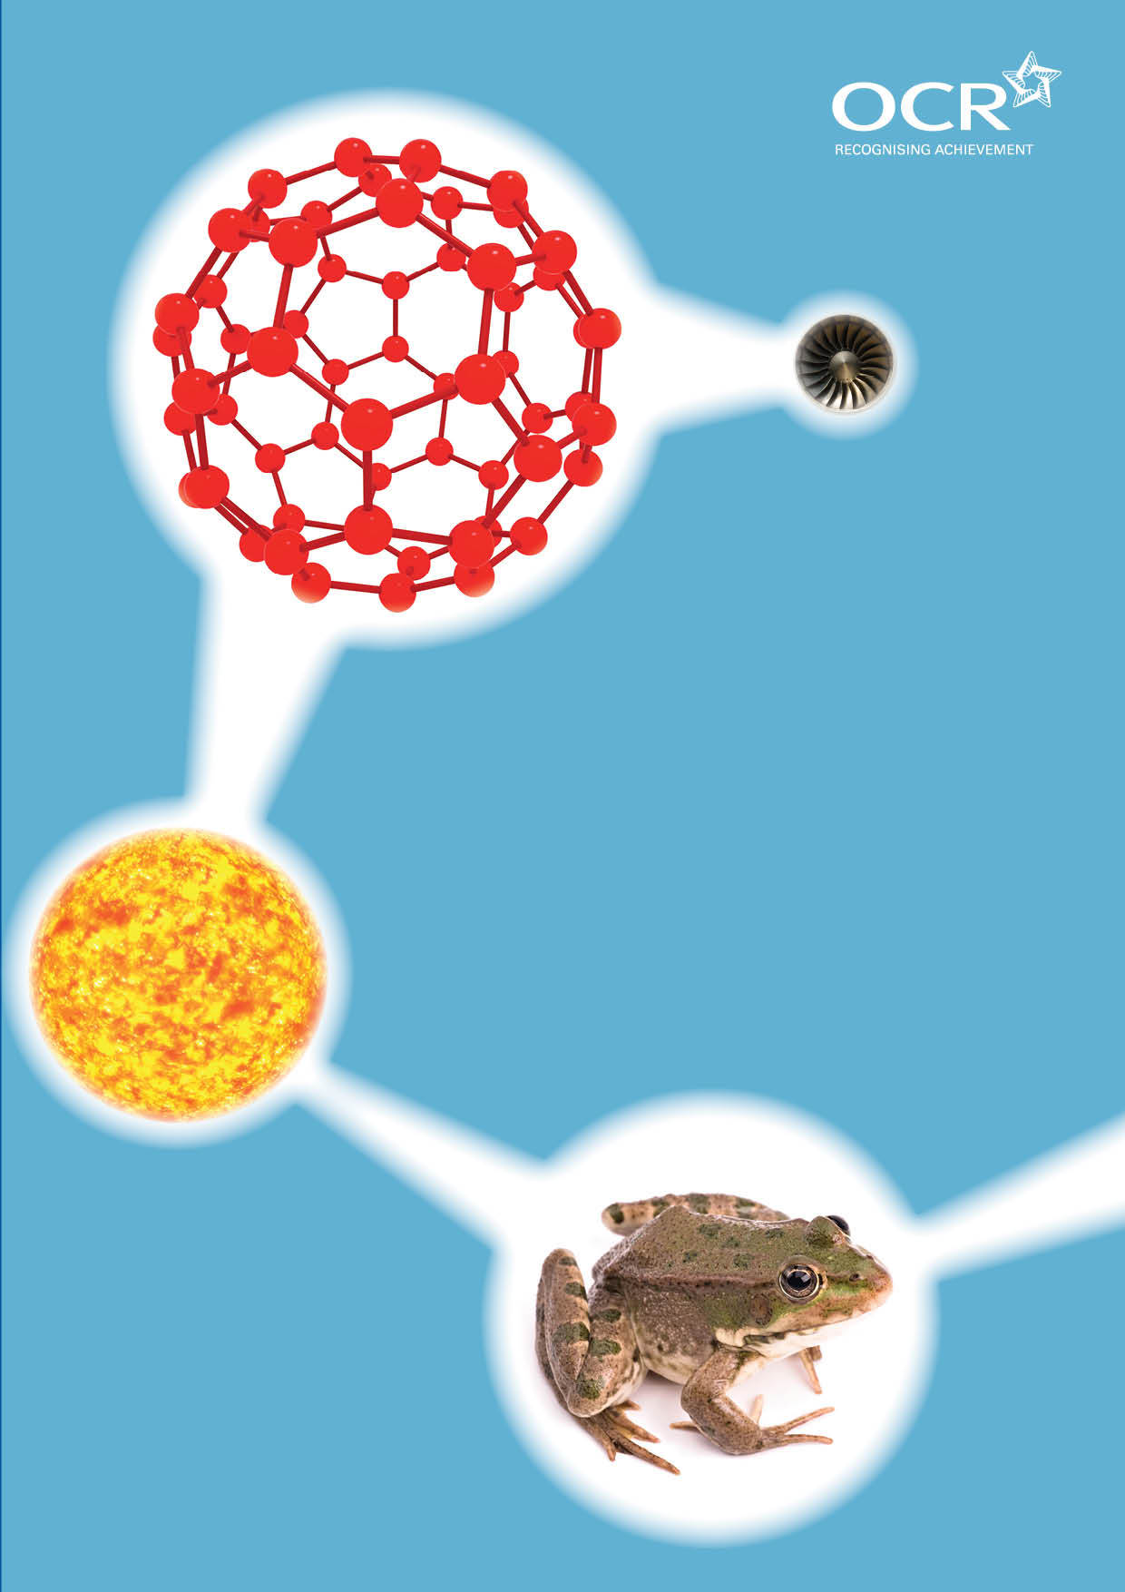
TWENTY FIRST CENTURY SCIENCE SUITE
SCHEMES OF WORK AND LESSON PLANS
P4: Explaining motion
VERSION 1 JULY 2011
Introduction
OCR involves teachers in the development of new support materials to capture current teaching practices tailored to our new specifications. These support materials are designed to inspire teachers and facilitate different ideas and teaching practices. Each Scheme of Work and set of sample Lesson Plans is provided in Word format – so that you can use it as a foundation to build upon and amend the content to suit your teaching style and students’ needs.
The Scheme of Work and sample Lesson plans provide examples of how to teach this unit and the teaching hours are suggestions only. Some or all of it may be applicable to your teaching.
The Specification is the document on which assessment is based and specifies what content and skills need to be covered in delivering the course. At all times, therefore, this Support Material booklet should be read in conjunction with the Specification. If clarification on a particular point is sought then that clarification should be found in the Specification itself. References to the content statements for each lesson are given in the ‘Points to note’ column.


Sample Scheme of Work
GCSE 21st Century Science Physics A J245
Module P4: Explaining motion
Suggested Teaching Time: 13 Hours

Topic outline | Suggested teaching and homework activities | Suggested resources | Points to note
Speed and velocity | Introduce equation and use examples to demonstrate its use.  As a class, make measurements of the speed of different objects e.g. students running 100m, or racing remote control cars.  Discuss how although the measurements were made of the same event, each measurement is likely to be different, and why. This should lead to a discussion of the need for repeat measurements for reliability.  Use example data with and without outliers to discuss how we can estimate a range that a true value lies within.  Discuss average speed vs. Instantaneous speed.  Introduce the concept of velocity as speed in a particular direction.  Higher tier: explain the difference between displacement and distance.  Consolidate learning using a worksheet with practice calculations. | Stop watches and tape measures to measure speeds.  Outside area for running (or using remote control cars) for measurements used in speed calculations.  Videos of speedometer in a car changing as a journey progresses, or of theme park rides, alongside information about journey/ride time and length can be used to discuss average vs. Instantaneous speed and displacement vs. Distance for higher tier.  Light gates could be demonstrated for measurements of speed.  Worksheet with practice calculations. Should be differentiated for higher and foundation candidates. | Opportunities for checking or developing several mathematical skills. For example, the use of units, plotting bar graphs and the < & > symbols.  Higher tier candidates need to be able to rearrange this equation and should be given opportunities to do so.  Higher tier candidates should be able to use standard form, so suitable calculations (e.g. speed of light calculations) should be included.

Topic outline | Suggested teaching and homework activities | Suggested resources | Points to note
Displacement – time graphs | Collect data from experiments using objects that are moving at two different constant speeds.  Higher tier: experiments should also include increasing and decreasing speeds.  Students plot distance-time graphs for these objects, and then discuss how the graphs can be used to tell which (constant speed) object is moving at the higher speed; explain that the steeper the gradient the higher the speed.  Discuss what a distance-time graph would be like for a stationary object (horizontal), and what a diagonally downwards line would mean (motion in reverse direction).  Higher tier: explain how to measure the speed of an object from the gradient of a straight section of a distance-time graph.  Give an example of a walk to school, giving the time taken different speeds of motion. Ask students to draw the distance-time graph of the motion.  Show students graphs of motion and ask them to interpret them.  Higher tier: discuss the concept of displacement, and how this is different from distance. Students could be challenged to walk across the room, mimicking the motion described in displacement-time graphs drawn on the board. | Could use ticker timers, data logging equipment, video sequences or stop watches and tape measures to collect data to draw distance-time graphs.  Worksheets with pre-printed distance-time graphs of journeys for students to describe, or data to translate into distance-time graphs.  Higher tier candidates should have access to resources that allows calculation of gradients, graphs with changing speeds, and displacement-time graphs (e.g. Graph of objects on a merry-go round, or a toy train).  Various packages exist for plotting distance-time graphs from video clips.  Some data logging equipment comes with a graphing package that can be used to plot real time distance-time graphs, or to compare pre-programmed graphs with real time movement.  GPS data loggers (often in modern mobile phones) can be used to collect data to be used for this and the following lesson. | All students need to be able to translate information between graphical and numerical formats.  Possible cross-curricular link for higher tier candidates, the concept of displacement could be used to help teach trigonometry, in translating diagonal distances into vertical and horizontal displacements. This will not be examined.

Topic outline | Suggested teaching and homework activities | Suggested resources | Points to note
Speed – time graphs and acceleration | Speed time graphs could be introduced via experiment, as in previous lesson.  Alternatively, for higher tier candidates, present a distance-time graph (including various different speeds, stationary sections and backwards movement) and ask students to plot a speed-time graph by measuring the gradient of different sections.  Display a speed-time graph and ask students to tell a “story” of the motion it describes.  Show two graphs of motion from rest to the same speed, but one taking a longer time to reach the speed. Use this to discuss the concept of acceleration and introduce the equation:  Higher tier: students could be introduced to this equation as the gradient of a velocity-time graph.  Higher tier: students revisit the ideas of displacement and velocity, and use them to discuss the difference between speed-time and velocity-time graphs. | Videos of the speedometer from car journeys, computer packages, ticker timers and tape or data logging equipment can all be used to collect data to draw speed-time or velocity-time graphs.  Worksheets with pre-prepared speed-time/velocity-time graphs and/or data to plot graphs.  “Top Trump” cards could be created with supercars, showing different top speeds, and a variety of ways of displaying acceleration (e.g. 0-100km/h in 3 seconds, acceleration of 0.4 m/s², distance-time and velocity-time graphs). | Use of tangents to measure instantaneous speed is not required by this specification, but may provide a good cross-curricular link for higher ability candidates.  Tachographs are no longer on the specification, but could be used as a teaching tool for this lesson.

Topic outline | Suggested teaching and homework activities | Suggested resources | Points to note
Interaction pairs | Introduce interaction pairs by asking two students of roughly equal mass to stand on skateboards, and to push against each other. Discuss the forces involved. Is it possible for one to push the other without moving him or herself?  Give students spring balances. In pairs, students link the hooks on the balances to each other and then pull. Ask one student to hold still and the other to pull with different forces, while recording the readings on the two meters. They should find they are equal at all times.  Discuss the idea of interaction pairs.  Work through a number of examples of interaction pair forces. Students could use mini white boards to answer questions on situations shown to them, identifying the two objects, the direction of the forces, and for each force, which object exerts it, and what object the force is acting on. The difficulty of the force pairs can be increased as the students become used to the ideas. Simple: pressing a hand on a desk, tennis ball on a tennis racket, harder: air resistance on a car, object falling to earth. | Two skateboards.  Sets of spring balances.  Animations or diagrams illustrating interaction pair forces.  Mini whiteboards. | Avoid using the wording “equal and opposite forces” as this does not emphasise the need for two objects.  Ensure that spring balances are suitably paired for the activity, so that they give the same reading as their partner.

Topic outline | Suggested teaching and homework activities | Suggested resources | Points to note
Friction and reaction of surfaces | Put a book on a table. Ask the students what is keeping it there. Why isn’t it falling through the table? (i.e. because of the reaction force of the table). How big is the force? (must be equal to the weight of the book, or the book would move up or down). Give examples when this is not the case (e.g. on water, trampolines). Identify weight and the reaction of the surface as an interaction pair.  Hand out pieces of thermal till roll paper. Ask the students to make a mark on it with their fingernails. How to make the darkest mark? Scratch it fast. Discuss why this is. Friction is linked to speed.  Introduce the idea that friction increases with applied force by pulling an object with a force meter, and discussing how the forces on the object must be balanced at all times until the object moves.  Allow students to plan investigations into friction. Depending on time, they could choose their own question and experiment, or they could follow a pre-set experiment. | Thermal till roll  Items for friction investigation will depend on the options. Could involve different surfaces (e.g. carpet, hardboard, perspex), or different objects to pull, plus spring balances. | Many students will have done an investigation into friction in primary school involving pulling trainers using spring balances.  Opportunity for discussion of types of graphs; bar graphs could be used for investigations with discrete variables (e.g. the friction from different surfaces), line graphs for investigations with continuous ones (e.g. the friction from surfaces at different angles to the horizontal), or pie charts for percentages (e.g. the percentage of shoes that provide different amounts of friction).  The mini investigations could be used to discuss one or more parts of the criteria from the controlled assessment practical investigation mark scheme.
Rockets | Use practical rockets to discuss how rockets work.  Examples could be using string rockets in the classroom to discuss the forces on the rockets, consolidating the ideas of pairs of forces, and water or hydrogen rockets outside to discuss forces on vertically moving objects.  Give out past exam questions on rockets, to check for understanding. Students share their answers and compare with the mark schemes, emphasising the need for precise language.  Possibility of an egg race, challenging the students to build parachutes or similar to drop eggs from a height (or after being thrown upwards) without breaking. Challenge the students not to wrap up the egg, but to vary the size or shape of the parachute. Emphasise that the weight will stay roughly the same, but the air resistance will be changed, and it is the resultant of these two forces that has the greatest affect on the egg’s landing. | String rocket example: http://www.thinkingfountain.org/r/rocket/rocket.html  Past exam questions on rockets. | A common misconception is that rockets take off because the exhaust gases push down against the ground. Starting with horizontally moving rockets could help to counter this.  Exam questions on how rockets work are often poorly answered, and students should have practice at answering these.

Topic outline | Suggested teaching and homework activities | Suggested resources | Points to note
Forces and motion | Attach two bench pulleys to either end of a bench. Attach a string to the front and back of a large toy car or a mechanics trolley. Pass the strings over the pulleys and attach slotted masses to either side. Use this set up to demonstrate what happens to objects with balanced and unbalanced forces.  Introduce the names “driving force” and “counter forces”, discuss what causes the two forces.  Introduce the term “resultant force”.  Show pictures of vehicles with different forces labelled. Students hold up mini whiteboards saying “speed up”, “slow down” or “constant speed” to describe the motion, plus an arrow with the direction and size of the resultant force.  Higher tier: ask a student to try to start moving while wearing roller skates. Discuss why it is difficult. Consolidate the ideas of resultant forces, friction and reaction by discussing the forces that occur during walking. | Bench pulleys, toy car or mechanics trolley, string, slotted masses.  Pictures of forces on cars.  Mini whiteboards.  Roller skates. | Risk assessment of student wearing roller skates in your laboratory will need to be made.

Topic outline | Suggested teaching and homework activities | Suggested resources | Points to note
Momentum | Demonstrate the Newton’s cradle. Show how when one ball is moved, one moves on the other side. Two on one side move two on the other side, etc.  Demonstrate a Galilean cannon by dropping one ball and showing that it rebounds to about the height it is dropped from. Challenge students to predict the height that the small ball will rise to once dropped. It will rise to many times the height dropped due to conservation of momentum.  Demonstrate the link between momentum and mass and velocity by using an air track and gliders, showing that when a large glider hits a small glider, the small glider moves off faster, and vice versa.  Introduce the equation and give examples of how it can be used in practice.  momentum = mass x velocity  (kg m/s) kg m/s  An air track with gliders or an air cushion table with pucks can be used to investigate how momentum changes in collisions and explosions. If available a data logger with light gates can be used to record the momentum before and after a collision. | Newton’s cradle  A Galilean cannon is a stack of balls of decreasing size and mass on a stick. Available pre-made under the name “astroblaster”.  www.grand-illusions.com/acatalog/astroblaster.html  Worksheets with opportunities for practicing momentum calculations.  Air track with gliders plus light gates or air cushion table with pucks. | Higher tier students need to be able to rearrange the equation.  Higher tier students could be introduced to some examples that use standard form as well, for example momentum calculations involving tankers or aircraft.

Topic outline | Suggested teaching and homework activities | Suggested resources | Points to note
Momentum, force and collisions. | Discuss how the momentum change of an object moving with constant speed is zero, so if the resultant force is zero, the momentum change is zero.  Use discussion, video clips or demonstrations (e.g. Balloon rockets with different amounts of air) to link the time that a force acts to the final speed, and therefore momentum. Introduce the equation:  change of resultant time for which  Momentum = force x it acts  (kg m/s) (n) (s)  Ask students to slap the table, and then to slap the table with some foam on it. Discuss why they feel different, although both slaps involve the same change in momentum.  Discuss how ideas of force and momentum can explain road safety measures (i.e. most increase the time of collision for the same change of momentum, therefore reducing the force of impact).  Students create posters showing a range of road safety measures and explaining the physics behind each. | Various investigations into collisions can be done, for example sitting a doll or egg on top of a dynamics trolley, and rolling it down a ramp into a solid wall. Crumple zones and seatbelts can be mocked up from junk materials. Could be used as a class challenge.  Video clips e.g. smart car crash testing:  www.youtube.com/watch?gl=gb&v=ju6t-yyou8s  Data logging force meters could be used to measure the force and time of collision for various impacts.  Poster making equipment. | Higher tier students are expected to rearrange the equation in an exam, but the results of rearrangement should be understood by all (e.g. if the time of a collision is shorter, the force would be larger)  Various investigations or data analysis exercises could be used in this lesson to investigate the link between factors involved in car crashes e.g. price of car and number of accidents, or speed of car and severity of accident, or amount of packing on the front of a dynamics trolley and the force of the impact.  The higher mathematics criteria for physics includes an understanding of percentiles and deciles. Information on car crashes could be used to practice using these.

Topic outline | Suggested teaching and homework activities | Suggested resources | Points to note
Kinetic energy and gravitational potential energy | Ask students to predict which of several pairs of objects would do “more damage” to something they collided with, e.g. A fly/a bullet, a car travelling at 15 m/s or 30 m/s, a car of mass 1000 kg travelling at 15 m/s or a car of mass 2000 kg travelling at 30 m/s.  Introduce the equation  Kinetic energy = ½ x mass x [velocity]²  (joules, (kilograms, kg) ([meters per  second]², [m/s]²)  Higher tier students should be able to rearrange the equation, including to calculate velocity.  Students practice using the equation to calculate the kinetic energy of various objects.  Drop balls made of different materials into sand, from different heights, to introduce the equation:  Change in gravitational = weight x vertical  potential energy height  difference  (joules, j) (newtons, n) (metres, m)  Students practice using the equations. | Demonstrations of the effect of mass and speed could be done by rolling dynamics trolleys down ramps into a pile of blocks and varying the mass of the trolley and the speed it is travelling (by increasing the acceleration distance).  Balls of the same size, but different masses (i.e. Different materials), sand trays.  Worksheets with practice of kinetic energy and gravitational potential energy equation.  If time, students could investigate roller coasters, either via simple roller coaster calculations, or building model rollercoaster sets and carrying out calculations on the findings.  A webquest is also available at http://www.glencoe.com/sec/ science/webquest/content/rollercoast.shtml students could work through the quest, following the links and doing the activities. Note that the units are often imperial and may need some explaining. Alternatively some of the ideas could be incorporated into worksheets. | Ideas of elastic and inelastic collisions are not required at GCSE.  Note: students are not expected to be able to calculate weight from mass and gravitational field strength, so GPE=mgh is not required.  Opportunity to develop investigation skills using the dropping ball experiment.

Topic outline | Suggested teaching and homework activities | Suggested resources | Points to note
Work done | Pose the problem: if a battery is used to power a motor pulling an object, what factors will affect the distance it can be pulled (e.g. friction, vertical height, size of object).  Introduce the idea of work done as an energy transfer and the equations:  Work done = force x distance moved in the  by a force direction of the force  (joules, j) (newtons, n) (metres, m)  Amount of energy transferred = work done  (joules, j) (joules, j)  Use demonstrations to show the link between all the different types of energy. Depending on the demonstrations, students could calculate the expected energy (or speed for higher tier).  Students practice using (and higher tier: rearranging) the equations. | There are many different examples of machines that could be used to demonstrate the interconnection between work done, kinetic energy and gravitational energy, for example Meccano roller coasters, “penguin race”, toy cars with loop-the-loop courses. Various experiments could be done on them, for example using light gates to measure speed at various points and measuring the energy changes. | Opportunity for calculating percentage losses of energy.  Teachers may find it easier to teach the energy topics in a different order, introducing the equations quickly and then using the rest of the time to give examples of how they are used and what affect they have on motion.
Falling | Demonstrate the guinea and feather, or use a video of Neil Armstrong dropping a hammer and feather on the moon.  Discuss the energy changes in falling, explaining how when friction can be ignored, gravitational potential energy lost will be equal to kinetic energy gained.  Quantify the changes, by giving examples of calculations that could be carried out (including, for higher tier, calculating the speed of an object dropped from height).  Students carry out a short investigation into dropping paper snowflakes, emphasising the difficulty of varying one factor without affecting another, and therefore the difficulty of making firm conclusions of correlations between factors. | Neil Armstrong on hammer and feather video  www.youtube.com/watch?v=pe81zghnb0w  Guinea and feather demonstration: a reinforced glass tube, with a small coin and feather, sealed at both ends and attached to a vacuum pump. When there is air in the tube, the feather drops more slowly. When the air is removed, they drop at the same rate.  Scrap paper and scissors to make snowflakes, plus stop watches.

Topic outline | Suggested teaching and homework activities | Suggested resources | Points to note
Revision and test | Revision activities could include mind mapping the topic, constructing a loop activity or many others, such as;  Give students a basic description of a journey of a car, with changes of height, speed etc. Ask students to annotate a picture of the journey with key words from the unit, and examples of how the equations from the unit could be used.  Give past paper questions to students to test understanding. | Past paper questions. | The legacy specification papers do not include the 6 mark questions that will exist on the new papers. Examples of these should be included in tests.

Sample Lesson Plan
GCSE 21st Century Science Chemistry A J244
Module P4: Explaining motion

Speed and velocity
OCR recognises that the teaching of this qualification above will vary greatly from school to school and from teacher to teacher. With that in mind this lesson plan is offered as a possible approach but will be subject to modifications by the individual teacher.
Lesson length is assumed to be one hour.

Learning Objectives for the Lesson
Objective 1 | To be able to apply the following equation to situations where an average speed is involved:
Objective 2 | To distinguish between average speed and instantaneous speed.
Objective 3 | Higher Tier: To understand the concept of displacement.
Objective 4 | To understand why it is important to repeat measurements.

Recap of Previous Experience and Prior Knowledge
Key Stage Three knowledge of speed, force and motion.

Content
Time | Content
5 minutes | Hand three students pieces of paper that read “fast”, “slow” and “medium speed”, and ask them to walk from one end of the room to the other at the speed indicated on the paper. Ask the other students to say who had which paper, and ask how they knew. Most students link the speed to the order of finishing.  Then swap the papers, and ask the student with “slow” to start from one step from the finish line, “medium” half way to the finish line and “fast” from the other end of the room.  Ask students to explain how they still were able to judge the speed. Use this discussion to formalise the link between speed, distance and time, using the equation:
20 minutes | Give students examples of calculations to practise the use of the equation. Higher tier: students should be able to rearrange the equation and use standard form calculations. This could be done by giving them a table of data about different objects, with one piece of information missing from each row. More able students should also be able to convert between units e.g. km to m and hours to seconds.  Foundation tier: students can measure the speed of different movements (e.g. hopping, walking, jumping from one end of the room to the other), and then practise graphing this data.
10 minutes | Give the class stop watches and take measurements of the speed of something/ someone moving (e.g. a student running 100m, or a remote control car travelling 10m). Write up the readings, and use this data to discuss the need for repeat measurements. Discuss reliability, and outliers / anomalous results, and the use of a range to estimate the “true value” of something.

Time | Content
10 minutes | Show a video of a speedometer on a car as it travels along a road at varying speeds. Use this to discuss average speed and instantaneous speed. Students are likely to have seen both average speed cameras and radar detectors, you could use these to emphasise the differences.
10 minutes | Introduce the idea of velocity (and for higher tier students: displacement), by asking how fast a car travelling around a square is going, if it has ended up back where it started.  Give examples of where the difference matters (e.g. the velocity of a car going along a road that is not straight will be different from the average speed calculated from the distance between the start and end points and the time taken). Use of trigonometric formulas for calculation of components is not required at this level.

Consolidation
Time | Content
5 minutes | Use a “Play your cards right” game to consolidate the lesson: write a number of calculations on cards (e.g. “a car travels 10 m in 2 s”) and the students have to guess whether the next card will have a calculation that is higher or lower than the previous one. Higher tier candidates could have various calculations resulting in different quantities, with only the numerical part of the answer being compared, or they could convert between units before working out whether the cards are higher or lower.

