EDEXCEL GCSE MATHEMATICS
June 2001 Paper 6

Question 1 (3 marks)
Calculate the area of trapezium ABCD.
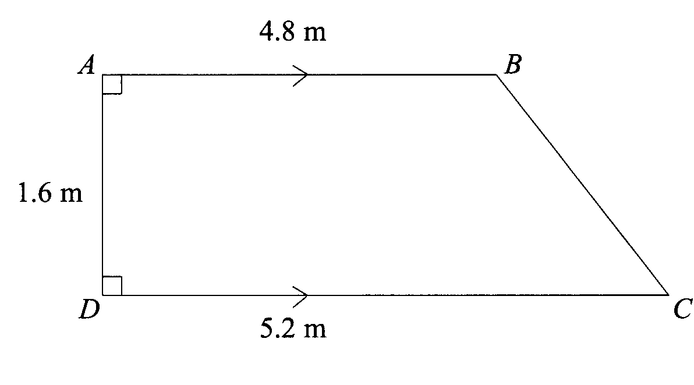

Question 2 (3 marks)
Solve the equation 5(x+2) = 3x + 7

Question 3 (3 marks)
In a sale, all the normal prices are reduced by 15%. In the sale, Winston pays £15.64 for a shirt.
Calculate the normal price of the shirt.

Question 4 (3 marks)
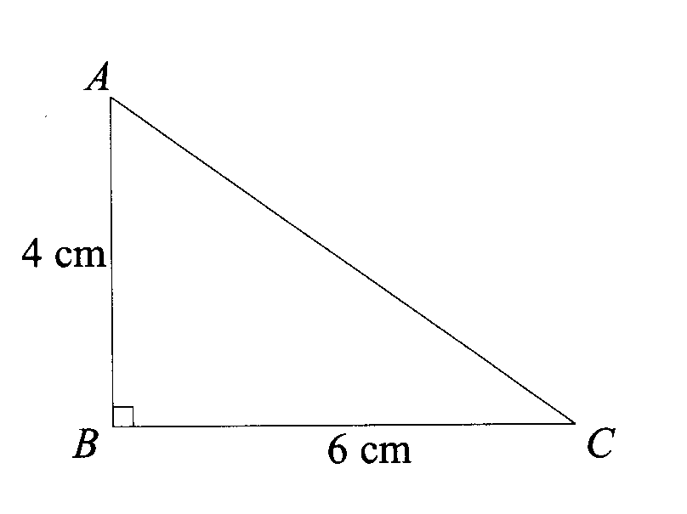
£5000 is invested for 3 years at 4% per annum compound interest. Work out the total interest earned over the three years.

Question 5 (3 marks)
ABC is a right-angled triangle. Calculate the length of AC, giving your answer in centimetres correct to 3 significant figures.

Question 6 (4 marks)
Use the method of trial and improvement to solve the equation x³ + x = 26.
Give your answer to one decimal place and show all of your working.

Question 7 (9 marks)
The grouped frequency table shows information about the number of hours worked by each of 200 headteachers in one week.

Number of hours worked (t) | Frequency
0 < t ≤ 30  30 < t ≤ 40  40 < t ≤ 50  50 < t ≤ 60  60 < t ≤ 70  70 < t ≤ 80 | 0  4  18  68  79  31

(a) Work out an estimate of the mean number of hours worked by the headteachers that week.
(b) Copy and complete the cumulative frequency table.
Number of hours worked (t) | Cumulative Frequency
0 < t ≤ 30  0 < t ≤ 40  0 < t ≤ 50  0 < t ≤ 60  0 < t ≤ 70  0 < t ≤ 80 | 0

(c) Draw a cumulative frequency graph for this data using an x-axis scale from 30 to 80 and a y-axis scale from 0 to 200.
(d) Use your graph to estimate the interquartile range for this data. Show your method clearly.

Question 8 (3 marks)
Calculate the value of
$$\frac{5\text{.}\text{98}×{\text{10}}^{8}+4\text{.}\text{32}×{\text{10}}^{9}}{6\text{.}\text{14}×{\text{10}}^{−2}}$$

Give your answer is standard form correct to 3 significant figures.

Question 9 (4 marks)
Solve the simultaneous equations: 4x + y = 4
2x + 3y = −3

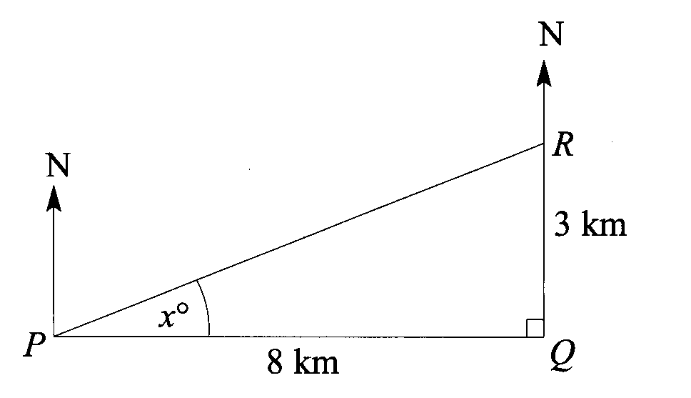
Question 10 (5 marks)
The diagram shows the positions of three schools P, Q and R.
- Calculate the size of the angle marked x. Give your answer correct to one decimal place.
- Simon’s house is 8km due East of school Q. Calculate the bearing of Simon’s house from school R.

Question 11 (3 marks)
(a) Factorise x² – 6x + 8
(b) Solve the equation x² – 6x + 8 = 0

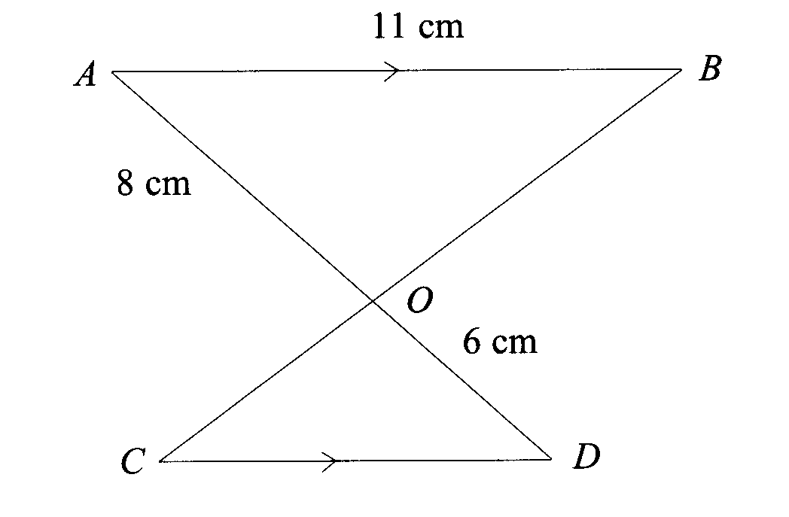
Question 12 (3 marks)
The lines AB and CD are parallel. Calculate the length of CD.

Group | Number of Students
A | 135
B | 225
C | 200
Question 13 (7 marks)
The table shows the number of students in three groups attending Maths City High School last Monday. No student belonged to more than one group.

Mrs Allen carried out a survey about the students’ travelling times from home to school last Monday. Mrs Allen worked out that:
• the mean time for Group A students was 24 minutes
• the mean time for Group B students was 32 minutes
• the mean time for Group C students was the same as the mean time for all 560 students.
(a) Work out the mean time for all 560 students.
Mrs Allen interviewed some of these students. She used a stratified sample of 50 students according to each group.
(b) Work out the number of students from each group which should have been in her sample of 50.

Question 14 (6 marks)
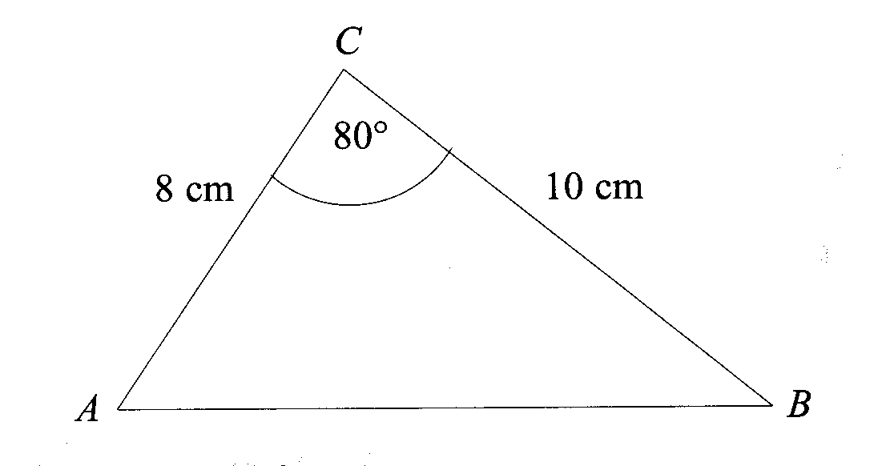

(a) Calculate the length of AB. Give your answer, in centimetres, correct to 3 sig.fig.
(b) Calculate the size of the angle ABC. Give your answer correct to 3 sig.fig.

Question 15 (4 marks)
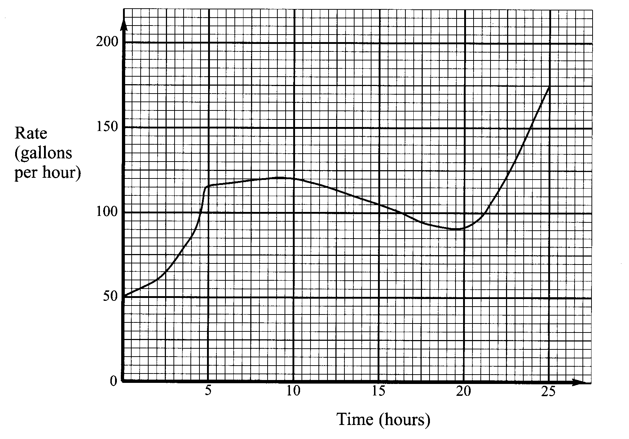

The amount of water used in a car wash was investigated for a period of 25 hours. This graph shows the rate at which water was used, in gallons per hour.
Calculate an estimate for the total number of gallons of water used in the 25 hours.

Question 16 (3 marks)
A sphere has a radius of 5.4cm. A cone has a height of 8cm. The volume of the sphere is equal to the volume of the cone.
Calculate the radius of the base of the cone. Give your answer in centimetres to 2 sig. fig.

Question 17 (2 marks)
x = 3, correct to 1 sig.fig. y = 0.06, correct to 1 sig.fig.
Calculate the greatest possible value of
$$y−\frac{x−7}{x}$$

Question 18 (7 marks)
y is directly proportional to x². When x = 2, y = 36.
- Express y in terms of x.

z is inversely proportional to x. When x = 3, z=2.
- Show that z = cy^{n}, where c and n are numbers and c > 0. (You must find values of c and n).

Question 19 (7 marks)
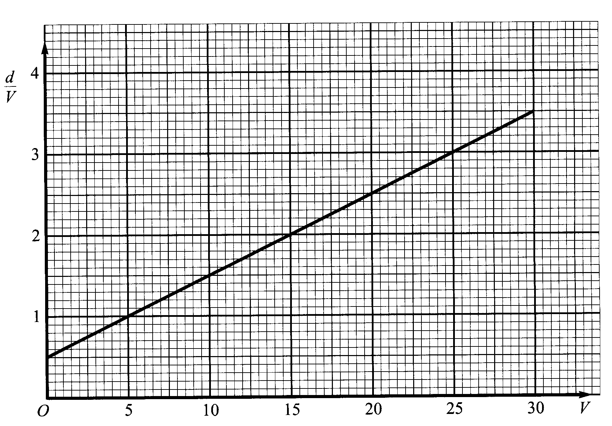

A car travelling at a speed of V metres per second has a stopping distance of d metres.
The Straight line graph of d/v against V has been drawn on the grid above.
The car travels at a speed of 18m/s.
(a) Use the straight line graph to find the stopping distance of the car.
(b) By first finding the equation of the line, obtain a formula for d in terms of V.

Question 20 (7 marks)
A transformation has been applied to the graph of y = x² to give the graph of y = -x².
(a) Describe fully the transformation.
For all values of x, x² + 4x = (x + p)² + q
(b) Find the values of p and q.
A transformation has been applied to the graph of y = x² to give the graph of y = x² + 4x.
(c) Using your answer to part (b), or otherwise, describe fully the transformation.

Question 21 (11 marks)
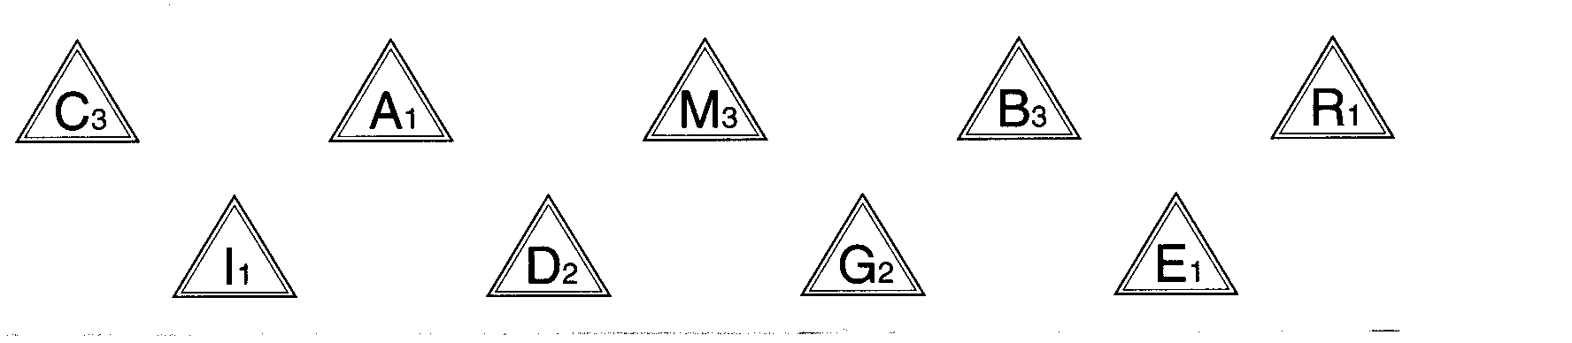
The diagram shows nine tiles from a word game. On each tile is a letter and a score.
Caroline puts all nine tiles in a bag. She picks at random two tiles without replacement.
(a) Calculate the probability that
(i) the two tiles have equal scores,
(ii) the scores on the two tiles will have a sum of 5 or more.
Jack picked 20 other tiles from his word game. The table shows the scores of the 20 tiles.
Score | Number of tiles
1 | 6
2 | 1
3 | 5
4 | 6
5 | 1
6 | 0
7 | 0
8 | 1
(b) For the scores of these twenty tiles, find the standard deviation.
Peter added 4 to all the scores of Jack’s 20 tiles.
(c) Find the standard deviation of Peter’s 20 numbers.

END OF EXAM

