Paper Reference(s)
1385/03 1386/03
Edexcel GCSE
Mathematics A – 1385
Mathematics B – 1386

Paper 3 – Non-Calculator
Intermediate Tier
Wednesday 29 May 2002 − Afternoon
Time: 2 hours

Materials required for examination Items included with question papers
Ruler graduated in centimetres Formulae sheets
and millimetres, protractor,
compasses, pen, HB pencil, eraser.
Tracing paper may be used.

Instructions to Candidates
In the boxes on the answer book, write your centre number, candidate number, your surname and initials, the paper reference and your signature.
The paper reference is shown above. If more than one paper reference is shown, you should write the one for which you have been entered.
Answer ALL questions in the spaces provided in this book.
Supplementary answer sheets may be used.

Information for Candidates
The total mark for this paper is 100. The marks for the various parts of questions are shown in round brackets: e.g. (2).
Calculators must not be be used.
This paper has 22 questions. There are no blank pages.

Advice to Candidates
Show all stages in any calculations.
Work steadily through the paper.
Do not spend too long on one question.
If you cannot answer a question leave it out and attempt the next one.
Return at the end to those you have left out.

This publication may only be reproduced in accordance with Edexcel copyright policy.
Edexcel Foundation is a registered charity. ©2002 Edexcel
Answer ALL TWENTY TWO questions.

Write your answers in the spaces provided.

You must not use a calculator.

You must write down all stages in your working.

1. Here is a triangle T.

T

Here are nine more triangles.

 |  |  |  |  |  |  |  |  |  |  |  |  |  |  |  |  |  |  |  |  |  | D
 |  | A |  |  |  |  |  | B |  |  |  |  |  |  | C
 |  |  |  |  |  |  |  |  |  |  |  |  |  |  |  |  |  |  |  |  |  |  |  |  |  |  | E
 |  |  | F |  |  |  |  |  |  |  |  |  |  |  |  |  |  |  |  |  | H
 |  |  |  |  |  |  |  |  |  |  | G
 |  |  |  |  |  |  |  |  |  |  |  |  |  |  |  |  |  |  |  |  |  |  |  |  | I

(i) Write down the letter of a triangle that is an enlargement of triangle T.

……………
(ii) Find the scale factor of the enlargement.

……………
(Total 2 marks)

2. Here are some patterns made with crosses.

 | x |  |  |  |  |  | x |  | x |  |  |  |  |  | x |  | x |  | x
x |  | x |  |  |  | x |  | x |  | x |  |  |  | x |  | x |  | x |  | x
x |  | x |  |  |  | x |  | x |  | x |  |  |  | x |  | x |  | x |  | x

Pattern Number 1 Pattern Number 2 Pattern Number 3

 | x |  | x |  | x |  | x
x |  | x |  | x |  | x |  | x
x |  | x |  | x |  | x |  | x

Pattern Number 4

The table shows the number of crosses in Pattern Numbers 1, 2, 3 and 4.

Pattern Number (n) | 1 | 2 | 3 | 4
Number of crosses (C) | 5 | 8 | 11 | 14

Write down a formula for the number of crosses, C, in terms of the Pattern Number, n.

C = ……………………

(Total 2 marks)

3.

A shop sells different sound systems on credit.
The weekly payment is w pounds.
The total amount paid, C pounds, is given by the formula
C = 10w + 35

The total amount paid for a mini sound system is £260.

Calculate the weekly payment for a mini sound system.

£ ……………….

(Total 3 marks)

4. A maths book costs £7.34.
(a) Work out the cost of 25 maths books.

£ ……………….
(3)
20 of the 25 maths books have plastic covers.

(b) Write 20 out of 25 as a percentage.

……………….%
(2)
(Total 5 marks)

5. 30 pupils were asked about their lunch one day.
The table gives some information about their answers.

 | School dinners | Sandwiches | Other | Total
Boys | 12 | 3 |  | 16
Girls | 8 |  | 2
Total |  |  |  | 30

(a) Complete the table.

(2)
(b) How many of the girls had sandwiches?

……………
(1)
(Total 3 marks)

6. (a) Simplify fully

6n + 7n – 8n

……………
(1)

(b) Simplify fully

4a × 5b

……………
(1)

(c) Multiply out

3(2x + 5)

……………
(1)
(Total 3 marks)

7. The diagram shows part of a shape.
The shape has rotational symmetry of order 4 about the point P.

P

(a) On the grid above, complete the shape.
(2)
(b) On the grid below, show how the shaded shape will tessellate.

You should draw at least 5 shapes.

(2)
(Total 4 marks)
8. (a) Work out 60% of 5300 kg.

………………kg
(2)

(b) Find the simple interest on £2500 invested for 2 years at 6% per year.

£………………
(3)
(Total 5 marks)

9. 4 cm Diagram NOT
accurately drawn

3 cm

Work out the area of the triangle.
Give the units with your answer.

…………… ……………
(2)
(Total 3 marks)

10. Here is a 4-sided spinner.

4 1
3 2

The sides are labelled 1, 2, 3, 4.
The spinner is biased.

The probability that the spinner will land on each of the numbers 1 to 3 is given in the table.

Number | 1 | 2 | 3 | 4
Probability | 0.3 | 0.4 | 0.1

Sabia spins the spinner once.

(a) (i) Work out the probability that the spinner will land on the number 4.

…………
(ii) Write down the number that the spinner is most likely to land on.

…………
(iii) Work out the probability that the spinner will land on an odd number.

…………
(5)

Nick spins the spinner 100 times.

(b) Work out an estimate for the number of times the spinner will land on the number 2.

…………
(2)

Ben spins the spinner twice.

(c) Work out the probability that the spinner will land on the number 1 both times.

…………
(2)
(Total 9 marks)

11. Diagram NOT
accurately drawn

x + 1 3x + 2

2x + 5

The lengths, in cm, of the sides of the triangle are

x + 1
2x + 5
3x + 2

(a) Write down, in terms of x, an expression for the perimeter of the triangle.
Give your expression in its simplest form.

……………………… cm
(2)

The perimeter of the triangle is 50 cm.

(b) Work out the value of x.

x = …………………
(2)
(Total 4 marks)

12. 3$\frac{3}{4}$ 11$\frac{1}{2}$ Diagram NOT
accurately drawn
A
B
C
D

The diagram shows some of the junctions on a motorway.
Each junction is labelled with a letter in a circle.
The distance from junction A to junction B is 3$\frac{3}{4}$ miles.
The distance from junction B to junction C is 11$\frac{1}{2}$miles.

(a) Work out the total distance, in miles, from junction A to junction C.

……………… miles
(2)
The distance from junction B to junction D is 14$\frac{3}{4}$ miles.

(b) Work out the distance, in miles, from junction C to junction D.

……………… miles
(2)
Sophie drove from junction A to junction B in 5 minutes.

(a) Work out her average speed, in miles per hour, for this part of the journey.

……………… miles per hour
(3)
(Total 7 marks)

13. The grid represents part of a map.

 |  |  |  |  |  |  |  |  |  |  | N
 |  | A |  |  |  |  |  |  |  | B

(a) On the grid, draw a line on a bearing of 037° from the point marked A.
(1)

The point C is on a bearing of 300° from the point marked B.
C is also 3 cm from B.

(b) Mark the position of the point C on the grid and label it with a letter C.
(2)
(Total 3 marks)

14. Wayne is going to carry out a survey to record information about the type of vehicles passing the school gate.

In the space below, draw a suitable data collection sheet that Wayne could use.

(Total 3 marks)

15. 1.54 × 450 = 693

Use this result to write down the answer to

(i) 1.54 × 45

………………
(ii) 1.54 × 4.5

………………
(ii) 0.154 × 0.45

………………
(Total 3 marks)

16. Diagram NOT
A accurately drawn
x°

B E
100° 100°

100° 100°
C D

The diagram shows a pentagon.
AB = AE
BC = CD = DE
Find the size of the angle marked x°.

…………….°
(Total 4 marks)

17. Here are three expressions.

Expression | Length | Area | Volume | None of these
πa²h
πb² + 2h
2ah

a, b and h are lengths.
π and 2 are numbers and have no dimensions.

Put a tick (✓) in the correct column to show whether the expression can be used for length, area or none of these.

(Total 3 marks)

18. The table gives information about the weights, in kilograms, of 100 pigs.

Weight of pigs (w kg) | Frequency
65 < w ≤ 70 | 4
70 < w ≤ 75 | 10
75 < w ≤ 80 | 34
80 < w ≤ 85 | 32
85 < w ≤ 90 | 16
90 < w ≤ 95 | 4

(a) Work out the class interval which contains the median.

………………
(2)

(b) Complete the table below to show the cumulative frequency for this data.

Weight of pigs (w kg) | Cumulative  Frequency
65 < w ≤ 70 | 4
70 < w ≤ 75
75 < w ≤ 80
80 < w ≤ 85
85 < w ≤ 90
90 < w ≤ 95 | 100

(1)
(c) On the grid, draw a cumulative frequency graph for the data.

Cumulative
frequency
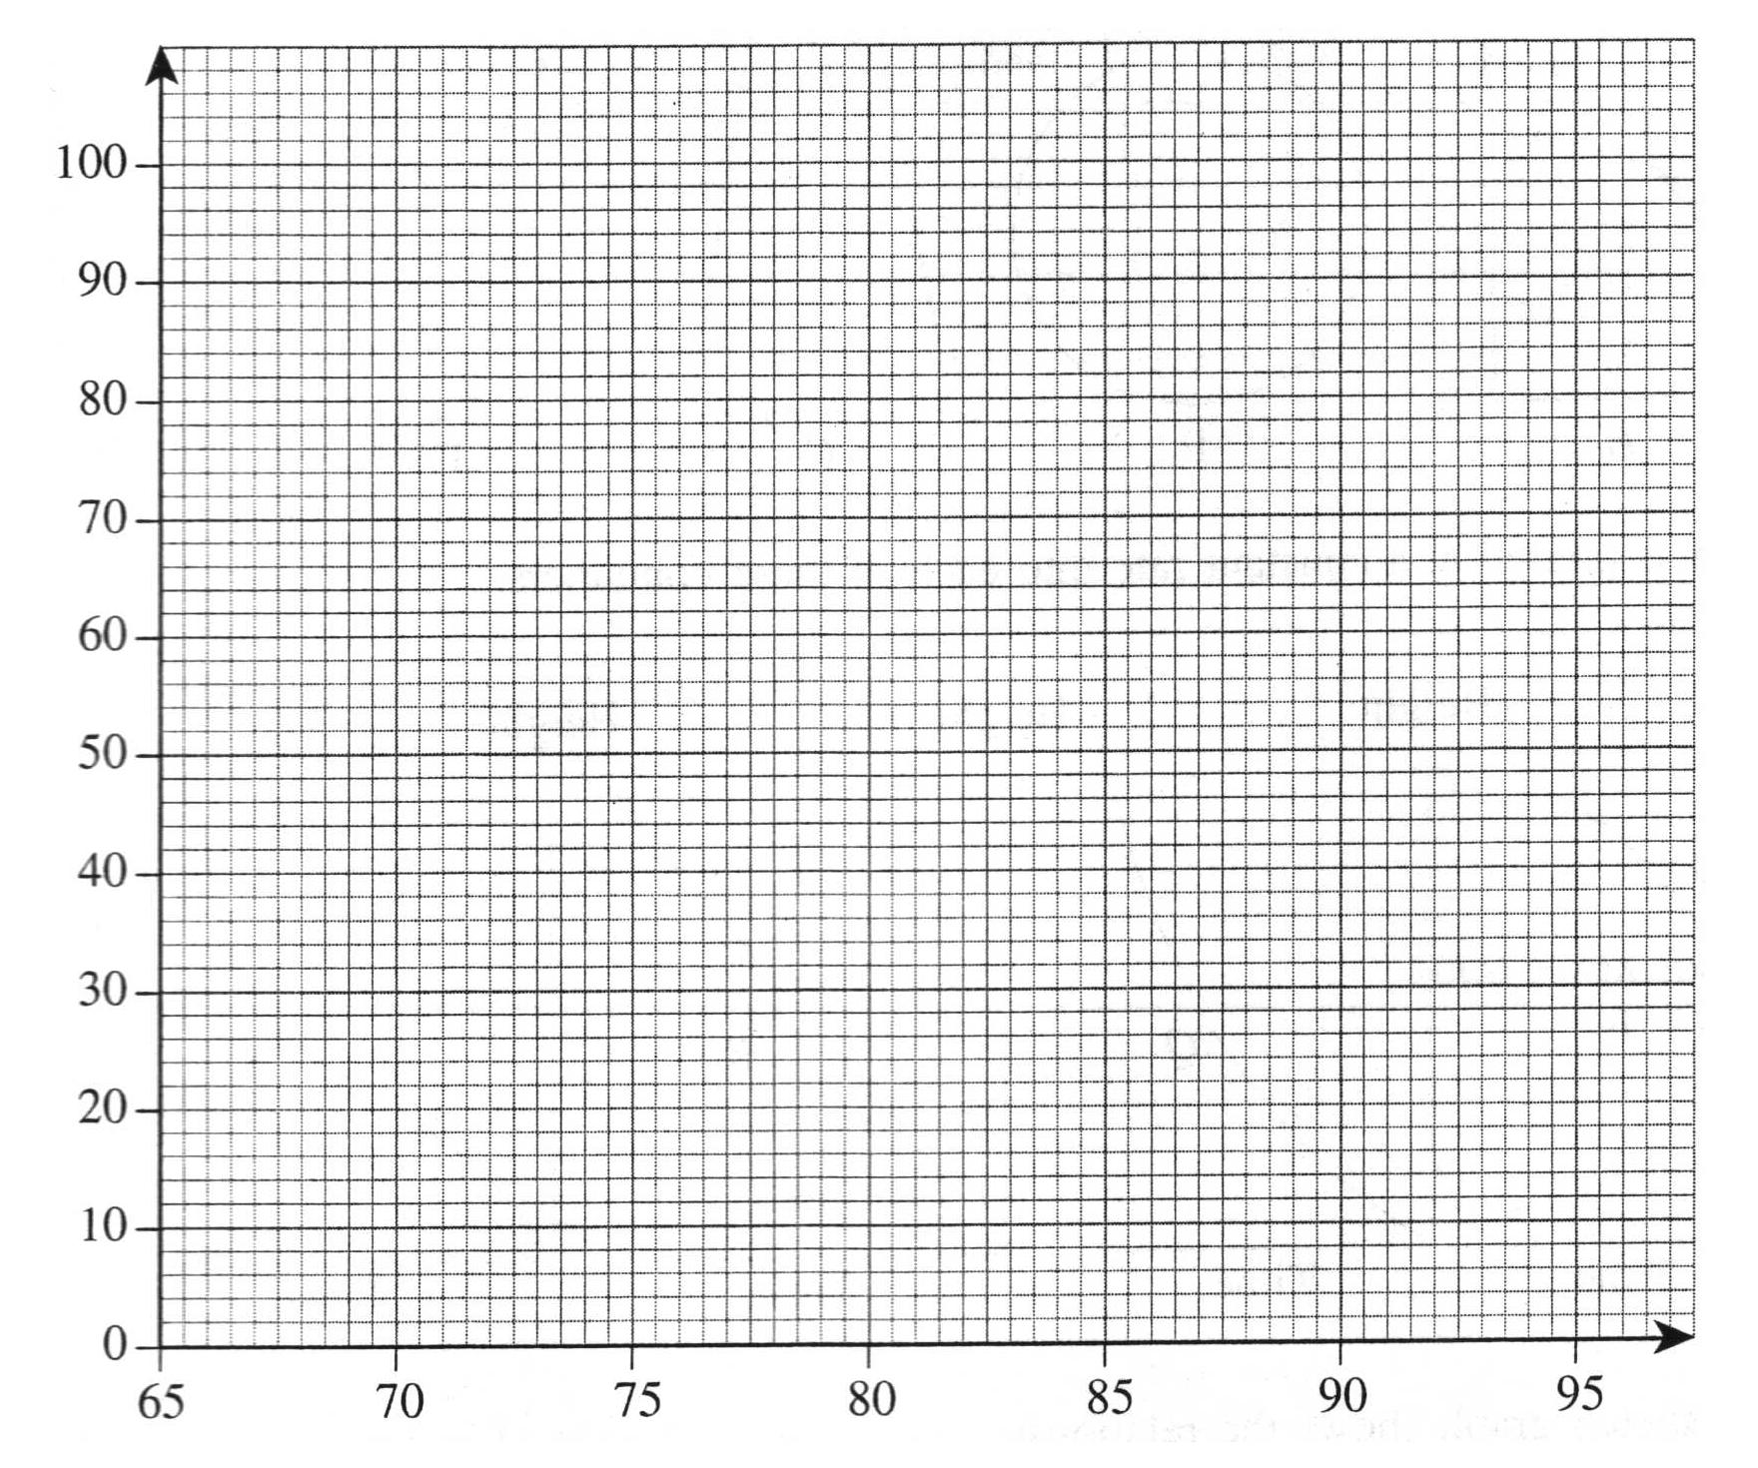
Weight of pigs (w kg)

(d) Use your graph to work out an estimate for

(i) the interquartile range.

…………………kg

(ii) the number of pigs which weigh more than 87.5 kg.

……………………
(3)
(Total 9 marks)
19. The diagram shows four empty containers.

A B C D

Water is poured at a constant rate into each of these containers.

Height Height Height Height

P Q R S

Time Time Time Time

Each sketch graph shows the relationship between the height of water in a container and the time as the water is poured in.

Write the letter of each graph in the correct place in the table.

Container | Graph
A
B
C
D

(Total 3 marks)

20.
 |  |  |  |  |  |  | y
 |  |  |  |  |  |  | 7
 |  |  |  | C |  |  | 6 |  | B
 |  |  |  |  |  |  | 5
 |  |  |  |  |  |  | 4
 |  |  |  |  |  |  | 3 |  |  |  |  | A
 |  |  |  |  |  |  | 2
 |  |  |  |  |  |  | 1
−7 | −6 | −5 | −4 | −3 | −2 | −1 | O | 1 | 2 | 3 | 4 | 5 | 6 | 7 | x
 |  |  |  |  |  |  | −1
 |  |  |  |  |  |  | −2
 |  |  |  |  |  |  | −3
 |  |  |  |  |  |  | −4
 |  |  |  |  |  |  | −5

Triangle B is a reflection of triangle A.
(a) (i) Draw the line of reflection.
(ii) Write down the equation of the line of reflection.

………………
(2)

(b) Describe fully the single transformation that maps triangle A onto triangle C.

………………………………………………………………………………………….

………………………………………………………………………………………….
(3)
(Total 5 marks)

21. (a) Complete the table of values for the graph of y = x³ + 2.

x | −3 | −2 | −1 | 0 | 1 | 2
y = x³ + 2 | −25 |  |  |  |  | 10

(2)

(b) On the grid, draw the graph of x³ + 2.
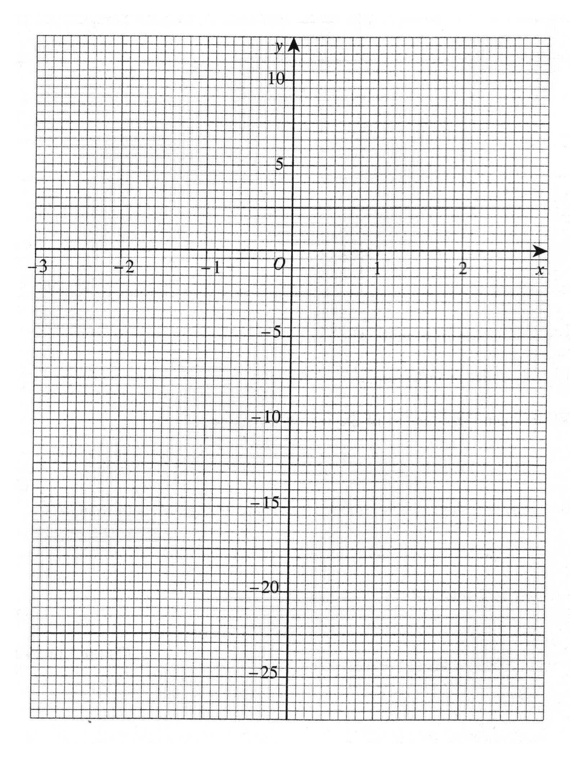
(2)
(c) Use your graph to find

(i) an estimate of the solution of the equation x³ + 2 = 0.

x = ………………

(ii) an estimate of the solution of the equation x³ + 2 = 8.

x = ………………
(3)
(Total 7 marks)

TURN OVER FOR QUESTION 22

22. (a) Simplify y³ × y⁴

………………
(1)

(b) Expand and simplify 5(2x + 3) – 2(x – 1)

………………
(2)

(c) (i) Factorise 4a + 6

………………

(ii) Factorise completely 6p² – 9pq

………………
(3)
(d) Find the value of

(i) 10⁻²

………………
(ii) 7⁰

………………
(2)
The number 1104 can be written as 3 × 2^{c} × d, where c is a whole number and d is a prime number.

(c) Work out the value of c and the value of d.

c = ………………

d = ………………
(2)
(Total 10 marks)

TOTAL FOR PAPER: 100 MARKS

END

