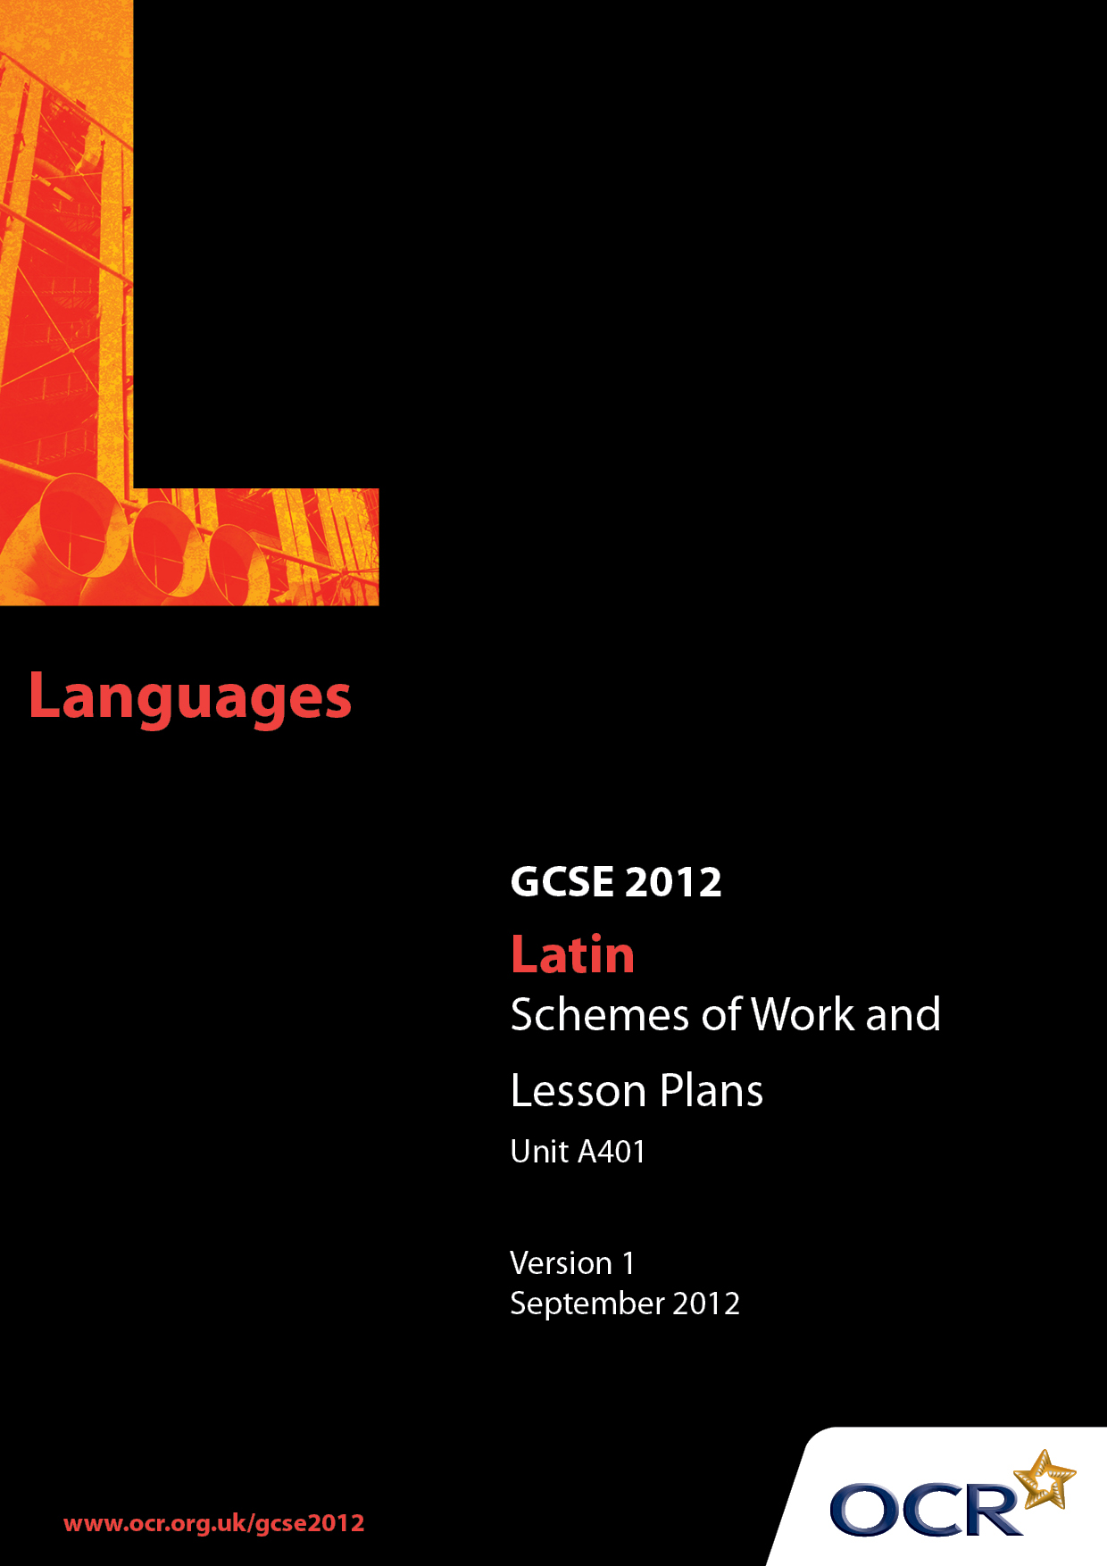

Contents
Contents 2
Introduction 3
Unit A401: Latin Language 1 (Mythology and domestic life)- Sample Scheme of Work 5
Unit A401: Latin Language 1 (Mythology and domestic life) – Sample Lesson Plan 13

Introduction

Background
OCR has produced a summary brochure, which summarises the changes to Latin. This can be found at www.ocr.org.uk, along with the new Specification.
In response to reforms announced by the Government and in response to Ofqual mandated changes to GCSEs, unitised assessment of this qualification is being replaced by linear assessment. This means that candidates commencing a two year course from September 2012 will take all of their GCSE units at the end of the course in June 2014.
In order to help you plan effectively for the implementation of the specification we have produced these Schemes of Work and Sample Lesson Plans for Latin. These Support Materials are designed for guidance only and play a secondary role to the Specification.

Our Ethos
OCR involves teachers in the development of new support materials to capture current teaching practices tailored to our new specifications. These support materials are designed to inspire teachers and facilitate different ideas and teaching practices.
Each Scheme of Work and set of sample Lesson Plans is provided in Word format so that you can use it as a foundation to build upon and amend the content to suit your teaching style and students’ needs.
The Scheme of Work and sample Lesson Plans provide examples of how to teach this unit. The teaching hours are suggestions only. Some or all of it may be applicable to your teaching.
The Specification is the document on which assessment is based and specifies what content and skills need to be covered in delivering the course. At all times, therefore, this Support Material booklet should be read in conjunction with the Specification. If clarification on a particular point is sought then that clarification should be found in the Specification itself.

A Guided Tour through the Scheme of Work

= Innovative Teaching Idea
This icon is used to highlight exceptionally innovative ideas.


= ICT Opportunity
This icon is used to illustrate when an activity could be taught using ICT facilities.

Unit A401: Latin Language 1 (Mythology and domestic life)
Suggested teaching time | 1 hour | Topic | Revision of vocabulary - nouns
Topic outline |  | Suggested teaching and homework activities |  | Suggested resources | Points to note
To revise vocabulary – (nouns) via a bingo game |  | - Teacher tests students on all the nouns of the first three declensions on the vocabulary list. If any of the students are taking the Foundation Tier it might be more appropriate just to test those as this will be a whole class activity.  - Students choose 6 nouns from the DVL. These should include some or all they were unsure of in the test above.  - Using computers to download pictures, each student illustrates 6 nouns on an A4 sheet adding the Latin as a caption for each picture.  - Each student prints out his/her pictures. Each sheet will then act as a bingo card.  - The class play “Bingo” with either the teacher or a pupil as caller. It is suggested that the nouns are called out in English to reinforce the connection between picture, Latin meaning.  - Students swap cards for subsequent round so that they have a variety of nouns with which to become familiar. |  | - The ICT room would be appropriate for part of this lesson.  - The teacher might like to provide small motivational prizes for those who get a full house (or villa plena). | - This activity is intended for the revision weeks prior to the examination where the teacher has two main responsibilities:  - To revise key grammar points  - To keep the spirits of the students buoyant and positive.  - This activity is suitable for both Foundation and Higher Tier candidates.  - Students may prefer to draw pictures or cut them out from magazines.  - Some students might want to use lateral thinking to illustrate particular nouns eg rock musician for saxum etc.

Unit A401: Latin Language 1(Mythology and domestic life)
Suggested teaching time | 1 hour | Topic | Revising the ablative absolute (Higher Tier candidates only)
Topic outline |  | Suggested teaching and homework activities |  | Suggested resources | Points to note
To revise the components of the ablative absolute and to consider its effective translation |  | - Teacher asks students to recall the ablative endings. Writes on board to confirm. Emphasises that one of the meanings of the ablative is WITH.  - Every student writes a noun in the ablative singular on a piece of card which is placed in a receptacle. NB teacher might wish to stipulate declension so the resultant examples contain a mixture of different types of words.  - Teacher invites students to recall the appearance, meaning and characteristics of participles. Writes examples on the board.  - Every student writes a participle in the ablative singular on a different coloured card and places in the receptacle. Teacher should aim to have examples of perfect passive, perfect active, present and future.  - Students take it in turn to take two pieces of card, one of each colour from the receptacle.  - Students translate the resultant ablative absolute phrase and suggest , in English, how the sentence might continue.  - Teacher writes particularly appealing sentences on the board in English and invites different translations for the ablative absolute.  - Teacher might translate one or two of the whole sentences into Latin and write on board with the ablative absolute appearing in a place OTHER than at the beginning separated by a comma.  - The exercise is repeated using plurals.  Homework activity  - Students translate a short passage from their textbook or a past paper which contains ablative absolutes. |  | - Paper or card, two different colours.  - Receptacle.  - Whiteboard. | - This activity is intended for the revision weeks prior to the examination where the teacher has two main responsibilities.  - To revise key grammar points  - To keep the spirits of the students buoyant and positive.  - NB This exercise is for Higher Tier candidates only. Foundation Tier students do not need to know the ablative absolute. However, the teacher could devise a similar activity for Foundation candidates using nouns and participles in the nominative case and inviting students to conjecture the rest of the sentence.

Unit A401: Latin Language 1(Mythology and domestic life)
Suggested teaching time | 1 hour | Topic | Revision of person ending and irregular verbs
Topic outline |  | Suggested teaching and homework activities |  | Suggested resources | Points to note
To revise person endings and irregular verbs |  | - Each student is given a different tense of an irregular verb. The aim should be that many different irregular verbs in their more “tricky” tenses are distributed around the class.  - On each of the six faces of the die, the student writes out their allotted verb and tense et fui, fuisti, fuit, fuimus, fuistis, fuerunt or tuli, tulisti, tulit etc making sure that he or she is very clear about the meaning.  - Each student then glues the flat net together to make a 3D die.  - In pairs, students roll their own die. Their partner has to correctly translate the face uppermost. They can keep score to see who wins.  - Students can change partners so that they revise different verbs throughout the course of the lesson.  Homework activity  - Students learn any verb for which they had a low score. |  | - Net for dice – one for each student. There are many available on the internet or the mathematics department might have them.  - Glue or sticky tape. | - This activity is intended for the revision weeks prior to the examination where the teacher has two main responsibilities.  - To revise key grammar points  - To keep the spirits of the students buoyant and positive.  - As a die, conveniently, has six faces this activity may also be used to practice case endings.

Unit A401: Latin Language 1(Mythology and domestic life)
Suggested teaching time | 1 hour | Topic | Revision of case endings
Topic outline |  | Suggested teaching and homework activities |  | Suggested resources | Points to note
To revise nominative, accusative and dative case endings for the first three declensions using a revision wheel |  | - Each student is given four concentric circles of card, each divided into 6 segments.  - Each student chooses any six nouns from the DVL provided they are for animate objects eg servus, imperator, femina. They should be encouraged to include at least one noun from each declension.  - Each student writes these 6 nouns in the nominative singular case around the top edge of the largest circle in each of the 6 divided segments.  - Each student chooses a further 6 nouns, again for animate objects. They should be encouraged to included one noun from each declension.  - Students write the dative singular for each of these nouns on the top edge of the second largest circle in the segments.  - Students choose 6 nouns which may be inanimate and write the accusative form on the edge of the next smallest circle eg gladium, cibum, silvam, etc.  - Teacher supplies 6 verbs which should be written on the smallest circle eg dedit, ostendit, tradidit, offerebat, emit, paravit, quaerebat.  - Students fasten their circles together using fasteners. They can now rotate the circles to make a series of sentences, reading from the centre outwards. eg uxor cani togam dedit.  - Students share particularly bizarre or amusing sentences their wheel has generated.  HOMEWORK ACTIVITY  - Students write out and translate 7 different sentences they have created from their revision wheel. |  | - Four concentric circles of card (these may be different colours). for each student. Each card is to be divided into 6 sections (it is easier if these are predrawn onto an original template for photocopying – alternatively students can draw them on themselves with ruler and pencil).  - Wing paper fasteners. | - This activity is intended for the revision weeks prior to the examination where the teacher has two main responsibilities.  - To revise key grammar points  - To keep the spirits of the students buoyant and positive.  - Teacher may need to check accuracy of noun endings.  - This activity may also be used to revise plural endings if appropriate.  - The genitive may be added as a fifth circle.  - The students can swap revision wheels to make and translate additional sentences.

Unit A401: Latin Language 1(Mythology and domestic life)
Suggested teaching time | 1 hour | Topic | Translation strategies
Topic outline |  | Suggested teaching and homework activities |  | Suggested resources | Points to note
To discuss strategies for translating a text  To develop strategies for negotiating difficulties |  | - Students translate a short passage individually (NB this might be done as a homework prior to the lesson).  - Teacher goes over the translation with the whole class.  - In pairs student go over the Latin text again colour coding and labelling grammar and syntax.  - Plenary discussion on any key syntactical point the teacher feels needs highlighting.  - In pairs students discuss how they went about the translation originally.  - Each pair decides on the own top ten translation tips.  - Whole class discussion on top ten tips leading to definitive class ten tips which may be written up for later distribution.  - Students are given another short translation to consider. If possible it should be slightly more challenging than the last one. They are asked to translate individually until they come to a bit they “can’t” translate.  - Students pool ideas about how to cope with translation challenges:  - An awareness of context based on reading the introduction to the translation and the glossed words;  - Having two or three notional, logical alternatives ;  - Temporarily leaving out tricky phrases until a likely meaning becomes clear from the rest of the passage.  - Making sure that the maximum is gained from what the student does know eg person and voice of a verb is not exact meaning; case of a noun etc  Homework activity  - Students are given a short piece to translate using the top ten tips the class have devised. |  | - Three short Latin texts of appropriate difficulty for translation.  - It is suggested that the homework piece is sensitively chosen to give students confidence in their abilities. Ritchie’s Fabulae Faciles for example is readable and relatively straightforward but contains words which are not on the DVL –encouraging intelligent guesswork. Available as a free download from www.thelatinlibrary.com/ritchie.html | - This activity is intended for the revision weeks prior to the examination where the teacher has two main responsibilities.  - To revise key grammar points  - To keep the spirits of the students buoyant and positive.  - If the text contains unfamiliar vocabulary not on the DVL that is an advantage as the challenge is to develop strategies of intelligent inference not solely dependent on knowledge of vocabulary.

Unit A401: Latin Language 1(Mythology and domestic life)
OCR recognises that the teaching of this qualification above will vary greatly from school to school and from teacher to teacher. With that in mind this lesson plan is offered as a possible approach but will be subject to modifications by the individual teacher.
Lesson length is assumed to be one hour.

Learning Objectives for the Lesson
Objective 1 | Students to reflect on their translation strategies.
Objective 2 | Students to use translation strategies to improve translation confidence.
Objective 3 | Students to develop strategies to cope with texts where they have forgotten key vocabulary or syntactical structures.

Recap of Previous Experience and Prior Knowledge
- In previous lessons, students may have revised key vocabulary, grammar and syntax.

Content
Time | Content
10 minutes | Students translate a short passage individually.
7 minutes | Teacher goes over translation.
7 minutes | In pairs students colour code and label the key grammatical and syntactical features of the Latin text. (eg case endings, subjunctives, participles etc)
5 minutes | Teacher-led discussion about key features, opportunity for students to share their observations and look at each others work.
7 minutes | In pairs, students discuss how they arrived at their original translations and device their own Top Ten Translation Tip.
7 minutes | Class sharing of Translation Tips – so that a whole class Top Ten Tips emerges. This may be written on the board for the students to copy.
10 minutes | In pairs students translate another short text using the strategies above but this time discussing how they negotiate difficulties without recourse to vocabulary list, grammar book or teacher ie when they don’t understand particular words, phrases or clauses for whatever reason.

Consolidation
Time | Content
7 minutes | Students share strategies and teacher writes key Problem busting points on board for students to copy.

Homework task – Consolidation and Development

Time | Content
20 minutes | Students to translate a short passage using the Translation Tips and Problem busting strategies they have devised. They should be encouraged not to use dictionaries, primers or parents for this exercise.

