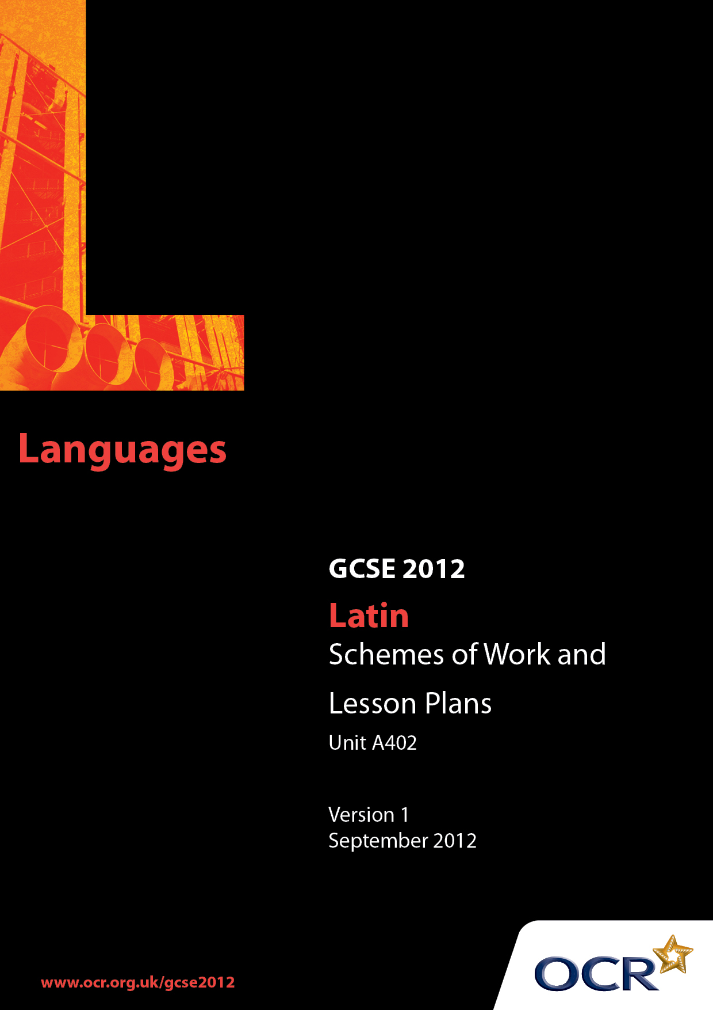

Contents
Introduction 3
Unit A402: Latin Language 2 (History) – Sample Scheme of Work 5
Unit A402: Latin Language 2 (History) – Sample Lesson Plan 15

Introduction

Background
OCR has produced a summary brochure, which summarises the changes to Latin. This can be found at www.ocr.org.uk, along with the new Specification.
In response to reforms announced by the Government and in response to Ofqual mandated changes to GCSEs, unitised assessment of this qualification is being replaced by linear assessment. This means that candidates commencing a two year course from September 2012 will take all of their GCSE units at the end of the course in June 2014.

In order to help you plan effectively for the implementation of the specification we have produced these Schemes of Work and Sample Lesson Plans for Latin. These Support Materials are designed for guidance only and play a secondary role to the Specification.

Our Ethos
OCR involves teachers in the development of new support materials to capture current teaching practices tailored to our new specifications. These support materials are designed to inspire teachers and facilitate different ideas and teaching practices.
Each Scheme of Work and set of sample Lesson Plans is provided in Word format so that you can use it as a foundation to build upon and amend the content to suit your teaching style and students’ needs.
The Scheme of Work and sample Lesson Plans provide examples of how to teach this unit. The teaching hours are suggestions only. Some or all of it may be applicable to your teaching.
The Specification is the document on which assessment is based and specifies what content and skills need to be covered in delivering the course. At all times, therefore, this Support Material booklet should be read in conjunction with the Specification. If clarification on a particular point is sought then that clarification should be found in the Specification itself.

A Guided Tour through the Scheme of Work

= Innovative Teaching Idea
This icon is used to highlight exceptionally innovative ideas.


= ICT Opportunity
This icon is used to illustrate when an activity could be taught using ICT facilities.

Unit A402: Latin Language 2 (History)
Suggested teaching time | 1 hour | Topic | Revision of subjunctive - verbs of fearing and time clauses
Topic outline |  | Suggested teaching and homework activities |  | Suggested resources | Points to note
To revise form and uses of the subjunctive |  | - Teacher provides students with a number of sentences containing the subjunctive in its various uses e.g. fearing, result clauses, purpose clauses, indirect commands, indirect questions, time clauses. These should include examples with both imperfect and pluperfect tenses and the verbs esse and posse.  - Students to be encouraged to volunteer methods of distinguishing imperfect from pluperfect subjunctives. Teacher should also highlight/provide students with list of easily confused irregular verbs such as esse and posse.  - Recognition exercise: teacher gives students a word/group of words which have to be identified as imperfect or pluperfect subjunctives. Students should be asked for translation of verbs to consolidate understanding of imperfect and pluperfect tenses.  - Teacher writes on board 3 sentences containing verb of fearing + ne + subjunctive, including one with ne … non. Students volunteer translations with particular attention paid to most appropriate translations of ‘ne’.  - Temporal clauses: group students and give them 4 sentences which contain either dum + subjunctive or priusquam + subjunctive: ask them to feed back their preferred translations of both dum and priusquam.  - Possible homework: in advance of the following lessons on the subjunctive the teacher could prepare a vocab sheet containing relevant words from the DVL such as question words, signpost words for result clauses, verbs of ordering, requesting, suggesting etc. for students to learn. |  | - A room with an interactive whiteboard or whiteboard with projector is useful to enable text to be discussed by the group as a whole. | - This activity is intended for revision purposes after the bulk of the accidence and syntax on the syllabus has been covered  - This activity is designed for Higher Tier candidates.  - Students are encouraged to keep nota bene sheets or books in which they should make notes of particularly useful linguistic points made by the teacher e.g. easily confused words, or vocabulary which they find is unknown or regularly mistranslated.  - Example sentences should ideally be composed of DVL words to consolidate learning.

Unit A402: Latin Language 2 (History)
Suggested teaching time | 1 hour | Topic | Revision of the subjunctive - purpose clauses
Topic outline |  | Suggested teaching and homework activities |  | Suggested resources | Points to note
To revise purpose clauses and to consider their effective translation |  | - Vocabulary test of words from the DVL relevant to the subjunctive such as question words, signpost words for result clauses, verbs of ordering, requesting, suggesting etc. (set as homework in previous lesson).  - Mark test with students.  - Working in groups, students are given a series of sentences to translate containing purpose clauses with ut + subjunctive. Teacher works with class to arrive at various ways of translating ut and those that work best. Students note these down.  - Unseen passage for translation given to students, chosen to contain at least one purpose clause. They spend five minutes reading passage and noting vocabulary not known. Students read the passage aloud (one sentence each).  - If possible, unseen passage should be displayed on whiteboard. Students work orally translating the passage with teacher assistance. Students might be asked to attempt a written translation of a purpose clause within the unseen.  - Suggested homework could be to write out a fair translation of the passage worked on in class. |  | - Unseen passages with a range of difficulties can be found in Carter, A, Latin Momentum Tests for GCSE, Duckworth/BCP, or for slightly trickier passages look at Taylor, J, Essential GCSE Latin, Duckworth/BCP. Use passages with historical stories, suitable to the theme of this language unit.  - A room with an interactive whiteboard or whiteboard with projector is useful to enable text to be discussed by the group as a whole. | - This activity is intended for revision purposes after the bulk of the accidence and syntax on the syllabus has been covered.  - This activity is designed for Higher Tier candidates.  - Students are encouraged to keep nota bene sheets or books in which they should make notes of particularly useful linguistic points made by the teacher e.g. easily confused words, or vocabulary which they find is unknown or regularly mistranslated.  - Example sentences should ideally be composed of DVL words to consolidate learning.  - Unseen passages should be historical in theme.

Unit A402: Latin Language 2 (History)
Suggested teaching time | 1 hour | Topic | Revision of subjunctive - result clauses
Topic outline |  | Suggested teaching and homework activities |  | Suggested resources | Points to note
To revise result clauses, learning how to recognise and translate them |  | - Test students on meaning of result clause signpost words from DVL via simple sentences on whiteboard. Students should note down any which they don’t recognise. Example result clause sentences should include at least one with ut … non.  - Provide students with sheets containing building blocks for creating sentences i.e. a separate column with a number of the following chosen from the DVL: noun + signpost word + erat + ut + [non] + [subject] + verb in imperfect subjunctive. Students work in groups to create a specified number of result clauses with at least one in the negative using ut … non. An example from each group could be written on whiteboard and translated by the class  - Unseen passage for translation given to students, chosen to contain at least one result clause. They spend five minutes reading passage and noting vocabulary not known. Students read the passage aloud (one sentence each).  - Students answer comprehension questions set by teacher on the passage. Teacher goes through answers with students in class to ensure all understand technique for scoring full marks.  - Homework: to compose and translate three further result clauses using worksheet provided in class. |  | - Unseen passages with a range of difficulties can be found in Carter, A, Latin Momentum Tests for GCSE, Duckworth/BCP, or for slightly trickier passages look at Taylor, J, Essential GCSE Latin, Duckworth/BCP. Use passages with historical stories, suitable to the theme of this language unit.  - A room with an interactive whiteboard or whiteboard with projector is useful to enable text to be discussed by the group as a whole.  - Prepared worksheet with lists of words with which to construct result clauses. | - This activity is intended for revision purposes after the bulk of the accidence and syntax on the syllabus has been covered.  - This activity is designed for higher tier candidates  - Students are encouraged to keep nota bene sheets or books in which they should make notes of particularly useful linguistic points made by the teacher e.g. easily confused words, or vocabulary which they find is unknown or regularly mistranslated.  - Example sentences should ideally be composed of DVL words to consolidate learning.  - Unseen passages should be historical in theme.

Unit A402: Latin Language 2 (History)
Suggested teaching time | 1 hour | Topic | Revision of commands, both direct and indirect
Topic outline |  | Suggested teaching and homework activities |  | Suggested resources | Points to note
To revise use and translation of commands, both direct and indirect |  | - Each student is given a sheet with some examples of direct commands with singular, plural, positive and negative imperatives amongst them. These are translated orally around the class.  - The sheet should also contain examples of common irregular forms such as dic! and fer!. In groups students are asked to compose their own simple commands which they give to other groups to perform e.g. fer mihi librum!. This is also an excellent opportunity to revise dative forms of personal pronouns.  - A list of key verbs of ordering, suggesting, encouraging, asking etc. are displayed on whiteboard. Teacher encourages noting of unfamiliar vocabulary.  - Sentences containing indirect commands are provided to students with examples of iubeo, impero, ut + subjunctive and ne + subjunctive. Students work individually to produce written translations which the teacher goes through with class. Students are asked to explain difference between use of iubeo and impero. Particular focus also on translation of ‘ne’. Opportunity also for further consolidation of imperfect and pluperfect subjunctive endings.  - Homework: unseen passage which contains examples of direct and indirect commands. |  | - Unseen passages with a range of difficulties can be found in Carter, A, Latin Momentum Tests for GCSE, Duckworth/BCP, or for slightly trickier passages look at Taylor, J, Essential GCSE Latin, Duckworth/BCP. Use passages with historical stories, suitable to the theme of this language unit.  - A room with an interactive whiteboard or whiteboard with projector is useful to enable text to be discussed by the group as a whole. | - This activity is intended for revision purposes after the bulk of the accidence and syntax on the syllabus has been covered.  - This activity is designed for higher tier candidates.  - Students are encouraged to keep nota bene sheets or books in which they should make notes of particularly useful linguistic points made by the teacher e.g. easily confused words, or vocabulary which they find is unknown or regularly mistranslated.  - Example sentences should ideally be composed of DVL words to consolidate learning.  - Unseen passages should be historical in theme.

Unit A402: Latin Language 2 (History)
Suggested teaching time | 1 hour | Topic | Revision of direct and indirect questions
Topic outline |  | Suggested teaching and homework activities |  | Suggested resources | Points to note
To consolidate recognition and translation of direct and indirect questions and associated vocabulary from DVL |  | - Vocabulary test of question words from the DVL .  - Mark test with students.  - Provide students with list of simple statements e.g. multos servos habes which have to be turned into questions. For each specify whether the answer to the question is expected to be open, no or yes. Highlight how use of -ne can sometimes lead to strange-looking words.  - A list of key verbs associated with indirect questions are displayed on whiteboard. Teacher encourages noting of unfamiliar vocabulary.  - Examples containing indirect questions given to students for translation. Examples chosen should include utrum…an and num. Students should be able to explain the different translations of num for direct and indirect questions.  - Unseen passage for translation given to students, chosen to contain at least one indirect question. They spend five minutes reading passage and noting vocabulary not known.  - If possible, unseen passage should be displayed on whiteboard. Students work in pairs to translate a section of the passage which the teacher then reviews with the whole class before students move on to the next section.  - At the end of the group of lessons focussing on the subjunctive, students could revise this topic in preparation for a short test. |  | - Unseen passages with a range of difficulties can be found in Carter, A, Latin Momentum Tests for GCSE, Duckworth/BCP, or for slightly trickier passages look at Taylor, J, Essential GCSE Latin, Duckworth/BCP. Use passages with historical stories, suitable to the theme of this language unit.  - A room with an interactive whiteboard or whiteboard with projector is useful to enable text to be discussed by the group as a whole. | - This activity is intended for revision purposes after the bulk of the accidence and syntax on the syllabus has been covered.  - This activity is designed for higher tier candidates.  - Students are encouraged to keep nota bene sheets or books in which they should make notes of particularly useful linguistic points made by the teacher e.g. easily confused words, or vocabulary which they find is unknown or regularly mistranslated.  - Example sentences should ideally be composed of DVL words to consolidate learning.  - Unseen passages should be historical in theme.

Unit A402: Latin Language 2 (History)
OCR recognises that the teaching of this qualification above will vary greatly from school to school and from teacher to teacher. With that in mind this lesson plan is offered as a possible approach but will be subject to modifications by the individual teacher.
Lesson length is assumed to be one hour.

Learning Objectives for the Lesson
Objective 1 | Students to be able to recognise and translate the different methods of asking direct questions
Objective 2 | Students to reacquaint themselves with the structure and translation of indirect questions
Objective 3 | Students to hone translation skills

Recap of Previous Experience and Prior Knowledge
- In previous lessons, students may have revised key vocabulary, grammar and syntax.

Content
Time | Content
5 minutes | Students take short vocabulary test of question words from DVL.  Test is marked in class.
5 minutes | Using examples on whiteboard, teacher reminds class of the ways in which direct questions can be asked i.e. -ne, nonne and num.
10 minutes | Teacher provides students with a list of simple statements e.g. multos servos habes.  Students are asked to turn each statement into a question (for each example the expected answer is stated i.e. open, yes, or no) and translate.  Teacher reviews answers with class.
5 minutes | A list of key verbs associated with indirect questions is written/displayed on board.  Meanings checked with class and students encouraged to note unfamiliar words.
10 minutes | In pairs students translate example sentences featuring indirect questions. Examples should include utrum … an and num.  Teacher asks students to explain different translations of num in direct and indirect questions.

5 minutes | Students read through an unseen passage which has been chosen to contain at least one indirect question  Unfamiliar vocabulary should be noted
10 minutes | Working individually, students translate for 10 minutes
10 minutes | With the unseen text displayed on the board, teacher leads a translation of the text, ensuring that the indirect question has been identified and correctly translated and that any difficulties in vocabulary, grammar or syntax are shared and discussed

Consolidation
Time | Content
20 minutes | Students to revise the various uses of the subjunctive covered in the previous lessons in preparation for a short test.

