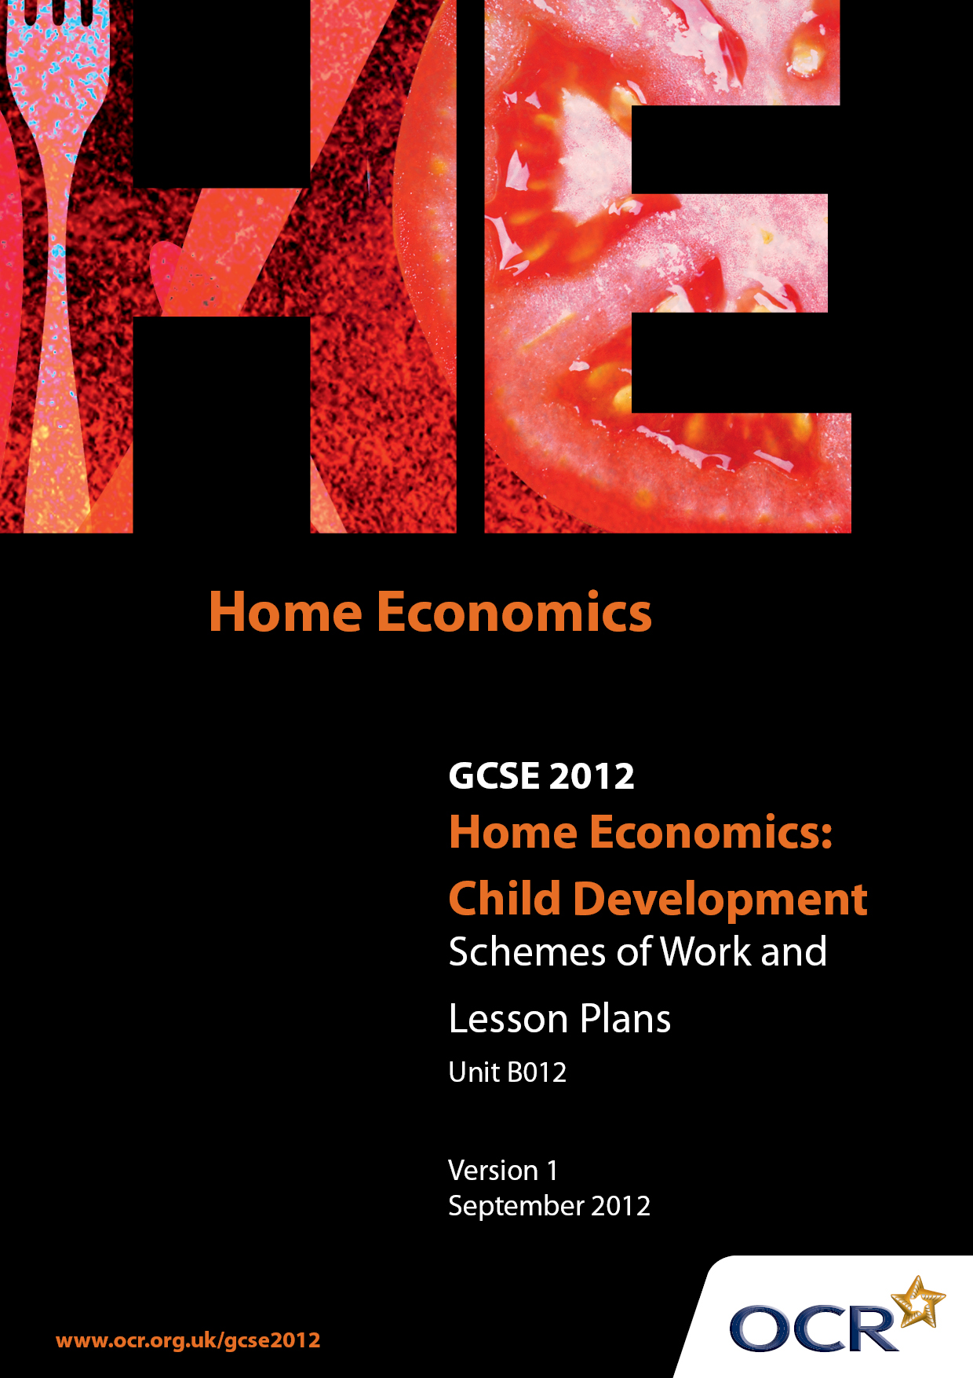

Contents
Introduction 3
Sample Scheme of Work: OCR GCSE Home Economics (Child Development) Unit B012: Child Study 3
Sample Lesson Plan: OCR GCSE Home Economics (Child Development) Unit B012: Child Study 3

Introduction

Background
OCR has produced a summary brochure, which summarises the changes to Home Economics (Child Development). This can be found at www.ocr.org.uk, along with the 2012 specification.
In order to help you plan effectively for the implementation of the new specification we have produced these schemes of work and sample lesson plans for Home Economics (Child Development). These support materials are designed for guidance only and play a secondary role to the specification.

Our Ethos
OCR involves teachers in the development of new support materials to capture current teaching practices tailored to our new specifications. These support materials are designed to inspire teachers and facilitate different ideas and teaching practices.
Each scheme of work and set of sample lesson plans are provided in Word format to be used as a foundation to build upon and amend the content to suit your teaching style and students’ needs.
The scheme of work and sample lesson plans provide examples of how to deliver these units and suggested teaching hours which could be applicable to your teaching.
The specification is the document on which assessment is based and specifies what content and skills need to be covered in delivering the course. At all times, therefore, this support material booklet should be read in conjunction with the specification. Any clarification should be found in the specification.

A Guided Tour through the Scheme of Work

= Innovative Teaching Idea
This icon is used to highlight exceptionally innovative ideas.

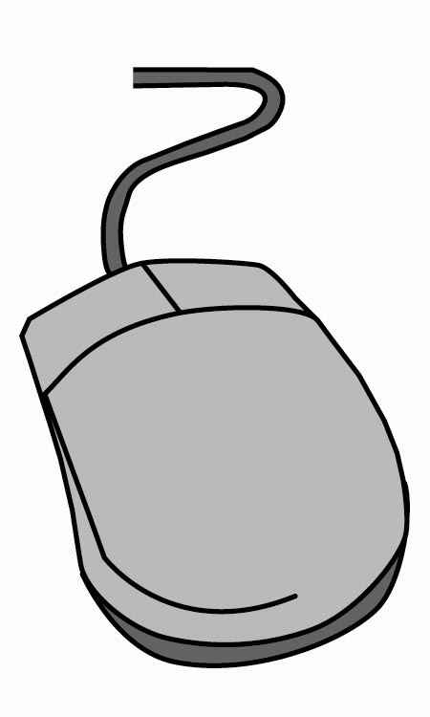
= ICT Opportunity
This icon is used to illustrate when an activity could be taught using ICT facilities.

OCR GCSE Home Economics (Child Development) Unit B012: Child Study
Suggested teaching time |  | 22 hours | Topic | How a five year old child develops intellectual skills through a wide range of everyday activities?
Topic outline |  |  | Suggested teaching and homework activities |  | Suggested resources | Points to note
Introduction - Research |  |  | - Teacher to introduce content, with overall guidelines and themes appropriate to the Child Study.  - Each assessment area to be highlighted with suggested time allocation. Discussion to also take place on the breakdown of marks in each section. |  | - Interactive white board/projector  - Copy of suitable OCR themes for Child Study  - OCR breakdown of assessment areas and mark allocations | - Specification areas to be clearly identified to students. Ideas to be discussed with teacher before embarking on study.
Research |  |  | - Recap from previous week. Students to choose an area of the specification and then produce a Task Title from the OCR set theme list.  - Once the Title has been agreed with the Teacher, students to give clear reasons for their choice.  - Homework – students could visit their local Health Centre, library, collect magazines – e.g. Mother and Baby to gain a range of information to use in their research.  - Students to identify the child they are going to study and meet the parents and child. It is important they ask the parents as much background information about the child as possible, so they can gain an overall ‘picture’ of the child they are going to study. |  | - Interactive white board – bullet points of reasons for particular titles.  - Magazines  - Library  - Leaflets – Local Health Centre | - Students to check that their Task Title is from the OCR set theme list.  - Questionnaire to parents could be included in this section to enable the student to gain as much relevant information as possible about the child they are going to study.  - However personal details about the family such as surnames, addresses should not be included – confidentiality of the child must be protected  - Irrelevant information such as family trees, layout of house should not be included.  - Students to give as much detail as possible and work independently if high marks are to be awarded.
Research  Continued |  |  | - Teacher to check what information students have collected on the child they are going to study. Gaps should be clearly identified so that the student can collect any outstanding information on which to support their future research.  - Teacher support to be given on an individual basis although PIES can be taught generally as part of a class lesson.  - The child’s developmental skills (at present) can be compared to those of the norms as identified in text books.  - The results could then be displayed in chart form. Using a range of ICT methods.  - Homework – Meet and talk to parents of the child to gain as much relevant information on the child they are going to study. |  | - Internet. www.childdevelopmentguide.com  - GCSE Power point presentations;  - www.theproductshop.co.uk  - writing frame for less able candidates in chart form with headings for example - intellectual development – skills “can do” “cannot do”.  - Interactive white board with suggested ideas | - Research should come from a range of primary and secondary resources for high marks to be awarded. If only one resource is used marks should be limited (1 to 4 maximum).  - Students to consider a range of suitable resources to use to undertake an depth research on their development area.  - Secondary and primary resources should be used. PIES also need to be researched but this should link to the age of the child being studied and the development area
Research |  |  | - Using the information gained from homework and previous research, students to collate and compile relevant background information on the child being studied. This could include;  - family structure, character (personality – friendly, happy, bubbly, quiet, introvert) and personal qualities, likes and dislikes e.g. foods, sports, T.V. programs characters, PIES related to child/age, comparison with norms, |  | - Resources as above.  - – word process information gained under relevant headings.  - Use homework to support research on the child.  - Mind maps, charts could be constructed to produce the information. | - It is not necessary to include a photograph of the child.  - Further discussion with the parents if it is thought necessary.
Research |  |  | - Students to select findings from previous research and summarise. Teacher to support students in producing a clear outline of the steps to be taken to carry out and complete the task.  - This could be in the form of a mind map, flow chart, specification. |  | - to be used where possible. | - Information should be summarised independently.  - Students to use previous research collected to present results and draw detailed conclusions.
Selecting and Planning the Observations |  |  | - Class arranged into groups with further discussion to take place on what students have complied so far in their study. Main points on possible ideas and activities to be highlighted and fed back to the main class, a group at a time. Key words/ideas linked to development area selected and age of child. This can be summarised on a white board linking ideas and activities. Further question and answer session on range of ideas that could be used for observations. |  | - Interactive white board/projector | - If candidates do not work independently for example, where support is given by a Teaching Assistant this needs to be identified on the marking front cover sheet.  - Ideas for activities during the observations ideally should be based on the previous research and the class work now undertaken.
Selecting and Planning the Observations |  |  | - Recap on previous lesson. Students to work independently selecting a number of ideas and activities they could plan for their observations with the child.  - Focusing back to the Task Title and the child, students to plan activities which could be considered. For example – cooking, drawing and painting, playing games, watch television, read and write, visit to the park, playing musical instrument, colouring pictures, playing game on the internet, story time, memory games, puzzle and jigsaw,.  - Each activity and method should be related to the suitability of the child and development area being studied. Once the activities have been decided upon students need to make a final selection. These activities must now have clear reasons for being chosen.  - Homework – final selection of activities and methods to be completed. |  | - As above  - A range of suitable ideas could be displayed in poster form, OHT, projector.  - – range of charts, pictures  - SCO – by range of activity, detail and outcome | - When students select their final range of activities they need to justify clearly why they have selected them, able candidates will also refer back to their original research and use this information when justifying their final choices.  - Teacher to check on suitability and viability of activities finally selected, and the commitment and ability of the student undertaking them.
Selecting and Planning the Observations  Continued |  |  | - Recap on activities and methods going to be used for the observations.  - Exemplar materials discussed – which methods suits which activity?  - Ways to observe the child could include – in a public place (library/park), with parents, with sibling, friends, in shops/supermarket, at home with child,  - Students to use the activities selected to focus on skills they would like to see and develop in the child they are studying. They should refer back to the Task Title, for example, “How a 5 year old child develops Intellectual skills through a wide range of everyday activities’. Skills that could be a focus for this task – memory, concentration, understanding, language, imagination, manners, read/writing, creativity and following instructions. |  | - Exemplar flow charts, mind maps,  - Writing frame for less able.  - Methods of observation could include –  - Naturalistic  - Snapshot  - Structural  - Longitudinal  - Participative  - Non-Participative  - Tick sheet for students to cross reference that they have addressed each area in this section. | - A variety of methods must be used, repetitive planning of similar observations is not recommended.  - Headings/ proforma’s/writing frames may be useful for less able candidates for example:  - Bullet point sheets, mind maps, simple charts, tick sheets.
Selecting and Planning the Observations |  |  | - Each observation must be finally planned and include – purpose of visit, location, time/length, activity to be undertaken, skills to hopefully see, resources needed for each planned activity, method of observing the child, alternative plans if problems occur. A range of methods should be used. SCO |  | - – range of recording sheets to use during visits.  - A wide range of methods should be used if high marks are to be awarded. | - Methods to record could include – place of visit, length, type, resources needed.  - Written notes  - Diagrams  - Students should include what to do if problems occur and have an alternative plan for each visit.
Selecting and Planning the Observations |  |  | - Checklist by teacher could be used to ensure outstanding work in the section is completed. Clear plans of observations should be drawn up. These should include – number of visits, length of visits, matching suitable activities to time allocations and child.  - Decision on plan of visits – For example one visit per week to enable the student to see how the child develops intellectually over time. Twice per week, so the activities take a shorter time. Once every 2 weeks but that might be too long a gap?  - Length of visits - For example 20 minutes short activity reading a story or doing a puzzle, 30 minutes playing the piano or reading,50 minutes two activities can be completed namely; reading and writing, or a longer planned visit at 90 mins to undertake some cooking,  - Homework tasks could be to check each planned observation for length of visits, activities planned, resources required, and recording charts for evidence. |  | Checklist of carrying out a successful observation:  - Get to know the child and build up a positive and happy relationship  - Carry out the observation in familiar surroundings  - Allow the child to be as natural as possible  - Keep the observation focussed on the development area planned  - Plans should be detailed but easy to follow  - Cover a variety of activities during your visits  - Be prepared to change your plan if necessary  - Use the evidence collect for example to write up the observation in detail and soon after the visit as possible  - Do not make the child’s activity too long as their concentration span may be limited. | - As above  - Depending on the area of development being studied and age of the child 6 observations are recommended.  - The distance between student, child and school might also have an influence on number and lengths of visits. Availability and convenience of studying a particular child must be considered  - Students are advised to complete an overall plan of their observations.  - This section is ideal for the use of ICT to construct tables, charts, check lists etc to record their observations.  - Students should check that they have planned a variety of activities using a range of methods and resources.
Observations suggest six sessions |  |  | - Students to carry out the observations according to their plans.  - Teacher to reiterate the importance of undertaking the activities planned accurately and relating them to the areas of development already identified and researched. |  | - Resources will depend on the activity being undertaken.  SCO –on outcome | - Each activity should be undertaken in sequence unless problems occur – for example the child is unwell.
Observation One  Puzzle and watching Television activity |  |  | - Aim of activity  - Visit one  - To find out if a five year old child can concentrate on one thing for a while and solve a puzzle.  - Two simple activities undertaken – completing a problem solving puzzle 20 minutes, watch DVD 40 minutes. |  | - Tick Chart headings to include  - Activity watch DVD, tick box, comments  - T.V. DVD player, puzzles, clock, camera | - Photographs and pictures – not full face  - Evidence of work completed with the child – a picture or piece of writing  - Pictures of the child completing the puzzle could be included.  - Complete record sheet during the activities or after the visit.  - Location at home
Practical Observations - |  |  | - Class discussion – question and answer session on the outcome of the students first observation.  - Class to focus on positive and negative experiences.  Teacher to recap on  - the importance of accurately recording observations.  - ensuring the observations relate to the development area being studied  - see a number of different methods when observing the child |  | - Students to share their experiences on their first observations within the classroom.  - Good practice.  - Examples of different methods of recording observations on display.  - Writing frames can be used by less able students to record their observations but this should then be reflected in their marks. | - Recording observations must refer to what was originally planned or clear justified reasons given for a change of plan. The development area being studied must be clear.  - Basis descriptive accounts of what has taken place should not be awarded high marks.  - The recording of observations must be accurate and detailed for high marks to be awarded
Observation Two – Cooking Activity |  |  | - Aim of activity  - Visit two – cooking activity to see if the child can follow simple instructions, complete in the correct order and understand the concepts of a cooking activity. |  | - Cooking muffins and decorating with icing.  - Muffin ingredients and flowchart, equipment and use of kitchen  - Notebook, camera. | - Pictures of the child making muffins and finished results with range of decorated toppings.  - Location at home
 | Observation three –Colouring and making |  | - Aim of activity  - Visit three - to ascertain if the child can recognise all the colours and then relate them to the correct word. To also see if the child can colour pictures neatly and cut them out using favourite characters. This could then be used as a book mark. |  | - Range of coloured written words  - Range of colouring pens  - Glue  - Coloured card  - Characters to cut out for example ‘Winnie the Pooh’ character pictures  - Table to complete notes on observation  - Scissors  - Spellings. | - Pictures of child colouring in characters and cutting out. These can be included in the study.  - Location at home  - Cut out characters could be fabricated into a bookmark.
 | Observation four – Reading and Writing |  | - Aim of activity  - Visit four - to gauge the level of intellect through reading and writing and how these compare with child norms.  - Write the child’s name and interests. |  | - Work books/Simple reading books  - Lined paper and pens/pencils/rubber/ruler  - card  - Recording sheet  - Camera  - Tick chart | - Photographic evidence desirable  - Location at home
 | Observation five – Playing Board Game Activities /Memory game and card games |  | - Aim of activity  - Visit five - can the child follow the rules of a board game, taking turns and accept losing?  - To see the child use its memory skills, knowledge and number skills to play games that have been made by the student. |  | - Board game  - Different characters  - Dice  - Two friends of similar age to play the game  - Four different types of card made by student  - Pairs, spellings, picture and spelling match up game and shape cards  - Camera  - Notebook | - A five year old should be able to share toys with friends, play and communicate and accept losing.  - Location at home
 | Observation six –painting activity |  | - Aim of activity  - Visit six – child to undertake simple picture painting and drawing to see its creative talents. During this activity the child can draw a familiar item e.g. house with coloured garden and sun.  - Hand and finger painting can also be completed.  - Teacher to review each visit with student on an individual basis, checking that they are fulfilling all aspects of their previous planning. |  | - Coloured paper  - Printer  - Computer  - Paint brush  - Glitter  - Paints  - Camera  - Notebook  After each observation students should record their visit accurately and in detail.  A range of recording methods should be used as previously mentioned. | - Location at home  - If time allows in any observation a second activity can be undertaken for example;  - A game matching the correct fruits against the correct spellings.  - Making a book mark.  - Story book reading.  - Jigsaw puzzle.  - In all the above observations the student tries to undertake activities that encourage intellectual development through everyday activities. Recording observations should be undertaken during or after each visit while experiences are fresh in students mind.  - Depending on the nature of the activity planned results of the child’s work can also be included in the study. For example drawings, pictures of puzzle making. Please note that photographs should only be included if they are relevant and then full faces should not be included for child protection reasons.
 | Apply understanding to observations |  | Teacher led lesson – areas to be covered in this section.  - What have students understood during their observations?  - use information on recording sheets previously completed on each observation to help understand and interpret the area being studied  - use previous knowledge gained from research  - include students own thoughts and opinions about what they have seen and experienced  - compare the child with other children at the same age/stage – use knowledge gained from observation where child being studied interacted with peers.  - compare the child to textbooks norms |  | - Interactive white board and projector  - Original planning – use research and information included in the planning section of their study.  - Student’s individual recording sheets to support their reflection and understanding on the observations they have undertaken. Samples of child’s work e.g. drawing, photographs, feedback from parents.  Writing frame | - Students can complete this section after each observation has taken place or when they have completed all their observations.  - Suggest that students attempt this section after each observation rather than a separate section.  - Students must continually refer back to the development area being studied.
 | Apply understanding to observations |  | - Students to work independently on completing this section as fully as possible.  - Teacher to support on a one to one basis |  | - As above  - SCO by outcome | - As above
 | Evaluation |  | - Class discussion  - Question and answer session under key words.  - Review – the candidate must review all aspects of the task. This could be achieved by completing an essay (high order skills – able students) reviewing work under each section (use key words – middle able candidates) writing frame with detailed headings /key words (less able students).  - In addition students need to draw or reflect on the Task Title and the evidence and outcomes of their observations through logical conclusions.  - Discussions should include what the students have found relating to their Task Title for example: How has the five year old child developed intellectual skills through the range of everyday activities that have been planned and observed?  - Students could use a mind map to identify their strengths and weaknesses and give an explanation as to why these were evident. |  | - Interactive white board and projector  - Key words - headings for example, review strengths, weaknesses, changes, conclusions – refer back to task title. Students own views to include improvements, recommendation for further work.  - These key words could be used in a writing frame to support less able candidates – marks should reflect their use. | - For high marks to be awarded students must produce a high level of written communication skills throughout the task. Specialist terms and terminology should be used together with the accurate use of spelling and grammar. Information should be presented in a structured format with few or no omissions or errors.
 | Evaluation |  | - Recap from previous lesson and continue to focus on outstanding aspects of students completing their evaluation.  - Students should include recommendations to improvements to their work or recommend further work that could be completed to enhance their child’s study.  - For example – more detailed planning to include comprehensive lists of resources required to enable smooth trouble free observations.  - Realistic time allocations.  - Suitable activities to match the age and type of child |  | - As above  - Word processing  - Questionnaire to parents on;  - child’s views of visits and activities planned  - parents views on the suitability of activities,  - parents views on interaction between student and child,  - overall comments on the application of the child’s study | - As above

OCR GCSE Home Economics (Child Development) Unit B012: Child Study

Selecting and Planning Observations
OCR recognises that the teaching of this qualification above will vary greatly from school to school and from teacher to teacher. With that in mind this lesson plan is offered as a possible approach but will be subject to modifications by the individual teacher.
Lesson length is assumed to be one hour.

Learning Objectives for the Lesson
Objective 1 | Understand what is meant by a range of methods that can be used for observations
Objective 2 | Know how ICT can be used effectively for the recording of observations
Objective 3 | Understand what should be included in the planning of each observation

Recap of Previous Experience and Prior Knowledge
- Refer back to discussion of what makes a good range of planned observations linking ideas to the child and development area being studied.

Content
Time | Content
5 minutes | Recap on what constitutes a range of methods. Question and answer sessions based on previous knowledge.
10 minutes | Students to suggest how these methods could be used successfully together with their own ideas when planning the activities they wish to undertake with the child being studied.
15 minutes | Student Activity: students to record the range of methods that they could use for their observations.
10minutes | Explain how ICT could be used to record observations showing students a range of ideas/good practice. Discussion to follow on the benefits and disadvantages of each method of recording.
10 minutes | Student Activity: students to note how they can use ICT when recording their observations and depending upon time and availability of computers, to draft a recording sheet.

Consolidation
Time | Content
10 minutes | Plenary: use of range of methods and recording sheets on display/ interactive white board to ensure students understand requirements when planning their observations.

