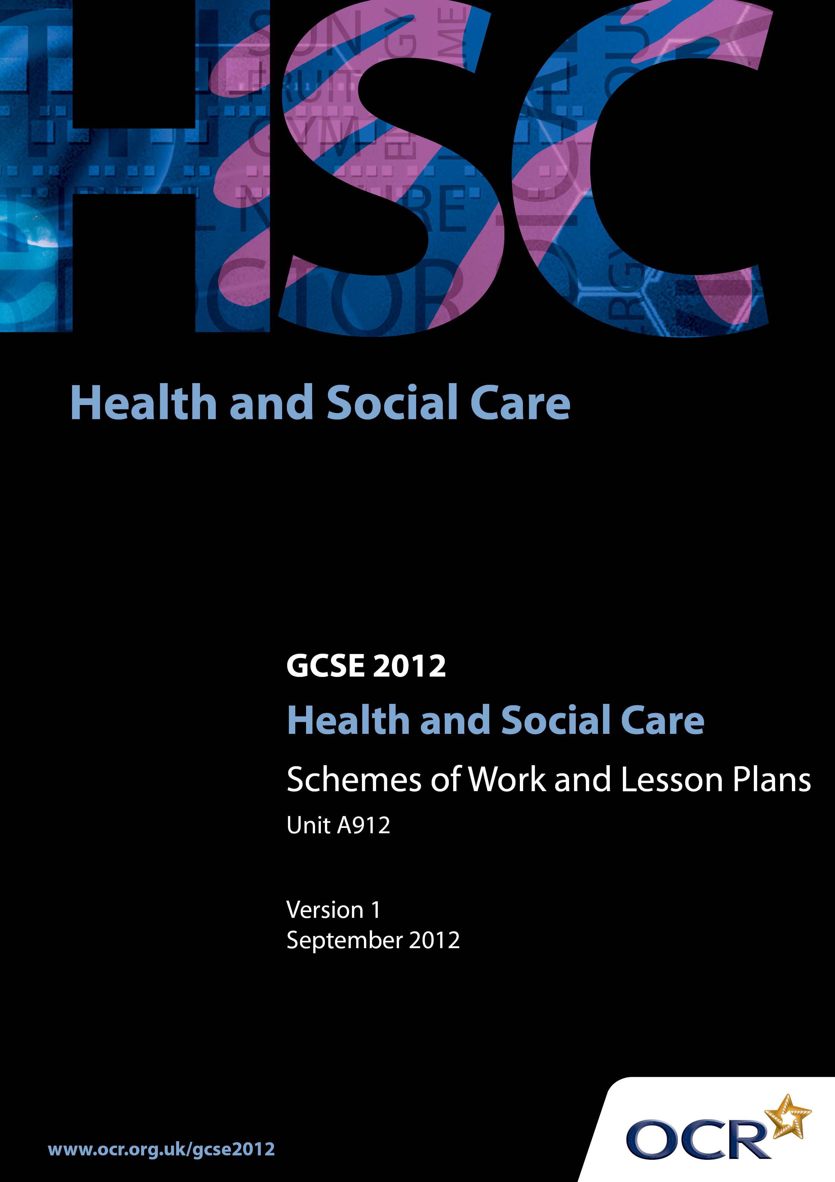

Contents
Introduction 3
Sample Scheme of Work: OCR GCSE Health and Social care J406 Unit A912: Understanding Personal Development and relationships 5
Sample Lesson Plan: OCR GCSE Health and Social Care J406 Unit 912:
Understanding Personal Development and Relationships 16

Introduction

Background
In December 2011 the GCSE qualification criteria were changed by Ofqual. As a result, all GCSE qualifications have been updated to comply with the new regulations.
The most significant change for all GCSE qualifications is that, from 2014, unitised specifications must require that 100% of the assessment is terminal.
The sections below explain in more detail the rules that apply from the June 2014 examination series onwards.
Please note that there are no changes to the terminal rule and re-sit rules for the January 2013 and June 2013 examination series:

- at least 40% of the assessment must be taken in the examination series in which the qualification is certificated.

- candidates may re-sit each unit once before certification, i.e. each candidate can have two attempts at a unit before certification.

For full information on the assessment availability and rules that apply in the January 2013 and June 2013 examination series, please refer to the previous version of these specifications, GCSE Health and Social Care and GCSE (Double Award) Health and Social Care (July 2009), available on the website.
In order to help you plan effectively for the implementation of the specification we have produced these Schemes of Work and Sample Lesson Plans for Health & Social Care. These Support Materials are designed for guidance only and play a secondary role to the Specification.

Our Ethos
OCR involves teachers in the development of support materials to capture current teaching practices tailored to our specifications. These support materials are designed to inspire teachers and facilitate different ideas and teaching practices.
Each Scheme of Work and set of sample Lesson Plans is provided in Word format – so that you can use it as a foundation to build upon and amend the content to suit your teaching style and candidates’ needs.
The Scheme of Work and sample Lesson plans provide examples of how to teach this unit and the teaching hours are suggestions only. Some or all of it may be applicable to your teaching.
The Specification is the document on which assessment is based and specifies what content and skills need to be covered in delivering the course. At all times, therefore, this Support Material booklet should be read in conjunction with the Specification. If clarification on a particular point is sought then that clarification should be found in the Specification itself.

A Guided Tour through the Scheme of Work

= Innovative Teaching Idea
This icon is used to highlight exceptionally innovative ideas.


= ICT Opportunity
This icon is used to illustrate when an activity could be taught using ICT facilities.

OCR GCSE Health and Social care J406 Unit A912:
Understanding Personal Development and relationships
Suggested teaching time | 10 hours | Topic | 3.2.1. The stages and pattern of human growth and development
Topic outline |  | Suggested teaching and homework activities |  | Suggested resources | Points to note
How do individuals grow and develop during each life stage? |  | - What are the different life stages  - Drawing a time line and mark on it the various life stages and age ranges covered.  - Research in pairs to find out the physical, intellectual, emotional, and social characteristics within a life stage  - Prepare A4 poster for one life stage  - Divide the class into groups of 5, all having researched one different life stage. Candidates present the findings to the rest of the group  - Candidates take notes during presentations  - Teacher input: What is the difference between growth and development?  - Use of percentile charts and case studies used to make comparisons to the norms of growth  - Check knowledge: Candidates given case studies for different life stages, they identify aspects of development  - Produce an information booklet on development issues to be used by social workers. Each life stage should contain information on all 4 areas of development. Your information booklet could contain pictures and/or illustrations |  | - GCSE Health and Social Care textbooks  - DVD BBC The Human Body - Robert Winston  - Plain paper  - Glue  - Poster paper and flipchart marker pens.  - Percentile charts  - Mini tests  - Case studies  - Access to computer facilities | These are:  - infancy (0-3),  - childhood (4-10),  - adolescence (11-18),  - adulthood (19-65),  - later adulthood (65+)  - Growth refers to an increase in physical size (mass and height)  - Development is concerned with the emergence and increase in sophistication of skills, abilities and emotions.

OCR GCSE Health and Social care J406 Unit A912:
Understanding Personal Development and relationships
Suggested teaching time | 16 hours | Topic | 3.2.2. The different factors that can affect human growth and development
Topic outline |  | Suggested teaching and homework activities |  | Suggested resources | Points to note
Introduction: Why are we all different? |  | - Why am I like I am?  - Circular diagrams - candidate in the middle and write what or who they think has affected who they are  - Read a prepared case study which illustrates factors that affect growth and development. Candidates make a circular diagram, the case study in the middle and recording all the factors that have affected the individual’s life  - Class discussion on factors identified and how they can influence an individual's health, well-being and life opportunities? |  | - GCSE Health and Social Care textbooks  - Plain paper  - Coloured pens | Hints during session:  - physical  - social/emotional  - environmental  - economic  Understanding how these factors can interrelate and how they can affect an individual's:  - self-esteem  - physical and mental health  - employment prospects  - level of education
Physical factors that affect human growth and development |  | - Teacher input: Facts about physical factors  - Identify what effect abuse and neglect can have on personal development  - Candidates create a magazine style booklet to show to their peers the importance of physical factors within adulthood |  | - GCSE Health and Social Care textbooks  - Access to computer  - Paper and magazines to illustrate candidates work  - NSPCC website | Include:  - genetic inheritance  - diet  - amount and type of physical activity  - sexual health (ensure sensitivity is used , and work for the magazine in general terms only)  - experiences of illness or disease
Social and emotional factors that affect human growth and development |  | Teacher input:  - Facts about social and emotional factors for notes  Candidate activity: imagine you are a journalist and have been asked to answer readers’ questions to the problem page  - Every candidate answers one question anonymously  - Collect them all in and then sit in a circle and read the question and answers, discuss responses |  | - GCSE Health and Social Care textbooks  - ‘Agony Aunt’ style letters | Include:  - gender  - family relationships  - friendships  - educational experiences  - employment/unemployment  - ethnicity and religion  - life experiences such as birth, marriage, death and divorce
Economic factors that affect human growth and development |  | Teacher input:  - Facts about economic factors for notes understand terminology  - Candidates decide 10 material possessions they must have on a desert island.  - Compare ideas in groups, then decide as a group which 5 they would take and why |  | - GCSE Health and Social Care textbooks  Glossary to define:  - Employment  - Unemployment  - Wealth  - Poverty  - Income  - Disposable income  - Material possession | Include:  - income and material possessions
Environmental factors that affect human growth and development |  | - Teacher input  - Facts about environmental factors for notes  - Recap on all the factors and how they have affected an individual’s development by playing with the group a game ‘consequences’. |  | - GCSE Health and Social Care textbooks  - Plain paper | Include:  - housing conditions  - pollution  - access to health and welfare services
Recall and application of knowledge |  | Write down a minimum of six factors (at least one from each section) make a paper chain to show how they interrelate to one another  Under the following titles note how the person has been affected:  - self-esteem  - physical and mental health  - employment prospects  - level of education  - Using notes write a case study and give to another person who will work out:  a) the factors  b) how the factors have influenced development  c) how the factor are interrelated  - Share answers |  | - Strips of paper to form paper chains  - GCSE Health and Social Care textbooks  - Paper  - Access to computers
Practice examination technique |  | - Practice questions under controlled conditions in preparation for the test based on:  a) life stages  b) characteristics of growth and development for each life stage  c) factors that affect development  d) effects of factors on development  - Peer assessment and discussion of the answers after questions are marked |  | - Past exam papers  - GCSE Health and Social Care textbooks

OCR GCSE Health and Social care J406 Unit A912:
Understanding Personal Development and relationships
Suggested teaching time | 10 hours | Topic | 3.2.3. The development of self-concept and different types of relationships
Topic outline |  | Suggested teaching and homework activities |  | Suggested resources | Points to note
How relationships play a key part in an individual's social and emotional development during each life stage. |  | - What relationships do we have at the life stage we are now? Draw a spider diagram to show our relationships  - Make a chart to show different types of relationships and their characteristics, for example, a baby’s relationship with its mother is ‘dependency’  - For each main life stage, make a spider diagram and a chart to show the different types of relationships people could have identifying the key characteristics |  | - GCSE Health and Social Care textbooks  - Glossary of words for types of relationships | - Family relationships (e.g. with parents, siblings and as parents)  - Friendships  - Intimate personal and sexual relationships  - Working relationships (including teacher/candidate, employer/employee, peers, colleagues)
Identify how relationships can have a positive or negative effect on personal development. |  | - What is meant by ‘positive’ and ‘negative’ relationships?  - Read and discuss a case study that shows both positive and negative effects of a relationship  - What effect can abuse, neglect and lack of support can have on personal development |  | - Speaker from the occupational sector to talk about positive and negative relations experienced by individuals and their effects on individuals e.g. Manager of residential Home, Social Worker, Play Therapist etc.  - ‘Childline’ and NSPCC websites
What is self concept? |  | - Read a case study that shows how self concept is developed and discuss  - Give out a second case study showing a change in an individual’s circumstances and discuss/answer questions about how the person’s self concept may have changed |  | - GCSE Health and Social Care textbooks | Self-concept is affected by factors such as:  - age  - appearance  - gender  - culture  - emotional development  - education  - relationships with others  - sexual orientation
Preparation for examination questions |  | - Answering questions under controlled conditions relating to relationships and positive and negative effects of relationships on development  - Peer marking and discussion of the answers after questions are marked |  | - GCSE Health and Social Care textbooks  - Practice papers form previous exams

OCR GCSE Health and Social care J406 Unit A912:
Understanding Personal Development and relationships
Suggested teaching time | 9 hours | Topic | 3.2.4. Major life changes and sources of support
Topic outline |  | Suggested teaching and homework activities |  | Suggested resources | Points to note
Life events can have a major impact on an individual's personal development |  | - Group work List life event/changes  - relationship changes (e.g. marriage, divorce, living with a partner, birth of a sibling or own child, death of a friend or relative)  - physical changes (e.g. puberty, accident or injury, menopause)  - changes in life circumstances (e.g. moving house, starting school, college or a job, retirement, redundancy or unemployment)  - Identify and describe how these events would affect a person’s development  - Homework: Talk to someone in later adulthood (or a fictional person). Create timeline with their life events on it (e.g. grandparent, but remember confidentiality) |  | - GCSE Health and Social Care textbooks
Understand how support comes from different sources |  | - Investigate how individuals adapt and use sources of support to cope with the effects of life events  - Case studies showing different life events- candidates identify support and show this enabled the person to cope |  | - GCSE Health and Social Care textbooks  - Case studies. Build up a selection of people /scenarios and how support could be given | - Partners, family and friends  - Professional carers and services  - Voluntary and faith-based services e.g. social worker: assess needs, discuss concerns, organise practical help, write care plan, review provision of care etc
Practice examination techniques and applying knowledge |  | - Practice questions based on life event changes, the type of support needed and how this enables people to cope |  | - Past papers  - GCSE Health and Social Care textbooks

GCSE Health and Social Care J406 Unit 912: Understanding Personal Development and Relationships

‘Why we change during our life’
OCR recognises that the teaching of this qualification above will vary greatly from centre to centre and from teacher to teacher. With that in mind this lesson plan is offered as a possible approach but will be subject to modifications by the individual teacher.
Lesson length is assumed to be one hour.

Learning Objectives for the Lesson
Objective 1 | To understand the five main life stages
Objective 2 | To understand that people go through different patterns of physical growth and development during the five main life stages

Recap of Previous Experience and Prior Knowledge
- Candidates’ personal experiences in life

Content
Time | Content
5 minutes | Candidates form a straight line from the shortest to the tallest  Candidates repeat the exercise using birth date from the youngest to the oldest
15 minutes | Teacher input… why are the lines different?  Key words…  Growth - increase in physical size (mass and height)  Development - the emergence and increase in sophistication of skills, abilities and emotions  PIES - physical, intellectual, emotional, social development
10 minutes | Divide the class into five groups.  Name: ‘infancy, childhood, adolescence, adulthood, later adulthood’  Using a roll of paper, one candidate draws around another candidate who is lying flat on the paper. (Ensure the tallest person is used for the adult, the smallest for the child, a doll for infancy)  Hang the silhouette on the wall.  Group’s research:  - Age range of their life stage  - Two physical, two intellectual, two emotional and two social developments that are characteristic of their life stage  - Pictures of people in the life stage to show that everyone is different  Record the information found and add the information found to the silhouette using coloured paper. (E.g. physical characteristics on blue paper, social on green etc)
10 minutes | Each group present their findings to the class

Consolidation
Time | Content
10 minutes | Distribute hand out: (information jumbled)  Words: infancy, childhood, adolescence, adulthood, later adulthood  Numbers: 0-3, 4-10, 11-18, 19-65, 65+  Candidates put them in the right sequence:  Life Stage Age range ( in years)  Correct answers given, self assessment.  Homework: Candidates learn life stages and age ranges  This work could be extended into the next lesson as groups look at a different life stage and add two different characteristics to each life stage poster.

GCSE Health and Social Care J406 Unit 912: Understanding Personal Development and Relationships

Economic Factors that affect human growth and development
OCR recognises that the teaching of this qualification above will vary greatly from centre to centre and from teacher to teacher. With that in mind this lesson plan is offered as a possible approach but will be subject to modifications by the individual teacher.
Lesson length is assumed to be one hour.

Learning Objectives for the Lesson
Objective 1 | To understand what economic factors are
Objective 2 | To understand how economic factors interrelate to affect a person’s life

Recap of Previous Experience and Prior Knowledge
- Other factors that can cause individual differences in patterns of growth and development

Content
Time | Content
5 minutes | Candidates individually imagine that they are on a ‘Desert island’ and they can only take only 10 possessions with them
5 minutes | Teacher input:  - Economic factors relate to income… material possessions
10 minutes | Candidates record the following terminology into their glossary:  - Employment  - Unemployment  - Wealth  - Poverty  - Income  - Disposable income  - Material possessions  Teacher input
5 minutes | How the factors affect personal development in terms of:  - Self-esteem  - Physical and mental health  - Employment prospects  - Level of education
5 minutes | In groups of three or four candidates, they pool their 10 ideas for the Desert Island, and discuss
5 minutes | They are then told that as a group they can only take five items with them
10 minutes | The items chosen need to be justified in terms of influencing:  - the health  - the well being and  - the life opportunities of the group

Consolidation
Time | Content
15 mins | Using De Bonos thinking hats:  What were the suggestions?  What are your recommendations?  What are your feelings about the solution?  Are there any other ideas?  we  What facts did you base your suggestions on?

GCSE Health and Social Care J406 Unit 912: Understanding Personal Development and Relationships

How Relationships affect our Self Concept
OCR recognises that the teaching of this qualification above will vary greatly from centre to centre and from teacher to teacher. With that in mind this lesson plan is offered as a possible approach but will be subject to modifications by the individual teacher.
Lesson length is assumed to be one hour.

Learning Objectives for the Lesson
Objective 1 | To understand the different relationships a person has in their life
Objective 2 | To begin to understand what is meant by our self concept
Objective 3 | To extend vocabulary

Recap of Previous Experience and Prior Knowledge

Content
Time | Content
10 minutes | As candidates enter the room they are given a piece of card with a feeling word written on it. (Ensure there is a balance of positive and negative feelings)  They are asked to prepare a ‘Mr Men’ character for their word, using as many adjectives as possible with the same letter, to show the feeling  (Have dictionaries available if they are unsure of the meaning of the word) e.g. I am Mr Happy, I am hoping to help to ensure that Henry is healthy and Happy.  Words that could be used:  (Confident, happy, elated, helpful, loved, valued, self assured, assertive, independent, optimistic, trusting, carefree, cheerful, proud, vivacious, willing, ashamed, vulnerable, afraid, shy worthless, guilty, useless, upset, inadequate, desperate, fat, good for nothing, helpless, hopeless, incompetent, ineffective, pointless, unsuccessful, waste of space, worthless, reluctant)  Each candidate reads out their ‘Character’ and move in the room to show if the word is a negative feeling or a positive feeling
10 minutes | Feelings are recorded on two Flipchart sheets

5 minutes | Candidates create a ‘Circular Ring’ diagram about themselves  Inner Circle… themselves (alone)  - 1st Ring Family members (genetic bond)  - 2nd Ring Family members who are not related by blood ties  - 3rd Ring Friends who you are close to and share your secrets.  - 4th Ring Friends through common interests  - 5th Ring Work/school ‘mates’
5 minutes | Using the Inner Ring… how do they feel about themselves?  (Sensitivity must be shown as candidates may not wish to share their feelings with others)  Use at least three words
5 minutes | Candidates ask someone else in the room to write at least three descriptive words about them. This can be linked to Ring 5
5 minutes | Explain that they are building up a picture of how they see them selves and how others see them, which contribute to our self-concept
10 minutes | Homework:  - Candidates seek opinions about themselves from someone in Rings 2, 3, and 4  Class thought shower - what other factors might affect someone’s self-concept besides relationships?  Age, appearance, gender, culture, emotional development, education, sexual orientation

Consolidation
Time | Content
10 minutes | Complete the pyramid, which are collected in as candidates leave the room:  i  Name 2 relationships  Name 3 positive feeling words  3 negative Feeling words  One question you would like to ask

GCSE Health and Social Care J406 Unit 912: Understanding Personal Development and Relationships

Life Changes in our Lives
OCR recognises that the teaching of this qualification above will vary greatly from centre to centre and from teacher to teacher. With that in mind this lesson plan is offered as a possible approach but will be subject to modifications by the individual teacher.
Lesson length is assumed to be one hour.

Learning Objectives for the Lesson
Objective 1 | To introduce what life events are
Objective 2 | To consider what support is available to help people through events and how this helps

Recap of Previous Experience and Prior Knowledge
- The different relationships in our lives
- The physical developmental changes in our lives

Content
Time | Content
5 minutes | Candidates draw a straight line on a piece of paper and mark the line evenly to coincide with their age (or this could be pre drawn to save time and reproduced)  E.g. 0_____1______2_____3_____4_____5_____6_____7_____8_____etc.  - As each stage of the lifeline is completed, teacher will need to recap prior knowledge as revision  - Use a Stop Watch to keep candidates to time  - Candidates need to use different coloured pens
10 minutes | Candidates write in different ‘relationships’ that have encountered:  E.g. Martha…. Age 15 Work experience supervisor  Grandfather Age 0 Family etc  Candidates need to include 5 different people which cover the four relationship groups that they learnt in 3.2.3. (family, friendships, intimate personal, working relationships)

10 minutes | Next colour pen:  - Physical changes that have occurred  e.g. Trebled birth weight Age 0- 1  Started to develop new teeth Age 7-8
10 minutes | Candidates try to think of an appropriate development for 5 different years  Next colour pen  Life Event: (Teacher input to explain what a Life event is)  E.g. birth of brother Jamie Age 2-3  Broke leg playing football Age 10-11
5 minutes | Candidates try to think of 5 different life events that they have been involved in
15 minutes | Set homework  Candidates to find an older person that they know who would be prepared to talk to them about the relationships, physical changes and life circumstances in their life  Draw up a similar time line as completed in class, but in 10-year makings not yearly  Candidates go back to their Timeline  Working in pairs, select three different ‘changes/events’ that they share in their lives.  Name a person or profession that has supported them  e.g.: started periods:  Person Action How it enabled me to cope.  Mum Talked  Gave me information and sanitary pads I knew what was happening and why it was happening to my body  I knew I could talk to her about my fears. I had someone to comfort me when I was in pain. I did not feel alone  School Nurse Gave accurate information.  Allowed us to ask questions I knew the facts and understood what was happening and why

Consolidation
Time | Content
5 minutes | Change roles: candidate as teachers…Write down three questions you would ask the class and why

