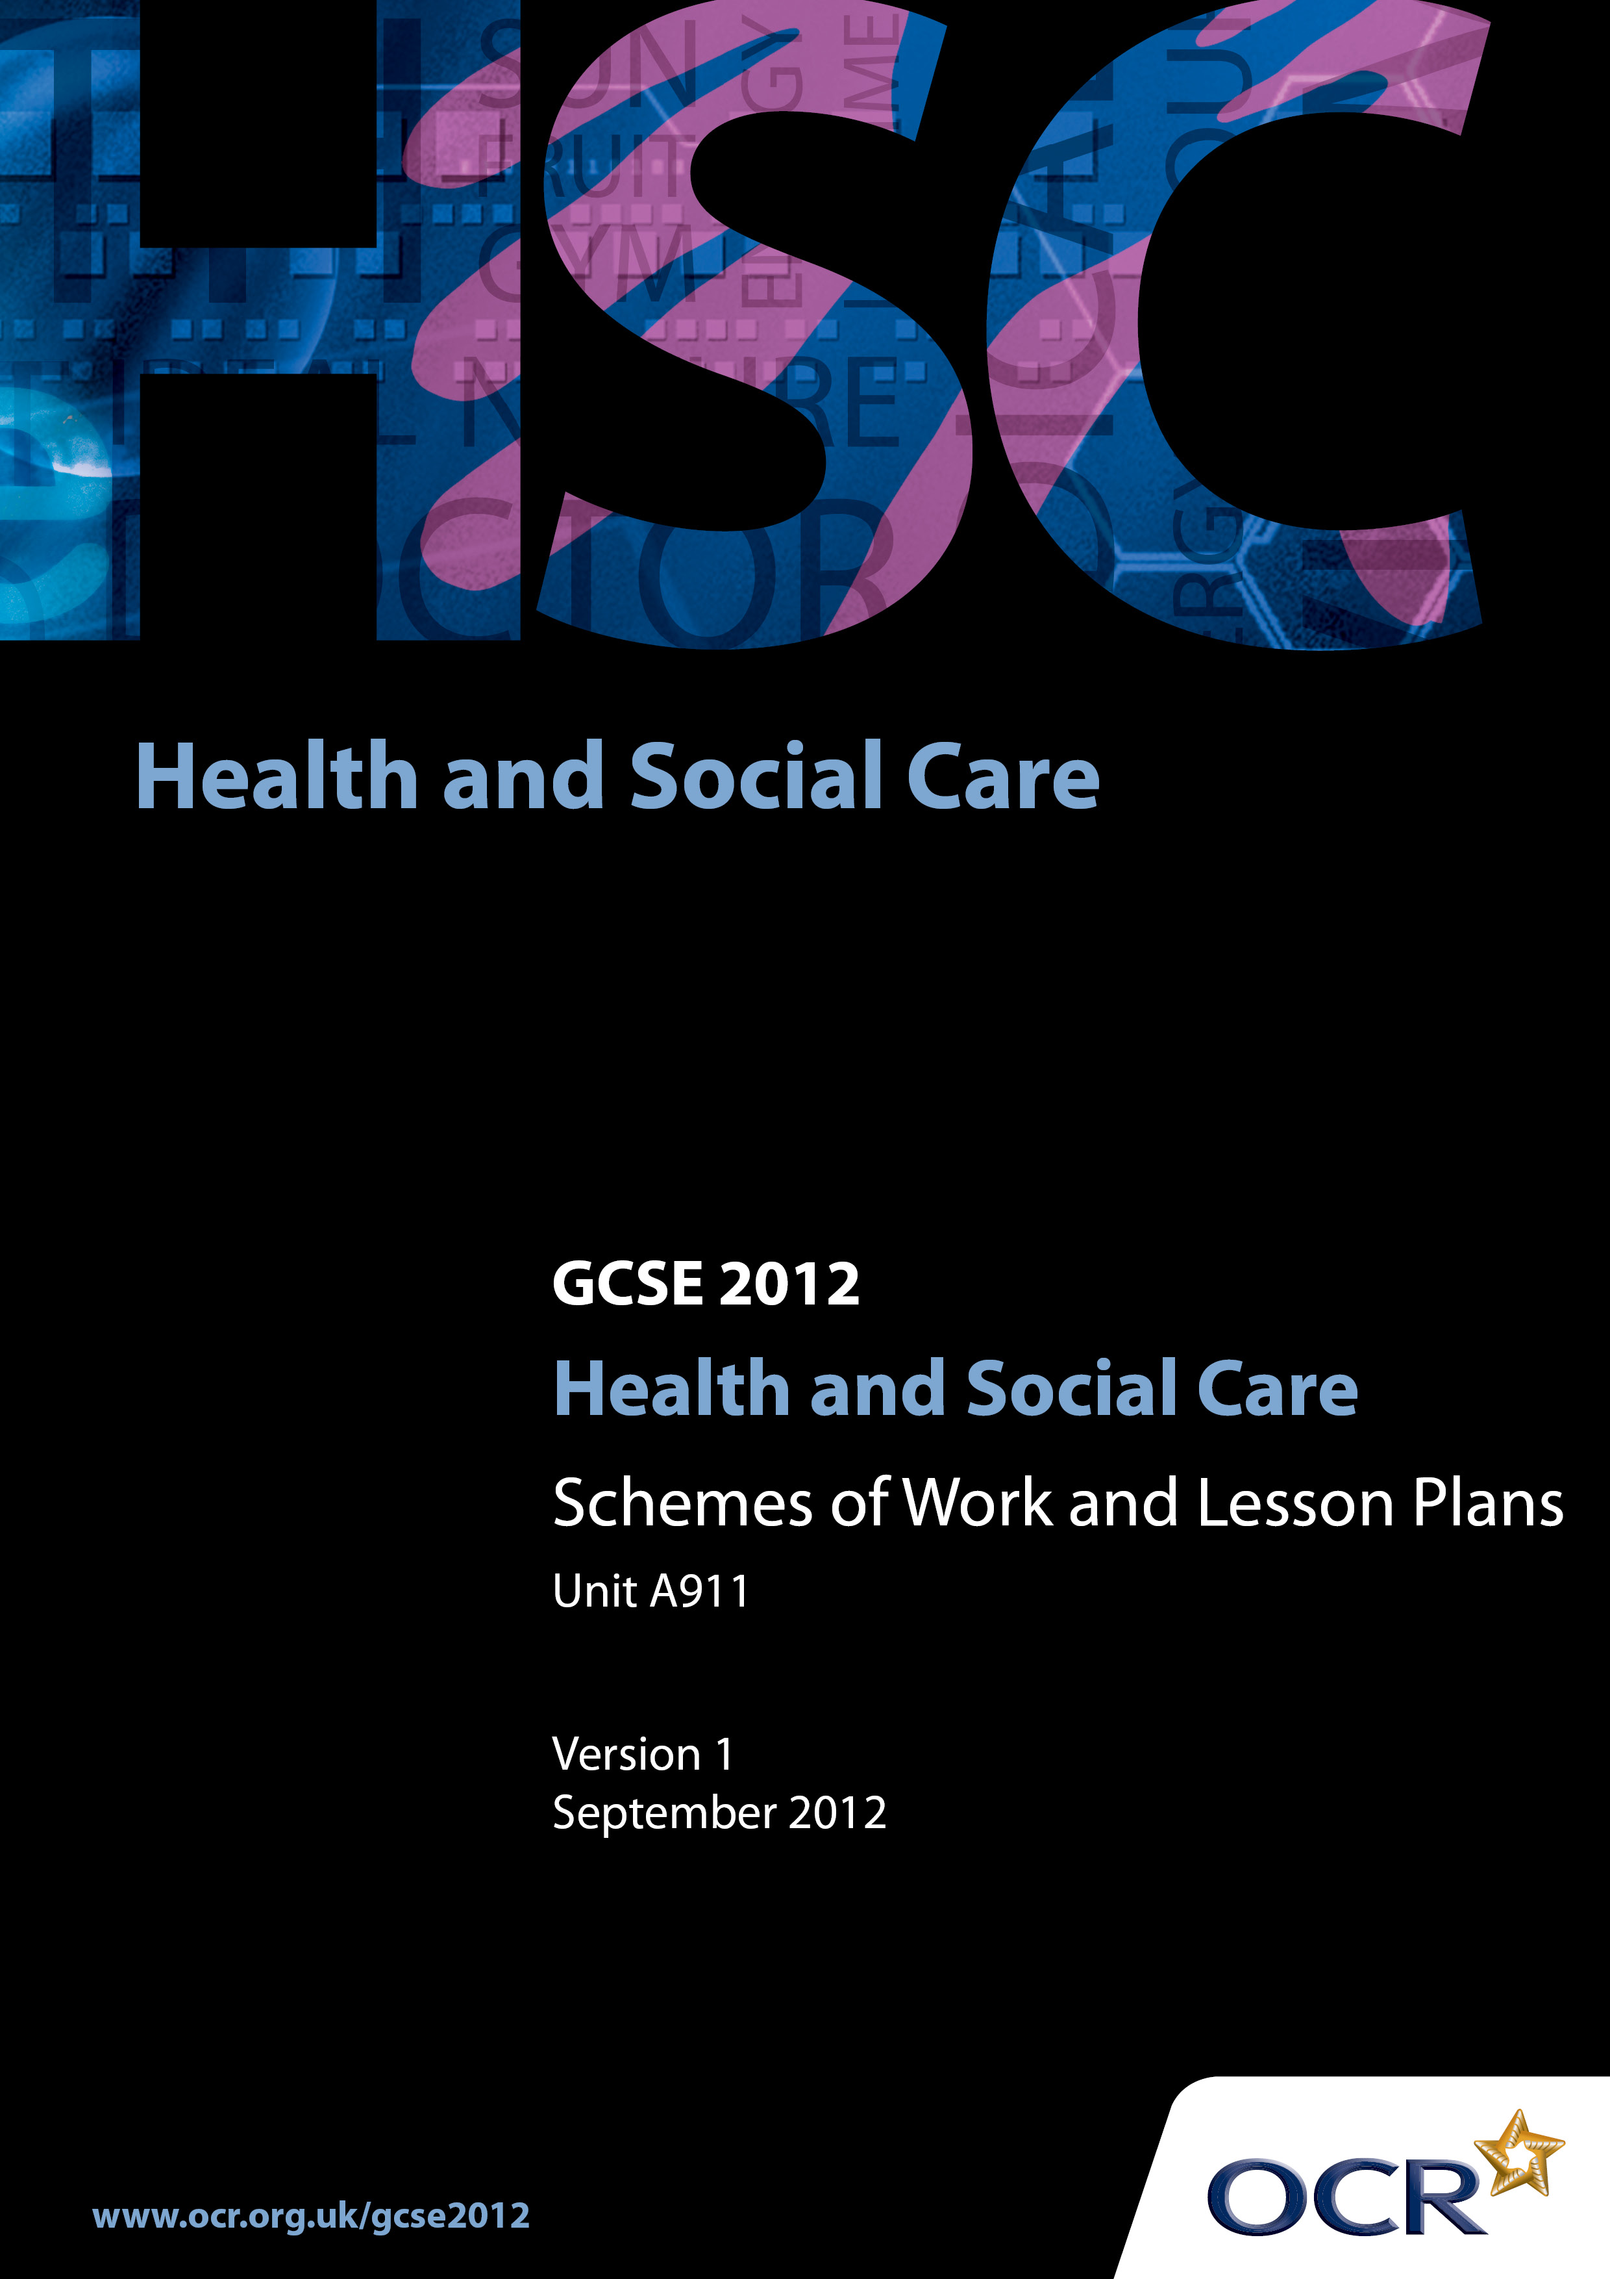

Contents
Contents 2
Introduction 3
OCR GCSE Health & Social Care Unit A911:
Health Social Care and Early Year Provision 5
OCR GCSE Health & Social Care Unit A911:
Health Social Care and Early Year Provision 19

Introduction

Background
In December 2011 the GCSE qualification criteria were changed by Ofqual. As a result, all GCSE qualifications have been updated to comply with the new regulations.
The most significant change for all GCSE qualifications is that, from 2014, unitised specifications must require that 100% of the assessment is terminal.
The sections below explain in more detail the rules that apply from the June 2014 examination series onwards.
Please note that there are no changes to the terminal rule and re-sit rules for the January 2013 and June 2013 examination series:

- at least 40% of the assessment must be taken in the examination series in which the qualification is certificated.

- candidates may re-sit each unit once before certification, i.e. each candidate can have two attempts at a unit before certification.

For full information on the assessment availability and rules that apply in the January 2013 and June 2013 examination series, please refer to the previous version of these specifications, GCSE Health and Social Care and GCSE (Double Award) Health and Social Care (July 2009), available on the website.
In order to help you plan effectively for the implementation of the specification we have produced these Schemes of Work and Sample Lesson Plans for Health & Social Care. These Support Materials are designed for guidance only and play a secondary role to the Specification.

Our Ethos
OCR involves teachers in the development of support materials to capture current teaching practices tailored to our specifications. These support materials are designed to inspire teachers and facilitate different ideas and teaching practices.
Each Scheme of Work and set of sample Lesson Plans is provided in Word format – so that you can use it as a foundation to build upon and amend the content to suit your teaching style and candidates’ needs.
The Scheme of Work and sample Lesson plans provide examples of how to teach this unit and the teaching hours are suggestions only. Some or all of it may be applicable to your teaching.
The Specification is the document on which assessment is based and specifies what content and skills need to be covered in delivering the course. At all times, therefore, this Support Material booklet should be read in conjunction with the Specification. If clarification on a particular point is sought then that clarification should be found in the Specification itself.

A Guided Tour through the Scheme of Work

= Innovative Teaching Idea
This icon is used to highlight exceptionally innovative ideas.


= ICT Opportunity
This icon is used to illustrate when an activity could be taught using ICT facilities.

OCR GCSE Health & Social Care Unit A911:
Health Social Care and Early Year Provision
Suggested teaching time | 24 hours | Topic | Controlled Coursework Assessment
Topic outline |  | Suggested teaching and homework activities |  | Suggested resources | Points to note
- Opportunities need to be given to candidates to complete their coursework under controlled conditions as this Unit of work is being taught
- This will vary from centre to centre depending on the availability of local services to support the evidence gathering required to meet the needs of the tasks set

OCR GCSE Health & Social Care Unit A911:
Health Social Care and Early Year Provision
Suggested teaching time | 6 hours | Topic | 3.1.1.The range of care needs of major client groups
Topic outline |  | Suggested teaching and homework activities |  | Suggested resources | Points to note
To identify and describe the reasons why individuals may require and seek to use health, social care, and early years services |  | - What are health, social care and early years services?  - What health, social care and early years services have class used? Record on flip chart. What need did each meet?  - Place in categories:  - health services  - social care services  - early years services  - What other needs did the services meet for other individuals? |  | - GCSE Health and Social Care textbooks
Understanding how care services are designed to meet the health, developmental, and social care needs of major client groups |  | - Who are people who use services?  - Introduce the idea of placing individuals in different life stages  - What are life stages?  - Where are the boundaries for each life stage?  - Draw a lifeline and mark on it the different life stages and identify services which could be used  - Revise the basic needs for all human beings  - Develop location map to show which individuals use the services and identify two needs that the service meets |  | - Availability of a large notice board  - Paper and Flip Chart pens.  - GCSE Health and Social Care Textbooks | - The major groups are:  - babies and children  - adolescents  - adults  - older people  - people with disabilities
Understand how services provide equality and meet the needs of a diverse cultural population |  | - Identify the five groups  - In groups identify care services which meet the needs of the five groups  - Are these services provided in the local community?  - Organised ‘Town Trail’. Divide candidates into four groups each supervised by an adult if under 16 years of age  - Provide with a pre-written town trail so that each group walks in a different area to find out about the services available, the type of services offered, for which individuals, availability, etc  - Each group to organise a display to show the services, the type of help provided for the individuals who are people who use services and their location on a map  - Each group gives a short (5 minute) presentation about the services they have found |  | - Permission forms for candidates to leave the site  - Risk assessment  - Enlarged map of area/town trail  - Clip boards  - Availability of a large notice board  - Paper and Flipchart pens
Writing questionnaires to obtain primary research. |  | - How to draw up a questionnaire  - Discuss what makes a good question  - Candidates write questions relating to their GP Surgery  - Use the questions with a partner in the class to find out how a GP surgery meets the needs of the individuals  - Pool the best questions in groups/pairs and draw up a questionnaire to use with individuals using a specific service to see if needs are being met  - Homework  - Use the questionnaire with at least four individuals (more if possible).Collate results and present data in graphic form |  | - Paper  - Photocopying or duplicating facilities | - Needs:  - health, developmental and social care  - Services providing for the need:  - health, social care, early years  - How needs are met
Understand that health authorities and local authorities assess the care needs of local populations in order to identify likely service demand in a local area  Understand how universal services are developed and targeted services meet social policy goals, such as reducing child poverty, homelessness, and drug misuse in the population and transforming the lives of Children and Young people in care |  | - Why are services developed?  - Teacher input to show how services have been developed to meet needs through demographic service analysis and the development of policies  - What is a policy?  - How are policies developed?  - Brief explanation  - Teacher input: How local authorities assess the care needs of their communities and how this influences demand for services  - Exercise: based on demographic influence on services in the area  - Discuss the development of services and the policies that influenced them e.g. The National Dementia Strategy 2008  - Look at the local authority plans, e.g. council tax information leaflet, annual report  - What are the priorities of your local authority?  - Why?  - Group presentation on research |  | - Videos or CD-Rom about the history of the development of health, social care services, or any other recording that is suitable  - Local demographic information from the Council and PCTs  - Literature:  - annual reports of the council/health authority, details about Local Council budgets, targets  - GCSE Health and Social Care textbooks | - Research (if possible using websites and books)  - How services have developed to reduce child poverty and the policies that influenced their development  - Homelessness + policies  - Drug misuse + policies  - Education and care for children + policies  - Care for older people + policies  - Health care for all + policies

OCR GCSE Health & Social Care Unit A911:
Health Social Care and Early Year Provision
Suggested teaching time | 5 hours | Topic | 3.1.2 The ways people can obtain services and the possible barriers that could prevent people from gaining access to services
Topic outline |  | Suggested teaching and homework activities |  | Suggested resources | Points to note
Understand different methods of referral  Understand how an individual needs to take control of his or her life rather than relying on other people  Legislation that protecting an individual’s right accessing services they require |  | - Thought shower to look at ways they have accessed support/care  - Case studies to look at how people who use services have received care and how they were referred  - Teacher input .. Empowerment  - Revise Statutory, Private, and Voluntary services  - Human Rights to live to a certain standard and Statutory rights to receive care in UK |  | - GCSE Health and Social Care textbooks  - Computer access | - self-referral –  - professional referral –  - third-party referral –  - Human Rights Act 1998 (updates 2000)  - Mental Health Act 1983 updated 2007  - Disability Discrimination Act 1998  - Nursing and Residential Care Home Regulations 1984 (amended 2002)  - Children’s Act 2004
Identifying barriers that might prevent people from making use of the services that they need |  | - Group work to explore what the barriers might be  - Report to whole class, giving examples on things they have seen in the community from the town trail |  | - GCSE Health and Social Care textbooks | - physical barriers …  - psychological barriers …  - financial barriers …  - geographical barriers …  - cultural and language barriers …  - resource barriers …
Identifying ways in which services, and the individuals they serve, might overcome these barriers |  | - Class to consider the plans for a local Health Centre and discuss/ observe all the things that have been put in place to ensure empowerment  - Discussion back in classroom |  | - Local Health Care Centre Plan (or any plan of a building that provides care in the community, or a visit if it can be arranged, or a videoed virtual tour)
To develop understanding of poor integration of services:  - rationing  - postcode lottery |  | - Teacher to provide stimuli on three aspects by newspaper articles and/or internet research  - In groups candidates to write a report highlighting the inequalities  - At the end of the report to give recommendations as how improve /overcome the situation(s) |  | - Newspaper /internet articles  - Access it ICT

OCR GCSE Health & Social Care Unit A911: Health Social Care and Early Year Provision
Suggested teaching time | 3 hours | Topic | 3.1.3. The types of services that exist to meet needs and how they are developed and organised
Topic outline |  | Suggested teaching and homework activities |  | Suggested resources | Points to note
Investigate organisations and private practitioners that deliver health care, social care and early years services |  | - Understanding who does what  - Glossary of terms  - Using evidence collected from the ‘town trail’  - Identify the services that are available  - Code them into Health, Social Care, or Early Years  - Identify who uses these services |  | - Town trail display  - GCSE Health and Social Care textbooks | - Define the following terms:  - Optician  - Pharmacist  - Paediatrician  - Orthodontist  - Consultant  - Psychiatrist  - Physiotherapist  - Babies and Children  - Adolescents  - Adults  - Older people  - People with disabilities(additional services)  - All services used by individuals given above as well as:  - specialist medical and nursing services: physiotherapy, psychology, occupational therapy, complementary therapies  - Specialist education and training services (e.g. work-related and rehabilitative training schemes)  - Specialist education provision and support services are provided in addition to integration within mainstream provision
To understand the differences between statutory; private and third sector provision of services.  . |  | - Groups investigate :  - statutory care sector (including NHS Trusts and local authority services)  - private care sector (including private companies and self-employed practitioners)  - third sector/voluntary care sector (including charities and local support groups, using volunteers and not-for-profit organisations with paid employees)  - informal carers (family, friends, and neighbours) and types of care given  - Groups report their findings  - Teacher input:  - national and regional variations  - How services are paid for  - Identify local and national examples of service providers who operate in the area  (reference to town trail)  - Type of organisation– place in the right category |  | - GCSE Health and Social Care textbooks | - To understand the differences between statutory, private and third sector provision of services
Understand how the different providers of care services work together to meet needs |  | - Work in pairs and identify the care services that are being accessed by the individuals in the case studies  - For each case study:  - Draw a spider diagram to identify the services and then extend it in a different coloured ink, who provides the services- categorise the services (statutory, private third sector)  - and then identify the provider (local, national)  - Are the people who use the services needs being met?  - Would you add any other services to provided support for the individual?  - What other services in the area could they have access to?  - What is the advantage of working together? |  | - Case studies prepared  - Use of internet and GCSE Health and Social Care Textbooks

OCR GCSE Health & Social Care Unit A911: Health Social Care and Early Year Provision
Suggested teaching time | 4 hours | Topic | 3.1.4 The principles of care that underpin all care work with individuals
Topic outline |  | Suggested teaching and homework activities |  | Suggested resources | Points to note
Understand the values that are an essential feature of all care practice |  | - Thought shower: what makes a good carer.  - From the list in groups make up a list of ‘rules’ you would expect someone caring for you to follow  - Distribute work sheet  - Candidates make a comparison with the list they have compiled to the one on the worksheet  - Why do individuals need to have empowerment?  - Give two examples of confidentiality, one when it should be kept secret and one when it should be breached |  | - Worksheet showing the underpinning principles that all care practitioners use as their guidelines and codes of practice to empower individuals by:  - promoting equality and diversity of people who use services  - maintaining confidentiality  - promoting individuals' rights and beliefs | - Empowerment
Understanding how these values are reflected in the behaviour and attitudes of care workers |  | - Role play scenarios  - Class prepare role plays and act them in front of the class  - Discussion on good practice of care and poor practice. How does the individual feel when poorly treated |  | - Selection of different scenarios which are on laminated sheets  - GCSE Health and Social Care Textbooks | - Why should Services aim to help people to develop or maintain their independence  - Understand the balance that services have to achieve between getting involved in people’s lives or not, including the risks to both individuals and society associated with both action and inaction

OCR GCSE Health & Social Care Unit A911: Health Social Care and Early Year Provision
Suggested teaching time | 3 hours | Topic | 3.1.5 The main work, role, and skills of people who provide health, social care, and early year’s services
Topic outline |  | Suggested teaching and homework activities |  | Suggested resources | Points to note
Understanding the range of opportunities available to deliver care |  | - Who provides care?  - Class exercise. Make a list of all the caring roles you would expect to see within Health Care, Social Care and Early Years Settings  - Each candidate investigates a different care worker and presents their findings to the whole group on an A4 sheet  - Then identify how the CVB has been used in your work |  | - Kudos  - Connexions  - Websites  - A4 plain paper with headings to guide candidates | - Direct care: nurse, doctor, social worker, care assistant, nursery nurse, etc  - Candidates need to be aware of the support given to direct care workers by indirect carers - medical receptionist, cleaner, porter etc
What skills and qualities are needed to work in Health, Social Care or Early Years settings |  | - What is a skill?  - What is a quality?  - Why might skills need to be learnt as a person s job roles changes?  - Recognise the differing communication needs of those using care services |  | - GCSE Health and Social Care textbooks | - Understand why care workers need good interpersonal skills to develop care relationships, provide and receive information and report on the work that they do with individuals  - Understand how effective communication can help support relationships with colleagues, individuals and their families. Understand how poor skills can reduce the effectiveness of care work or damage care relationships

OCR GCSE Health & Social Care Unit A911: Health Social Care and Early Year Provision

Promoting access for all
OCR recognises that the teaching of this qualification above will vary greatly from centre to centre and from teacher to teacher. With that in mind this lesson plan is offered as a possible approach but will be subject to modifications by the individual teacher.
Lesson length is assumed to be one hour.

Learning Objectives for the Lesson
Objective 1 | Candidates will understand that legislation allows fair access for all
Objective 2 | Develop observation skills
Objective 3 | To understand how barriers to care can be overcome and how this empowers people who use services

Recap of Previous Experience and Prior Knowledge
- How individuals are referred to services.
- What constitutes a barrier to access

Content
Time | Content
5 minutes | Give out a plan of a local Health Clinic.  - Starter.. candidates recall services that they would expect to see provided at the Health Clinic.
10 minutes | Introduce the idea that not all individuals may be able to access the facilities:  - Working in pairs candidates consider all the points that the manager and architect need to consider to ensure that all individuals can access the services provided.
5 minutes | Teacher input….  - Information about the Human Rights Act  - Disability Discrimination Act
10 minutes | Candidates continue to consider the design aspects of the Clinic and say why each point it is important in empowering individuals

15 minutes | Group discussion with comments and reasons.  Examples could include:  - Low desk at reception  - Push button doors/automatic doors openings  - Hearing loop system  - Wheel chair space in waiting area  - Ramps  - Lifts  - Toilets for access with a wheel chair, handles  - Name of centre  - Charging fees  - Geographical situation.. on a bus route, car parking facilities, train station access  - Posters in waiting area… cultural impact/welcoming?  - Literature in a range of languages  - Access to an interpreter
5 minutes | Homework:  - Take a visit to a local Health, Social Care or Early Years setting and record from your observation five things that you can see that would support our class discussions today

Consolidation
Time | Content
10 mins | - Write down three things discussed today that would empower an individual to be able to independently access the health care at the Centre.  - As candidates leave the room they say/give one point to the teacher.

