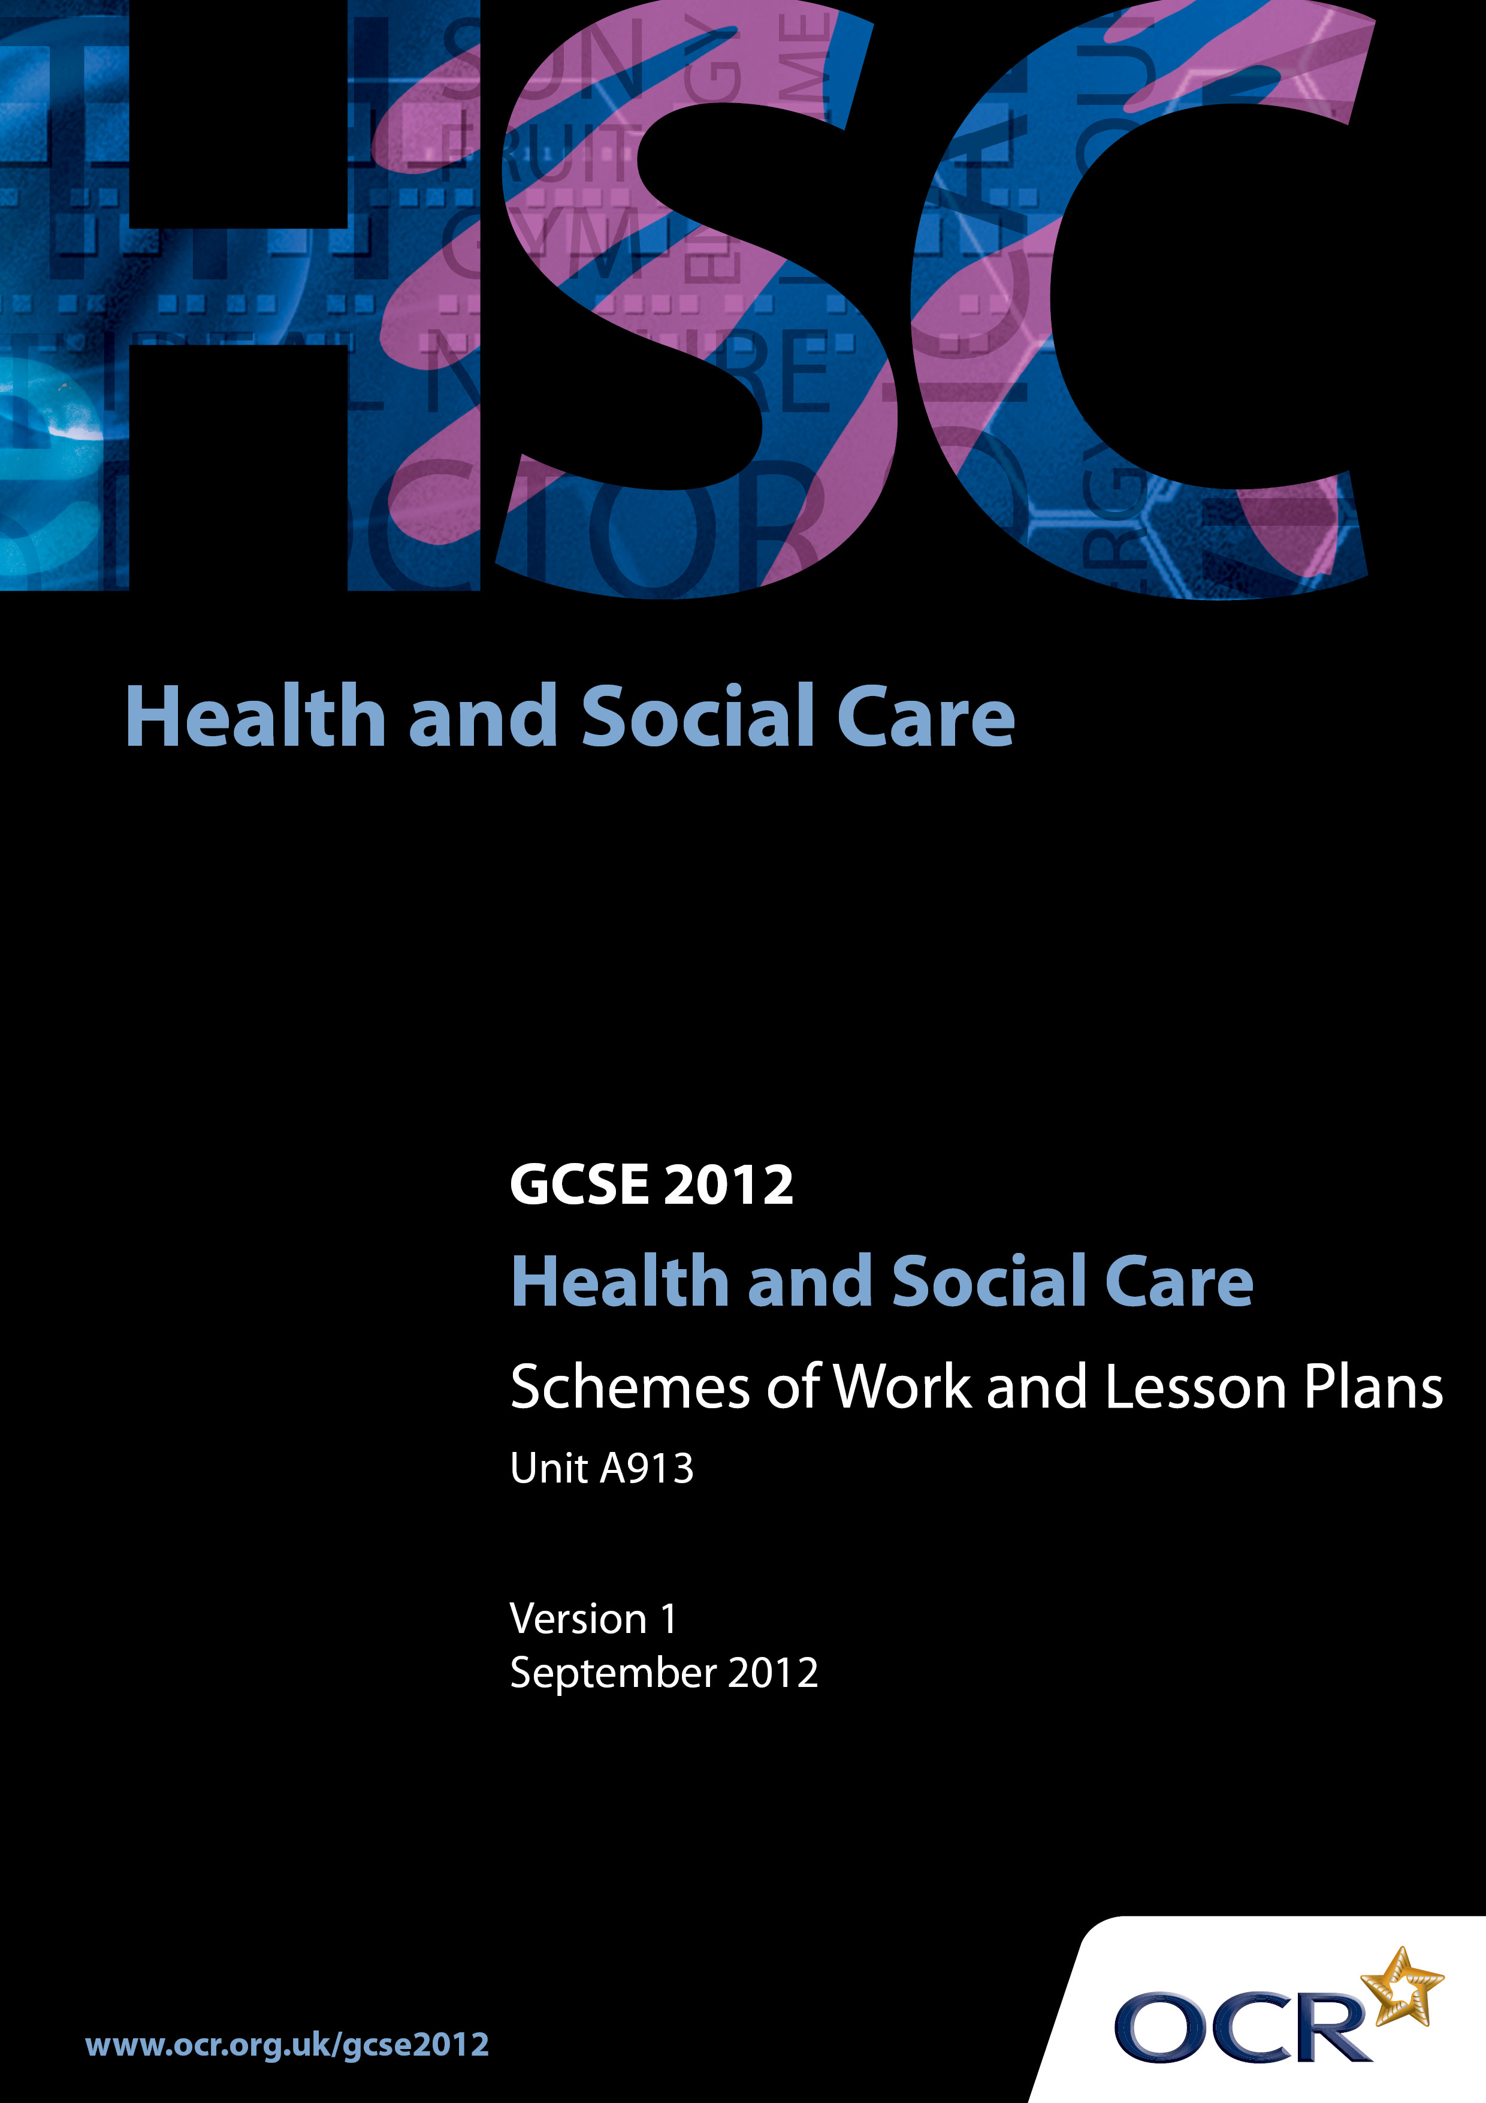

Contents
Introduction 3
Sample Scheme of Work: OCR GCSE Health and Social Care J412 Unit 913: Promoting Health and Wellbeing 5
Sample Lesson Plan: OCR GCSE Health and Social Care J412 Unit 913:
Promoting Health and Wellbeing 17

Introduction

Background
In December 2011 the GCSE qualification criteria were changed by Ofqual. As a result, all GCSE qualifications have been updated to comply with the new regulations.
The most significant change for all GCSE qualifications is that, from 2014, unitised specifications must require that 100% of the assessment is terminal.
The sections below explain in more detail the rules that apply from the June 2014 examination series onwards.
Please note that there are no changes to the terminal rule and re-sit rules for the January 2013 and June 2013 examination series:

- at least 40% of the assessment must be taken in the examination series in which the qualification is certificated.

- candidates may re-sit each unit once before certification, i.e. each candidate can have two attempts at a unit before certification.

For full information on the assessment availability and rules that apply in the January 2013 and June 2013 examination series, please refer to the previous version of these specifications, GCSE Health and Social Care and GCSE (Double Award) Health and Social Care (July 2009), available on the website.
In order to help you plan effectively for the implementation of the specification we have produced these Schemes of Work and Sample Lesson Plans for Health & Social Care. These Support Materials are designed for guidance only and play a secondary role to the Specification.
.

Our Ethos
OCR involves teachers in the development of support materials to capture current teaching practices tailored to our specifications. These support materials are designed to inspire teachers and facilitate different ideas and teaching practices.
Each Scheme of Work and set of sample Lesson Plans is provided in Word format – so that you can use it as a foundation to build upon and amend the content to suit your teaching style and candidates’ needs.
The Scheme of Work and sample Lesson plans provide examples of how to teach this unit and the teaching hours are suggestions only. Some or all of it may be applicable to your teaching.
The Specification is the document on which assessment is based and specifies what content and skills need to be covered in delivering the course. At all times, therefore, this Support Material booklet should be read in conjunction with the Specification. If clarification on a particular point is sought then that clarification should be found in the Specification itself.

A Guided Tour through the Scheme of Work

= Innovative Teaching Idea
This icon is used to highlight exceptionally innovative ideas.


= ICT Opportunity
This icon is used to illustrate when an activity could be taught using ICT facilities.

OCR GCSE Health and Social Care J412 Unit 913:
Promoting Health and Wellbeing
Suggested teaching time | 3 hours | Topic | 3.3.1 Define the health and wellbeing of individuals
Topic outline |  | Suggested teaching and homework activities |  | Suggested resources | Points to note
Understanding the meaning of health and wellbeing  Creating a questionnaire |  | - Define your health and wellbeing  - Compare definitions  - Teacher input:  - what contributes to good health  - positive, negative and holistic definitions  - how ideas about health have changed over time and cultures. Discussion  - Teacher input; confidentiality; sensitivity issues  - Asking questions  - In groups write six questions to ask someone about their health  Homework:  - Interview three different people (ideally from different life stages)  - To define health and wellbeing - what does ‘being healthy’ mean to them |  | - GCSE Health and Social Care textbooks | - Health and wellbeing can be described as the absence of physical illness, disease and mental distress. This is a negative definition of health and wellbeing  - Health and wellbeing can be described as the achievement and maintenance of physical  - Fitness and mental stability. This is a positive definition of health and wellbeing  - Health and wellbeing can be described as being the result of a combination of physical, social, intellectual and emotional factors. This is a holistic definition of health and wellbeing
Developing questionnaires |  | - Share research from homework task  - Individually write a definition for good health  - Make a poster to illustrate ‘what health is’ for people in different life stages  - Prepare questions to obtain information about the physical, intellectual, emotional and social health of a friend |  | - GCSE Health and Social Care textbooks  - Research made real – a guide for candidates – Mark Walsh – Nelson Thornes  - Coloured paper and magazines

OCR GCSE Health and Social Care J412 Unit 913:
Promoting Health and Wellbeing
Suggested teaching time | 4 hours | Topic | 3.3.2 Interpret physical measures of health for the individual
Topic outline |  | Suggested teaching and homework activities |  | Suggested resources | Points to note
Indicators of physical health |  | - When you go to the doctor how does he assess your health?  - How can health be measured?  Demonstration of how to take:  - pulse,  - blood pressure  - peak flow  Practical work:  - take pulse before and after exercise.  - height and weight.  - how to work out BMI  - Homework: work out an individual’s BMI |  | - GCSE Health and Social Care textbooks  - Scales  - Height chart/wall measure  - Blood pressure measure  - Calculators  - Stop watch  - Peak Flow  - Local Fitness Centre  - Physical Education Department in centre | - Blood pressure  - Peak flow  - Height and weight/body mass index  - Resting pulse and recovery after exercise  - Waist and hip ratio  - Teachers need to be sensitive to candidates own health issues. When practicing measurements of health, for some a case study may be more appropriate to use
Understand how physical measurements of health can lead to producing a plan for health improvement or to maintain the physical health and wellbeing of someone |  | - From previous work, what factors need to be taken into consideration: (age, sex and lifestyle of people)  - What is the individual already doing e.g. diet, exercise?  - What are targets? SMART  - Create some specific targets for case studies  - Investigate other questions that a health professional might ask before creating a plan |  | - GCSE Health and Social Care textbooks  - Case Studies  - Dept Health website  - Magazines | S specific  M measurable  A achievable  R realistic  T time

OCR GCSE Health and Social Care J412 Unit 913:
Promoting Health and Wellbeing
Suggested teaching time | 4 hours | Topic | 3.3.3 Factors that have positively affected the individual’s health and wellbeing  Some of the teaching COULD be taught in conjunction with Unit A912
Topic outline |  | Suggested teaching and homework activities |  | Suggested resources | Points to note
You should know about factors that contribute positively to health and wellbeing, such as: |  | - Candidates sit in a circle and take turns to select a card explaining why they put it into the happy or sad bucket with some class discussion |  | - Laminated Cards with scenarios (see lesson plan)  - Two buckets, one with a smiley face, ☺ and one with an unhappy face | - After this exercise the laminated cards need to be kept in two envelopes, one with positive factors and one with negative factors because they can be used for teaching in 3.3.4 as well
a balanced diet  regular exercise  leisure activity  use of health monitoring and illness prevention services (such as screening and vaccination)  use of risk management to protect individuals and promote personal safety  supportive relationships  adequate financial resources  stimulating work, education and leisure  sufficient sleep  stimulating work  education  work life balance |  | - Using the slips from the ☺ bucket, divide the group into 10 small groups.  - Groups need to present their findings on one factor to the rest of the group using a simple A4 hand out.  Assessment criteria:  - benefits to health and wellbeing  - two pieces of research that have been done to make society aware of the factor being important to a persons health and wellbeing  - how the factor contributes to the development of PIES  - how the factor contributes to a persons self-concept.  - Useful resources found (website, books) |  | - GCSE Health and Social Care textbooks  - Access to internet  - Proforma/template worksheet with headings of assessment criteria for candidates to follow  - Photocopying facility | - Diet: nutritional content, a balanced diet, food tables, the weight balance  - Patterns of eating discussion about the ‘food tray’  - Exercise: benefits, types of exercise, choosing the right exercise, frequency of exercise  - Leisure: different types of leisure, benefits  - The A4 sheet produced should not be detailed, but support candidates in future to know where to access information

OCR GCSE Health and Social Care J412 Unit 913:
Promoting Health and Wellbeing
Suggested teaching time | 6 hours | Topic | 3.3.4 Risk to the individual’s health and wellbeing  Some of the teaching COULD BE taught in conjunction with Unit A912 as well AS PSHE; Science lessons in Centres.
Topic outline |  | Suggested teaching and homework activities |  | Suggested resources | Points to note
Identify the lifestyle factors over which people have control and also the genetic, social and economic factors which people may not be able to change |  | - Class produce a thought shower on factors that could be a risk to health.  - Check answers from the ‘Bucket exercise’  As scenarios are being taken from the bucket class put them into two piles:  - Factors that people have control over and  - Those which people may not be able to change  - Distribute the scenarios, giving one to each pair of candidates  - Research and complete the A4 teacher prompt sheet. |  | - Select scenarios from bucket exercise in 3.3.3. To cover topics in ‘points to note’ - ensure that there is sufficient for the whole class to take part in the exercise  - GCSE Health and Social Care textbooks  - A4 sheet to complete:  Risk  - Do people have control over this risk?  - Short term risk  - Long term risk  - Impact on Society  - Useful resources | - Genetically inherited diseases and conditions  - An unbalanced, poor quality or inadequate diet  - Lack of personal hygiene  - Lack of regular physical exercise  - Social isolation  - Poverty  - Inadequate housing  - Unemployment  - Environmental pollution  - Tobacco smoking  - Excessive alcohol intake  - Stress
Understand how substance misuse can affect an individual's health and wellbeing |  | - Fact sheet or suitable video  Candidates imagine that they are writing to a friend who has started to mix with a group who are known drug takers. The letter must:  - inform the friend of the dangers of taking drugs and  - give details of support which is available to help those who wish to stop taking drugs |  | - GCSE Health and Social Care textbooks  - Suitable video material from Health Promotion Unit.  - School Liaison Police Officer | - Teachers will need to be aware of the centres policy on teaching drugs education  - Literacy – persuasion techniques
Understand how unprotected sex can affect an individual's health and wellbeing |  | Dialogue on STIs and contraception.  Candidates to produce a guide on STIs:  - STIs and symptoms  - Sources of support  - The importance of safe sex |  | - GCSE Health and Social Care textbooks  - Use of Brook Advisory Service | - Teachers will need to be aware of the centres policy on teaching sex education
Understand that some factors have a wider impact than just putting the person at risk |  | - Using the Bucket Scenarios and the work candidates have done in pairs  - Look at the impact of each factor on society |  | - GCSE Health and Social Care textbooks  - Local statistics on crime figures | Impact on Society in terms of:  - Crime  - Health provision  - Social care provision  - Economic implications  - Impact on families  - Impact on environment

OCR GCSE Health and Social Care J412 Unit 913:
Promoting Health and Wellbeing
Suggested teaching time | 4 hours | Topic | 3.3.5 Health promotion and improvement methods
Topic outline |  | Suggested teaching and homework activities |  | Suggested resources | Points to note
Investigate the different types of health promotion materials that are used to inform, motivate, and support people to improve their health and wellbeing |  | - Candidates are given a piece of health promotional material  - They need to evaluate the effectiveness of their material  - Peer assessment (pyramid style) sharing their reviews |  | - Selection of resources from the local Health Promotion Unit for candidates to use  Assessment proforma for candidates to use to evaluate the work:  - Target audience  - What information is given  - How would it motivate a person  - How would it support target audience  - How could it be improved?
Understand how different health behaviours can help people achieve their targets |  | - Candidate asked to draw a picture of self in the centre of a piece of paper  - What motivates them to learn at college?  - What stops some candidates wanting to learn?  - Teacher input: drawing from candidates’ responses to look at different types of behaviour |  | - GCSE Health and Social Care textbooks | How this lesson is conducted will depend upon the level of motivation within the group  - Medical conditions  - Education/level of understanding to address target  - Self-motivation  - Facilities/finances  - Self concept  - Social isolation  - Pessimist/optimist
Know why physical health assessment and target setting should happen before a health improvement plan is produced for an individual  Learn how realistic health improvement targets are established for others. |  | Working in pairs, look at the scenarios  - Identify health issues  - Identify target to reach (using SMART)  - Find one piece of health promotional material suitable to support the plan or design their own health promotional material to support the plan  - Peer assessment and comparing ideas |  | - GCSE Health and Social Care Text books  - Local Fitness centre  - PE Department  - Magazines  - Professionals e.g. Dietician, Weight Watcher etc.  - Scenarios of four unhealthy people | Scenarios to include:  - Eats excessively  - Excess alcohol consumption  - Smoking  - Drives everywhere they go

OCR GCSE Health and Social Care J412 Unit 913:
Promoting Health and Wellbeing
Suggested teaching time | 24 hours | Topic | A913. Controlled Coursework
Topic outline |  | Suggested teaching and homework activities |  | Suggested resources | Points to note
- Opportunities need to be given to candidates to complete their coursework under controlled conditions as this unit of work is being taught
- This will vary from centre to centre depending on how candidate’s access information from their chosen individual
- Research time needs to be carefully planned so that candidates can gather the required evidence to meet the needs of the tasks set

OCR GCSE Health and Social Care J412 Unit 913: Promoting Health and Wellbeing

What affects our health and development?
OCR recognises that the teaching of this qualification above will vary greatly from centre to centre and from teacher to teacher. With that in mind this lesson plan is offered as a possible approach but will be subject to modifications by the individual teacher.
Lesson length is assumed to be one hour.

Learning Objectives for the Lesson
Objective 1 | To understand what factors have a positive effect on our health and development
Objective 2 | To understand what factors have a negative effect on our health and development

Recap of Previous Experience and Prior Knowledge
- What is understood by the terms ‘growth’ and ‘development’
- What is understood by ‘being healthy’

Content
Time | Content
5 minutes  thinking time | As candidates enter the room they are given a slip/s of paper and asked to think if the statement (see ideas below) will have a positive or negative effect on a persons health and development. All the statements need to be distributed.  Everyone sits in a circle.  Two different coloured buckets are placed in the centre of the circle, one bucket has smiley faces and states positive factors and the other sad faces and states negative factors.  These statements are examples of what could be used; they should cover all the factors mentioned in OCR’s specification for 3.3.3. and 3.3.4  - Abdu eats 5 pieces of fruit/veg every day  - Tommy skips breakfast but always has chocolate bars mid morning  - Beryl always drives to the shops although she lives within walking distance  - Asad and his mother have joined the school ‘walking bus’  - Ross has a hectic social life, rarely going to bed before 2.30 am. He has to report to work at 7.00 am every day to drive a fork lift at the factory where he works  - Grace starts her shift every day at 6.00 am; she always makes sure she is in bed by 10.00 pm  - Richard avoids cleaning his teeth unless reminded to do so by his mother  - Andrew, 25, does not have his teeth checked regularly as he cannot find a local NHS dentist  - Annette has taken out an insurance policy so that she can have private dental care  - Gail, 85, cannot afford to have more than one ‘bar’ on her fire lit during the winter months  - The Roberts family of eight are renting a three-bedroom house, which gets very damp  - Angela 8 and Robert 6 are given a kiss and a hug several times a day by their parents  - Gareth 15 has lots of pets in his home. At school other pupils do not like sitting with his because he smells  - Sophie’s father has a well paid job and she is able to go on the school skiing holiday  - Graham is learning a great deal on his Modern Apprenticeship course  - Jenny often truants school  - Grace has just started teaching and enjoys swimming twice a week with her friend  - Sarah has to work long shift hours as well as manage her family and home  - She has no hobbies or time to herself  - Nicola has decided that she will let her children have the MMR vaccination.  - Allyson thinks that having a suntan looks healthy so spends a lot of her spare time outside, sunbathing  - Megan has been taught the Green Cross Code by her mother.  - Richard has had many sexual partners but refuses to wear a condom.  - David is a haemophiliac  - Darren smokes 20 cigarettes per day  - If Joe does not visit his local pub every evening for 2 pints of beer, he drinks at home  - Timmy and his friends meet in the park every evening where they sniff glue  - Mary has been in a lot of pain recently and takes ‘Paracetamol’ four times a day  - Greg lives within a mile of the local power station  - Janice has been given a months notice at work. Her husband Rob has been out of work for over a year and cannot find any employment in the area
5 minutes | Teacher revises the meaning of the words:  - growth, development; positive health, negative health, holistic health  Teacher revises that age, gender and lifestyle affect a person’s health
40 minutes | - Teacher explains that the statements may have a positive or negative effect on a persons life  - Teacher chooses who puts their statement into a bucket, (this could be done by pulling names out of a hat)  - Candidate has to read the statement to the class and say why they are putting it in the bucket  - The group needs to agree that the statement has been put in the correct bucket  - Discussion about the reasons

Consolidation
Time | Content
10 minutes | - Candidates have blank sheet of paper and try and remember all the factors that have gone into the Smiley Bucket  - Teacher takes the statements from the ☺ Smiley Bucket  - As teacher recalls the positive factors  - Candidates give themselves a point for the ones that they have remembered and record the factors that they did not remember for their notebook

