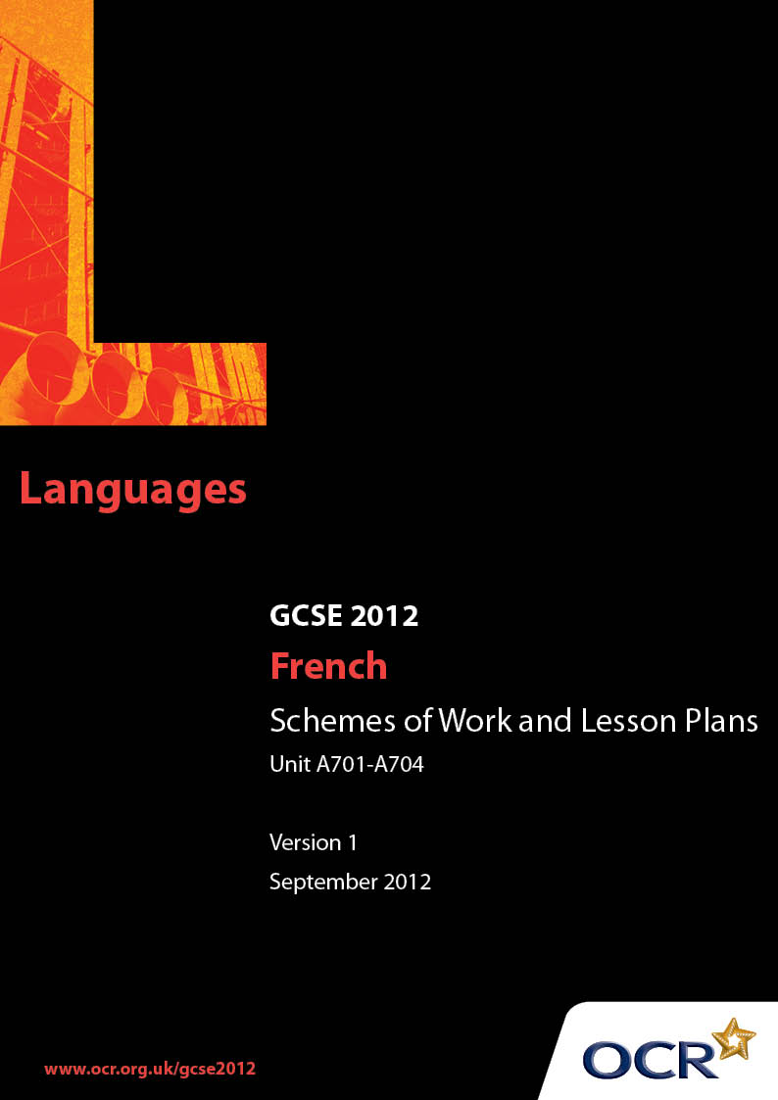

Contents
Contents 2
Introduction 3
OCR GCSE French J730 Unit A701-A704: Holidays and Exchanges 5
OCR GCSE French J730 Unit A701-A704: Holidays and Exchanges 13
Published Resources 15

Introduction

Background
OCR has produced a brochure, which summarises the changes to French. This can be found at www.ocr.org.uk along with the new 2012 specification.
In addition and in response to reforms announced by the Government and in response to Ofqual mandated changes to GCSEs, unitised assessment of this qualification is being replaced by linear assessment from September 2012. This means that candidates commencing a two year course from September 2012 will take all of their GCSE units at the end of the course in June 2014.
In order to help you plan effectively for the implementation of the specification we have produced these Schemes of Work and Sample Lesson Plans for French. These Support Materials are designed for guidance only and play a secondary role to the Specification.

Our Ethos
OCR involves teachers in the development of new support materials to capture current teaching practices tailored to our new specifications. These support materials are designed to inspire teachers and facilitate different ideas and teaching practices.
Each Scheme of Work and set of sample Lesson Plans is provided in Word format – so that you can use it as a foundation to build upon and amend the content to suit your teaching style and students’ needs.
The Scheme of Work and sample Lesson plans provide examples of how to teach this unit and the teaching hours are suggestions only. Some or all of it may be applicable to your teaching.
The Specification is the document on which assessment is based and specifies what content and skills need to be covered in delivering the course. At all times, therefore, this Support Material booklet should be read in conjunction with the Specification. If clarification on a particular point is sought then that clarification should be found in the Specification itself.

A Guided Tour through the Scheme of Work

= Innovative Teaching Idea
This icon is used to highlight exceptionally innovative ideas.


= ICT Opportunity
This icon is used to illustrate when an activity could be taught using ICT facilities.

OCR GCSE French J730 Unit A701-A704: Holidays and Exchanges
Suggested teaching time | 12 hours | Topic | Holidays and exchanges (topic area 4)
Topic outline |  | Suggested teaching and homework activities |  | Suggested resources | Points to note
1. Holiday Destinations  (speaking revision with suitable written reinforcement)  ½ hour |  | - Starter activity on revision of familiar vocabulary  - Supplement vocabulary  - Teach/revise use of prepositions with countries and places e.g. à Paris, en Espagne, au Portugal, aux États-Unis)  - Add suitable activities (e.g. word search, hangman etc.). |  | - KS3 familiar vocabulary  - OCR French vocabulary list - to introduce any new words e.g. auberge de jeunesse  - GCSE French for OCR: OUP Students’ Book, pages 108-109 (different climates) | - Possible destinations, include different countries, countryside, seaside, mountains, etc.  - Most of this material should already be familiar from KS3 but it needs to be reinforced, particularly for FT pupils.
2. Transport  (speaking revision of familiar KS3 material with written reinforcement as above)  ½ hour |  | - Starter activity based on familiar vocabulary elicited by suitable transport visuals  - Revision of present tense of common verbs. Concentrate mainly on first person singular and plural forms e.g. je voyage/nous voyageons; je vais/nous allons; je prends/nous prenons  - Writing of simple sentences using transport e.g. je préfère le vélo; nous avons une auto. |  | - Transport visuals  - Appropriate video material  - Transport anagrams  - GCSE French for OCR: OUP Students’ Book, pages 36-37 (eco transport)  - GCSE French for OCR: OUP Grammar Workbook, pages 38-43 (present tense)  - GCSE French for OCR: OUP Exam Skills Workbooks, page 29 (present tense) | - This activity again aims to build on familiar vocabulary and structures covered in KS3 and to reinforce this prior knowledge with supplementary vocabulary and structures.
3. Sentence building using 1. and 2. above  (speaking, followed by written consolidation)  1 hour |  | - Speaking activities in pairs and groups, following model provided by teacher, building sentences using material from 1. and 2. above. e.g. Je vais en Espagne en avion en juillet avec mes copains.  - HW: write up six sample sentences, with illustrations (Clip Art etc.). |  | - Map of G.B./Europe/World.  - Appropriate visuals of holiday locations, transport | - Pupils speak in pairs and groups to  create model sentences. Their best sentences are written and/or word-processed.  - Their work is displayed in the class room.
4. Holiday Plans  (sentence building  as above using immediate future – spoken work followed by written consolidation)  1 hour |  | - As above, pupils follow model sentence e.g. Nous allons visiter le Pays de Galles. Nous allons passer une semaine au mois d’août dans un hôtel au bord de la mer.  - Pupils add additional material as appropriate  - HW: write/word-process further examples. |  | - GCSE French for OCR: OUP Grammar Workbook, page 63 (immediate future), pages 64-65 (future tense) | - The 1 hour estimated time would include opening activities, lesson targets, revision of 3. above and plenary  - If preferred, teacher could use future tense e.g. nous visiterons/nous passerons etc.
5. Holiday Accommodation  1 hour – preferably in IT room |  | - Pupils use the Internet to find details  of suitable holiday accommodation in France or French-speaking country  - They note preferred accommodation with reasons for their choice, following model e.g. Je préfère l’Hôtel Excelsior parce qu’il y a une piscine.  - HW: written summary of above work. |  | - Suitable French websites e.g.  www.france-jeunes.net  www.yahoo.fr  - GCSE French for OCR: OUP Grammar Workbook, pages 10-11 (adjectives to compare)  - GCSE French for OCR: OUP Exam Skills Workbook , page 49 (comparing) | - Pupils select area of France, Switzerland etc. which they would like to visit. They find out details of hotels, campsites, hostels etc. in preparation for 6. below.
6. Sending an email/letter to  book holiday accommodation  1 hour |  | - Pupils are given advice on writing a formal letter  - They use details noted in 5. above to contact a hotel, camp site, hostel and  write a letter/email to book  accommodation for a planned holiday  - Having drafted the letter in class, checked by peers/teacher, they write a final version for HW. |  | - GCSE French for OCR: OUP Students’ Book page 112Text book and other available resources for guidance on writing formal letters. | - It may be thought preferable for pupils to write both an email and a letter, given the differing nature of styles used for each  - Alternatively, FT pupils could write email and HT pupils write letter.
7. Listening and Reading activities on holidays  1 hour |  | - Using available resources, pupils are given listening and reading exercises to reinforce their understanding of appropriate vocabulary and grammatical structures. |  | - GCSE French for OCR: OUP Students’ Book, page 185 (reading activities)  - Suitable passages and exercises in text book  - Additional resources as available e.g. Concentrate on … Unit 4*; Achieve* etc  - Exercises on holidays from past OCR listening. and reading papers  - Appropriate ICT resources. | - This particular unit need not be covered at this stage, nor does it need to be one stand-alone unit. Suitable listening and reading exercises could be used as an element of any lesson within this topic.
8. Arriving at the holiday  * For more details on these publications, please see the French GCSE Resource List in the Teachers Handbook available at www.ocr.org.uk.  destination – booking in to  a hotel/campsite/youth hostel  1 hour |  | - Pupils work in pairs to devise role plays on booking in to the holiday place  - The teacher gives a model role play, or use dialogue suitable examples can be used from GCSE French for OCR: OUP Student’s Book, page 112  - Pupils are required to give details of name (spelt using French alphabet), duration of stay, type of room/pitch required and ask questions about available facilities  - HW activity: to write up and learn the role play. |  | - Legacy OCR past speaking papers (Unit 2352): role play cards and booklets on checking in to hotel etc. (FT pupils study Sections 1 and 2; HT pupils study Sections 2 and 3)  - Concentrate on Speaking* Unit 4 (FT pupils study Sections 1 and 2; HT pupils study Sections 2 and 3). | - Pupils work in pairs and alternate playing role of customer/employer  - When practised enough, role plays can be recorded and/or performed to class and/or another class.
9. Talking about a recent holiday*  (speaking presentation in past tense)  1 hour  * Please see Sample Lesson Plan below for a detailed plan for this unit of work. |  | - Revision of the perfect tense (GCSE French for OCR: OUP Grammar Workbook, page 57)  - Starter activity on perfect tense forms relevant to holidays (e.g. J’ai passé une semaine dans un hôtel.)  - Revision of weather in past tense (e.g. faisait soleil; Il a plu etc,)  - Introduction of pluperfect tense (GCSE French for OCR: OUP Grammar Workbook, page 61) and present participle (GCSE French for OCR: OUP Grammar Workbook, page 46)  - Pupils prepare presentation about recent holiday, to include when / where / with whom / how long /impressions / activities / weather / food and drink / souvenirs  - Group/pair work: each pupil delivers his/ her presentation to group/class (and makes recording of it)  - HW: write up presentation. |  | - Legacy OCR past speaking papers (Unit 2352): role play cards and booklets on checking in to hotel etc. (FT pupils study Sections 1 and 2; HT pupils study Sections 2 and 3)  - Concentrate on Speaking Unit 4. (FT pupils study Sections 1 and 2; HT pupils study Sections 2 and 3)  - GCSE French for OCR: OUP Students’ Book pages 116-117 (describing a trip)  - GCSE French for OCR: OUP Exam Skills Workbook, page 5 (preparing for speaking assessments) Relevant sections in course book. | - The speaking presentation could be a possible controlled assessment task for the final speaking task.  - The written task could be adapted to be a suitable controlled assessment task for the final writing task.  - Examples of possible speaking tasks for this topic (and others) can be found on the OCR website in the Controlled Assessment Guidance Booklet for Speaking.
10. Planning an exchange visit.  1 hour |  | - Pupils use details supplied about an exchange partner (fictional or, if school has exchange school, real character)  - Pupils write an introduction about her/himself and describe plans for desired activities while on exchange  - Teacher revises conditional mood (e.g. Je voudrais visiter la plage)  - Teacher revises writing of questions (e.g. Est-ce que nous pourrions aller...?). |  | - Use French Internet resources for details of French exchange partners e.g.  www.momes.net  www.adosurf.net  - GCSE French for OCR: OUP Students’ Book, pages 114-115 (planning exchange visit)  - GCSE French for OCR: OUP Exam Skills Workbook, page 47 (conditional)  - GCSE French for OCR: OUP Grammar Workbook (pages 66-67 (conditional) | - This activity will appear more relevant to learners if real identities can be used. If the school has a link school in France, or pupils have pen friends, such contacts would be ideal.
11. Meeting the Exchange  Partner.  1 hour |  | - Teacher revises language used for introductions.  - Pupils work in pairs enacting pupil and exchange partner, then reversing roles.  - Conversations can be recorded on audio or audio-visual media.  - HW: pupils write out conversation |  | - Listening material in which French people introduce themselves. Pupils note details.  - Reading material on same topic using available resources e.g. Concentrate on … Unit 1.  - GCSE French for OCR: OUP Students’ Book, page 115 (conversations with exchange partner) | - Pupils can perform their role plays to the rest of the class.  - All pupils note the details and report back or answer questions put by teacher or performers.
12. Writing an article about  activities and impressions about an exchange visit.  1 or 2 hours |  | - Expressing opinions with reasons, using the past tense  - Revision of past tense – imperfect, perfect, and pluperfect (GCSE French for OCR: OUP Grammar Workbook, page 62)  - Use of avant de + infin. and après avoir / être + past participle (GCSE French for OCR: OUP Grammar Workbook, page 56)  - First draft in class with teacher/peer supervision  - HW: write up final draft  - Possible submission as controlled assessment task. |  | - Suitable explanations and exercises on use of past tenses  - Listening and reading material demonstrating above  - Past OCR legacy writing papers on exchange visits.  - GCSE French for OCR: OUP Exams Skills Workbooks, page 48 (to draft writing)  - GCSE French for OCR: OUP Students’ Book, page 121 (written account of exchange visit) | - FT candidates would be taught pluperfect tense mainly for recognition.  - Final version could be  word-processed  and illustrated suitably  with photos etc.  - This unit could be used as part of preparation for a controlled speaking assessment task.
13. Background material on holiday areas in France, checking in to hotels etc.  1 hour |  |  |  | - Available TV / video / DVD resources  - BBC and Channel 4 have a number of suitable resources.  - GCSE French for OCR: OUP Students’ Book, pages 108-109 (climates) | - This would not necessarily feature as the final activity in the unit. Extracts of selected programmes could be played for the final 15 minutes of any lesson as deemed appropriate.

OCR GCSE French J730 Unit A701-A704: Holidays and Exchanges

Talking about a recent holiday (Based on Part 9 of the Scheme of Work.)
OCR recognises that the teaching of this qualification above will vary greatly from school to school and from teacher to teacher. With that in mind this lesson plan is offered as a possible approach but will be subject to modifications by the individual teacher.
Lesson length is assumed to be one hour.

Learning Objectives for the Lesson
Objective 1 | To practise using the perfect tense in spoken French.
Objective 2 | To introduce further past tense forms and grammatical structures (e.g. après que).
Objective 3 | To guide pupils in preparing a spoken presentation about a recent holiday. (See GCSE French for OCR: OUP Exam Skills Workbook, page 5)
Objective 4 | To enable pupils to practise and record their presentation.
Objective 5 | To follow up in written form the material prepared for speaking.

Recap of Previous Experience and Prior Knowledge
- Revision of familiar perfect tense forms (mainly in first persons singular and plural). Responses elicited by visuals, key words etc. The resulting verbs to be supplemented by further details including opinions (material covered in sections 1 – 3 of the SOW) e.g. Nous sommes allés en vacances en Espagne. Nous avons passé une semaine dans un petit hôtel au bord de la mer. C’était formidable.

Content
Time | Content
5 minutes | Starter activity of perfect tense forms using visuals, key words etc. (see above).
5 minutes | Supplementing of verb forms with further details (see above).
10 minutes | Teacher introduces concept of pluperfect tense using model sentences e.g. Quand nous étions arrivés à l’hôtel....; Après que nous avions fini le dîner.... Pupils write similar examples and read them to the class. (See GCSE French for OCR: OUP Grammar Workbook, page 61, for examples.) Teacher comments.  Teacher gives further appropriate grammatical structures (e.g. après que...)
15/20 minutes | Pupils write in note form individual presentations about a recent holiday, with directives to include details of when, where, with whom, how long, impressions, activities, weather, food and drink etc. During this time they consult support materials available including dictionaries, course book etc. Teacher circulates giving help or advice where necessary.

Consolidation
Time | Content
10 minutes | Pupils recite their presentation to their partner. Volunteers recite it to the class. Teacher comments, suggests improvements etc. If possible, pupils start making their own recording of the presentation.
5 minutes | Pupils are instructed to write or word-process a neat version of their presentation for homework and to learn it for recitation from memory in a subsequent lesson.
5 minutes | Plenary session to recap work covered and to clarify the homework task.

Published Resources
OCR offers centres a wealth of quality published support for new specifications with a fantastic choice of ‘Official Publisher Partner’ and ‘Approved Publication’ resources, all endorsed by OCR.

Publisher partners
We work in close collaboration with our three publisher partners; Hodder Education, Heinemann and Oxford University Press to ensure you have access to quality materials, written by experts, when you need it. The publisher partnerships are not exclusive (see Approved Publications below). All OCR endorsed resources undergo our thorough quality assurance process to ensure match to the specification.
Oxford University Press is the publisher partner for OCR GCSE French.


Oxford University Press has produced the following resources for OCR GCSE French for first teaching in September 2009.

Danièle Bourdais et al, GCSE French for OCR Student Book, ISBN: 9780199154982 (Published 02 April 2009)

Sarah Provan et al, GCSE French for OCR Teachers’ Resources Book (including e-Copymasters), ISBN: 9780199180684 (Published 02 July 2009)

Danièle Bourdais and Sue Finnie, GCSE French for OCR Exam Skills Workbook Higher, ISBN: 9780199180660 (Published 30 April 2009)

Danièle Bourdais and Sue Finnie, GCSE French for OCR Exam Skills Workbook Foundation, ISBN: 9780199135387 (Published 30 April 2009)

Danièle Bourdais, Sue Finnie, Marian Jones, and Sarah Provan, GCSE French for OCR Audio CDs, ISBN: 9780199180691 (Published 14 May 2009)

Marian Jones and Gill Maynard, GCSE French for OCR Grammar Workbook, ISBN: 9780199180677 (Published 21 May 2009)

Danièle Bourdais, Sue Finnie , and Geneviève Parkes, GCSE French for OCR Resources and Planning OxBox CD-ROM, ISBN: 9780199180707 (Published 02 July 2009)

GCSE French for OCR Assessment OxBox CD-ROM, ISBN: 9780199139576 (Published January 2010 (estimated)).

Approved publications
OCR still endorses other publisher materials, which undergo a thorough quality assurance process to achieve endorsement. By offering a choice of endorsed materials, centres can be assured of quality support for all OCR qualifications.

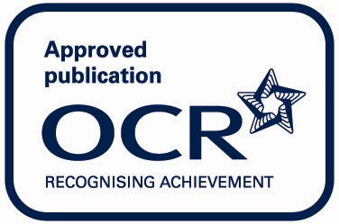

There are currently no OCR Approved publications for GCSE French.

