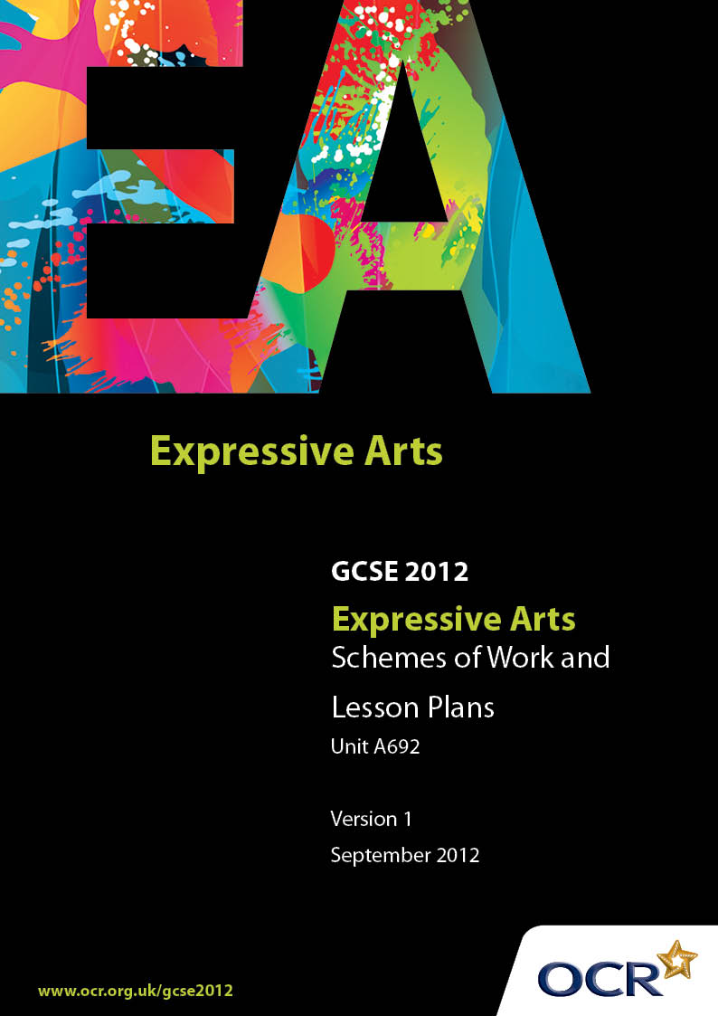

Contents
Introduction 3
Sample Scheme of Work: OCR GCSE Expressive Arts J367 Unit A692: Expressive Arts: Working in Response to a Stimulus 5
Sample Lesson Plan: OCR GCSE Expressive Arts J367 Unit A692: Expressive Arts: Working in Response to a Stimulus 13

Introduction

Background
Following a review of 14 – 19 education and the Secondary Curriculum Review, the Qualifications and Curriculum Authority (QCA) has revised the subject criteria for GCSEs, for first teaching in September 2009. This applies to all awarding bodies.
The new GCSEs have more up-to-date content and encourage the development of personal, learning and thinking skills in your students.
We’ve taken this opportunity to redevelop all our GCSEs, to ensure they meet your requirements. These changes will give you greater control of assessment activities and make the assessment process more manageable for you and your students. Controlled assessment will be introduced for most subjects.
From September 2012 assessment tasks may be undertaken at any point between release of the task and the examination series for which the task must be submitted.
OCR has produced a summary brochure, which summarises the changes to Expressive Arts. This can be found at www.ocr.org.uk, along with the new specification.
In order to help you plan effectively for the implementation of the new specification we have produced these Schemes of Work and Sample Lesson Plans for Expressive Arts. These Support Materials are designed for guidance only and play a secondary role to the Specification.

Our Ethos
OCR involves teachers in the development of new support materials to capture current teaching practices tailored to our new specifications. These support materials are designed to inspire teachers and facilitate different ideas and teaching practices.
Each Scheme of Work and set of sample Lesson Plans is provided in Word format – so that you can use it as a foundation to build upon and amend the content to suit your teaching style and students’ needs.
The Scheme of Work and sample Lesson plans provide examples of how to teach this unit and the teaching hours are suggestions only. Some or all of it may be applicable to your teaching.
The Specification is the document on which assessment is based and specifies what content and skills need to be covered in delivering the course. At all times, therefore, this Support Material booklet should be read in conjunction with the Specification. If clarification on a particular point is sought then that clarification should be found in the Specification itself.
Unit A692:

This Unit is distinct from A691 in a number of ways.
First of all, candidates must work individually. This means completely on their own with their assessed work being identified as completely theirs.
It should be possible for learners to access a range of grades that represent their ability within approximately 20 hours of assessed work.
The learners respond to a contextualised starting point, not something that is set without any explanation or randomly. This will impact on the use of the areas of study as learners explore and apply them and as they look at how they impact upon their ideas.
Learners must be exposed to or study three new practitioners. These must be different to the ones used in Unit A691 and learners should consider the influence of the ideas, intention, skills and techniques of their practitioners, cross referencing to areas of study as appropriate.
They will use a range of skills, some of which have been learnt through exposure to or study of practitioners. Practitioners will not drive the response and outcome as they do in Unit A691, but may:
- impact upon the way areas of study are reflected
- influence the type of response. It may be that the style of one practitioner in a particular context and with a specific type of audience is seen as very effective, and something the learner would like to replicate with their own idea
- allow candidates to apply what is learnt about ideas and intention from works by practitioners, and reflect this in the development of their own skills in a realisation. The practitioners chosen could be nothing whatsoever to do with the nature of the stimulus chosen
- allow candidates to develop their own individual styles and techniques by integrating aspects from practitioners with the candidate’s own unique skills and interpretation. Remember that sometimes a choice may be made following the rejection of an idea. So in considering, for example, atmosphere and its use by a practitioner studied, the learner may refer to how it was used and then decide that the approach would not be appropriate for the ideas chosen. If the learner can say why, this is likely to attract higher marks.
The specification states that the context will suggest and then define the nature of the audience. This is very important for this unit and intention and audience must be considered very carefully.
It is essential to note that there is not a free choice in this unit. The stimulus selected by the teacher must be from one of the following contexts:
An emotive word, such as ‘Fear’
A theme, such as ‘The Four Seasons’
An historical context, such as ‘The Gunpowder Plot’
A photograph
A newspaper or magazine article.
In the example given below, there is a common thread that runs through the selection of the practitioners. This is one way of approaching the selection of practitioners in this unit, but is not the only one. The selection could be for other reasons entirely, perhaps relying on the types of skills learners need to grasp, or to provide a strong understanding and sense of the areas of study.

A Guided Tour through the Scheme of Work

= Innovative Teaching Idea
This icon is used to highlight exceptionally innovative ideas.


= ICT Opportunity
This icon is used to illustrate when an activity could be taught using ICT facilities.

OCR GCSE Expressive Arts J367 Unit A692: Expressive Arts: Working in Response to a Stimulus
Suggested teaching time | 9 hours | Topic | Introducing a stimulus
Topic outline |  | Suggested teaching and homework activities |  | Suggested resources | Points to note
Introducing a stimulus and linking with three artworks by practitioners
The stimulus:  The stimulus presented to the learners is a photograph of a Remembrance Day ceremony with old soldiers, middle aged people of both sexes and several cultures, and some very young children.  1 hour |  | The nature of the photograph is explored :  - Why are they there?  - Why different ages?  - Conflict around the world and the different reasons for it  - How do people react to conflict- does your age or your culture make any difference?  - How do the media deal with conflict?  - How do the arts respond to conflict? |  | It is important that mono-cultural aspects of conflict are avoided. Photographs and press reports of contemporary and past conflicts will be useful such as:  - Afghanistan  - the problems in Zimbabwe  - Civil unrest in the past in Northern Ireland  - Civil unrest in Spain  - The Falklands’ war | - This will provide a rich background and evidence for consideration of the Area of Study of Social, Historical, Political and Cultural Contexts
The artworks:  Joan Littlewood  Oh What A Lovely War  Bob Dylan  Holst  From the Planets suite - Mars the bringer of war  One hour |  | - These three arts practitioners are from different cultures. One is still performing; one died recently; another died in 1934, so there is a span of time periods. Whilst two of them use War from apolitical and philosophical approach, the third uses the subject more as an inspiration and sets it in an historical setting using Greek mythology.  - In introducing the artworks, Learners should see them as both an inspiration for creating their own ideas, and different models for creating for different types of audiences.  - At this stage it might be enough to play them selections of the three, and give a brief context |  |  | - The use of Greek mythology offers further opportunities to explore cultural and historic issues.
Joan Littlewood  Oh What A Lovely War  Two hours |  | - Introduce the play – it was the result of a workshop development – and focus on the way the play tries to make audiences question what happened in World War 1 by entertaining its audiences.  - There are several sections that could be selected that show the emotion and humanity of the real people taking part in the fighting and contrasting it with those making money whilst people died, or making decisions that caused hundreds to die whilst they sipped tea. There are many opportunities for improvisation here, and for looking at how other writers looked at war.  - Homework activities could include finding out how the press at the time reported the war to the people. If learners became very interested in a particular conflict they could research it. |  | - The play itself is widely available.  - In its obituary on Joan Littlewood the BBC wrote: ‘This play came about after a conventional play about World War I was dramatically altered in 1963, when Littlewood decided that "war is for clowns".  - With her incomprehensible sergeant-major's drill and Frenchmen walking into battle "baa-ing like lambs to the slaughter", Littlewood combined slapstick humour with serious satire to set a new style in improvised theatre.’  - The full article can be found at http://news.bbc.co.uk/1/hi/uk/1628351.stm  Another article describes the play as follows:  - ‘The whole thing was dressed up as an Edwardian music hall show performed by pierrots who were popular in seaside pier shows.  - Theatre Workshop was a radical left-wing theatre company who aimed to bring theatre to the people. Much of their work was created through improvisation in rehearsal. As part of the process of creating Oh What A Lovely War the company invited locals to come and see the work in progress, and ended up incorporating some of their stories into the production.’  - http://www.peopleplayuk.org.uk/  guided_tours/drama_tour/post_1945/littlewood.php | - It might be useful to look briefly at other practitioners and artworks.  - Berkoff’’s ‘Sinking the Belgrano’ deals with the Falklands’ war and he deliberately didn’t release it for performance until several years afterwards so the hysteria in support of the war would have dissipated. Rupert Brooke’s poems provide another source.  - Christopher Bruce also created work with inspiration of regime’s that treat people badly and how ordinary people are affected.
Bob Dylan  Two hours |  | - Introduce some of Dylan’s songs and relate them to the times in which he lived. This can cross reference to many areas of study, and especially genre, audience and Social, Historical, Political and Cultural Contexts.  Suggested songs are:  - For the times they are a changing (1964)  - A Hard Rain’s a-Gonna Fall (1963)  - Blowin’ in the wind (1963)  - Dylan’s songs dealt with a range of political issues and things he thought unfair. Stories about African Americans treated badly, the Vietnam War, and the Cold War and the fear of nuclear war killing everyone were some of the topics.  - Modern Times is his most recent album and it went to number one in the US charts.  - This artist is particularly useful in relation to the intention behind the creation of a work, and also the sorts of audience his songs were for.  - Homework could include finding other protest song writers, and perhaps more contemporary ones. |  | - It is reported Dylan said,  ‘Hard Rain is a desperate kind of song. Every line in it is actually the start of a whole song. But when I wrote it, I thought I wouldn't have enough time alive to write all those songs so I put all I could into this one." www.songfacts.com  - ‘The Lonesome Death of Hattie Carroll’ released in 1963 and re-released in 1992 is a very good example of a song writer taking up an issue and keeping it in the public eye, asking questions. There is an excellent account in an article by the Guardian newspaper which may be found at http://www.guardian.co.uk/music/2005/feb/25/bobdylan | - Learners with a particular leaning towards music could explore the instrumentation in the songs: the way guitar and harmonica are used.
Holst  From the Planets suite - Mars the bringer of war  Two hours |  | - Learners should discover how this piece is different from the previous works of art in a number of ways.  - It was not a reaction to a political event, nor was it a protest. Rather it uses Greek mythology and the character of the God to bring out some musical ideas.  - The use of drums and the clashes of armies are represented in the music.  Learners could explore how music is used to glorify war, and how music is used in war, with for example  - marching military bands  - drumming in tribal warfare  - drums used for messages and communication.  - Homework could include research into Greek mythology and the character of Mars in that mythology. |  | - Information about the composer and the Planets Suite can be found at this website.  http://classicalmusic.suite101.com/article.cfm/  gustav_holst___the_planets_  - The following website gives information about a performance of the music with visual effects added, although it refers to a pay channel.  http://www.skyarts.co.uk/music/article/holst-the-planets  - The notion of the way war is linked with quests might be explored. Reference here could be made to the book, ‘Lord of the Rings’ by JRR Tolkien. | - This piece was written originally for Organ and drums.
Areas of Study  One hour |  | - Learners should consider each area of study and how the three artworks are most reflected, and how this might influence a piece of their own choosing. Learners should be reminded that this exercise is to see areas of study as tools to aid their own creativity, and that some of them may not be relevant in their own devising.
Early Ideas  One hour |  | - Learners should return to the stimulus photograph and look at it in the light of what they have learnt from the practitioners.  They should ask themselves  - Whether there are there any conflicts they would like to protest about or comment upon  - If there are personal issues that arise from conflict that they would like to reflect in a mood or atmospheric piece  - If they want to entertain, educate or raise awareness, or just provide a background |  | - Refer back to the precise demands of the specification. | - It is very important here for learners to be firm about their purpose and their intended audience as this will drive forward the style of their devising.

The following realisation uses the example given above.

Aspect | Content | Comment
Stimulus | A photograph of a Remembrance Day ceremony with old soldiers, middle aged people of both sexes and several cultures, and some very young children.
Idea chosen | An atmospheric piece to reflect the issues war raises. | These issues might include the anti-war argument; the notion of remembrance and the giving up of life for a cause; the pain of those who suffer losses; the camaraderie between those who fight.
Intention | To raise awareness of the different viewpoints and aspects of war. | It is important that the selection of intention is not too woolly.
Audience | Cinema audiences to be shown between adverts before the main feature film. | Similar to some of the government sponsored adverts that are intended to raise awareness.
Nature of Realisation | A dance with a series of images as a backdrop and sound provided by different aspects of war developed into a soundscape. | The soundscape could include gunfire, bombs dropping, human suffering, military music blended together or developed into rhythms.  The images should be drawn by the learner but could be inspired by another practitioner, perhaps.
Art forms to be used | Dance, art and design and music | There are opportunities here to use IT or digital technology.
Practitioner influence | The three practitioners in the scheme of work are Joan Littlewood, Bob Dylan and Gustav Holst | Joan Littlewood explores a range of themes about war and the people who are involved; Bob Dylan takes a ‘protest’ stand; and Gustav Holst’s music is more identified with a Nationalistic approach, and Mars has often been used as a rousing accompaniment to positive images of aspects of war
Genre and Style | Advert approach, with an abstract contemporary dance and some documentary style soundscape and images. | There may be opportunities to reference other practitioners here, as well as the three studied. For example, Christopher Bruce’s work could be interesting as an influence.
Areas of Study | Atmosphere – Switching between emotions, perhaps using triggers such as poppy petals and other symbols of war in contrasting ways.  Audience – The selection of a cinema audience means the realisation has to be short and punchy.  Structure and Shape – The interaction of the dance, soundscape and back-projection will mean some careful structuring of the piece to ensure they all work together.  Narrative – there is unlikely to be any narrative, more a series of images.  Motif- It may be that a motif could be introduced as a link between sections, or as an overall Genre – Possibly surrealism  Symbol – the use of symbolic items  Social, Political, Historical, and Cultural Contexts – These may come about as a result of the source of the images. | The nature of this realisation means this area of study is likely to be a major one for consideration, and is well-supported by all three practitioners.  The practitioners also support this area of study with both Littlewood and Dylan providing evidence of strong audience contact.  Holst’s Mars and Littlewood’s Oh What a Lovely War both provide sound ideas on structure and how it can be used for effect.  The pierrots in Oh What a Lovely War are a good example of this  The poppy and perhaps elements of the impact of war, such as gravestone crosses, weapons and war posters, are useful examples.  It is important that mono-cultural aspects of conflict are avoided. Photographs and press reports of contemporary and past conflicts may be helpful such as:  Afghanistan  The problems in Zimbabwe  Civil unrest in the past in Northern Ireland  Civil unrest in Spain  The Falklands’ war

Alternative realisations
- Writing and composing a protest song influenced by the style of Bob Dylan. Music and creative writing
- Installation for a museum or gallery containing a mixture of 3D artefacts and images, and a soundscape with some poetry. Creative writing, art and design, music.
- Play using physical theatre approach. Creative writing and drama.
- Select the theme of ‘Festivals’ and use the celebration of Diwali, Christmas or similar. There is much art, music and creative writing connected with these.

OCR GCSE Expressive Arts J367 Unit A692: Expressive Arts: Working in Response to a Stimulus

Exploring conflict at a personal level, and how to present it
OCR recognises that the teaching of this qualification above will vary greatly from school to school and from teacher to teacher. With that in mind this lesson plan is offered as a possible approach but will be subject to modifications by the individual teacher.
Lesson length is assumed to be one hour.

Learning Objectives for the Lesson
Objective 1 | Introduce the notion of conflict at a more personal level
Objective 2 | Understand how two sides of an argument should be considered and presented
Objective 3 | Use areas of study in the creation of a piece of improvisation
Objective 4 | Decide if there is any relevance to their own response to the stimulus

Recap of Previous Experience and Prior Knowledge
- Reflect on what has been discovered about conflict from the study of artworks and discussions about the photograph.

Content
Time | Content
5 minutes | Warm up exercise in pairs with devising several ways of showing a conflict between the two.  Topic: Close friend has told lies about the other. Explore different potential reactions: anger, disappointment, rejection, betrayal.
10 minutes | Discussion about how the outcomes of the practical arm up could be reflected across all five disciplines, and how the response does not have to be loud and use shouting.  Coach on the use of proxemics
5-10 minutes | Describe the situation of Gollum in Lord of the Rings when he is accompanying Frodo and Sam, and whilst they are asleep the two parts of his split personality have an argument with each other.  Try the scenario out with partner on this topic: their friend has something very valuable that s/he won in a competition that the other person felt they should have won.  Listen to this scene played out on the CD of Lord of the Rings, the Musical. (Track 13)
15 minutes | Still in pairs, plan how to turn their improvisation into a more polished scene.  - Consider how it could use more than one art form.  - Each person plays both parts of the split role in an individual performance.  - Each person helps the other in developing their mini scene of about 20 seconds of argument and heart searching.  - Use areas of study to help in preparation of the outcome.
10 minutes | Show their outcomes to the whole group

Consolidation
Time | Content
5 minutes | Record what they have done as evidence in their portfolios and relate to possible influence on their own ideas regarding the stimulus.
10 minutes | Discussion about the art forms used, what worked and what didn’t and why, and ways outcomes could have been improved. Reference what was prepared to areas of study.

