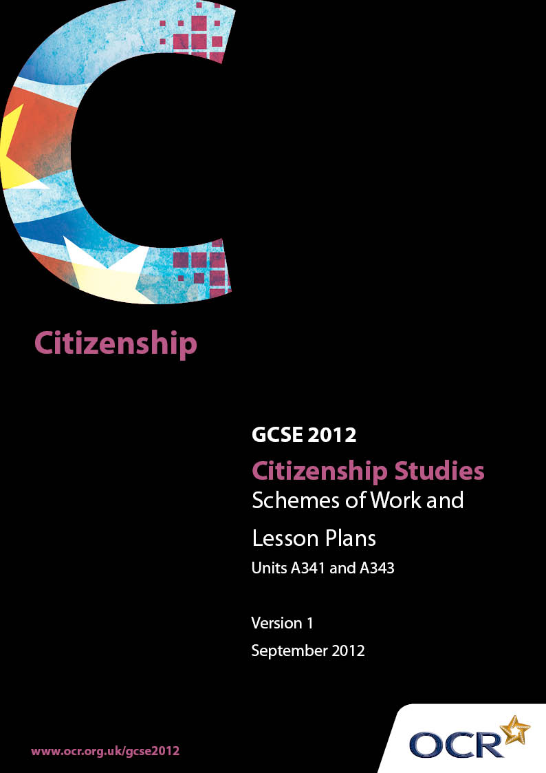

Contents
Contents 2
Introduction 3
GCSE Citizenship Studies (Short Course) Unit A341 6
GCSE Citizenship Studies Units A341 and A343 in combination 10
GCSE Citizenship Studies Unit A341 19
GCSE Citizenship Studies Unit A343 20

Introduction

Background
Following a review of 14 – 19 education and the Secondary Curriculum Review, the Qualifications and Curriculum Authority (QCA) has revised the subject criteria for GCSEs, for first teaching in September 2009. This applies to all awarding bodies.
The new GCSEs have more up-to-date content and encourage the development of personal, learning and thinking skills in your students.
We’ve taken this opportunity to redevelop all our GCSEs, to ensure they meet your requirements. These changes will give you greater control of assessment activities and make the assessment process more manageable for you and your students. Controlled assessment will be introduced for most subjects.
From September 2012 assessment tasks may be undertaken at any point between release of the task and the examination series for which the task must be submitted. Centres must ensure that candidates undertake a task that is valid for submission in the year in which the candidate intends to submit it.
OCR has produced a summary brochure, which summarises the changes to Citizenship Studies. This can be found at www.ocr.org.uk, along with the new specification.
In order to help you plan effectively for the implementation of the new specification we have produced these Schemes of Work and Sample Lesson Plans for Citizenship Studies. These Support Materials are designed for guidance only and play a secondary role to the Specification.

Our Ethos
OCR involves teachers in the development of new support materials to capture current teaching practices tailored to our new specifications. These support materials are designed to inspire teachers and facilitate different ideas and teaching practices.
Each Scheme of Work and set of sample Lesson Plans is provided in Word format – so that you can use it as a foundation to build upon and amend the content to suit your teaching style and students’ needs.
The Scheme of Work and sample Lesson plans provide examples of how to teach this unit and the teaching hours are suggestions only. Some or all of it may be applicable to your teaching.
The Specification is the document on which assessment is based and specifies what content and skills need to be covered in delivering the course. At all times, therefore, this Support Material booklet should be read in conjunction with the Specification. If clarification on a particular point is sought then that clarification should be found in the Specification itself.

A Guided Tour through the Scheme of Work

= Innovative Teaching Idea
This icon is used to highlight exceptionally innovative ideas.


= ICT Opportunity
This icon is used to illustrate when an activity could be taught using ICT facilities.

GCSE Citizenship Studies (Short Course) Unit A341
Suggested teaching time | 5 hours | Topic | Our Rights and Responsibilities (Section 3.1.1)
Topic outline |  | Suggested teaching and homework activities |  | Suggested resources | Points to note
Understand the ways in which moral and legal rights and responsibilities develop with maturity and age.  (Content from Unit A341 – Short Course) |  | - Students to work individually and in groups to match particular responsibilities to particular ages and to justify their choices  - Compare their results with the current age laws and identify any differences  - Express their own points of view in relation to any age laws they think should change  - Investigate how decisions are made on the “age laws”  This lesson or series of lessons, could be developed to become part of the introduction to the controlled assessment task on campaigning as follows:  - Reflect on the campaigns of the past about children’s rights. What made these campaigns successful? What methods were used to gather support and influence decision makers?  - Reflect on the needs and rights of children in our community. Are there rights that should be extended or safeguarded more rigorously by the authorities?  - Study some of the campaigning methods used in the past and the ways in which similar methods have been used successfully in the present. (The British Library resources include a particularly interesting video clip on the use of strong visual images in the campaign to abolish slavery and how photographs have been used successfully in similar ways to campaign against human trafficking. The same site has very good video clips on the use of posters, branding, leaflets and newspapers in historical campaigning and their potential as campaign methods today.)  - Follow the advice and guidance in the Teachers’ Handbook and Student Handbook to plan successful campaigns with your students.  - As part of preparing for the controlled assessment, consider using some of the activities on the British Library website. For example, the campaign tactics game will stimulate discussion about the n=most effective methods to use in a campaign. |  | - A detailed breakdown of the age laws from 14+ is available on www.thesite.org.uk  - Or from 5+ on www.childrenslegalcentre.com  - TheSite.org is owned and run by YouthNet UK, a registered charity founded in 1995. According to its website, TheSite.org aims to be the first place all young adults turn to when they need support and guidance through life  - The British Library has produced a range of outstanding resouces, ‘Campaign. Make an Impact!’’, that enable students to learn about effective campaigning through a study of historical campaigns. Student and teacher handbooks provide very useful guides to setting up a successful campaign. Historical campaigns on the rights of children could be used as a starting point for students to design a campaign about increasing the age of criminal responsibility or other aspects of the age laws. www.bl.uk/campaign  The British Library’s resources are organised according to a three step model. This helps students plan successful campaigns of their own by reflecting on the success of some historical campaigns.  - Step 1 Reflect on case studies of historical campaigns  - Step 2 Consider successful campaign methods from the past and their link with modern campaigns. A Make Yourself Heard section on the British Library’s website has video clips of eight different campaigning methods including the use of visual, spoken and written media.  - Step 3 Plan, run and evaluate your own campaign. Use the website’s Run Your Campaign section which includes excellent handbooks for teachers and students taking them through all aspects of successful campaigning. | - Ensure that students understand the difference between rights and responsibilities  - Explain the difference between moral and legal rights and responsibilities.  - You may wish to introduce a discussion about the reasons why the age for buying tobacco, staying in education, buying a pet and driving have been raised recently. Are these increases justified?  - Students will have a view on the age of criminal responsibility being 10  - This could lead to an introduction to power and decision-making. Who makes these decisions and how is it possible to influence them?  - Be cautious with the use of the British Library’s case studies of student campaigns. Some of these focus on raising awareness amongst other students and members of a community about a problem e.g. litter. The OCR controlled assessment requires students to take their campaign to appropriate decision-makers rather than to simply raise awareness amongst their peers. The British Library’s students and teacher handbooks reflect the OCR requirement.
Understand the moral and legal rights and responsibilities that apply to our interactions with others and know that members of families have responsibilities (moral and legal) as well as rights.  (Content from Unit A341 – Short Course) |  | - Students to produce lists of moral and legal rights and responsibilities that apply to a parents and a child in the home  - Comparison of lists in class and consideration of legal rights and responsibilities of parents  - Discussion of the rights and responsibilities of partners in a marriage or civil partnership and those who live together but without a civil partnership or marriage  - Homework to produce a leaflet advocating the advantages of marriage or civil partnership |  | - Simple grids can be produced as follows:      - A useful guide to the law on civil partnerships and marriage is available on  www.direct.gov.uk | - Be aware that some students may be very sensitive to discussions of family life. Check with pastoral staff
Understand the range and importance of fundamental human rights and their impact on national and international law. Identify and debate cases where different human rights may be in conflict.  (Content from A341 – Short Course) |  | - Students produce lists of things they think are human rights, compare to actual rights  - Discussion on whether everyone has these same rights – what happens if these rights are not met?  - Role plays to illustrate where different human rights may be in conflict |  | - A useful guide to fundamental human rights is available on www.direct.gov.uk.  - The Citizenship Foundation also have links to useful resources on human rights. www.citizenshipfoundation.org.uk  - 1048/01 Source Book for June 2007 on DNA testing – the use of compulsory DNA testing to reduce crime
Engage in responsible action to develop the school community, including understanding the benefits of an active School Council or Student Council.  (Content from A341 – Short Course) |  | - Discussion on current role of Student Council within your Centre  - How could it be improved, what are the benefits?  - SWOT analysis – strengths, weaknesses, opportunities, threats of possible action to develop school community  - Introduce controlled assessment – Citizenship Campaign |  | - Hodder Citizenship Teacher’s Handbook.  - For ideas on how students can be more involved in their school www.studentvoice.co.uk  - Teaching resources are available at www.schoolcouncils.org | - Make sure the Leadership Team are aware of any ideas your students have about campaigning to become more involved in school decision making

GCSE Citizenship Studies Units A341 and A343 in combination
Suggested teaching time | 10 hours | Topic | Our Rights and Responsibilities (An integration of Sections 3.1.1 and 3.3.1)
Topic outline |  | Suggested teaching and homework activities |  | Suggested resources | Points to note
Understand the ways in which moral and legal rights and responsibilities develop with maturity and age.  (Content from Unit A341 – Short Course) |  | - Students to work individually and in groups to match particular responsibilities to particular ages and to justify their choices  - Compare their results with the current age laws and identify any differences  - Express their own points of view in relation to any age laws they think should change  - Investigate how decisions are made on the “age laws”  This lesson or series of lessons, could be developed to become part of the introduction to the controlled assessment task on campaigning as follows:  - Reflect on the campaigns of the past about children’s rights. What made these campaigns successful? What methods were used to gather support and influence decision makers?  - Reflect on the needs and rights of children in our community. Are there rights that should be extended or safeguarded more rigorously by the authorities?  - Study some of the campaigning methods used in the past and the ways in which similar methods have been used successfully in the present. (The British Library resources include a particularly interesting video clip on the use of strong visual images in the campaign to abolish slavery and how photographs have been used successfully in similar ways to campaign against human trafficking. The same site has very good video clips on the use of posters, branding, leaflets and newspapers in historical campaigning and their potential as campaign methods today.)  - Follow the advice and guidance in the Teachers’ Handbook and Student Handbook to plan successful campaigns with your students.  - As part of preparing for the controlled assessment, consider using some of the activities on the British Library website. For example, the campaign tactics game will stimulate discussion about the n=most effective methods to use in a campaign. |  | - A detailed breakdown of the age laws from 14+ is available on www.thesite.org.uk  - Or from 5+ on www.childrenslegalcentre.com  - TheSite.org is owned and run by YouthNet UK, a registered charity founded in 1995. According to its website, TheSite.org aims to be the first place all young adults turn to when they need support and guidance through life  - The British Library has produced a range of outstanding resouces, ‘Campaign. Make an Impact!’’, that enable students to learn about effective campaigning through a study of historical campaigns. Student and teacher handbooks provide very useful guides to setting up a successful campaign. Historical campaigns on the rights of children could be used as a starting point for students to design a campaign about increasing the age of criminal responsibility or other aspects of the age laws.  www.bl.uk/campaign  The British Library’s resources are organised according to a three step model. This helps students plan successful campaigns of their own by reflecting on the success of some historical campaigns.  - Step 1 Reflect on case studies of historical campaigns  - Step 2 Consider successful campaign methods from the past and their link with modern campaigns. A Make Yourself Heard section on the British Library’s website has video clips of eight different campaigning methods including the use of visual, spoken and written media.  - Step 3 Plan, run and evaluate your own campaign. Use the website’s Run Your Campaign section which includes excellent handbooks for teachers and students taking them through all aspects of successful campaigning. | - Ensure that students understand the difference between rights and responsibilities  - Explain the difference between moral and legal rights and responsibilities  - You may wish to introduce a discussion about the reasons why the age for buying tobacco, staying in education, buying a pet and driving have been raised recently. Are these increases justified?  - Students are likely to have a view on the age of criminal responsibility currently being 10  - This could lead to an introduction to power and decision-making. Who makes these decisions and how is it possible to influence them?  - Be cautious with the use of the British Library’s case studies of student campaigns. Some of these focus on raising awareness amongst other students and members of a community about a problem e.g. litter. The OCR controlled assessment requires students to take their campaign to appropriate decision-makers rather than to simply raise awareness amongst their peers. The British Library’s students and teacher handbooks reflect the OCR requirement.
Understand the moral and legal rights and responsibilities that apply to our interactions with others and know that members of families have responsibilities (moral and legal) as well as rights.  (Content from Unit A341 – Short Course) |  | - Students to produce lists of moral and legal rights and responsibilities that apply to a parents and a child in the home  - Comparison of lists in class and consideration of legal rights and responsibilities of parents  - Discussion of the rights and responsibilities of partners in a marriage or civil partnership and those who live together but without a civil partnership or marriage  - Homework to produce a leaflet advocating the advantages of marriage or civil partnership |  | - Simple grids can be produced as follows:  - A useful guide to the law on civil partnerships and marriage is available on  www.direct.gov.uk | - Be aware that some students may be very sensitive to discussions of family life. Check with pastoral staff
Know that members of the school/college community have responsibilities (moral and legal) as well as rights.  (Content from Unit A343 – Full Course) |  | - Interview a member of the school’s Leadership Team about the legal responsibilities and rights that apply to the different groups in a school  - Consider the moral responsibilities that apply in a school. Students to revise or draw up a simple code of behaviour for classrooms / corridors / playgrounds, etc.  - Students to present these to the School Council |  | - Access to Leadership Team, Governors or School Council  - Existing school Code of Behaviour  - Useful materials on building an effective School Council are available from www.schoolcouncils.org | - This could lead on to a discussion of the benefits of an active School Council – See 3.1.1 Short Course
Understand the formal (legal) and informal means through which rights and responsibilities can be balanced, supported and safeguarded in schools.  (Content from A343 – Full Course) |  | - Discussion on legal means of ensuring rights and responsibilities can be supported  - Informal means – brainstorm what can you do if you feel your rights and not being supported at school?  - Homework – research the law on education |  | - The Children's Legal Centre is a unique, independent national charity concerned with law and policy affecting children and young people  www.childrenslegalcentre.com/
Evaluate the additional formal and independent support available to individuals requiring information and advice, including that available from: government departments, agencies and official regulators; Citizens’ Advice, consumer protection or rights organizations and solicitors.  (Content from A343 – Full Course) |  | - Allocate different places for support to groups of students to research  - Each group to present their findings and produce a leaflet summarising the support offered  - Discussion evaluating the work of each agency  - Research can be carried out as homework |  | - www.direct.gov.uk is a good starting point to show the support available  - www.citizensadvice.org.uk for the work of Citizens’ Advice
Understand the range and importance of fundamental human rights and their impact on national and international law. Identify and debate cases where different human rights may be in conflict.  (Content from A341 – Short Course) |  | - Students produce lists of things they think are human rights, compare to actual rights  - Discussion on whether everyone has these same rights – what happens if these rights are not met?  - Role plays to illustrate where different human rights may be in conflict |  | - A useful guide to fundamental human rights is available on www.direct.gov.uk.  - The Citizenship Foundation also have links to useful resources on human rights www.citizenshipfoundation.org.uk  - 1048/01 Source Book for June 2007 on DNA testing – the use of compulsory DNA testing to reduce crime
Analyse the Universal Declaration of Human Rights, the European Convention on Human Rights and the Human Rights Act. With reference to these documents, evaluate possible infringements of human rights in the UK and elsewhere.  (Content from A343 – Full Course) |  | - Matching pairs exercises, cut and paste to show understanding of different documents  - Assess the legitimacy of holding people in detention without trial  - Homework – research using Amnesty International examples where human rights have been infringed |  | - www.unhchr.ch/udhr/  - www.hri.org/docs/ECHR50.html  - www.direct.gov.uk  - www.amnesty.org  - Copies of the documents can be found at the links above | - Make sure you have copies of Universal Declaration of Human Rights, The European Convention on Human Rights and the Human Rights Act
Engage in responsible action to develop the school community, including understanding the benefits of an active School Council or Student Council. |  | - Discussion on current role of Student Council within your Centre  - How could it be improved, what are the benefits?  - SWOT analysis – strengths, weaknesses, opportunities, threats of possible action to develop school community.  - Introduce controlled assessment – Citizenship Campaign |  | - Hodder Citizenship Teacher’s Handbook.  - For ideas on how students can be more involved in their school. www.studentvoice.co.uk  - Teaching resources are available at www.schoolcouncils.org | - Make sure the Leadership Team are aware of any ideas your students have about campaigning to become more involved in school decision making

GCSE Citizenship Studies Unit A341

Section 3.1.1 Moral and legal rights and responsibilities
OCR recognises that the teaching of this qualification above will vary greatly from school to school and from teacher to teacher. With that in mind this lesson plan is offered as a possible approach but will be subject to modifications by the individual teacher. Lesson length is assumed to be one hour.

Learning Objectives for the Lesson
Objective 1 | Understand the ways in which moral and legal rights and responsibilities develop with maturity and age.
Objective 2 | To be able to express their own points of view in relation to age laws they think should change.
This is likely to be the first lesson for Unit A341. This lesson, or series of lessons, could be developed to become part of the introduction to the controlled assessment task on campaigning. See the scheme of work for more details, and visit the British Library website for ideas and resources from its Campaign. Make an Impact! section. www.bl.uk/campaign

Content
Time | Content
5 minutes | Students to work individually to match particular responsibilities to particular ages.
5 minutes | In pairs, compare their results with the current age laws and identify any differences.
5 minutes | In pairs, justify their choices for particular ages.
10 minutes | Class discussion about the reasons why the age for buying tobacco, staying in education, buying a pet and driving have been raised recently. Students to support their points with evidence from their studies.
15 minutes | In groups identify a law they think should be changed. Research using www.thesite.org.uk different age laws. Put together a case.
10 minutes | Groups to present their case and to advocate a change in the law.

Consolidation
Time | Content
10 minutes | Check students’ understanding of ages and set homework for students to research how decisions are made on the age laws.

GCSE Citizenship Studies Unit A343

Section 3.3.1 Responsibilities as well as rights
OCR recognises that the teaching of this qualification above will vary greatly from school to school and from teacher to teacher. With that in mind this lesson plan is offered, as a possible approach but will be subject to modifications by the individual teacher.
Lesson length is assumed to be one hour.

Learning Objectives for the lesson
Objective 1 | Understand that members of the school/community have legal responsibilities as well as rights.
Objective 2 | Know that members of the school/community have moral responsibilities as well as rights.
This is likely to be the first lesson for Unit A343. It will be important to build the lesson on an understanding of rights and responsibilities covered in A341

Content
Time | Content
5 minutes | Recap different age laws from A341
5 minutes | Teacher-led discussion about difference between legal and moral responsibilities.
10 minutes | In groups plan an interview with member of Leadership Team, Governors or School council
10 minutes | Interview member of Leadership Team, Governor or School council representative.
10 minutes | Class discussion about current code of behaviour operating at the school.
10 minutes | In pairs revise or draw up a simple code of behaviour for classrooms / corridors / playgrounds etc

Consolidation
Time | Content
10 minutes | Check students’ understanding of different moral and legal responsibilities and set homework to devise posters to emphasise new code.

