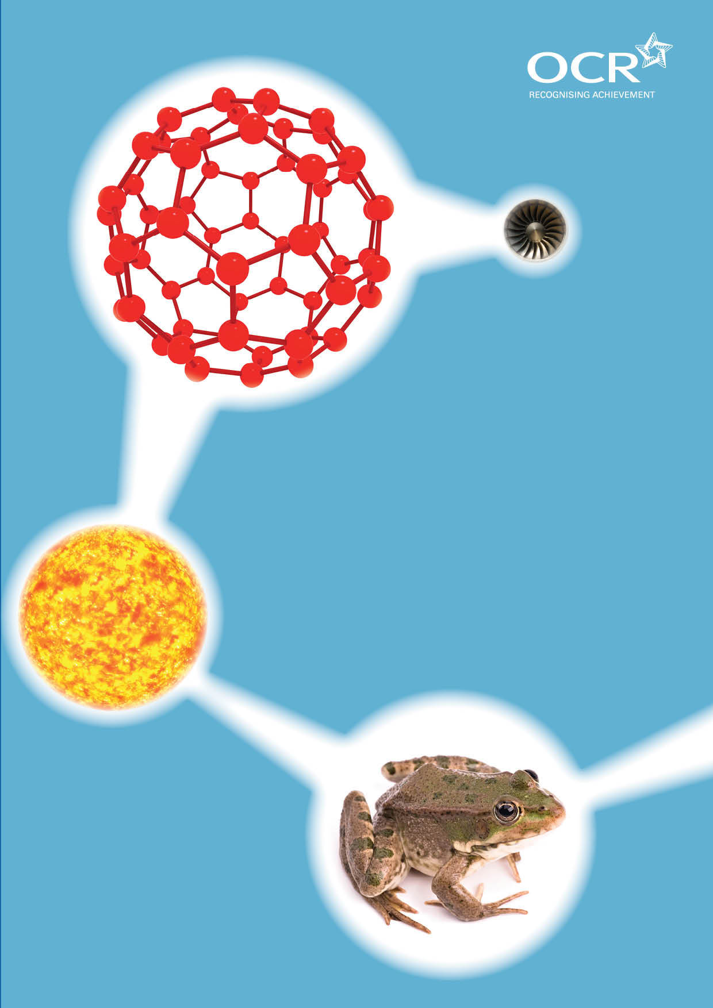
TWENTY FIRST CENTURY SCIENCE SUITE
SCHEMES OF WORK AND LESSON PLANS
C4: Chemical patterns
VERSION 1 JULY 2011
Introduction
OCR involves teachers in the development of new support materials to capture current teaching practices tailored to our new specifications. These support materials are designed to inspire teachers and facilitate different ideas and teaching practices. Each Scheme of Work and set of sample Lesson Plans is provided in Word format – so that you can use it as a foundation to build upon and amend the content to suit your teaching style and students’ needs.
The Scheme of Work and sample Lesson plans provide examples of how to teach this unit and the teaching hours are suggestions only. Some or all of it may be applicable to your teaching.
The Specification is the document on which assessment is based and specifies what content and skills need to be covered in delivering the course. At all times, therefore, this Support Material booklet should be read in conjunction with the Specification. If clarification on a particular point is sought then that clarification should be found in the Specification itself. References to the content statements for each lesson are given in the ‘Points to note’ column.

Sample Scheme of Work
GCSE 21st Century Science Chemistry A J244
Module C4: Chemical patterns

Suggested Teaching Time: 13 Hours

Topic outline | Suggested teaching and homework activities | Suggested resources | Points to note
History of the periodic table  (1 to 2 hours) | Students to colour in metals and non-metals on a white copy of the periodic table.  Set a research task for students to present their ideas about Dobereiner, Newlands and Mendeleev. Some examples of useful websites are given in suggested resources. Students should discuss that Dobereiner grouped elements together in triads, Newlands developed a reoccurring pattern of eight elements known as his law of octaves and Mendeleev who left gaps for undiscovered elements. | Copies of the periodic table  www.tutorvista.co.uk/content/science/science-ii/periodic-classification-elements/dobereiner-triads.php information on Dobereiner. This website has links to information on Newlands and Mendeleev.  http://corrosion-doctors.org/periodic/periodic-1.htm#development this website shows the development of the periodic table in a unique way but also includes information about the scientists involved. | ICT suite would be helpful here to allow students to research scientists for themselves.  This could be done as a poster, power point presentation or word document.
Safety precautions and hazard symbols  (1 hour) | Introduce hazard symbols such as flammable, harmful, toxic, oxidising agent, corrosive, etc.  This can lead to discussion about the hazchem code and the safe storage and transportation of chemicals such as the halogens.  Students can be given a set of cards with chemical names on and asked to assign a hazard to each based on their prior understanding (discuss misconceptions about dangers here). | www.ngfl-cymru.org.uk/vtc/ngfl/science/103_new/asc1/hazardsymbol.htm this is a simple site with clear images of the standard hazard symbols with a brief description.

Topic outline | Suggested teaching and homework activities | Suggested resources | Points to note
Understanding atoms  (1 to 2 hours) | Model the structure of the atom using students holding footballs, basketballs and table tennis balls to represent protons, neutrons and electrons respectively. Use this to discuss relative mass and charge of the nuclear particles and that all atoms of the same element have the same number of protons.  Electrons exist in shells. Use whiteboards to lead students through the filling of shells and electronic structure as you move across the period. Discuss the fact that atoms have the same number of electrons as protons.  Introduce the convention for writing electronic configuration using numbers, e.g. 2,8,7 for chlorine. This should be done for the first 20 elements. Students should draw the shells/energy levels for each element and then write the electronic configuration.  Discussions should also include the fact that the chemical properties of an element is related to the number of electrons in the outer shell and that the group in periodic table represent the number of electrons in the outer shell and periods corresponds to the number of shells. | Individual whiteboards and pens.  Copies of a periodic table.
Flame colours and spectroscopy  (1 hour) | Students carry out flame tests of a variety of compounds to show that some elements emit distinctive flame colours when heated.  Discuss the fact that when an element emits light it is of a specific colour and if we use a device called a spectroscope we can see that the light emitted forms lines. The set of lines produced is unique to that element and can be likened to a fingerprint to help identify unknown substances. This has allowed chemists to discover new elements. | Salts of group 1 and group 2.  Wooden splints soaked in water (or the salt solution). | If the splints are soaked in water it prevents them from burning and allows the flame colour to be seen when the splint is dipped into the solid then the flame. You can also soak the splints in the salt solution. This prevents your bunsen burners getting clogged up when the salt falls from the splint.

Topic outline | Suggested teaching and homework activities | Suggested resources | Points to note
Group 1 metals  (1 hour) | Demo the reactions of group 1 metals with water.  Show through demonstration, how metals can be cut and are shiny when first cut but tarnish quickly.  Discuss safety of the metals such as the storage of these metals under oil and the need for gloves, goggles, safety screen when carrying out these reactions.  Show video of Rubidium and Caesium reactions with water.  Interpretation of the reactivity of the group 1 metals properties based on their electron structure. Discussions should include the effect of shielding and distance from the nucleus on the attraction of the outer most electron. | http://video.google.com/videoplay?docid=-2134266654801392897# this is a section of the programme ‘Brainiac’ which shows the reactions of group 1 metals with water, including Rubidium and Caesium.  www.rsc.org/chemsoc/visualelements/pages/pertable_fla.htm this is an interactive periodic table that gives descriptions of elements.  Large glass trough  Group 1 metals (rice grain sized pieces recommended for use – see CLEAPPs).  Safety screen.  Tweezers, scalpel, gloves and goggles. | A graph/timeline of metals against the date of their first extraction can be used to elicit ideas on reaxctivity i.e. most reactive are the most difficult to extract.
Group 7 halogens  (1 hour) | Use websites/videos to allow students to research the properties of halogens and trends in properties such as colour, state at room temperature, melting points, boiling point, etc. This could be done as a homework.  Students to carry out the displacement reactions using potassium chloride, potassium bromide and potassium iodide with chlorine water, bromine water and iodine solution to deduce the reactivity of the halogens (these can also be shown using websites or videos.) | www.chemicalelements.com/groups/halogens.html this website contains information about the halogens. Good for data.  www.chem4kids.com/files/elem_halogen.html this is a useful website, which is well set out with concise information.  www.chemtopics.com/elements/halogen/halogenf.htm this website includes photos of the elements but also has excellent links to further information about the elements.  www.bbc.co.uk/schools/gcsebitesize/science/edexcel/patterns/groupsrev5.shtml this has an animation that allows students to add chemicals using a pipette. The products are named and colours shown.  www.chemistry-videos.org.uk/chem%20clips/ks3%20halogen%20displacment/halogen%20displacement.html this video shows the displacement of halogens reactions.

Topic outline | Suggested teaching and homework activities | Suggested resources | Points to note
Writing and balancing equations  (1 hour) | Demonstrate the experiments of group 1 metals with air and chlorine. Students can then be asked to write equations for the reactions.  For the less confident chemist, students can be shown a video of the reactions of group 1 metals with air, chlorine and water then asked to write equations for each reaction.  Students should start with word equations then progress to balanced symbol equations. The general formula of a group 1 metal hydroxide (MOH) and a group 1 metal chloride (MCl) can be used here to show patterns in the reactions of a specific group. | www.practicalchemistry.org/experiments/heating-group-1-metals-in-air-and-in-chlorine,127,ex.html for the more confident chemists, this link gives a practical method for reacting group 1 metals in air and chlorine. Please read the health and safety guidance first!  http://media.rsc.org/videoclips/demos/reactionsgroup1metals.wmv this is a clear video showing how to carry out all reactions and is at the bottom of the website above. This could be used with a class to show all the reactions of the first three group 1 metals with air, chlorine and water.  www.chemhume.co.uk/aschem/unit%201/ch3chemstr/chemical%20struct.htm this website has some excellent information which could be displayed to aid teaching. | Molymods could be used as a helpful teaching tool for students who struggle with this (the different coloured elements used to balance each side of the equation).
Writing ionic formulae  (2 hours) | Students should be introduced to the convention for showing the loss and gain of electrons in the outer shells of atoms to produce positive and negative ions respectively.  Dot and cross diagrams should be drawn for the transfer of electrons from group 1 metals to group 7 halogens during reactions between the two elements. Remember to include square brackets and charges for ions. This can be attempted using individual white boards.  Recall from earlier in the topic that the group in the periodic table tells us the number of electrons in the outer shell and relate this to the charged formed on each ion of that group. Introduce the idea that all elements are working towards a noble gas configuration as this is the most stable form.  Students can be given cards of different sizes (height) depending on their charge (and different colours depending on positive or negative) and they are asked to construct the formula of a series of compounds using the cards for help. | Individual whiteboards and pens  Cards of different elements  Group 1 metals 5cm by 2cm  Group 2 metals 5cm by 4cm  Aluminium 5cm by 6cm  These should be one colour to represent positive ions.  Group 7 5cm by 2cm  Group 6 5cm by 4cm  these should all be the same colour but different to the positive ions  e.g. NaCl  e.g. MgCl₂  The boxes have to be equal depth for the formula to work. Also include HO- and other polyatomic ions.

Topic outline | Suggested teaching and homework activities | Suggested resources | Points to note
Properties of ionic compounds  (2 hours) | Discuss the formation of the lattice as an attraction of oppositely charged ions and discuss the strength of these forces of attraction. Show models, images and example compounds of sodium chloride and other ionic compounds. The properties can be compared to non-ionic compounds (students are not aware of covalent compounds at this stage).  Demo the electrolysis of lead bromide. Show the substance does not conduct electricity when solid but does when molten. Discuss the fact that melting breaks up the regular lattice to create ions which are free to move.  Recall the electrolysis of brine (from topic C3) and relate this to the fact that the sodium chloride is dissolved in water and that the dissolving breaks the regular lattice structure of the salt. This can also be demonstrated by putting some sodium chloride on a watch glass and showing using carbon electrodes, bulb and power supply that it does not conduct electricity. Add a small amount of water to the watch glass to allow the salt to dissolve and then show the bulb will light. | Model of sodium chloride lattice  Collection of ionic compounds placed on watch glasses for students to view.  Lead (II) bromide  Evaporating basin  Carbon electrodes  Power supply  Bulb  Wires  Watch glass  Sodium chloride.  http://wizznotes.com/chemistry/bonding/properties-of-ionic-compounds this site has a clear image and a few basic notes of the properties of ionic compounds  www.800mainstreet.com/4/0004-004-properties.html this website looks a little dull but it has good clear information including a table of melting points and solubilities  www.practicalchemistry.org/experiments/electrolysing-molten-leadii-bromide,106,ex.html this website shows how to carry out electrolysis of lead bromide. | Safety when carrying out electrolysis of lead bromide (refer to Hazcards for safety).  Safety of electrolysis of sodium chloride solution should be carried out for a short time only due to formation of chlorine.

Sample Lesson Plan
GCSE 21st Century Science Biology A J243
Module C4: Chemical patterns

History of the Periodic Table
OCR recognises that the teaching of this qualification above will vary greatly from school to school and from teacher to teacher. With that in mind this lesson plan is offered as a possible approach but will be subject to modifications by the individual teacher.
Lesson length is assumed to be one hour.

Learning Objectives for the Lesson
Objective 1 | Recall the main contributors to the Periodic table we know today
Objective 2 | Describe how ideas about the classification of elements have been developed over time.
Objective 3 | Explain how ideas about reactivity of elements helped scientists to classify elements in the Periodic table

Recap of Previous Experience and Prior Knowledge
No prior knowledge of the periodic table development is expected but students should be aware of the basic structure of an atom and the definition of an element.

Content
Time | Content
5-10 minutes | Distribute copies of the periodic table and 2 different coloured pencils. Ask one student at a time to name a metal. Each student should then colour in the metal in one colour. When a suitable number of metals have been coloured in, pose the question of where metals are on the periodic table and can they describe any pattern. Once this is established complete colouring of metals. Colour non-metals in a different colour.
25 minutes | Students can use ICT suite or information provided by the teacher to research the contributions of Dobereiner, Newlands and Mendeleev. (See SOW for weblinks to use in this activity). To aid this students can create ‘top trump’ style cards of elements as Mendeleev did when organising his table. These cards can be used to form triads, octaves and then final groups
15-20 minutes | Students to create a flow chart of the ideas they have researched to emphasise the development over time. This can be done in groups to feed back ideas to the class.

Consolidation
Time | Content
10 minutes | Groups of students present their findings to the rest of the class in the form of their flow charts. Different groups of students can be assigned a different scientist to present to avoid too much repetition in the presentations

