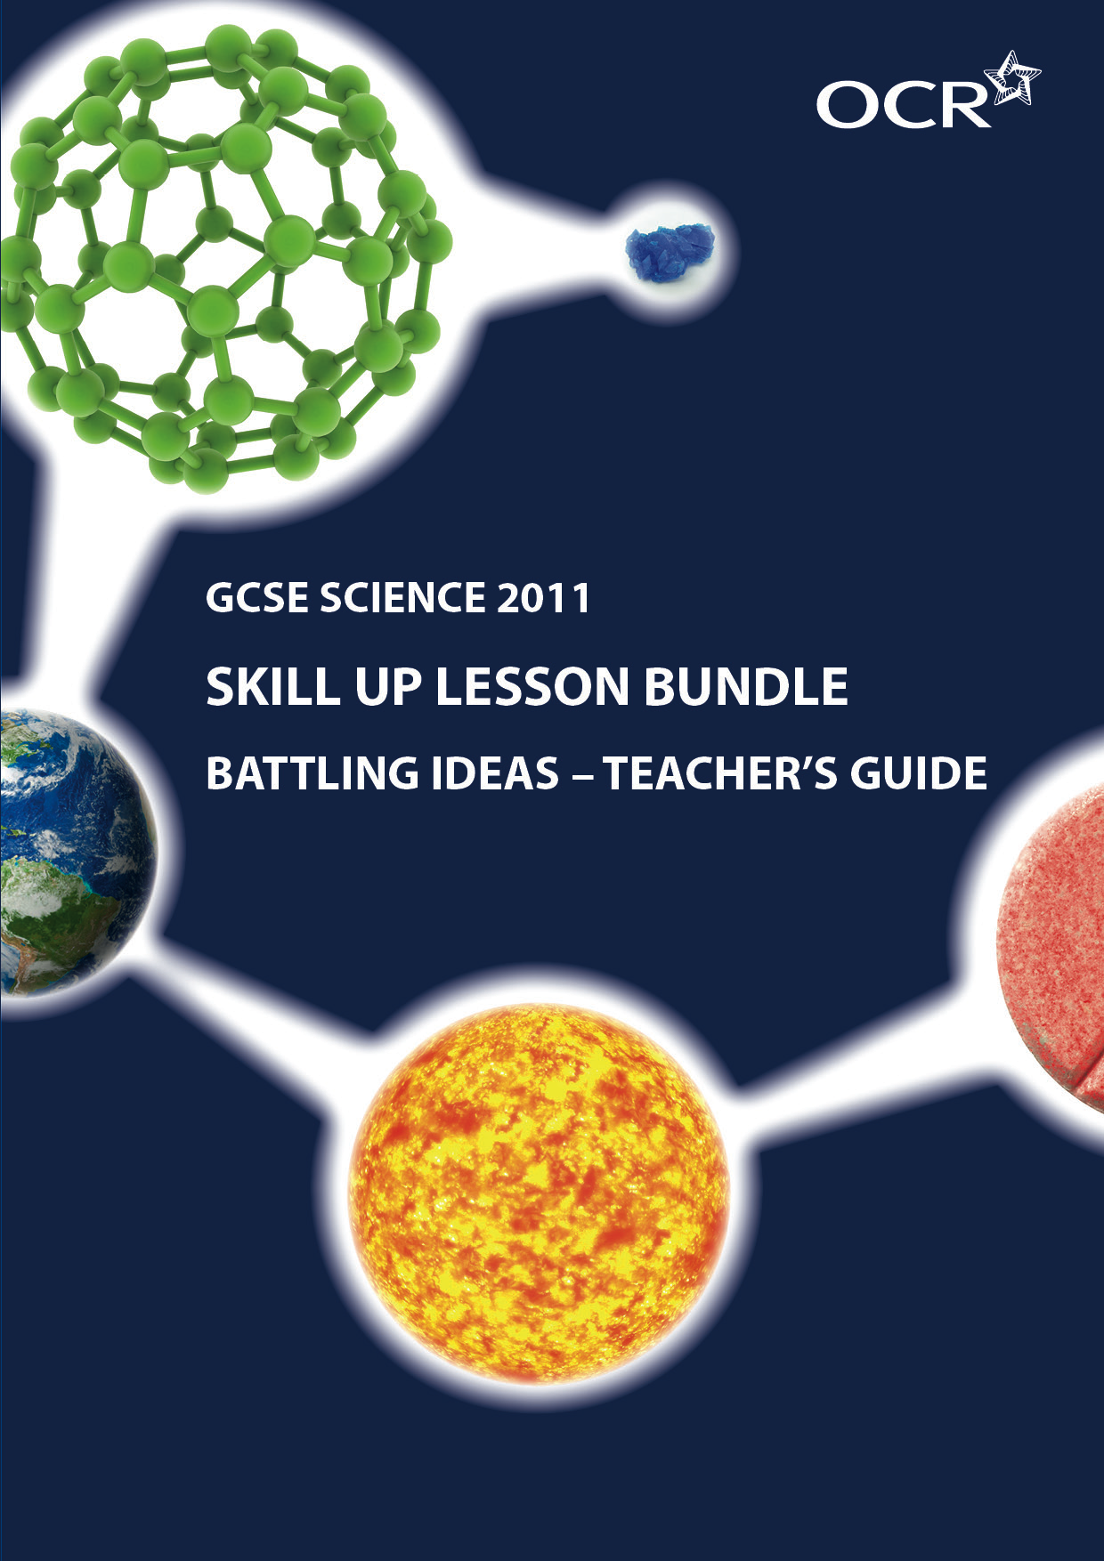
Battling IDEAs
Teacher’s Guide

Summary
OCR has worked with the Centre for Science Education to produce three sets of teaching resources linked to our GCSE Science specifications.

These lesson bundles comprise of a guide for teachers, student worksheets and a Powerpoint presentation.

The Teacher’s Guide, which is this document, sets the scene and give you an exemplar lesson plan to adapt and use.

The student worksheets can be printed off or used electronically as part of the lesson, in conjunction with the Powerpoint presentation, as you see fit.

This skill development activity is set for: OCR GCSE in Science B J261. Carbon Chemistry C1c Clean air. Chemical Resources C2a The Structure of the Earth
Science A J241. Air quality C1.2. Acid rain. Earth in the Universe. P1.2 Changing Earth.
This game-based set of activities is designed to convey the language of theories and predictions, and make the abstract idea of how explanations develop more accessible. Students start with number games, and how they work out patterns, and then apply the same reasoning to scientific explanations. The activity uses the teaching tool of a ‘boxing match’ to represent the ‘battle’ between two competing theories. It helps students reflect on how each prediction borne out by observation makes the theory stronger.

Learning objectives
The main focus is to address ‘Developing students’ skills to support achievement in GCSE sciences’, strand 1:
1) (Low demand) Recognise that science explanations are provisional because they only explain the current evidence
2) (Standard demand) Recognise that science explanations are provisional but more convincing if predictions can be made and subsequently confirmed
3) (High demand) Recognise that confidence increases in provisional scientific explanations if observations match predictions but this does not prove the explanation is correct

To address content from the specification, there is an extra objective.
4) (Science A P1.2) Understand Wegener’s theory of continental drift and his evidence for it
(Science B C2a) Explain why the theory of plate tectonics is now widely accepted.

CONTENT
Time | Stage | Activity
10 min | Engage  Students try a numbers game to see if they can predict the next number. | How do theories become accepted?  We start answering this in the realm of number explanations.  Slides 3-7  Give students SS1, in which they record their predictions and outcomes from the two number games.  Round 1 - Present each number in turn. Ask students to predict what number comes next  Slides 8-14  Round 2 – in this game ask students to work out and write down the rule connecting the numbers but students should only declare their rule when they are sure.  Slide 15  Ask students to consider the questions on the slide. They should be encouraged to realise that they started off with a 'provisional' explanation. They then made 'predictions' and if the 'observation' matched, they believed their explanation more. Where the observation didn’t match they needed to try a different explanation.  Slides 16-17  Links the game to real-life
25 min | Explore  Students take part in a boxing match between two battling ideas. Which one will win? | Slide 18  Students find out if this works with real scientific theories.  Slides 19-24.  Introduces the observation that trees are dying around Mammoth mountain. The first ‘boxing contest’ is introduced. One idea is in the ‘red corner’ and the other in the ‘blue corner'. Students can work alone, in pairs or in small groups. Each has a copy of SS2 and pick a boxer to support – whose idea do they back?  Slides 25-35  For each round of the contest a question is considered.  Encourage students to suggest what each idea would predict, before revealing the predictions on screen.  Then reveal the observations. Only one idea will have predicted correctly. That idea wins the round.  Using SS2, after each round each student should record how confident they feel that they've made the right choice.  At the end of the round, a small prize could be awarded to the groups who choose the correct idea at the start.  Slides 36-53  Students can try the game again with round 2. They should be encouraged to use what they learnt in the previous contest when considering their decisions.  It is worth discussing that more evidence may yet come to light (e.g. more photos from the Messenger space probe) so theories can still change.
10 min | Explain  Information on why science theories are always only provisional and could change. | Slides 54-57  Students answer the two questions at the bottom of SS2.  Encourage them to use the terminology introduced on the slides.
15 min | Evaluate  Students take part in a discussion on how theories become accepted. | Ask students to read out their answers and use these to initiate a discussion on how theories become more convincing over time and if theories can ever become fact.
 | Extend *  Students apply their understanding to a new situation. | Students complete an exam-style question where they judge another theory (Wegener’s theory of continental drift). This can be found on SS3 or SS4. In SS4 the question is broken down into stages which may help the less able. See teacher marking guide for help in assessing the objectives (SS5)

* As homework or part of a subsequent lesson

Skillup activity OCR created by the upd8 team © OCR 2012. Teachers and others who download this material may use it freely within their institution. For any other usage consult OCR. OCR are not responsible for any revision that may be made to the material after it has been downloaded.

2163040133
1/12

