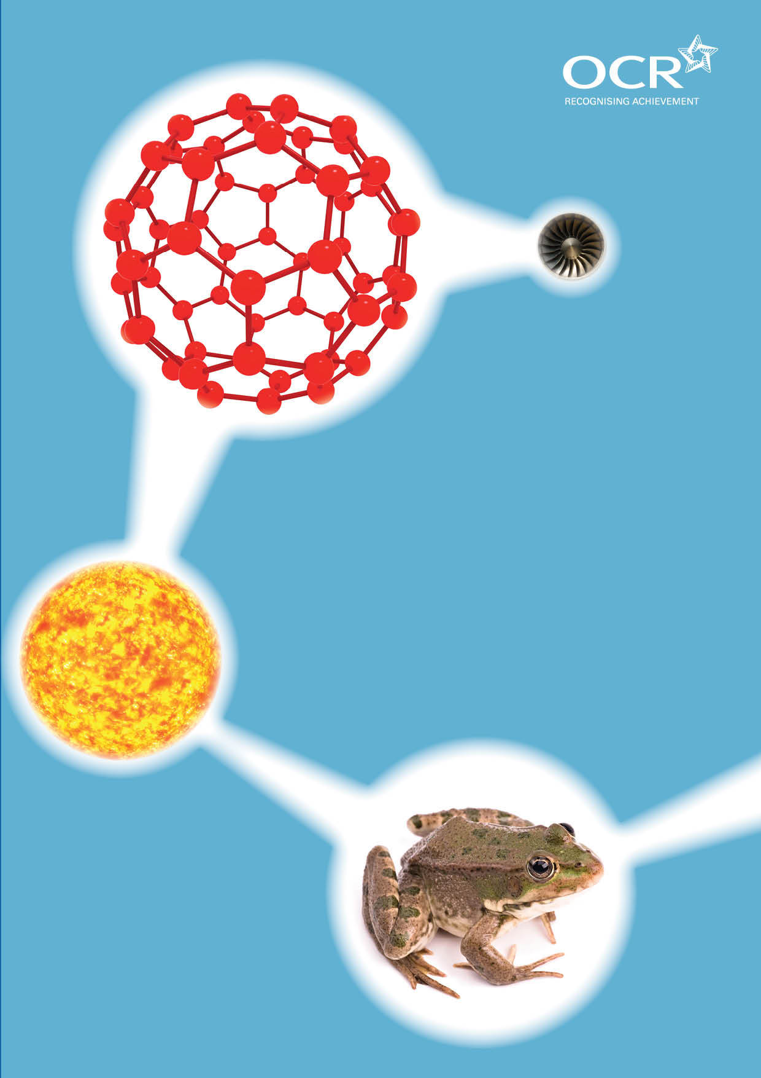
TWENTY FIRST CENTURY SCIENCE SUITE
SCHEMES OF WORK AND LESSON PLANS
B1: You and your genes
VERSION 1.1 JULY 2011
Introduction
OCR involves teachers in the development of new support materials to capture current teaching practices tailored to our new specifications. These support materials are designed to inspire teachers and facilitate different ideas and teaching practices. Each Scheme of Work and set of sample Lesson Plans is provided in Word format – so that you can use it as a foundation to build upon and amend the content to suit your teaching style and students’ needs.
The Scheme of Work and sample Lesson plans provide examples of how to teach this unit and the teaching hours are suggestions only. Some or all of it may be applicable to your teaching.
The Specification is the document on which assessment is based and specifies what content and skills need to be covered in delivering the course. At all times, therefore, this Support Material booklet should be read in conjunction with the Specification. If clarification on a particular point is sought then that clarification should be found in the Specification itself. References to the content statements for each lesson are given in the ‘Points to note’ column.
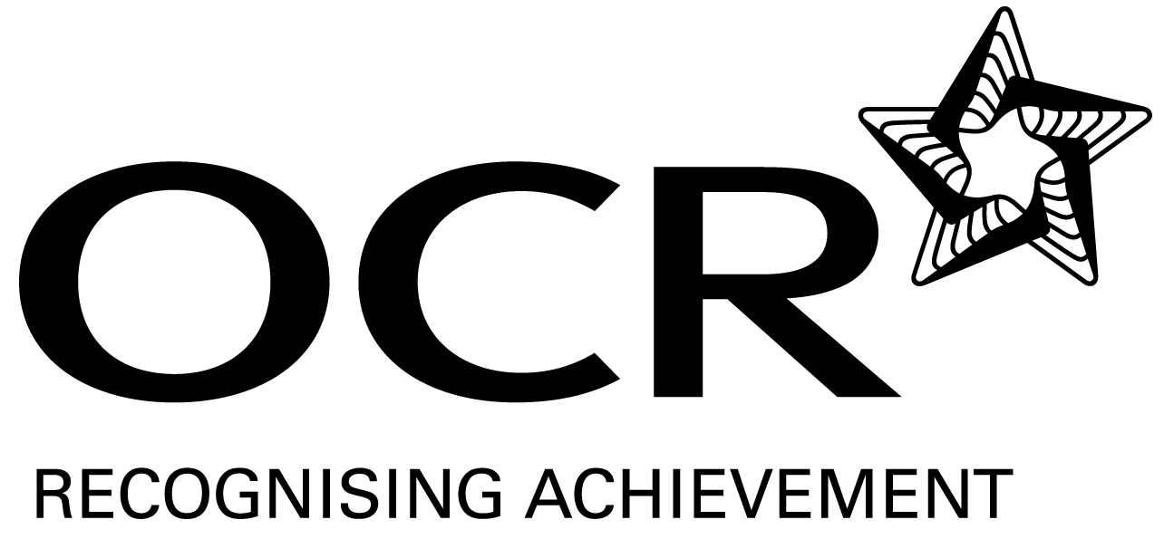
Sample Scheme of Work
GCSE 21st Century Science Biology A J243
Module B1: You and your genes
Lesson 1: What makes you the way you are?

Suggested Teaching Time: 1 Hour

Topic outline | Suggested teaching and homework activities | Suggested resources | Points to note
Learning objectives  Describe that characteristics are controlled and inherited through genetic material (DNA) in the nucleus of cells.  Compare how the members of families often share characteristics.  Explain that characteristics are affected by inheritance and environment. | Present a series of pictures to students showing (possibly famous): fathers and sons, mothers and daughters, siblings, and identical twins. E.g. George Bush and George W. Bush. Danni and Kylie Minogue.  Students should list differences and similarities in their characteristics (not only physical but others e.g. Accent).  From the list of characteristics students have made discuss the concepts of inherited (e.g. Eye colour) and environmental (e.g. Accent) characteristics have students choose if they are inherited, environmental or both.  Discuss the concept of inheritance. Link to Key Stage 3 – how do we inherit characteristics from our parents. We inherit half of our DNA from each parent. Our siblings also inherit half of their DNA from each parent – but get different genes.  Looking at the pictures of identical twins – how do they help use identify which characteristics and inherited and which are environmental (mention twin studies).  Give examples of how some inherited characteristics are controlled by many genes and environmental influences e.g. Height, eye colour, risk of heart disease. | Opportunities for practical work: Deck of cards (or equivalent) can be used to represent characteristics/genes to simulate inheritance through the formation of sex cells and fertilization. | Details of genetic crosses and dominant and recessive alleles do not need to be covered in this lesson.  Specification links:  B1.1 - 1. Recall that instructions to control how an organism develops and functions are found in the nucleus of its cells and are called genes;  B1.1 - 4. Recall that genes are sections of very long DNA molecules that make up chromosomes in the nuclei of cells;  B1.1 - 5. Understand that some characteristics are determined by genes (e.g. Dimples); some are determined by environmental factors (e.g. Scars) and some are determined by a combination of genes and the environment (e.g.; weight);  B1.1 - 6. Understand that many characteristics are determined by several genes working together (e.g. Eye colour).

Lesson 2: Genes and proteins

Suggested Teaching Time: 1 Hour

Topic outline | Suggested teaching and homework activities | Suggested resources | Points to note
Lesson objectives:  Recall the definition of a gene.  Recall that proteins may be structural (e.g. collagen) or functional (e.g. enzymes such as amylase).  Understand hat genes are instructions for a cell that describe how to make proteins. | Describe several uses for proteins. If possible have some demonstration material e.g. A chicken wing shows collagen (skin and cartilage/bone), keratin in hair/nails/rhino horn, enzymes e.g. amylase.  Proteins are made from amino acids.  ICT: Students use the web to find out about uses for proteins and if they are structural or functional (provided examples e.g. keratin, collagen, amylase, crystalline, insulin)  Extension: Introduce the concept of genetic engineering where a gene can be transferred from one organism to another to produce a protein e.g. Insulin) this will be cover in a later topic | Examples of proteins  Opportunity for practical work: Either as a demo or a class practical (although this is difficult) place chicken bone, muscle and skin in 1M hydrochloric acid or vinegar (acetic acid) and leave for a few days to show how proteins are digested into amino acids. Students can also conduct a simple experiment to show how amylase breaks down starch to show the affect of an enzyme. | Knowledge of DNA structure, protein synthesis and enzyme function are not part of this unit but are in later topics.  Specification links -  B1.1 - 2. Recall that genes are instructions for a cell that describe how to make proteins.  B1.1 - 3. Recall that proteins may be structural (e.g. Collagen) or functional (e.g. Enzymes such as amylase).

Lesson 3: How do we inherit our genes?

Suggested Teaching Time: 1 Hour

Topic outline | Suggested teaching and homework activities | Suggested resources | Points to note
Learning objectives:  Describe the relationship between cells, nucleus, chromosomes and genes.  Define the terms DNA, chromosome, gene and allele  Explain how fertilisation leads to new combinations of chromosomes and alleles | Students use a worksheet or draw a diagram to show the link between the cell>nucleus>chromosome and a gene. Students define the terms DNA, chromosome, gene and allele, e.g. gene – the basic unit if inheritance. A short section of DNA which encodes for one protein. Chromosome – a length of DNA that contains many genes. DNA – the chemical substances that makes up our genetic material.  Discuss that each person has two copies of each chromosome and hence gene. One comes from each parent (refer back to demonstration using deck of cards from last lesson).  Define the term allele – different versions of a single gene e.g. blue eyes/ brown eyes.  Sex cells (sperm and eggs) carry one copy of each chromosome.  Recap on the Key Stage 3 topic of fertilisation. What happens when a sperm and egg fuse?  Students make a poster to show a sperm and an egg. Each sex cell should show for simplicity two different chromosome (using different length lines), and when they fertilise the fertilised egg would contain 4 chromosomes in 2 pairs. | Worksheet/writing frame showing cell>nucleus>chromosome>gene. Higher ability students could just draw this.  ICT: There are many animations and videos showing the process of fertilisation on the web.  Opportunities for practical work: Students often respond well to a “role play” where each student is a chromosome. Sort the students into two groups of about 12 “chromosomes” if possible. Arrange those 12 students into pairs to represent the pairs of chromosomes (you could even give them numbered cards 1-6). One group is the mother, one the father. Choose one student to act as “god or random chance”. This student chooses half of the mothers chromosomes (one from each pair) to make an egg, and then the same of the father to make a sperm. The students chosen to represent the sperm and egg mix together to represent the fertilised egg. | Details of genetic crosses and dominant and recessive alleles do not need to be covered in this lesson.  Specification links  B1.2 - 1. Recall that body cells contain pairs of chromosomes and that sex cells contain only one chromosome from each pair.  B1.2 - 2. Understand that chromosomes in a pair carry the same genes in the same place, but that there may be different versions of genes called alleles.  B1.2 - 3. Recall that an individual usually has two alleles for each gene.  B1.2 - 5. Understand that during sexual reproduction genes from both parents come together and produce variation in the offspring.  B1.2 - 6. Understand that offspring have some similarities to their parents because of the combination of maternal and paternal alleles in the fertilised egg.  B1.2 - 7. Understand that different offspring from the same parents can differ from each other because they inherit a different combination of maternal and paternal alleles.

Lesson 4: Dominant and recessive

Suggested Teaching Time: 1 Hour

Topic outline | Suggested teaching and homework activities | Suggested resources | Points to note
Learning objectives:  Define the terms dominant and recessive.  Recall that inherited characteristics can be caused be recessive or dominant alleles.  Explain using a genetic cross diagram how parents can pass on recessive alleles. | Why do some people with brown eyes have children with blue eyes? Why do some people who are health have children with genetic disorders?  Recap on the idea that each person has two alleles, one from each parent. Each allele controls a characteristic.  Alleles can be dominant or recessive. For dominant alleles you only need one copy of that allele to have that characteristic. For recessive alleles you need to have two copies of that allele to have that characteristic.  Work through an example genetic cross (punnett square) diagram use an example like tongue rolling (being able to roll the tongue is dominant, not being able to roll is recessive) to show how parents can pass on recessive characteristics.  Higher: Students should use the terms homozygous and heterozygous.  Link to the idea of genetic disorders e.g. deafness is caused by a recessive allele in Dalmatians.  Homework: Research deafness in Dalmatians. | Use worksheets or writing frames or genetic cross diagrams for lower ability students.  ICT: There are many animations and computer simulations available on this topic. E.g. Birchfield genetics and inheritance (www.birchfield.co.uk)  Opportunities for practical work: Take four students. Give each a sheet of A4 paper to represent the alleles for tongue rolling. Two students (T and t) represent the mother. Two students (T and t) represent the father. Get another student to choose one of the mothers alleles (at random e.g. Flip a coin). Do the same for the father. The two chose students represent a fertilisation. Students can then determine of the person can roll their tongue or not.  Opportunity for mathematics: Repeat a few times to show how statistically what percentages of students are unable to roll their tongue. This should be 25% but this may not be shown by the activity – why? | Cystic fibrosis and Huntington’s disorders are covered in later lessons.  Specification points:  B1.2 - 3. Recall that an individual usually has two alleles for each gene.  B1.2 - 4. Understand that in an individual the two alleles of each gene can be the same (homozygous) or different(heterozygous).  B1.2 -8 understand that an allele can be dominant or recessive, and that:  - An individual with one or both dominant alleles (in a pair of alleles) will show the associated dominant characteristic  - An individual with one recessive allele (in a pair of alleles) will not show the associated recessive characteristic  - An individual with both recessive alleles (in a pair of alleles) will show the associated recessive characteristic.  B1.2 - 11. Use and interpret genetic diagrams (family trees and punnett squares) showing the inheritance of single gene characteristics with a dominant and recessive allele.

Lesson 5: Huntington’s disorder

Suggested Teaching Time: 1 Hour

Topic outline | Suggested teaching and homework activities | Suggested resources | Points to note
Learning objectives:  Define the symptoms of Huntington’s disorder.  Recall Huntington’s disorder is caused by a dominant allele.  Explain, using a cross diagram, how Huntington’s disorder is inherited. | Show video from NSH choices website about Huntington’s disorder.  Describe how Huntington’s disorder is caused by a dominant allele (H) and the recessive allele (h) is the normal version. This means there are no carriers – you either have the disorder (HH or Hh) or don’t (hh). Work through example genetic crosses with different parents (Hh x hh).  Higher: Should again use the terms homozygous and heterozygous.  Explain Huntington’s is often undiagnosed until age 40+ by which time the person may have already had children and passed this on.  ICT: Students use the website NHS Choices – Huntington’s to research the symptoms.  Students design a leaflet (e.g. using MS Publisher or hand drawn) for the NHS to give to concerned people (finish for homework).  Students must know the symptoms of Huntington’s are: late onset, tremor, clumsiness, memory loss, inability to concentrate, mood changes. | Website – NHS Choices Huntington’s disease  Website – Huntington’s Disease Association  Foundation students may benefit from using writing frames to show the Huntington’s genetic cross.  Opportunity for mathematics: Students calculate the percentage chance of various genetic crosses producing individuals with Huntington’s disease. | Special care should be taken in this topic in case a student has been affected by the issues raised.  Specification points:  B1.3 - 1. Understand that a small number of disorders are caused by alleles of a single gene, including Huntington’s disease and cystic fibrosis.  B1.3 - 2. Recall that disorders may be caused by dominant alleles (e.g. Huntington’s disease) or recessive alleles (e.g. Cystic fibrosis).  B1.3 - 3. recall the symptoms of Huntington’s disease and cystic fibrosis, to include: Huntington’s disease – late onset, tremor, clumsiness, memory loss, inability to concentrate, mood changes.

Lesson 6: Cystic fibrosis and the lungs

Suggested Teaching Time: 1 Hour

Topic outline | Suggested teaching and homework activities | Suggested resources | Points to note
Learning objectives:  Define the symptoms of cystic fibrosis.  Recall cystic fibrosis is caused by a recessive allele.  Explain, using a cross diagram, how cystic fibrosis is inherited.  Interpret a pedigree diagram/family tree to determine the percentage changes of individuals inheriting genetic disorders. | Show video from the website NHS Choices – cystic fibrosis.  State that cystic fibrosis is caused by a recessive allele.  Demonstrate and get students to work through a series of genetic crosses (Ff x Ff, FF x Ff, FF x ff).  Higher – should again use the terms homozygous and heterozygous.  ICT: Students use the website NHS Choices – cystic fibrosis to research the symptoms of cystic fibrosis.  Students design a leaflet (e.g. using MS Publisher or hand drawn) for the NHS to give to concerned people (finish for homework).  Students must know that the symptoms of cystic fibrosis are - thick mucus, difficulty breathing, chest infections, difficulty in digesting food.  Extension: Many A-Level courses go further to explain cf is caused by a faulty protein (CFTR – cystic fibrosis transmembrane region protein) which controls the levels of chloride ions and hence by osmosis the thickness of the mucus). This makes a good further link to topics later e.g. B4.  Students should look at an example pedigree diagram showing at three generations and used this to track the recessive allele – and determine the risk that an individual in the third generation has. (the 1st generation cross should be Ff x Ff, in the second generation there should be 4+ individuals one who has cystic fibrosis. What is the risk of the other 3 being carriers? In the third generation one child has CF, are the parents of the third generation Ff or FF?) | Website – NHS Choices cystic fibrosis  Website – Cystic Fibrosis Trust  Opportunity for mathematics: Students calculate the percentage chance of various genetic crosses producing individuals with cystic fibrosis (or being carriers). Roughly 1/20 Caucasian Europeans carries one allele for CF. | Special care should be taken in this topic in case a student has been affected by the issues raised.  Specification points:  B1.3 - 1. Understand that a small number of disorders are caused by alleles of a single gene, including Huntington’s disease and cystic fibrosis/  B1.3 - 2. Recall that disorders may be caused by dominant alleles (e.g. Huntington’s disease) or recessive alleles (e.g. cystic fibrosis).  B1.3 - 3. Recall the symptoms cystic fibrosis, to include:  cystic fibrosis – thick mucus, difficulty breathing, chest infections, difficulty in digesting food.  B1.3 - 4. Understand that a person with one recessive allele (in a pair of alleles) will not show the symptoms of the disorder, but is a carrier and can pass the recessive allele to their children.  B1.3 - 5. Interpret through genetic diagrams (family trees and punnet squares) the inheritance of a single gene disorder, including the risk of a child being a carrier.

Lesson 7: Male or female

Suggested Teaching Time: 1 Hour

Topic outline | Suggested teaching and homework activities | Suggested resources | Points to note
Learning objectives:  Recall there are two sex chromosomes (X and Y).  Understand that the Y chromosome carries the genes which causes male characteristics.  Explain the chances of being a particular gender using genetic cross diagrams. | Recap on Key Stage 3 material. What are the differences between males and female humans, both before and after puberty? You can also show images of male and female animals (lions and lioness, peacock and peahen). What makes them different?  Show video from Website – BBC Sport – Semenya gender test row intensifies  Discuss what gender means and how it is determined.  Outline role of the X and Y chromosomes in humans. Students can work through “role play” activity (detailed on the right).  Higher: Discuss that genes on the Y chromosome determine gender – how do they do this? By producing proteins which are or can make chemicals messengers (hormones) e.g. androgen, testosterone which cause sexual characteristics to develop.  ICT: Students can investigate the topic of “intersex” where the individual may not be completely of one gender. Androgen insensitivity is an example where an xy individual is phenotypically female because their body doesn’t detect the hormone androgen which is an essential hormone for becoming male  Interesting concept to get across to students is that everyone’s base template is female! Only the action of hormones turn’s foetuses into males. Male embryos have a uterus and ovaries but these are broken down.  This is not the same in all species – some fish can change sex, and alligators and crocodiles sex is determined by the temperature of their eggs. | Opportunities for practical work: Take four students. Give each a sheet of A4 paper to represent the sex chromosomes. Two students (X and X) represent the mother. Two students (X and Y) represent the father. Get another student to choose one of the mothers alleles (at random e.g. flip a coin). Do the same for the father. The two chose students represent a fertilisation. Students can then determine the gender of the child.  Website – BBC Sport – Semenya gender test row intensifies  Website NHS Choices complete androgen insensitivity syndrome | Special care should be taken in this topic in case a student has been affected by the issues raised.  Knowledge of specific sex hormones and their affects is not required.  Specification points:  B1.2 - 9. Recall that human males have XY sex chromosomes and females have XX sex chromosomes.  B1.2 - 10 understand that the sex-determining gene on the y chromosome triggers the development of testes, and that in the absence of a Y chromosome ovaries develop.  B1.2 - 11. Use and interpret genetic diagrams (family trees and punnett squares) showing the inheritance of sex chromosomes.  B1.3 – 12 understand that the term genotype describes the genetic make-up of an organisms (the combination of alleles), and the term phenotype describes the observable characteristics that the organism has.

Lesson 8: Genetic testing

Suggested Teaching Time: 1 Hour

Topic outline | Suggested teaching and homework activities | Suggested resources | Points to note
Learning objectives:  Define the term genetic screening.  Give examples of uses for genetic screening.  Understand the term ethics and how different people have different opinions about ethics.  Understand the implications raised form genetic screening and abortion. | Watch video on website BBC News – Genetic testing brings heart hope.  Define the term genetic screening. What could genetic screening be used to test for?  Students discuss what would be the advantages and disadvantages for the following people being genetically tested:  - Testing someone to see it they will have side effects from a drug  - Testing someone to see if they have a gene which will cause heart disease  - Testing a young person to see if they have the gene for Huntington’s (but have yet to show symptoms)  - Testing a person to see if the have one recessive allele for cystic fibrosis  - Testing an unborn child to see if they have two recessive genes for cystic fibrosis.  Discuss different viewpoints, the person tested, their family, their children (higher: their employer, their insurance company). What are the options if genetic testing reveals a genetic disease in an unborn child. | Website BBC News – Genetic testing brings heart hope | Special care should be taken in this topic in case a student has been affected by the issues raised.  Specification points –  B1.3 - 6. Describe uses of genetic testing for screening adults, children and embryos, limited to:  - Predictive testing for genetic diseases.  - Testing an individual before prescribing drugs.  B1.3 - 7. Understand that testing adults and foetuses for alleles that cause genetic disorders has implications that need to be considered, including:  - Using results that may not be accurate, including false positives and false negatives  - Whether or not to have children at all  - Whether or not a pregnancy should be terminated  - Whether other members of the family should be informed.  B1.3 - 9. Understand the implications of the use of genetic testing by others (for example, for genetic screening programmes, by employers and insurance companies).  IaS 6.3 - In many areas of scientific work, the development and application of scientific knowledge are subject to official regulations.

Topic outline | Suggested teaching and homework activities | Suggested resources | Points to note
IaS 6.4 - Some questions, such as those involving values, cannot be answered by science.
IaS 6.5 - Some forms of scientific research, and some applications of scientific knowledge, have ethical implications. People may disagree about what should be done (or permitted).
IaS 6.6 - In discussions of ethical issues, one common argument is that the right decision is one which leads to the best outcome for the greatest number of people involved. Another is that certain actions are right or wrong whatever the consequences.

Lesson 9: Amniocentesis and CVC

Suggested Teaching Time: 1 Hour

Topic outline | Suggested teaching and homework activities | Suggested resources | Points to note
Lesson objectives:  Describe the process of amniocentesis and CVC.  Understand the risks involved with amniocentesis and CVC.  Debate the ethical implications of screening by amniocentesis and CVC. | Show video from NHS Direct – Antenatal screening.  Discuss they types of antenatal screening. What could be done before testing a foetus for cystic fibrosis? Both parents can be tested – only if both are carriers could the foetus be affected.  ICT: Students use the website NHS Direct to research into amniocentesis and chorionic villus screening and their risks.  What options would parents have if they found their child has cystic fibrosis  Students get into groups of three and design a role play. Two students play the part of people who are thinking of trying for a baby but are worried about CF because a close relative died from it. The third person plays a genetic councillor who will talk the parents through their options. Afterwards students write down the different options the people have.  Get all of the students to stand up. Draw (a real or imaginary) line down the room. One end represents strongly agree – one end strongly disagree. Make the following statements concerning abortion and then get the students to choose a space along the line.  Statements:  - Parents have the right to have healthy children  - Mothers have the right to an abortion if the child will have a terminal illness (tay sachs – causes death by the age of 5)  - Mothers have the right to an abortion if the child will suffer an illness which will cause serious mental or physical disability (down’s syndrome, cerebral palsy) | NHS Direct – Antenatal screening  NHS Direct – Amniocentesis  NHS Direct – Chorionic villus sampling  Opportunity for practical work: Decision making role play to discuss the ethics of genetic testing. | Special care should be taken in this topic in case a student has been affected by the issues raised.  Specification points –  B1.3 - 6. Describe uses of genetic testing for screening adults, children and embryos, limited to predictive testing for genetic diseases.  B1.3 - 7. Understand that testing adults and foetuses for alleles that cause genetic disorders has implications that need to be considered, including:  - Risk of miscarriage as a result of cell sampling for the genetic test  - Using results that may not be accurate, including false positives and false negatives  - Whether or not a pregnancy should be terminated.  IaS 6.3 - In many areas of scientific work, the development and application of scientific knowledge are subject to official regulations.  IaS 6.4 - Some questions, such as those involving values, cannot be answered by science.  IaS 6.5 - Some forms of scientific research, and some applications of scientific knowledge, have ethical implications. People may disagree about what should be done (or permitted).

Topic outline | Suggested teaching and homework activities | Suggested resources | Points to note
 | - Mothers have the right to an abortion if the child has a non-terminal but manageable disorder that affects quality of life (e.g. Cystic fibrosis)  - Mothers have the right to an abortion if the child has a undesired characteristic which doesn’t affect quality of life (eye colour, hair colour)  - Mothers have the right to an abortion if the child is of an undesired gender  - Mothers have the right to an abortion (no questions asked)  - Abortion is ethically immoral and should be illegal. |  | IaS 6.6 - In discussions of ethical issues, one common argument is that the right decision is one which leads to the best outcome for the greatest number of people involved. Another is that certain actions are right or wrong whatever the consequences.

Lesson 10: Pre-implantation genetic diagnosis

Suggested Teaching Time: 1 Hour

Topic outline | Suggested teaching and homework activities | Suggested resources | Points to note
Learning objectives:  Describe the process of pre-implantation genetic diagnosis (PIGD).  Debate the ethical implications of the use of PIGD. | Review student’s knowledge of IVF (in vitro fertilisation – test tube babies).  Show video from Website – NHS Choices IVF  Discuss how embryo’s fertilised by IVF can be tested genetically before implantation.  Only two or three eggs out of ten are implanted. Discuss the ethics of what happens to the eggs which are not implanted?  Higher: Discuss how PIGD is different from IVF in that at the eight cell state one cell is removed for screening (this can be linked to future topics on stem cells – why is it ok at the eight cell stage to remove one cell? Because the cells are all embryonic stem cells and can become any cell type).  Higher: Students make a media presentation to describe the steps and reasons for PGD. This could be a poster, and presentation, or even a short informational video like those on the NHS website. | Website – NHS Choices IVF  Website – BBC News - Q&A: Preimplantation genetic diagnosis | Specification points:  B1.3 - 6. Describe uses of genetic testing for screening adults, children and embryos, limited to testing embryos for embryo selection (pre-implantation genetic diagnosis).  B1.3 - 7. Understand that testing adults and foetuses for alleles that cause genetic disorders has implications that need to be considered, including:  - Using results that may not be accurate, including false positives and false negatives  - Whether or not to have children at all.  B1.3 -8. Understand the implications of testing embryos for embryo selection prior to implantation  IaS 6.3 - In many areas of scientific work, the development and application of scientific knowledge are subject to official regulations.

Lesson 11: Plants and cloning

Suggested Teaching Time: 1 Hour

Topic outline | Suggested teaching and homework activities | Suggested resources | Points to note
Learning objectives:  Define the term clone.  Understand how bacteria replicate asexually to form clones and how this is similar to replication of human cells in growth and repair.  Understand that cloning plants is asexual reproduction and doesn’t cause variation in offspring.  Explain the process by which plants can be cloned by taking cuttings. | Define the term clone. Discuss where cloning can be seen in everyday life – twins, cuttings from plant, reproduction of bacteria.  Describe how the reproductive process in simple single celled organisms leads to clones being formed and link this to cell division in humans creating cloned cells (knowledge mitosis is not required).  Describe the process of cloning in plants. Some cloning (asexual reproduction) in plants occurs naturally e.g. tubers like potatoes, strawberry and blackberry bushes/vines. Plants also reproduce sexually using flowers – this creates different offspring and not clones.  Show video on Website BBC Gardening propagate pelargoniums  Opportunity for practical work: Students take cuttings of a plant such as a geranium or busy lizzy. Students will need to wait for 2-3 weeks to see root growth. For best results use a cultivator tray (which can be available with 30 slots) which has a lid to retain moisture. They can be left in a green house or on the window of the lab.  Discuss that most plants today are created by cloning. Why is cloning plants an advantage (quick and creates exact duplicates) and why is a disadvantage (no variation, leads to vulnerability to disease)? If a flower grower wanted to create a new variety and colour of flower why would they not take cuttings? | Website BBC Gardening propagate pelargoniums | A common misconception is that when a plant self pollinates – this is a form of asexual reproduction. It is in fact sexual reproduction involves sex cells (pollen and ovule) and still creates some variation.  Specification notes:  B1.4 - 1. Understand that bacteria, plants and some animals can reproduce asexually to form clones (individuals with identical genes).  B1.4 - 2. Understand that any differences between clones are likely to be due only to environmental factors.  B1.4 - 3. Understand that clones of plants occur naturally when plants produce bulbs or runners.

Lesson 12: Reproductive cloning

Suggested Teaching Time: 1 Hour

Topic outline | Suggested teaching and homework activities | Suggested resources | Points to note
Learning objectives:  Define the term clone.  Explain how identical twins are created and why they are clones of each other (and not their parents).  Explain the process of nucleus transfer which was used to clone dolly the sheep. | Recap on reproduction in humans and other mammals. Students draw out how “maternal” identical twins and “paternal” non identical twins are formed differently.  Show students some news articles and video clips about dolly the sheep. Website – BBC News A decade on from Dolly  Define the term clone.  Higher: Students use the internet to research a poster to show the steps of how Dolly the sheep was cloned from her mother. (This method is called somatic nuclear transfer).  Students research the reasons that reproductive cloning is used for at the moment – and how it could be used in the future! | Website – BBC News A decade on from Dolly  A variety of animations can be found about how dolly was cloned from sites like youtube.  Website BBC News – S Korea unveils first dog clone (video) | Specification points  B1.4 - 4 understand that clones of animals occur:  - Naturally, when cells of an embryo separate (identical twins).  - Artificially, when the nucleus from an adult body cell is transferred to an empty unfertilised egg cell  IaS 6.3 - In many areas of scientific work, the development and application of scientific knowledge are subject to official regulations.  IaS 6.5 - Some forms of scientific research, and some applications of scientific knowledge, have ethical implications. People may disagree about what should be done (or permitted).

Lesson 13: Therapeutic cloning and stem cells

Suggested Teaching Time: 1 Hour

Topic outline | Suggested teaching and homework activities | Suggested resources | Points to note
Learning objectives:  Define the term clone and stem cell.  Understand how therapeutic cloning can be used to make stem cells.  Suggest possible used for therapeutic cloning and stem cells. | Show video from Website BBC News Stem cell cure for attack victim  Define the term (embryonic) stem cell. Where do they come from? Recap on the concepts of reproductive cloning and describe that in therapeutic cloning the egged formed by nuclear transfer is allowed to divide until it reaches 8 cells and then these cells are used to create tissues.  Students research the process of theraperutic cloning, its uses and the ethical issues surrounding it using the Website – Bioethics research or therapeutic cloning.  Discuss the difference between embryonic stem cells and adult stem cells and look at how scientists are trying to “deprogram” adult stem cells to create embryonic stem cells (without the need to use embryos). | Website BBC News Stem cell cure for attack victim  Website – Bioethics research or therapeutic cloning | Specification points –  B1.4 - 4 understand that clones of animals occur:  - Naturally, when cells of an embryo separate (identical twins)  - Artificially, when the nucleus from an adult body cell is transferred to an empty unfertilised egg cell.  B1.4 - 5 understand that there are different types of stem cells:  - Adult stem cells which are unspecialised cells that can develop into many, but not all, types of cells.  - Embryonic stem cells which are unspecialised cells that can develop into any type of cell.  B1.4 – 6. Understand that, as a result of being unspecialised, stem cells from embryos and adults offer the potential to treat some illnesses.  B1.4 - 7. Understand that the majority of cells of multicellular organisms become specialised during the early development of the organism.  IaS 6.3 - In many areas of scientific work, the development and application of scientific knowledge are subject to official regulations.  IaS 6.5 - Some forms of scientific research, and some applications of scientific knowledge, have ethical implications. People may disagree about what should be done (or permitted).

Sample Lesson Plan
GCSE 21st Century Science Biology A J243
Module B1: You and your genes

What makes you the way you are?
OCR recognises that the teaching of this qualification above will vary greatly from school to school and from teacher to teacher. With that in mind this lesson plan is offered as a possible approach but will be subject to modifications by the individual teacher.
Lesson length is assumed to be one hour.

Learning Objectives for the Lesson
Objective 1 | Describe that characteristics are controlled and inherited through genetic material (DNA) in the nucleus of cells
Objective 2 | Compare how the members of families often share characteristics
Objective 3 | Explain that characteristics are affected by inheritance and environment

Recap of Previous Experience and Prior Knowledge
At Key Stage 3 students will have learned the basic structure of an animal and plant cell. Students will be aware that the nucleus “controls” the cell. Students should from Key Stage 3 be aware of the process of fertilization of a sperm and an egg.

Content
Time | Content
10 minutes | Starter:  Using a PowerPoint or printed pictures show students a series of pictures of members of the same family. Using famous people is a way to engage students in this task e.g.  Father and Son: George Bush and George W. Bush  Sisters: Danni and Kylie Minogue  Twins: Selma and Patty Bouvier  Students should list differences and similarities in the people’s characteristics (not only physical but others e.g. accent). Why do these people have similar characteristics? Get pupils to give their opinions.
10 minutes | From the list of characteristics students have made discuss the concepts of inherited (e.g. eye colour) and environmental (e.g. accent) characteristics have students choose if they are inherited, environmental or both. Which characteristics about the above people are genetic, which are environmental and which might be both?

30 minutes | Discuss the concept of inheritance. Link to key Stage 3 – how do we inherit characteristics from our parents. Recap the process of fertilization. We inherit half of our DNA from each parent. Our siblings also inherit half of their genetic material/DNA from each parent – but get different genes. Where in the cell is the genetic material/DNA found?  Activity – This activity can be conducted used playing cards, or you can easily make a set of inheritance cards. Just get 8 blue cards and 8 red cards to represent chromosomes/genes (simplified from 46), Number each set them 1-4 so you have 2 red 1’s 2 blue 1’s, 2 red 2’s and two blue 2’s etc. Write on each set of cards a trait e.g. card/gene 1 could be short and tall, card/gene 2 could be blue eyes and brown eyes.  Split into red cards (mother) and blue cards (father). Student then take 4 cards at random from the red (taking one number 1, one number 2 etc). This represents the formation of an egg. The students the do the same with the blue cards.  Now you have the characteristics in each sex cell, fertilise the egg by mixing together the cards and see what characteristics the child will inherit. Shuffle the cards back and repeat with a different student (representing a sibling). This shows how siblings can inherit different characteristics from the same parents.  The questions that students may ask now is what happens if I get a card for tall and a card for short, or a card for brown eyes and a card for blue eyes – this leads onto the next lesson about dominant and recessive alleles of genes.  Give examples of how some inherited characteristics are controlled by many genes and environmental influences e.g. height, eye colour, risk of heart disease  HIGHER ABILITY Students can already think about and determine which characteristics are dominant and which are recessive based on common sense e.g. there are more people with brown eyes and blue. Students also might start thinking about probabilities. (Covered in detail in a later lesson).

Consolidation
Time | Content
10 minutes | Looking at the pictures of identical twins – how do they help use identify which characteristics and inherited and which are environmental (mention twin studies). Why do you think identical twins are identical? What isn’t identical about them? (Interesting fact – finger prints and retinal patterns are different in identical twins.
 | Homework - Draw a poster to show the steps of fertilization of an egg by a sperm labelling where the cells genetic material is. Write a short paragraph to explain why siblings are not identical.

