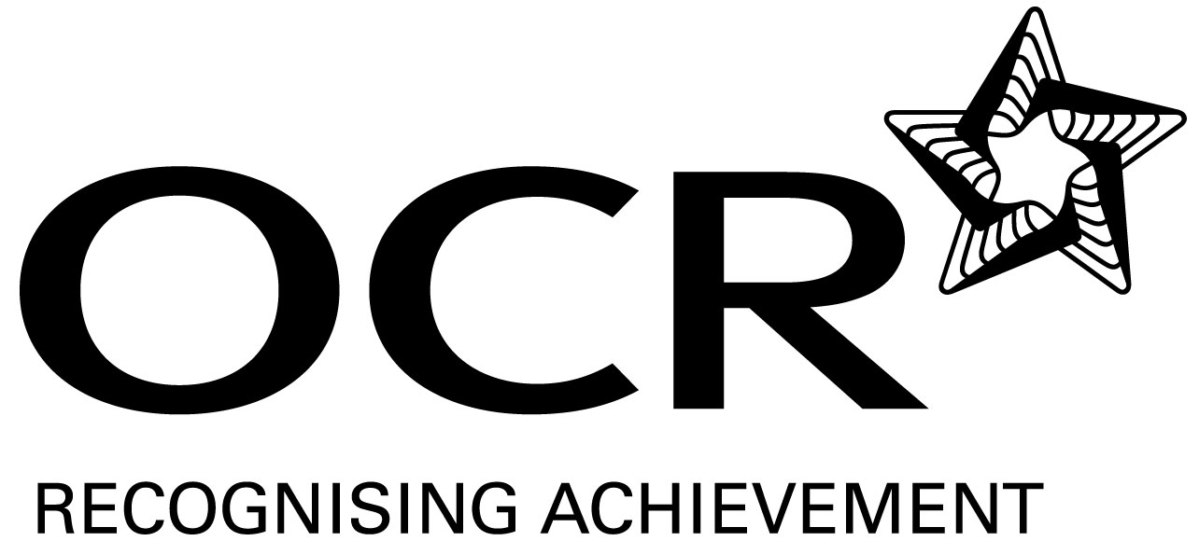
Support Material
GCE Modern Foreign Languages
OCR Advanced GCE in Turkish: H597
Unit: F890

This Support Material booklet is designed to accompany the OCR Advanced GCE specification in Turkish for teaching from September 2008.

Contents
Contents 2
Introduction 3
Turkish H597: Listening, Reading and Writing 2: F890 5
Sample Lesson Plan: Turkish H597 Listening, Reading and Writing 2: F890 7
Other forms of Support 9

Introduction

Background
A new structure of assessment for A Level has been introduced, for first teaching from September 2008. Some of the changes include:
- The introduction of stretch and challenge (including the new A* grade at A2) – to ensure that every young person has the opportunity to reach their full potential
- The reduction or removal of coursework components for many qualifications – to lessen the volume of marking for teachers
- A reduction in the number of units for many qualifications – to lessen the amount of assessment for learners
- Amendments to the content of specifications – to ensure that content is up-to-date and relevant.
OCR has produced an overview document, which summarises the changes to Turkish. This can be found at www.ocr.org.uk, along with the new specification.
In order to help you plan effectively for the implementation of the new specification we have produced this Scheme of Work and Sample Lesson Plans for Turkish. These Support Materials are designed for guidance only and play a secondary role to the Specification.

Our Ethos
All our Support Materials were produced ‘by teachers for teachers’ in order to capture real life current teaching practices and they are based around OCR’s revised specifications. The aim is for the support materials to inspire teachers and facilitate different ideas and teaching practices.

Each Scheme of Work and set of sample Lesson Plans is provided in:

- PDF format – for immediate use

- Word format – so that you can use it as a foundation to build upon and amend the content to suit your teaching style and students’ needs.

The Scheme of Work and sample Lesson plans provide examples of how to teach this unit and the teaching hours are suggestions only. Some or all of it may be applicable to your teaching.

The Specification is the document on which assessment is based and specifies what content and skills need to be covered in delivering the course. At all times, therefore, this Support Material booklet should be read in conjunction with the Specification. If clarification on a particular point is sought then that clarification should be found in the Specification itself.

A Guided Tour through the Scheme of Work

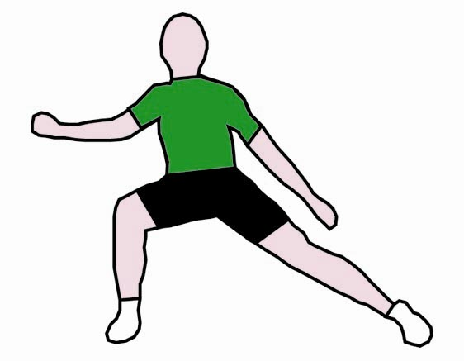
= Innovative Teaching Idea
All the teaching ideas contained in the SOW are innovative, but the icon is used to
Highlight exceptionally innovative ideas.

= Stretch & Challenge Activity
This icon is added at the end of text when there is an explicit opportunity to offer
Stretch and Challenge.

= ICT Opportunity
This icon is used to illustrate when an activity could be taught using ICT facilities.

Turkish H597: Listening, Reading and Writing 2: F890
Suggested teaching time | 8 hours | Topic | Heritage and history
Skills |  | Suggested teaching and homework activities | Suggested resources | Points to note
Listening |  | - Extract (1) on a piece of news about the maintenance and protection of heritage in Turkey – answers in English. | - Radio/TV items.  - Newspaper article to be recorded.
 |  | - Extract (2) on one of the most famous historical buildings in Turkey – gist and detailed comprehension with answers in Turkish. | - Radio /TV/internet items or newspaper articles to be adapted and recorded.
Speaking |  | - Role play – an interview between a TV presenter and the manager of a famous historical building in Turkey. | - Newspaper/magazine/internet items.  - Pre-prepared cards. | - TV presenter may use ICT to give information about the history of the building.
 |  | - Class discussion on how to improve the maintenance and conditions of heritage sites. | - Newspaper/magazine articles/pictures.
 |  | - Classroom quiz on vocabulary associated with heritage (Blockbuster style).
Reading |  | - Extract on the history of a town in Turkey and its heritage and the importance of heritage in tourism - gist and detailed comprehension with non verbal responses. | - Newspaper/magazine articles/internet items.
 |  | - Short section of extract for transfer of meaning task. | - Reading text.
 |  | - Independent research: opportunity to set as a library and/or internet session – gather items/articles on historical places in Turkey in preparation for Speaking and/or writing tasks. | - Books, Internet items, encyclopaedias.
Writing  = Innovative teaching idea  = Stretch and challenge opportunity idea  = ICT opportunity |  | - Write a letter to officials about the importance of historical places for future generations and/or tourism and what needs to be done to protect them. | - Newspaper, magazine articles, internet items, books.
 |  | - Write a short article about one of the famous historical sites in Turkey and give reasons for why it is important to visit it. | - Newspaper, magazine articles, internet items.
 |  | - Write an essay in Turkish in response to a given title, e.g. ‘Heritage gives us knowledge of history’. To what extent do you agree with this statement? | - All previously studied material.
Consolidation |  | - Encourage students to inquire and independently read around the subject. Create a corner in class to share the collected material brought by students. Identify possible texts for them.
 |  | - Students to produce a set of keywords for this topic in groups and share with the others. |  | - Students to expect to need to recall these words at any time. Useful starter activity.
 |  | - Explore previous exam questions on this topic. | - Past examination papers.
 |  | - Peer or self assessment of essays using mark schemes before handing in for formal teacher assessment.
= Innovative teaching idea
= Stretch and challenge opportunity idea
= ICT opportunity

Sample Lesson Plan: Turkish H597 Listening, Reading and Writing 2: F890

Heritage and History
OCR recognises that the teaching of this qualification will vary greatly from school to school and from teacher to teacher. With that in mind, this lesson plan is offered as a possible approach but will be subject to modifications by the individual teacher.

Lesson length is assumed to be one hour.

Learning objectives for the lesson
Objective 1 | Students to improve the key vocabulary and structure about the topic.
Objective 2 | Students to improve their listening skills – listening for gist.
Objective 3 | Students to improve their listening skills - listening for detailed information.

Recap of previous experience and prior knowledge
- Teacher to put up different types of posters, postcards, pictures of historical places, newspaper and magazine articles about history and heritage of Turkey.

Content
Time | Content
5 minutes | Warm-up activity to assess prior knowledge. Teacher to put jumbled pictures of historical towns and historical places belonging to these towns on desks. Students to identify the historical places and the buildings and match them.
10 minutes | - Teacher to write questions on the board for students to answer after listening to a text.  - Students to listen to the text and write down their answers and compare in groups.
5-10 minutes | - Teacher to test and teach the most important key words.  - Teacher to hand out the text with gaps to be filled by students and play the tape again.  - Students to listen and fill in the gaps. The texts are compared and the meaning of the words discussed.  - Teacher to hand out the definitions to be matched with the words.  - Students to listen to tape and check answers and correct mistakes.
15 minutes | - Teacher to highlight new structures and forms and ask concept questions.  - Students to use the new structures related to the topic.  - Students to produce questions about the text in groups.  - Students to ask prepared questions to other groups.

Time | Content
15 minutes | - Teacher hands out comprehension questions to be answered in Turkish.  - The answers are assessed in pairs and they are read out loud. (Peer assessment.)  - Students to prepare a dialogue between a TV presenter and a government official using the new information and knowledge of vocabulary and structure.

Consolidation
Time | Content
5 minutes | Teacher to make statements about the text and students to decide if it is true or not. Untrue statements are corrected by students.
 | Teacher to set homework. Students to write a short article about a place of interest using new information, target language and new vocabulary.

Other forms of Support
In order to help you implement these new specification effectively, OCR offers a comprehensive package of support. This includes:

OCR Training

Get Ready…introducing the new specifications
A series of FREE half-day training events are being run during Autumn 2007, to give you an overview of the new specifications.

Get Started…towards successful delivery of the new specifications
These full-day events will run from Spring 2008 and will look at the new specifications in more depth, with emphasis on first delivery.
Visit www.ocr.org.uk for more details.
For more information, please contact the Networks and Regional Coordinator on 024 7649 6396.

Mill Wharf Training
Additional events are also available through our partner, Mill Wharf Training. It offers a range of courses on innovative teaching practice and whole-school issues - www.mill-wharf-training.co.uk.

e-Communities
Over 70 e-Communities offer you a fast, dynamic communication channel to make contact with other subject specialists. Our online mailing list covers a wide range of subjects and enables you to share knowledge and views via email.
Visit https://community.ocr.org.uk, choose your community and join the discussion!

Interchange
OCR Interchange has been developed to help you to carry out day to day administration functions online, quickly and easily. The site allows you to register and enter candidates online. In addition, you can gain immediate a free access to candidate information at you convenience. Sign up at https://interchange.ocr.org.uk

Published Resources
Published Resources
OCR offers centres a wealth of quality published support with a fantastic choice of ‘Official Publisher Partner’ and ‘Approved Publication’ resources, all endorsed by OCR for use with OCR specifications.

Publisher partners
OCR works in close collaboration with three Publisher Partners; Hodder, Heinemann and Oxford University Press (OUP) to ensure centres have access to:

- Better published support, available when you need it, tailored to OCR specifications
- Quality resources produced in consultation with OCR subject teams, which are linked to OCR’s teacher support materials
- More resources for specifications with lower candidate entries
- Materials that are subject to a thorough quality assurance process to achieve endorsement

Oxford University Press (OUP) is the publisher partner for OCR GCE Modern Foreign Languages

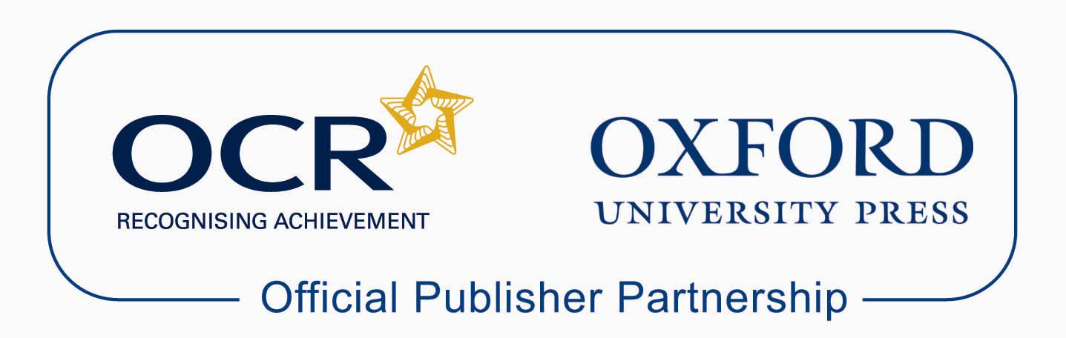

Approved publications
OCR still endorses other publisher materials, which undergo a thorough quality assurance process to achieve endorsement. By offering a choice of endorsed materials, centres can be assured of quality support for all OCR qualifications.

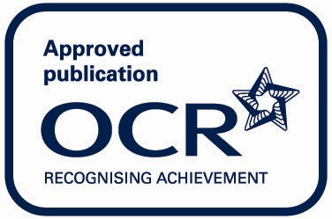

Endorsement
OCR endorses a range of publisher materials to provide quality support for centres delivering its qualifications. You can be confident that materials branded with OCR’s “Official Publishing Partner” or “Approved publication” logos have undergone a thorough quality assurance process to achieve endorsement. All responsibility for the content of the publisher’s materials rests with the publisher.

These endorsements do not mean that the materials are the only suitable resources available or necessary to achieve an OCR qualification. Any resource lists which are produced by OCR shall include a range of appropriate texts.

