
Support Material
GCE Religious Studies
OCR Advanced GCE in Religious Studies: H572
Unit: G583

This Support Material booklet is designed to accompany the OCR Advanced GCE specification in Religious Studies for teaching from September 2008.

Contents
Contents 2
Introduction 3
Religious Studies H572: Jewish Scriptures G583 5
Sample Lesson Plan: Religious Studies H572 Jewish Scriptures G583 12
Other forms of Support 13

Introduction

Background
A new structure of assessment for A Level has been introduced, for first teaching from September 2008. Some of the changes include:
- The introduction of stretch and challenge (including the new A* grade at A2) – to ensure that every young person has the opportunity to reach their full potential
- The reduction or removal of coursework components for many qualifications – to lessen the volume of marking for teachers
- A reduction in the number of units for many qualifications – to lessen the amount of assessment for learners
- Amendments to the content of specifications – to ensure that content is up-to-date and relevant.
OCR has produced an overview document, which summarises the changes to Religious Studies. This can be found at www.ocr.org.uk, along with the new specification.
In order to help you plan effectively for the implementation of the new specification we have produced this Scheme of Work and Sample Lesson Plans for Religious Studies. These Support Materials are designed for guidance only and play a secondary role to the Specification.

Our Ethos
All our Support Materials were produced ‘by teachers for teachers’ in order to capture real life current teaching practices and they are based around OCR’s revised specifications. The aim is for the support materials to inspire teachers and facilitate different ideas and teaching practices.

Each Scheme of Work and set of sample Lesson Plans is provided in:

- PDF format – for immediate use

- Word format – so that you can use it as a foundation to build upon and amend the content to suit your teaching style and students’ needs.

The Scheme of Work and sample Lesson plans provide examples of how to teach this unit and the teaching hours are suggestions only. Some or all of it may be applicable to your teaching.

The Specification is the document on which assessment is based and specifies what content and skills need to be covered in delivering the course. At all times, therefore, this Support Material booklet should be read in conjunction with the Specification. If clarification on a particular point is sought then that clarification should be found in the Specification itself.

A Guided Tour through the Scheme of Work

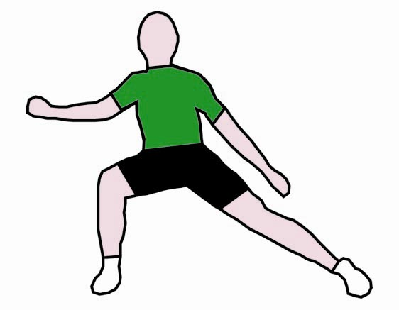
= Innovative Teaching Idea
All the teaching ideas contained in the SOW are innovative, but the icon is used to
Highlight exceptionally innovative ideas.

= Stretch & Challenge Activity
This icon is added at the end of text when there is an explicit opportunity to offer
Stretch and Challenge.

= ICT Opportunity
This icon is used to illustrate when an activity could be taught using ICT facilities.

Religious Studies H572: Jewish Scriptures G583
Suggested teaching time | 14 hours | Topic | Themes in Jewish scriptures: reward and punishment
Topic outline |  | Suggested teaching and homework activities | Suggested resources | Points to note
Reward and punishment:
Isaiah 53; Jeremiah 7; Ezekiel 18; Daniel 12; Psalm 1; 2 Maccabees 7.
The concept of reward and punishment as understood by the writers of the set texts;  an overview of the concepts of reward and punishment with an indication of their development. |  | - In this section students need to develop an overview of the concepts of reward and punishment.  - They need to consider whether there is a development in these ideas through the specified texts.  - After a general introduction students need to produce a specialised timeline showing the probable dates of the set texts (by whichever system is chosen) in order to be able to determine any development which may be present.
Isaiah 53 |  | - Students need to consider the idea of the servant in this passage but should be clear that, if they are approaching the text from a Christian perspective, the Jewish interpretation is very different | - Art Scroll Tenakh: Isaiah 53  - Standard commentaries | - Each of the following texts needs to be contextualized.
Jeremiah 7  = Innovative teaching idea  = Stretch and challenge opportunity idea  = ICT opportunity |  | - In relation to this passage students need to gain an understanding of the punishment in this passage and the reasons for it. | - Art Scroll Tenakh: Jeremiah 7  - Standard commentaries
Ezekiel 18 |  | - Consideration of the introduction of the concept of individual responsibility in the text. Comparison with Exodus 20:5. | - Art Scroll Tenakh: Ezekiel 18  - Standard commentaries
Daniel 12 |  | - This text would be well-suited to Reciprocal Reading so that students have the opportunity to analyze its contents closely. It is also important that the broader context of Daniel is studied in order to place it in context. | - Art Scroll Tenakh: Daniel 12  - Standard commentaries
Psalm 1 |  | - Set students to write their own commentary on this Psalm, explaining the concepts and placing it in the broader context of this section of the specification. | - Art Scroll Tenakh: Psalm 1  - Standard commentaries
2 Maccabees 7 |  | - This text needs special consideration as standing outside of the Tenakh and only existing in the Apocrypha of the Christian Bible.  - The story needs to be considered and placed the context of the general study. | - NRSV: 2 Maccabees 7  - Standard commentaries | - Although this text is outside of the Tenakh it is studied here to provide a consideration of later developments of the concept.
 |  | - Final homework: To what extent is there a development of the ideas of reward and punishment in the texts you have studied?
= Innovative teaching idea
= Stretch and challenge opportunity idea
= ICT opportunity

Religious Studies H572: Jewish Scriptures G583
Suggested teaching time | 14 hours | Topic | Themes in Jewish scriptures: Amos and Hosea
Topic outline |  | Suggested teaching and homework activities | Suggested resources | Points to note
Amos and a comparison with Hosea 1-3, 14. |  | - Students need a consideration of the historical and literary background of these two books.  - They should be able to consider their dates on the place them on their timeline showing the political events which surrounded them.
The book of Amos, with particular reference to social concerns |  | - Students need to begin with a read through and discussion of the whole of the book of Amos.  - Then they need to break the text down and consider exactly what were Amos’ concerns in the text. They need to consider all aspects of the text as well as looking particularly at his reference to social concerns. | - Art Scroll Tenakh: Amos  - Standard commentaries
Hosea 1-3, 14. |  | - Students need to begin with a read through and discussion of the whole of the book of Hosea.  - There needs to be explanation of the symbolism and symbolic language used in the text and students need to be familiar with the whole story.  - Students need to make their own detailed analysis of chapters 1-3.  - There then needs to be a separate consideration of chapter 14 with a discussion as to the teachings and ideas it contains and whether or not it is actually part of the original text or a sort of palliative added at a later date. | - Art Scroll Tenakh: Hosea  - Standard commentaries
Conclusion |  | - Students should then conduct their own comparison of the messages and teachings found in these two books.
= Innovative teaching idea
= Stretch and challenge opportunity idea
= ICT opportunity

Religious Studies H572: Jewish Scriptures G583
Suggested teaching time | 14 hours | Topic | Themes in Jewish scriptures: messianic hope
Topic outline |  | Suggested teaching and homework activities | Suggested resources | Points to note
Messianic hope and the ethical kingdom, with particular reference to Isaiah 40 – 43; Micah.
Isaiah 40 – 43  The concept of Messianic hope. |  | - Students need detailed knowledge of the set texts from Isaiah but should also be able to place these in their broader context.  - They should have good understanding of the concept of Messianic hope.  - Discussion: What sort of Messiah is expected according to the teachings of Isaiah 40-43? | - Art Scroll Tenakh: Isaiah 40-43  - Standard commentaries  - J. Mayled, Judaism, in S.Tyler and G. Reid, AS/A2 Religious Studies, 2007, Pearson
Micah  The concept of Messianic hope and the ethical kingdom. |  | - Students need detailed knowledge of the set text of Micah but should also be able to place this text in its broader context.  - They should have good understanding of the concept of Messianic hope.  - Discussion: What sort of Messiah is expected according to the teachings of Micah?  - Homework: Explain in detail what is meant in the book of Micah by the idea of an ethical kingdom? | - Art Scroll Tenakh: Micah  - Standard commentaries  - J. Mayled, Judaism, in S. Tyler and G. Reid, AS/A2 Religious Studies, 2007, Pearson
= Innovative teaching idea
= Stretch and challenge opportunity idea
= ICT opportunity

Religious Studies H572: Jewish Scriptures G583
Suggested teaching time | 14 hours | Topic | Themes in Jewish scriptures: Ruth
Topic outline |  | Suggested teaching and homework activities | Suggested resources | Points to note
Ruth as a part of the Ketuvim (Writings) in the Jewish Scriptures |  | - Students need to be able to place the Book of Ruth historically and show its position on their timeline.  - They should have an understanding of its place as part of the Ketuvim.  - They need to have a detailed knowledge of the entire text and not just the story which it contains.
The devotion of Ruth to Naomi (possibly written to correct the particularism of Judaism after the Exile and the rebuilding of the Temple); the importance of Ruth being shown as the great-grandmother of David. |  | - In studying this text students need to consider the ideas listed.  - They should perform a structured analysis of the text showing what is in each part of the book then they can demonstrate how the ideas of the text develop.  - The possibility that Ruth was written to counteract particularism should also be considered and students should do this with a consideration of its historical position.  - Finally, students need to consider for homework the issue of the importance of Ruth being shown as the great-grandmother of David – why was this done and what might have been being sought from it? | - Art Scroll Tenakh: Ruth  - Standard commentaries  - Film: Testament - Ruth | - Students need an understanding of Ruth 3:4 et seq. rather than a literal reading of the text..
= Innovative teaching idea
= Stretch and challenge opportunity idea
= ICT opportunity

Religious Studies H572: Jewish Scriptures G583
Suggested teaching time | 14 hours | Topic | Themes in Jewish scriptures: wisdom literature and religious experience
Topic outline |  | Suggested teaching and homework activities | Suggested resources | Points to note
Wisdom Literature and Religious Experience  I Kings 5:9-14 (4:29-34); Proverbs 1-3, 8 & 9, Song of Songs 1-3, Ecclesiastes 1-3 Ezekiel 1:1-28a. |  | - All these texts need placing on a timeline of probable dates so that students can trace their development. |  | - In studying this section of the text students need to develop an awareness and understanding of the particular nature of Wisdom Literature building on what they learnt at AS
Solomon’s wisdom as demonstrated in I Kings 5:9-14 (4:29-34) |  | - Students need a detailed knowledge of 1 Kings 5 (4) as well as being able to place it within its broader context. | - Art Scroll Tenakh: I Kings 5:9-14 (4:29-34)  - Standard commentaries | - Note: the Jewish Scriptures designate this passage as I Kings 5:9-14, the Christian Bible as 1 Kings (4:29-34)
Proverbs 1-3, 8 & 9  The concept of Wisdom in Proverbs including the presentation of Wisdom as a woman, the idea that the beginning of wisdom is fear of Hashem and the beginning of understanding is knowledge of the sacred; Wisdom as related not only to mystical aspects of religion but also social ethics;  = Innovative teaching idea  = Stretch and challenge opportunity idea  = ICT opportunity |  | - Students need a detailed knowledge of Proverbs 1-3, 8 & 9 as well as being able to place these passages within their broader context.  - Students need to consider the idea of Wisdom in these passages, shown as a woman.  - After a detailed study of the texts they need to consider the beginning of Wisdom as fear of G-d and the way in which it develops.  - Homework: What do the set passages from Proverbs teach about wisdom in relation to social ethics? | - Art Scroll Tenakh: Proverbs 1-3, 8 & 9  - Standard commentaries
Song of Songs 1-3  the imagery of the Song of Songs |  | - Students need a detailed knowledge of Song of Songs 1-3 as well as being able to place these passages within their broader context.  - Discussion: what is the nature of the Song of Sons? Is it erotic poetry or an allegory for Wisdom? | - Art Scroll Tenakh: Song of Songs 1-3  - Standard commentaries
Ecclesiastes 1-3  the wonders and laws of the natural world, and belief in the creator G-d in Ecclesiastes; |  | - Students need a detailed knowledge of Ecclesiastes 1-3 as well as being able to place these passages within their broader context.  - Students are unlikely to be familiar with Ecclesiastes and will need work to place it in context. | - Art Scroll Tenakh: Ecclesiastes 1-3  - Standard commentaries
Religious Experience:  Ezekiel 1:1-28a.the vision of Ezekiel and the omnipresence of G-d. |  | - Students need a detailed knowledge of Ezekiel 1:1-28a as well as being able to place this passage within its broader context.  - Students should conduct general research on the internet in relation to Ezekiel and the proscription on study of this passage.  - They could usefully undertake some broader reading on the concept of religious language.  - Homework: An analysis and interpretation of Ezekiel 1:1-28a. | - Art Scroll Tenakh: Ezekiel 1:1-28a  - Standard commentaries  - M. Taylor, Philosophy of Religion, Routledge
= Innovative teaching idea
= Stretch and challenge opportunity idea
= ICT opportunity
= Innovative teaching idea
= Stretch and challenge opportunity idea
= ICT opportunity

Sample Lesson Plan: Religious Studies H572 Jewish Scriptures G583

Hosea 14
OCR recognises that the teaching of this qualification will vary greatly from school to school and from teacher to teacher. With that in mind, this lesson plan is offered as a possible approach but will be subject to modifications by the individual teacher.
Lesson length is assumed to be one hour.

Learning objectives for the lesson
Objective 1 | Students to understand the text of Hosea 14.
Objective 2 | Students to be able to begin to explain the text in their own commentary.
Objective 3 | Students to consider the strengths and weaknesses of the argument that Hosea 14 is an addition to the text.

Recap of previous experience and prior knowledge
- Set a quick test. Students to provide answers to the following question: What are the key teachings of the book of Hosea?

Content
Time | Content
5 minutes | Warm up activity: quickly define the key teachings and arguments of the book of Hosea 1-13.
15 minutes | Read the text of Hosea 14.  Using reciprocal reading:  - What is the structure of the chapter?  - What are the key teachings of the chapter?
5 minutes | How is this chapter different from the previous chapters?
5 minutes | Ask students to list all the differences between the teachings of chapter 14 and those of chapters 1-13.
15 minutes | In groups students consider the idea of whether chapter 14 is a development of the text of chapters 1-13 or if it is more likely to be a later addition?

Consolidation
Time | Content
5 minutes | Is Hosea one continuous text?

Other forms of Support
In order to help you implement these new specification effectively, OCR offers a comprehensive package of support. This includes:

OCR Training

Get Ready…introducing the new specifications
A series of FREE half-day training events are being run during Autumn 2007, to give you an overview of the new specifications.

Get Started…towards successful delivery of the new specifications
These full-day events will run from Spring 2008 and will look at the new specifications in more depth, with emphasis on first delivery.
Visit www.ocr.org.uk for more details.

Mill Wharf Training
Additional events are also available through our partner, Mill Wharf Training. It offers a range of courses on innovative teaching practice and whole-school issues - www.mill-wharf-training.co.uk.

e-Communities
Over 70 e-Communities offer you a fast, dynamic communication channel to make contact with other subject specialists. Our online mailing list covers a wide range of subjects and enables you to share knowledge and views via email.
Visit https://community.ocr.org.uk, choose your community and join the discussion!

Interchange
OCR Interchange has been developed to help you to carry out day to day administration functions online, quickly and easily. The site allows you to register and enter candidates online. In addition, you can gain immediate a free access to candidate information at you convenience. Sign up at https://interchange.ocr.org.uk

Published Resources
Published Resources
OCR offers centres a wealth of quality published support with a fantastic choice of ‘Official Publisher Partner’ and ‘Approved Publication’ resources, all endorsed by OCR for use with OCR specifications.

Publisher partners
OCR works in close collaboration with three Publisher Partners; Hodder, Heinemann and Oxford University Press (OUP) to ensure centres have access to:

- Better published support, available when you need it, tailored to OCR specifications
- Quality resources produced in consultation with OCR subject teams, which are linked to OCR’s teacher support materials
- More resources for specifications with lower candidate entries
- Materials that are subject to a thorough quality assurance process to achieve endorsement

Heinemann is the publisher partner for OCR GCE Religious Studies

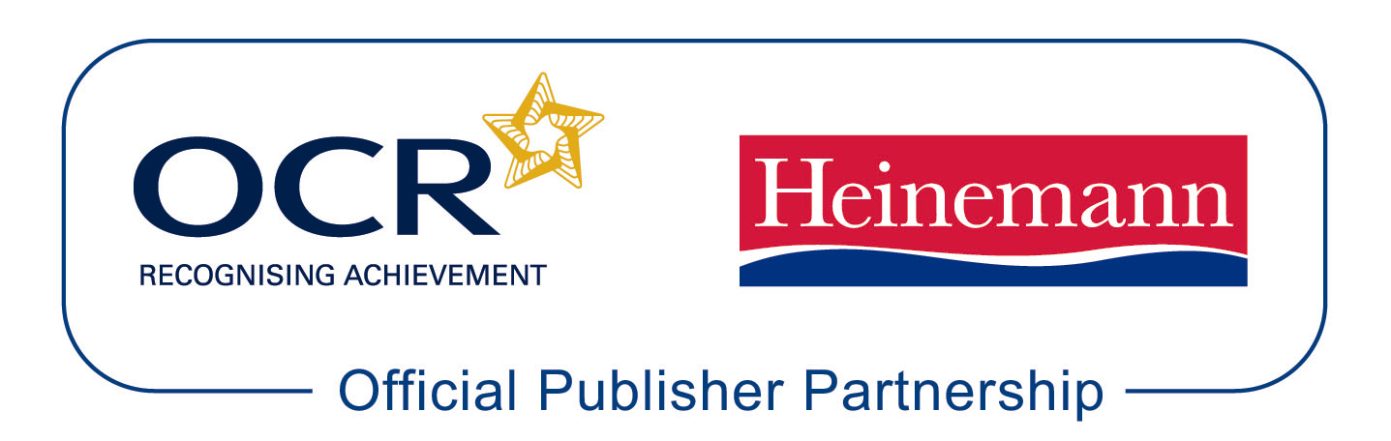

Heinemann is producing the following resources for OCR GCE Religious Studies for first teaching in September 2008.

Taylor, I, Eyre, C and Knight, R. AS Philosophy and Ethics Student Book.
ISBN: 978-0-435-30362-4

Eyre, C and Knight, R. AS Philosophy and Ethics Teacher Planning and Delivery Pack.
ISBN: 978-0-435-30363-1

Eyre, C and Knight, R. A2 Philosophy and Ethics Student Book. ISBN: 978-0-435-30358-7

Eyre, C and Knight, R. A2 Philosophy and Ethics Teacher Planning and Delivery Pack.
ISBN: 978-0-435-30358-7

Approved publications
OCR still endorses other publisher materials, which undergo a thorough quality assurance process to achieve endorsement. By offering a choice of endorsed materials, centres can be assured of quality support for all OCR qualifications.

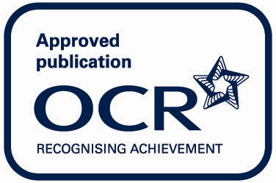

Endorsement
OCR endorses a range of publisher materials to provide quality support for centres delivering its qualifications. You can be confident that materials branded with OCR’s “Official Publishing Partner” or “Approved publication” logos have undergone a thorough quality assurance process to achieve endorsement. All responsibility for the content of the publisher’s materials rests with the publisher.

These endorsements do not mean that the materials are the only suitable resources available or necessary to achieve an OCR qualification. Any resource lists which are produced by OCR shall include a range of appropriate texts.

