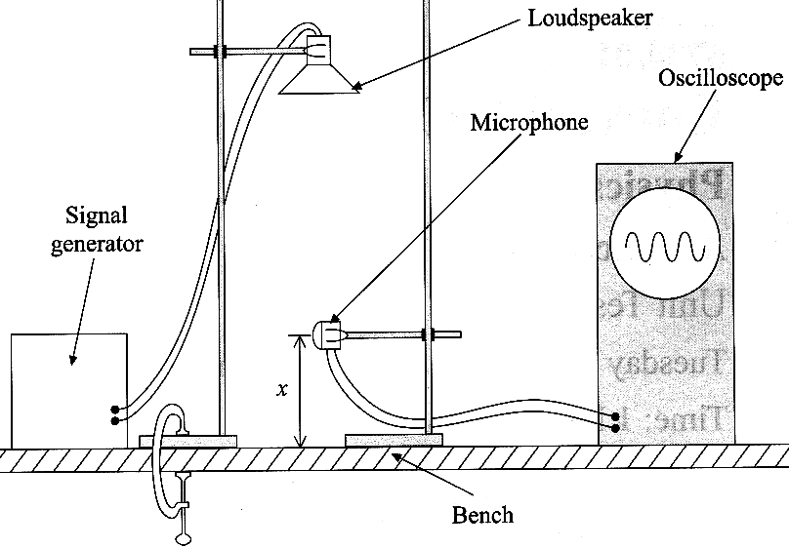
1. The diagram shows an experiment with sound waves.
A loudspeaker connected to a signal generator is mounted, pointing
downwards, above a horizontal bench. The sound is detected by
a microphone connected to an oscilloscope. The height of the
trace on the oscilloscope is proportional to the amplitude
of the sound waves at the microphone.
When the vertical distance x between the microphone and the
bench is varied, the amplitude of the sound waves is found to vary
as shown on the graph below.
Explain why the amplitude of the sound has a number of
maxima and minima.
You may be awarded a mark for the clarity
of your answer. [5]

The frequency of the sound waves is 3.20kHz.
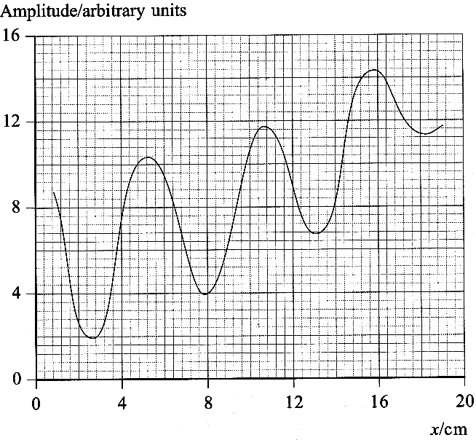
Use this, together with information from the graph, to
determine a value for the speed of sound in air. [4]
The contrast between the maxima and minima becomes less
pronounced as the microphone is raised further from the
surface of the bench. Suggest an explanation for this. [2]

2. A body of mass m travelling at constant speed v around a
circular path of radius r must have a resultant force F acting
upon it. Write down a formula for the magnitude of F
and state the direction in which it acts. [2]

The diagram below shows a car at the highest point A of a
hump-backed bridge. When the car is driven over the bridge it
follows part of a vertical circle of radius 25.0 m centred at the
point O below the bridge.
Next to the first diagram is a free-body force diagram for the
car at point A.
The mass of the car is 925kg.
Calculate the normal reaction force R
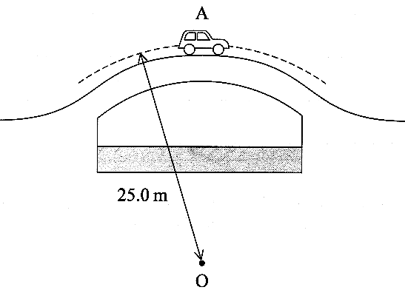
(i) when the car is parked at rest at A,
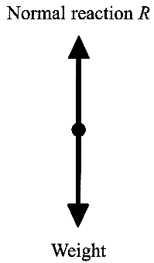
(ii) when the car is passing point A at a
speed of 10.0 m s ⁻¹. [4]

If the car is driven across the bridge repeatedly,
at gradually increasing speeds, it is found that,
above a certain critical speed, the car loses contact
with the road at A, and "takes off".
Explain why this happens. [1]
Calculate the critical speed for this particular bridge. [2]

An object which is in free fall is said to be "apparently weightless".
Explain what this means, illustrating your answer with reference to the
situation described in this question. [2]

3. Define simple harmonic motion (s.h.m.). [2]
A mass on a spring is displaced 0.036 m vertically downwards from its equilibrium position. It is then released. As it passes upwards through its equilibrium position a clock is started. The mass takes 7.60 s to perform 20 cycles of its oscillation.
Assuming that the motion is s.h.m., it can be described by the equation: x = x₀ sin 2π f t
where x is the displacement in the upward direction and t the time since the clock was started.
What are the values of x₀ and f in this case? [3]

Use the equation to calculate the displacement when t = 1.00 s. [1]
In practice, simple harmonic motion is not a perfect model of the motion of the mass, and so the equation above does not predict the displacement correctly. Explain how and why the motion differs from that predicted by the equation. [2]

4. If an oscillating system is made to perform forced oscillations at a frequency close to its natural frequency, then resonance occurs. Describe how you could demonstrate qualitatively the meanings of the terms in italics.
Include a diagram of the apparatus you would use. [7]

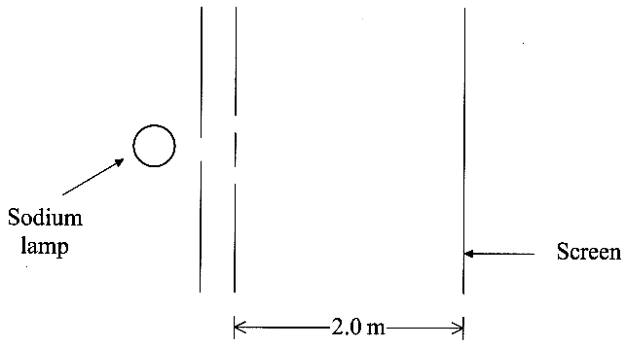
5. The diagram shows, in principle, an experiment which can be used to
demonstrate two-slit interference patterns with light.
The sodium lamp emits yellow light of wavelength 589.0 nm.
The fringe spacing for this wavelength is 3.9 mm.
Calculate the separation between the centres of the slits. [2]

The diagram below shows how the intensity varies with
distance across the screen for the central part of the
interference pattern produced by light of a single wavelength.
Add a second line to a copy of the diagram to show the intensity
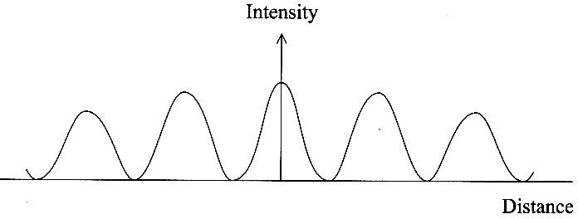
variation you would expect if the wavelength were increased. [1]

In addition to the wavelength of 589.0nm, the
sodium lamp also produces light of wavelength
589.6nm. The two emissions have similar
intensities. Explain whether you would expect
the presence of these two wavelengths to be
a problem in observing a clear interference pattern. [2]

6. The diagram opposite shows some of the energy levels of a mercury atom.
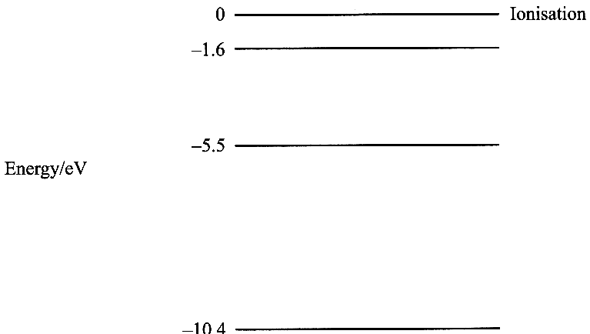
Calculate the ionisation energy in joules for an electron in the -10.4 eV level. [2]
- 10.4
A proton of kinetic energy 9.2 eV collides with a mercury atom.
As a result, an electron in the atom moves from the -10.4 eV level to
the -1.6 eV level.
What is the kinetic energy in eV of the proton after the collision? [1]
A transition between which two energy levels in the mercury atom
will give rise to an emission line of wavelength 320 nm? [3]

7. The diagram below shows apparatus for an experiment on the photoelectric effect.
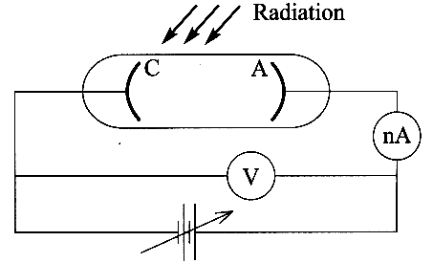

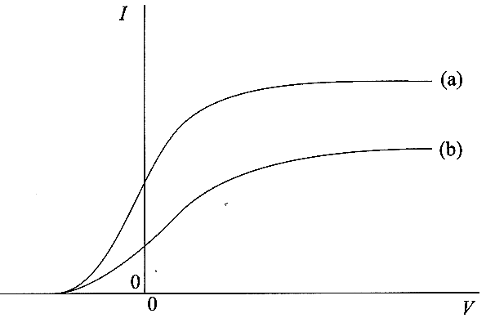

Monochromatic radiation strikes the cathode C and photoelectrons are
emitted towards the anode A. When a potential difference V is applied,
a current I is measured on the very sensitive ammeter. Data can also
be obtained with the polarity of the supply reversed. Using this
apparatus, graph (a) below was obtained. After making a change to
the incident radiation, graph (b) was obtained.
What can be deduced about the incident radiations from
(i) the fact that both curves start from the same point on the negative V axis,
(ii) the higher final value of the current I in (a) compared to (b)? [2]
The cathode is now replaced by one made from a metal with a higher work function.
On a copy of the same axes, sketch a graph labelled (c) showing what would be observed if the original radiation were used. [1]
The work function of the metal of the cathode is 7.2 x 10 ⁻¹⁹ J.
Calculate the maximum speed of the photoelectrons emitted when the incident radiation has a frequency of 7.9 x 10 ¹⁵ Hz. [4]

8. The hydrogen lines in the spectra of almost all galaxies show a red shift. Explain the meaning of a red shift. [2]
Explain how this red shift is thought to occur, and what the measurements of galactic red shifts suggest about the Universe. [3]

TOTAL FOR PAPER: 60 MARKS

