Topic B - Solid Materials

2. (a) Energy density is the energy stored per unit volume. Show that the expression
Energy density = ¹/₂ stress x strain is homogeneous with respect to units. (4)

(b) State Hooke's law. (2)
A brass wire of length 2.8 m and cross-sectional area 1.5 x 10 ⁻⁷ m² is stretched by a force of 34 N. The wire extends by 5.3 mm. Calculate the Young modulus of brass. Assume the stretched wire is still within the Hooke's law region. (4)

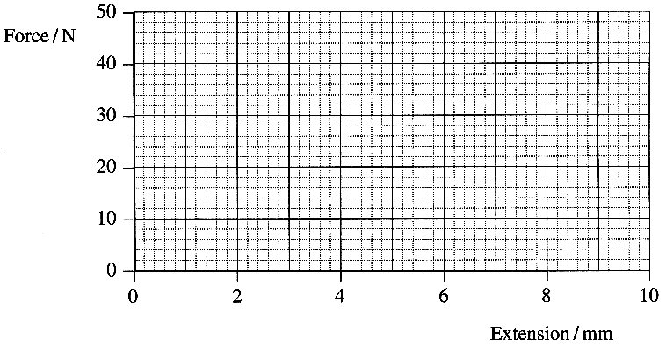
The wire obeys Hooke's law for forces up to 46 N. On a copy of the axes below draw a force-extension graph for this brass wire in the Hooke's law region. (2)
How could the graph be used to find the
energy stored in the wire when it is
stretched by a force of 24 N? (1)

A second wire is made from the same brass and
has the same length but a greater cross-sectional
area. This wire is also stretched by a force
of 24 N. Does the second wire store more energy,
the same energy or less energy
than the original wire? Justify your answer. (3)

(c) The stress-strain curves for Perspex and polythene
up to their breaking points are drawn below.
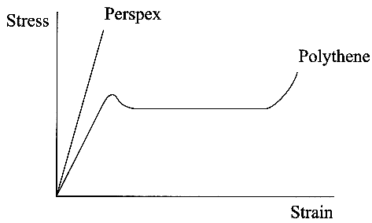
Describe the differences in behaviour of Perspex and polythene when they are stretched until they break. You may be awarded a mark for the clarity of your answer. (5)

(d) Draw a labelled diagram showing the molecular structure of an amorphous thermoplastic polymer such as Perspex. (2)
How does the molecular structure of a thermoset such as Melamine differ from that of Perspex? (1)

(e) A rod of quench hardened carbon steel can have its surface properties changed by tempering. What must be done to the rod to temper it? (1)
In what way do the properties of the surface of the rod change during this process? (1)

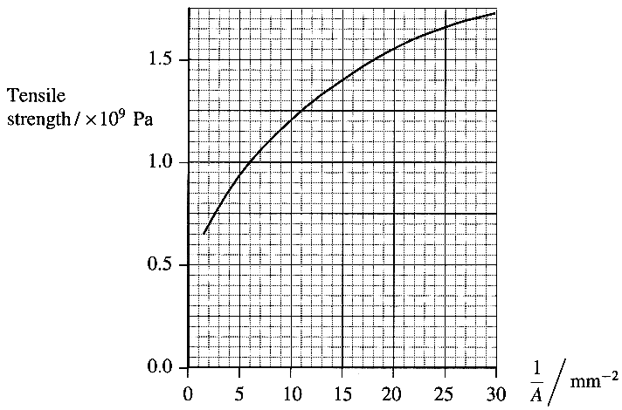
The graph opposite shows how the tensile strength of glass in the
form of fibres depends upon the cross-sectional area A of the fibres.

Complete a copy of the sentence below by sellecting
the correct term within the brackets.
Thin glass fibres are
( the same strength as, stronger than, weaker than)
thick glass fibres. (1)

Use the graph to determine the tensile strength of a glass
fibre of cross-sectional area 0.125mm².(2)

Could a glass fibre of cross-section 0.125 mm²
(0.125 x 10⁻⁶ m²) safely support a mass of 20 kg?
Justify your answer. (3)

(Total 32 marks)

