Modelling
In mechanics, it is necessary to take a real life problem and put it in mathematical language. This process is known as modelling.

Terminology
When modelling, we often make assumptions to make the mathematics simpler.
A particle is a body whose entire weight acts through a single point. A particle doesn’t suffer from air resistance.
A lamina is a two dimensional body, it is the 2-dimensional equivalent of a particle. All of the weight acts through one plane.
A body is said to be uniform if it has constant density. A body is non-uniform if the density varies throughout.
A smooth surface is one which has no friction.
A rough surface is one upon which friction acts.
We say an object is light if it has no mass. So no weight acts on a light body.
An inextensible string is a string which has a fixed length- it is impossible to stretch.
A rigid body is a body which is not a point and whose shape is fixed.

Acceleration

The “suvat” Equations
Acceleration is the rate of change of velocity of an object.
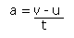
where a is acceleration, v is the final velocity of the object, u is the initial velocity of the object and t is the time that has elapsed.
This equation can be rearranged to give:
- v = u + at
If s represents the displacement of the object, then:
- s = ½ (u + v)t
- s = ut + ½ at²
- v² = u² + 2as
These equations are true if the acceleration of the body in question is constant (i.e. it doesn’t change over the time period). The units used must be consistent, and the standard units are:
Acceleration: ms⁻²(or m/s²)
Velocity: ms⁻¹ (or m/s)
Displacement: m
Time: s
The equation which you will need to use depends upon the question.

The Acceleration due to Gravity
If a body is dropped from a height, it will accelerate because of gravity. The acceleration caused by gravity is written as “g”, and is usually taken to be 9.8 ms⁻².

Example
A ball is dropped from the leaning tower of Pisa, at a height of 50m from the ground. The ball is dropped from rest and falls freely under gravity. How long will it be before the ball hits the ground?
We know: s = 50, a = 9.8, u = 0 and we want to find t.
The equation connecting these four is s = ut + ½ at²
So 50 = 0 + ½ × 9.8 × t²
Rearranging: t² = 10.20408
t = 3.19…
the time taken is 3.19s (3sf)

Newton's Laws of Motion

Forces
A force is "an influence tending to cause the motion of a body" (OED).
Forces are usually represented diagrammatically as an arrow, pointing in the direction the force. For example:
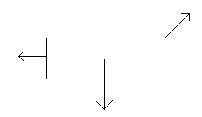
Force is measured in newtons (symbol N).

Newton's First Law
- Newton's First Law of Motion states that a body will remain at rest or will continue to move at a constant velocity, unless an external force is applied.
This means that in order for the acceleration of a body to change, there must be a net force applied to the body. Put another way, if the forces on an object balance, there will be no acceleration (the object will continue at the same speed).
So, if we are told that a body is not accelerating (i.e. if it is moving at a constant velocity), we know that the resultant (overall) force in any one direction will be zero.

Example
The following forces are acting on a body. The body moves at a constant speed of 5m/s. Find force X.
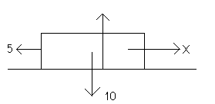
It should be clear that X = 5. The force is therefore 5N.

Newton's Second Law
- Newton's Second Law of Motion states that the rate of change in momentum of the body is directly proportional to the net force applied.
In other words, when an overall force is applied to an object, the acceleration will change. By how much the acceleration changes depends upon the magnitude of the force applied.
In fact, from Newton's Second Law we can derive the following equation:
- Resultant Force on Body = Mass of Body × Acceleration of Body
This is sometimes written as F = ma, though you should make sure you understand what this means (in particular, note that F is resultant force).

Weight and Mass
Students are often confused about the difference between weight and mass. Weight is the force due to gravity and is measured in newtons. Mass is the amount of matter that a body contains and is measured in kilograms (kg). Weight and mass are related by the equation:
- W = mg
This is a consequence of Newton's Second Law.

Newton's Third Law
- This law states that every action has an equal and opposite reaction.
For example, if a ball is placed on the table, the ball will exert a force on the table. At the same time, however, the table exerts a force on the ball (it is this force that prevents the ball from being sucked into the table!).
This "equal and opposite reaction force" is known as the normal reaction force, and the letter N or R is commonly used to represent it.

Vectors
See also: Vectors (pure section)
A vector quantity has both magnitude and direction. Acceleration, velocity, force and displacement are all examples of vector quantities. A scalar quantity is has only magnitude (so the direction is not important). Examples include speed, time and distance.
Vectors are usually represented as follows:
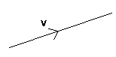
The arrow shows the direction and the number (v in this case) represents the magnitude.
Letters used to represent vectors should always be underlined or in bold type. For example, the velocity of an object may be represented by v. Since this is a vector quantity, it is in bold type. Small case letters are usually used to represent vectors.

Unit Vectors
A unit vector is a vector which has a magnitude of 1. There are three important unit vectors which are commonly used and these are the vectors in the direction of the x, y and z-axes. The unit vector in the direction of the x-axis is i, the unit vector in the direction of the y-axis is j and the unit vector in the direction of the z-axis is k.
Writing vectors in this form can make working with vectors easier.
For example, the vector 5i - 3j would look something like this on a diagram:
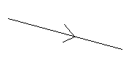

Adding Vectors
If two vectors are added together, the resultant is found by placing the vectors to be added end to end. If the vectors are given in unit vector form, you simply add together the i, j and k values.

Example
p = 3i + j, q = -5i + j. Find p + q.
Since the vectors are given in i, j form, we can easily calculate the resultant. 3i + j - 5i + j = -2i + 2j
This could also have been worked out from a diagram:
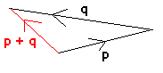

The Magnitude of a Vector
The magnitude of a vector can be found using Pythagoras's theorem.
- The magnitude of ai + bj = √(a² + b²)

Resolving a Vector
Resolving a vector means finding its magnitude in a particular direction.
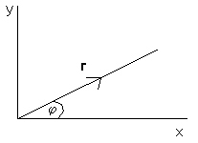
In the diagram above, the vector r has magnitude r and direction ϕ to the x-axis. Using basic trigonometry, we can calculate that the component of r in the direction of the x-axis is rcosϕ. The component in the direction of the y-axis is rsinϕ. Therefore r = rcosϕi + rsinϕj.

Using Newton's Laws
Newton's Laws of Motion can be used to work out forces and accelerations of bodies.

Solving Problems
When solving problems you should always draw a diagram. Mark on all of the forces and accelerations.

Example
A body of mass 5kg lies on a smooth horizontal table. It is connected by a light inextensible string, which passes over a smooth pulley at the edge of the table, to another body of mass 3kg which is hanging freely. The system is released from rest. Find the tension in the string and the acceleration.
- Since the string is inextensible and the two bodies are connected, they will both accelerate at the same rate. If the body hanging freely accelerates at a certain rate, the string will pull the other body so that it accelerates at the same rate.
- The tension in the string on both sides of the pulley will also be the same. This is because the pulley is smooth.
- Remember, W = mg. The mass of the first body is 5 kg and so its weight is 5g N. The mass of the second body is 3 kg and so its weight is 3g N.
- Remember to mark in the normal reaction force, a consequence of Newton's Third Law.

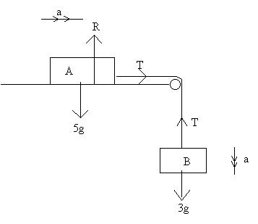
Using Newton's Second Law on body A (horizontally):
(F = ma)
T = 5a (1)
Using Newton's Second Law on body B (vertically):
3g - T = 3a (2)
Solving (1) and (2) simultaneously:
3g - 5a = 3a
8a = 3g
a = 3g/8
T = 15g/8
Therefore the acceleration is 3.68 ms⁻² (3sf) and the tension is 18.4 N (3sf)

Moments
The moment of a force about a point is found by multiplying the magnitude of the force by the perpendicular distance from the point to the line of action of the force.
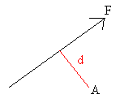

- The moment of the force F about point A is F × d.
Moments can be either clockwise or anti-clockwise. In the above example, the moment is clockwise (because the force would cause a body to move in a clockwise direction relative to A).
The moment of a force about a point measures the turning effect of the force about that point.

Couples
A couple is a system of forces which has a net moment but does not have a resultant force in any one direction.
Here is a very simple couple:
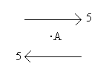
In any direction, the resultant force is zero but the moment about A is clearly not zero. Such forces acting on a body might cause the body to rotate, but not move in any one direction.
If a system is in equilibrium, the system will have zero resultant force and the sum of the moments about any point will be zero.

Impulse and Momentum

Momentum
- The momentum of a body is equal to its mass multiplied by its velocity.
Momentum is measured in N s. Note that momentum is a vector quantity, in other words the direction is important.

Impulse
The impulse of a force (also measured in N s) is equal to the change in momentum of a body which a force causes. This is also equal to the magnitude of the force multiplied by the length of time the force is applied.
- Impulse = change in momentum = force × time

Conservation of Momentum
When there is a collision between two objects, Newton's Third Law states that the force on one of the bodies is equal and opposite to the force on the other body.
Therefore, if no other forces act on the bodies (in the direction of collision), then the total momentum of the two bodies will be unchanged. Hence the total momentum before collision in a particular direction = total momentum after in a particular direction.
This can be used to solve problems involving colliding spheres (see also: restitution).

Example
We have the following scenario (a ball of mass 3kg is moving to the right with velocity 3m/s and a ball of mass 1kg is moving to the left with velocity 2m/s):
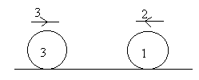
Suppose we are told that after the collision, the ball of mass 1kg moves away with velocity 2m/s, then we can use the principle of conservation of momentum to determine the velocity of the other ball after the collision.
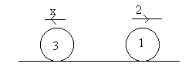
Initial momentum = 3.3 - 2.1 = 7 [the minus sign is important: it is there because the velocity of the 1kg body is in the opposite direction to the velocity of the 3kg body].
Final momentum = 2 - 3x
Hence 7 = 2 - 3x (since momentum is conserved)
x = -5/3
Which means that my arrow was pointing in the wrong direction (because of the minus sign), hence the velocity of the 3kg body after the collision is 5/3 ms⁻¹ to the right.

The Coefficient of Friction
Friction is "the resistance an object encounters in moving over another" (OED).
It is easier to drag an object over glass than sandpaper. The reason for this is that the sandpaper exerts more frictional resistance. In many problems, it is assumed that a surface is "smooth", which means that it does not exert any frictional force. In real life, however, this wouldn't be the case. A "rough" surface is one which will offer some frictional resistance.

Limiting Equilibrium
Imagine that you are trying to push a book along a table with your finger. If you apply a very small force, the book will not move. This must mean that the frictional force is equal to the force with which you are pushing the book. If the frictional force were less that the force produced by your finger, the book would slide forward. If it were greater, the book would slide backwards.
If you push the book a bit harder, it would still remain stationary. The frictional force must therefore have increased, or the book would have moved. If you continue to push harder, eventually a point is reached when the frictional force increases no more. When the frictional force is at its maximum possible value, friction is said to be limiting. If friction is limiting, yet the book is still stationary, it is said to be in limiting equilibrium. If you push ever so slightly harder, the book will start to move. If a body is moving, friction will be taking its limiting value.
In summary:
The frictional force between two objects is not constant, but increases until it reaches a maximum value. When the frictional force is at its maximum, the body in question will either be moving or will be on the verge of moving.

The Coefficient of Friction
The coefficient of friction is a number which represents the friction between two surfaces. Between two equal surfaces, the coefficient of friction will be the same. The symbol usually used for the coefficient of friction is μ
The maximum frictional force (when a body is sliding or is in limiting equilibrium) is equal to the coefficient of friction × the normal reaction force.
- F = μR
Where μ is the coefficient of friction and R is the normal reaction force.
This frictional force, F, will act parallel to the surfaces in contact and in a direction to oppose the motion that is taking/ trying to take place.

Example
A particle of mass 5 kg is at limiting equilibrium on a rough plane which is inclined at an angle of 30 degrees to the horizontal. Find the coefficient of friction between the particle and the plane.
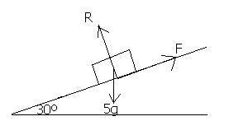
Resolving up the plane:
F - 5gsin30 = 0
Resolving perpendicular to the plane:
R = 5gcos30
In limiting equilibrium, so F = μR
5gsin30 = μ5gcos30
μ = sin30/cos30 = 0.577 (3sf)

Projectiles
When a particle is projected from the ground it will follow a curved path, before hitting the ground. How far the particle travels will depend on the speed of projection and the angle of projection.
The suvat equations can be adapted to solve problems involving projectiles.
Let's examine the general case. A particle is projected at a speed of u (m/s) at an angle of α to the horizontal:
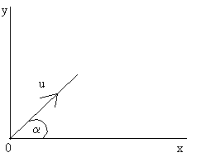

Range
The range (R) of the projectile is the horizontal distance it travels during the motion.
Now, s = ut + ½ at²
Using this equation vertically, we have that a = -g (the acceleration due to gravity) and the initial velocity in the vertical direction is usinα (by resolving). Hence:
- y = utsinα - ½ gt² (1)
Using the equation horizontally:
- x = utcosα (2)
Remember, there is no acceleration horizontally so a = 0 here.
When the particle returns to the ground, y = 0. Substituting this into (1):
0 = utsinα - ½ gt²
t (usinα - ½ gt) = 0
t = 0 or t = 2u sinα (3)
g
Therefore when x = R, t = 2u sinα / g
Substituting into (2):
R = ucosα (2u sinα)
g
- The range is therefore 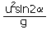

Time of Flight
The time the ball is in the air is given by (3).
Time of flight = 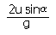

Maximum Range
If a particle is projected at fixed speed, it will travel the furthest horizontal distance if it is projected at an angle of 45° to the horizontal. This is because the maximum sin2α can be is 1 and sin2α = 1 when α = 45°.

Velocity
The velocity of the particle at any time can be calculated from the equation v = u + at.
By applying this equation horizontally, we find that:
- dx/dt = ucosα
By applying it vertically, we find that:
- dy/dt = usinα - gt
To find the speed or direction of the particle at any time during the motion, find the horizontal and vertical components of the velocity using the above formulae and use Pythagoras's theorem:
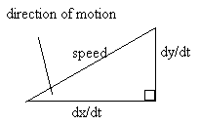

Example
A cannon ball is fired at an angle of 30° to the horizontal at a speed of 25ms⁻¹ .
a) How long will it be before the impact?
b) How far will the cannon ball travel before hitting the ground?
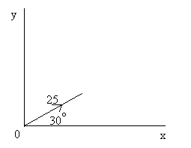
a) When the particle hits the ground, y = 0.
s = ut + ½ at²
Applying this equation vertically, when the particle hits the ground:
0 = 25Tsin30 - ½ gT² (Where T is the time of flight)
Therefore, T(25sin30 - ½ gT) = 0
So T = 0 or T = (50sin30)/g
Therefore the time of flight is 2.55s (3sf)
b) The range can be found working out the horizontal distance travelled by the particle after time T found in part (a)
s = ut + ½ at²
Applying this equation horizontally:
R = 25Tcos30
= 25 × 2.55 × 0.866
= 55.231...
Therefore the horizontal distance travelled is 55.2m (3sf)

Work, Energy & Power

Work Done
Suppose a force F acts on a body, causing it to move in a particular direction. Then the work done by the force is the component of F in the direction of motion × the distance the body moves as a result. Work done is measured in joules (which has symbol J).
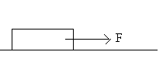
So if we have a constant force of magnitude F newtons, which moves a body a distance s (meters) along a flat surface, the work done is F × s joules.
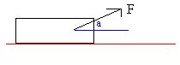
Now suppose that this force is at an angle of a to the horizontal. If the body moves a distance of s metres along the ground, then the work done is F cosa × s (since F cosa is the component of the force in the direction of motion).

Work Done Against Gravity
Now suppose that the force we are considering is one which causes a body to be lifted off of the ground. We call the work done by the force the "work done against gravity". This is equal to mgs joules, where s is the vertical distance moved by the body, m is the mass of the body and g is the acceleration due to gravity. [Compare with "gravitational potential energy" below].

Energy
The energy of a body is a measure its ability to do work.

Kinetic Energy
The kinetic energy (K.E.) of a body is the energy a body has as a result of its motion. A body which isn't moving will have zero kinetic energy, therefore.
- K.E. = ½ mv²
where m is the mass and v is the velocity of the body.

Gravitational Potential Energy
Gravitational potential energy (G.P.E.) is the energy a body has because of its height above the ground.
- G.P.E. = mgh
where h is the height of the body above the ground.
There are also other types of potential energy (such as elastic potential energy). Basically, the total potential energy measures the energy of the body due to its position.

Conservation of Energy
If gravity is the only external force which does work on a body, then the total energy of the body will remain the same, a property known as the conservation of energy.
Therefore, providing no work is done:
- Initial (PE + KE) = final (PE + KE)

Connection Between Energy and Work Done
If energy is not conserved, then it is used to do work.
In other words, the work done is equal to the change in energy. For example, the work done against gravity is equal to the change in the potential energy of the body and the work done against all resistive forces is equal to the change in the total energy.

Power
Power is the rate at which work is done (measured in watts (W)), in other words the work done per second.
It turns out that:
- Power = Force × Velocity
For example, if the engine of a car is working at a constant rate of 10kW, the forward force generated is power/velocity = 10 000 / v, where v is the velocity of the car (the 10 was changed to 10 000 so that we are using the standard unit of W rather than kW).

Example
A car of mass 500kg is travelling along a horizontal road. The engine of the car is working at a constant rate of 5kW. The total resistance to motion is constant and is 250N. What is the acceleration of the car when its speed is 5m/s?
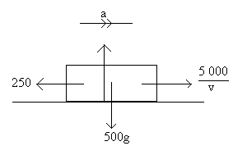
The equation of motion horizontally (from Newton's Second Law):
5000 - 250 = 500a
v
when v = 5:
500a = 750
a = 1.5
so the acceleration is 1.5ms⁻²

Centre of Mass
The centre of mass (/gravity) of a body or a system of particles is the resultant of the weights of the individual particles making up the body or system.

Uniform Bodies
A uniform body is a body whose density is the same throughout the body. Finding the centre of mass of uniform bodies is relatively straightforward.
A lamina is a 2-dimensional object. In other words, it is a flat object whose thickness is we can ignore.
If a body has a line of symmetry, the centre of mass will lie on this line. This fact is very useful. For example, the centre of mass of a circular lamina is at the centre of the circle, since the centre of mass is on each axis of symmetry and they all meet at the centre.

Standard Results
- The centre of mass of a uniform semicircular lamina of radius r lies on the axis of symmetry at a distance of 4r/3π from the straight edge
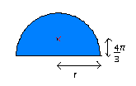
- The centre of mass of a uniform solid right circular cone of height h lies on the axis of symmetry at a distance of h/4 from the base
- The centre of mass of a uniform solid hemisphere of radius r lies on the axis of symmetry at a distance of 3r/8 from the base

Toppling
If a body is resting on a rough slope, it will be on the verge of toppling over when the weight of the body acts through the edge of the part of the body which is in contact with the slope.
Slope not steep enough for toppling to occur:
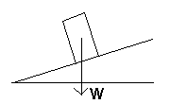
Object on verge of toppling:
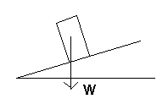
Here the object will topple:
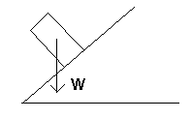
This is because, about the edge of the object, there is a net anti-clockwise moment (turning effect).
Remember, the weight acts through the centre of gravity of the object

Elastic Strings

Modulus and Natural Length
Elastic strings are strings which are not a fixed length (they can be stretched). Some strings are more stretchy than others and the modulus (or modulus of elasticity) of a string is a measure of how stretchy it is. The modulus is measured in newtons.
The length of an elastic string which does not have any forces acting upon it is known as the natural length of the string. If a string has been stretched, then the extension is how much longer the string is as a result of being stretched. Note that the extension = length of the string - natural length.

Hooke's Law
Hooke's law states that the tension in an elastic string (or spring), T, is found using the following formula:
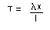, where λ is the modulus of elasticity of the string, x is the extension of the string and l is the natural length of the string.

Example
A string with modulus (of elasticity) 10 N has a natural length of 2m. What is the tension in the string when its length is 5m?
T = 10 × 3 = 15
2
So the tension in the string is 15N.

Potential Energy Stored in String
(See also: potential energy)
When an elastic string is extended it has elastic potential energy.
- Elastic potential energy stored in string = λx²/2l
In problems involving strings (and springs), if the only external force doing work is gravity then energy is conserved. Hence elastic potential energy + gravitational potential energy + kinetic energy = constant.

Springs
What has been said about strings also applies to springs. However, springs can be compressed as well as stretched. If a spring is compressed, then Hooke's Law still applies but T represents the "thrust" rather than the tension (basically the only difference is that thrust acts in the opposite direction to tension).

