Investigating shapes of graphs

Maximum and minimum points

On a graph y = f(x), there is a maximum at x = q if f(x) is less than f(q) on either side of x=q. For this to be the case then f’(x) has to be positive to the left of q, negative to the right of q, and zero at x = q.

Similarly there to be a minimum point at x = q then f’(q)=0, with f’(x) < 0 for x < q and f’(x) > 0 for x > q.

Values where f’(x) = 0 are called stationary points or turning points

To find the maximum and minimum points on the graph y = f(x)

- Find an expression for $\frac{\text{dy}}{\text{dx}}=f'(x)$
- List the values of x for which $\frac{\text{dy}}{\text{dx}}=0$
- Taking these values in turn find the sign of $\frac{\text{dy}}{\text{dx}}$to the left and right of that value.
- If the values are – and + respectively then it is a minimum point. If they are + and – respectively then it is a maximum point.
- For each value of x which gives a stationary point find the corresponding value of y = f(x)

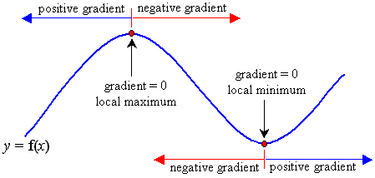

Second derivatives

If we take the derivative of f’(x) we get a ‘second derivative’, $\frac{d^{2}y}{{\text{dx}}^{2}}$.
For a stationary point if $\frac{d^{2}y}{{\text{dx}}^{2}}$<0 then it is maximum, whilst if $\frac{d^{2}y}{{\text{dx}}^{2}}$>0 it is a minimum

