C2 results that are not given in the examination booklet (page 1)

You are also expected to recall or derive C1 results that are not given in the examination booklet.

Logarithms and exponentials

Trigonometric ratios of some angles

 | 0º | 30º | 45º | 60º | 90º | 180º
 | 0 |  |  |  | 1 | 0
 | 1 |  |  |  | 0 | -1
 | 0 |  | 1 |  | - | 0

Trigonometric identities

Triangles

Area

Sine rule:

C2 results that are not given in the examination booklet (page 2)

Circular measure
º
360º Arc length Area of sector

Trigonometrical relationships

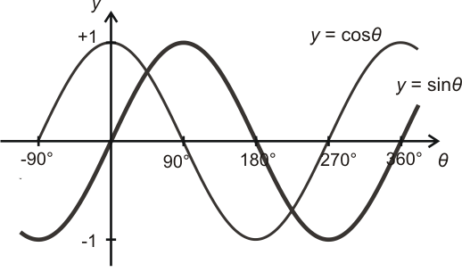

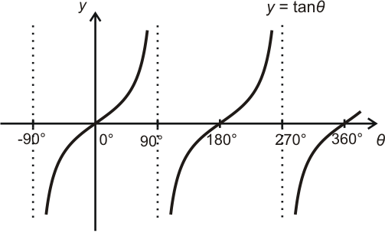

C2 results that are not given in the examination booklet (page 3)

Differentiation

Differentiation from first principles

is also written as

For ,

For

Integration

Definite integrals

gives the area of the region bounded by , the x-axis and the lines and .

