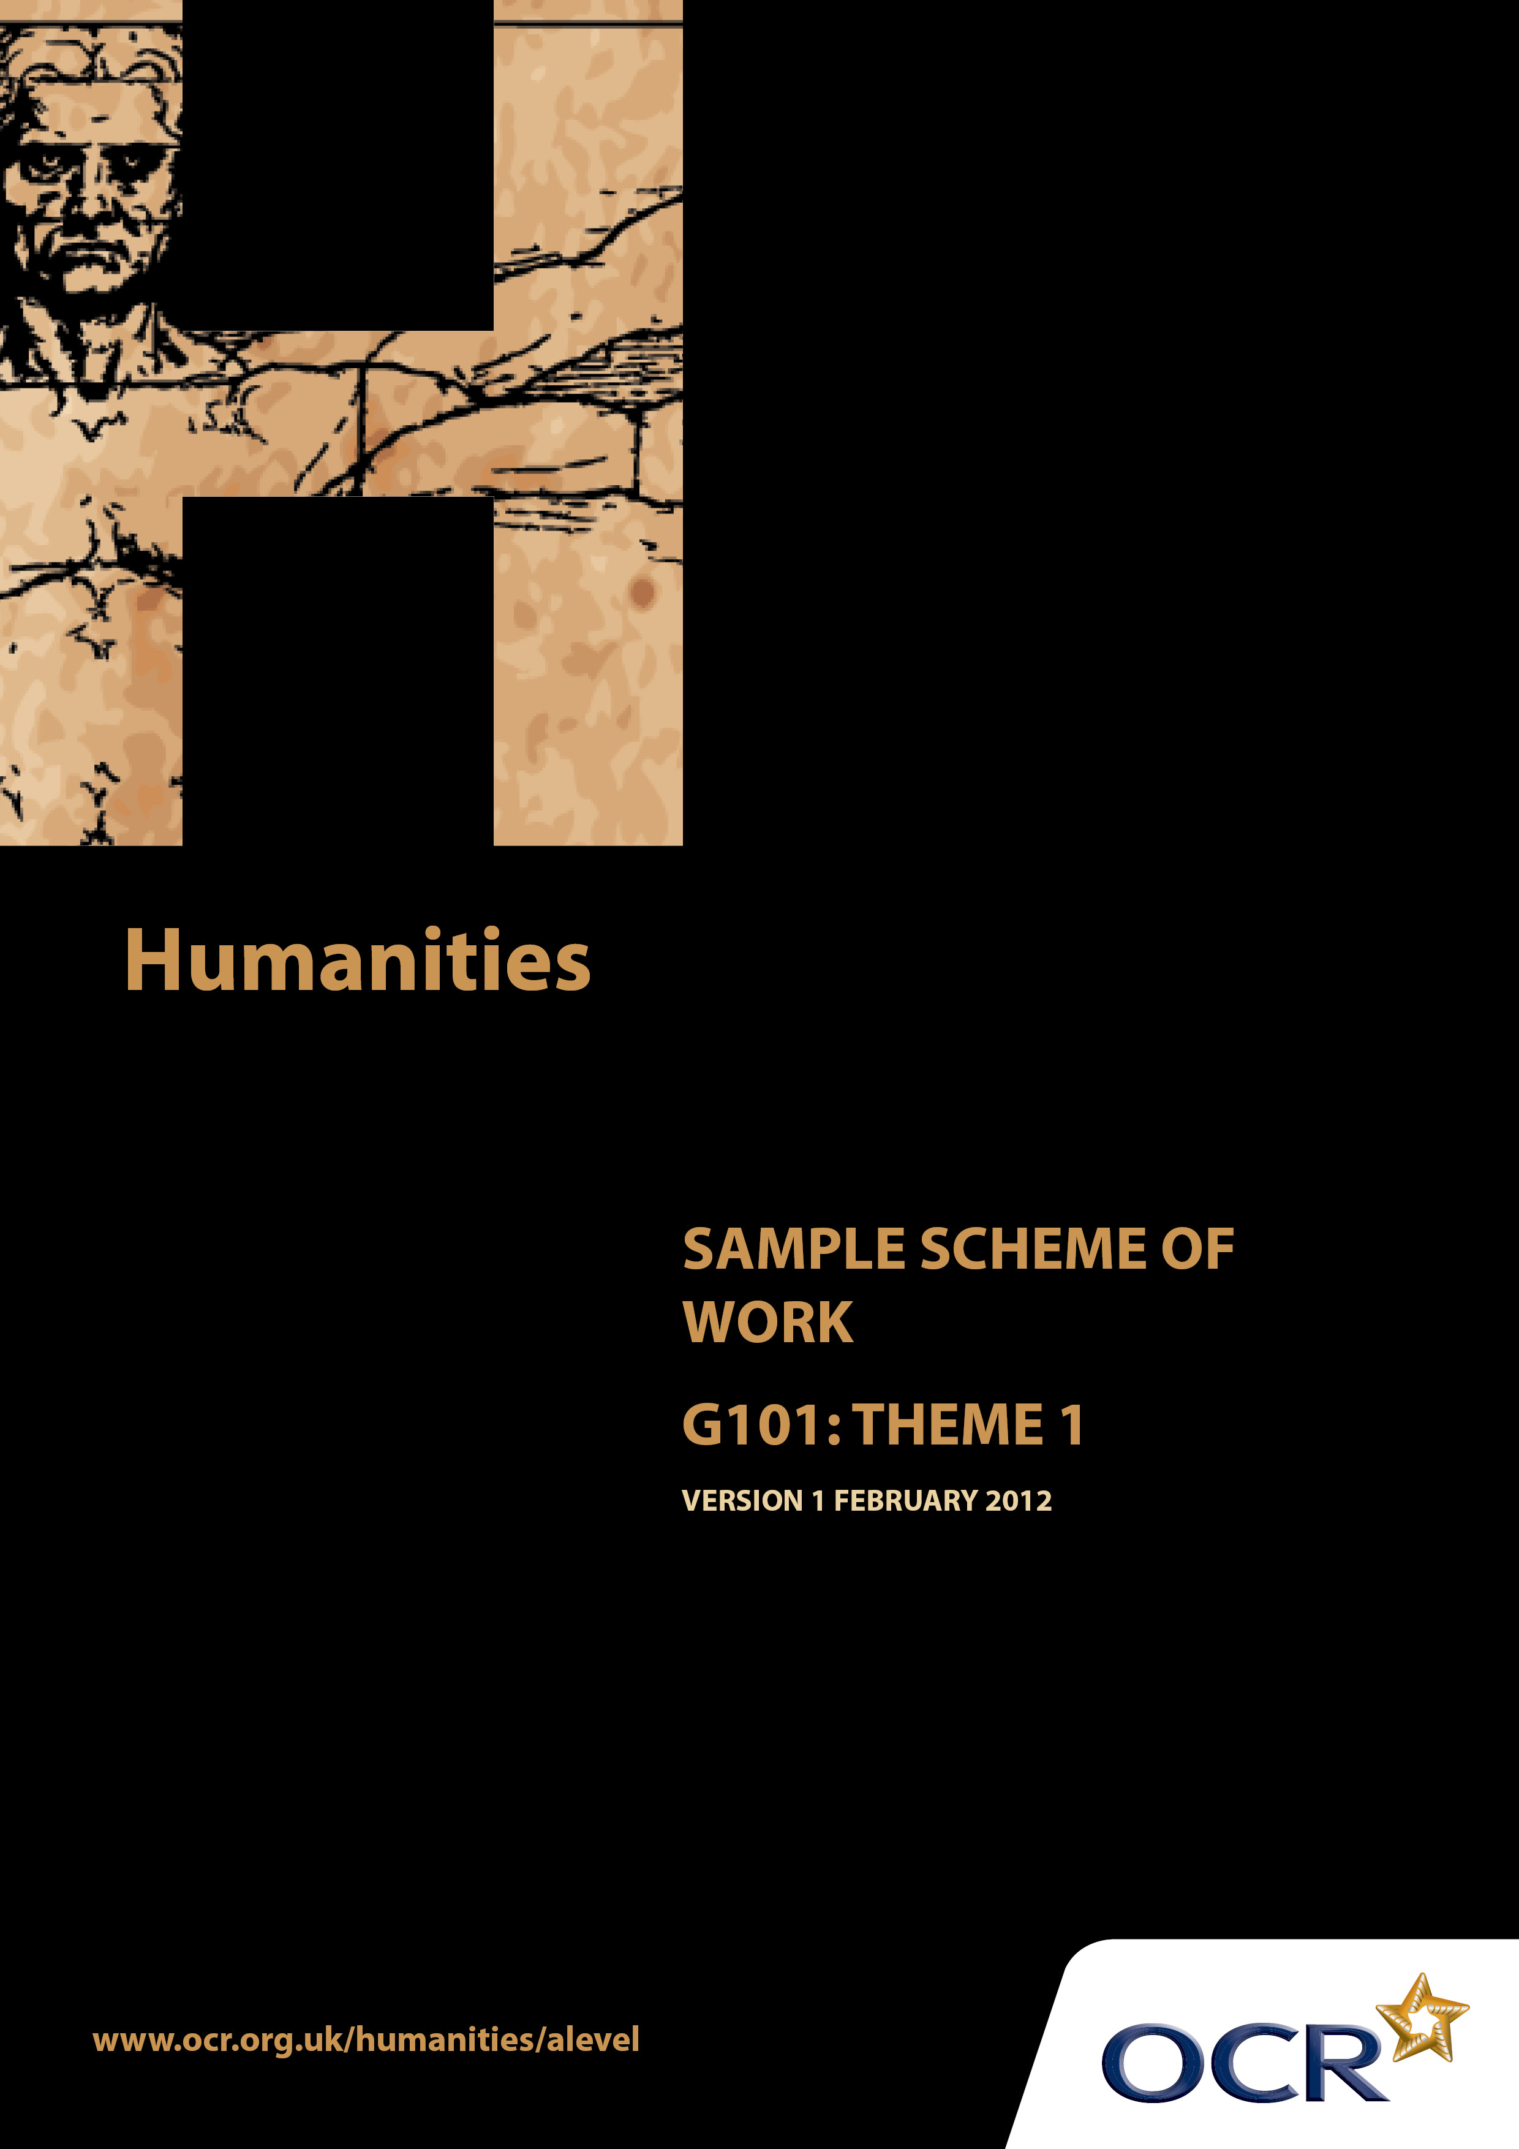
TWENTY FIRST CENTURY SCIENCE SUITE
SCHEMES OF WORK AND LESSON PLANS
B1: You and your genes
VERSION 1.1 JULY 2011
Introduction
OCR involves teachers in the development of new support materials to capture current teaching practices tailored to our new specifications. These support materials are designed to inspire teachers and facilitate different ideas and teaching practices. Each Scheme of Work is provided in Word format – so that you can use it as a foundation to build upon and amend the content to suit your teaching style and students’ needs.
The Scheme of Work provides examples of how to teach this unit and the teaching hours are suggestions only. Some or all of it may be applicable to your teaching.
The Specification is the document on which assessment is based and specifies what content and skills need to be covered in delivering the course. At all times, therefore, this Support Material booklet should be read in conjunction with the Specification. If clarification on a particular point is sought then that clarification should be found in the Specification itself.

Sample Scheme of Work
GCE Humanities
G101: Human Society and the natural world. Theme 1: Industrialisation and urbanisation

Suggested Teaching Time: 15 Hours

Aims of the whole unit

This unit is about the way human society and the natural world inter-relate. It explores: changes that human society has made to the natural world; ways that environment has influenced man; attempts to recognise the importance of the natural world and to act appropriately in order to retain the natural heritage.

Content of this theme
The unit has an historical dimension starting in the late 18th century with the Industrial Revolution in Britain. Industrialisation followed similar patterns in other countries during the 19thand 20 ^{th} centuries. ‘Industrialisation […] shifted people away from working the land in agricultural settings and urbanisation […] led to larger human settlements that generated living environments largely divorced from natural things’ Anthony Giddens (2009) Sociology Polity p.157. The significance of technology was a key factor as industrialisation progressed and underpins changes associated with and following the Industrial Revolution.

Teaching this unit

Conceptually this unit is based on an understanding of changes taking place through a period of time. There are links between this unit and unit G102 which will need to be made apparent to candidates to promote coherence in learning. A wide range of skills will be needed to study this unit.
The unit will particularly develop skills 3, 4, 5, 6, 7 and 8 listed on page 7 of the specification. As assessment will be through questions based on previously unseen sources, it will be especially important for candidates to become confident in analysing and evaluating source material in the light of subject specific knowledge.

The function of expanded content

The specification is arranged around key ideas which appear in the ‘Key concepts, ideas and terms’ column. This gives the emphasis and focus of what candidates need to learn. The expanded content is designed to provide material suitable for teaching the concepts, and it also forms the context in which the concepts will be examined. This is the content on which this scheme of work is based.

Topic outline | Suggested teaching and homework activities | Suggested resources | Points to note
Introduction to the Theme | Students could be provided with the essential information relevant to this unit/theme. This could include a brief summary of the strands within the theme, an overview of assessment, homework requirements and a reading list (if required).  Teachers will need to think carefully about the amount of detail students are provided with (or develop themselves) in relation to each area/example of industrialisation and urbanisation. It is important that teaching concentrates on using sources wherever possible to illustrate the topics under consideration and does not seek to overload students with too much factual detail.  A possible introductory research activity and way of helping students to enhance their factual knowledge would be for students to develop a set of ‘Summary Sheets’ on each key feature of industrialisation and urbanisation. These could be single-side A4 summaries of the key features. | ‘Summary Sheets’ could include the following topics:  - Population growth and labour supply  - The place of inventions in moving from the domestic system to the factory system  - Developments in water and rail transport  - Development of coal, iron and steel industries  - Water and steam power  - Agricultural changes in the 18th and 19th centuries  - The woollen and cotton industries  - Individual profiles of industrialists and entrepreneurs e.g..Brindley, Watt, Stephenson, Brunel, Wedgwood, Hudson  - Individual profiles of politicians and improvers e.g..Chadwick, Shaftesbury, Chamberlain, Titus Salt, Cadbury  The above list is not meant to be exhaustive and other topics could be included as teachers think fit.  Background reading and additional resources  Few suitable texts are easily available since this topic of British History is not taught at A level. However the following titles might be of use to students and teachers to provide background reading at a suitable academic level.  - A Social and Economic History of Britain 1760-1972 by Pauline Gregg  - The First Industrial Nation: The Economic History of Britain 1700-1914 – Peter Mathias  - The Village Labourer – JL&B Hammond  - The Town Labourer - JL&B Hammond  - Workshop of the World – JD Chambers  - Victorian People – Asa Briggs  - Victorian Cities – Asa Briggs  - English Social History – GM Trevelyan | Teachers will need to explain the focus of study as acquiring skills. The skills development document gives more guidance on teaching this area. Although acquiring knowledge and understanding of content is essential, the focus of the examination will be on applying skills to unseen material within the contextual area rather than demonstrating familiarity with the specific resources identified in this scheme of work.  It is hoped that much of the teaching of this theme can be done through sources.  Summary sheets would be just that – a summary of the main points relating to the events, inventions or individuals  Textbooks on this area of study are largely out of print. However there is a wealth of information on websites and in picture and cartoon libraries.  Many of these books are available from Amazon or other such sources. They are more likely to be suitable for teachers although there are excellent chapters in them that would be suitable for students.  Care should be taken in the use of the Pauline Gregg book since it is essentially a GCSE textbook.
Topic outline | Suggested teaching and homework activities | Suggested resources | Points to note
 |  | A GCSE textbook, still in print may also serve as a useful introduction to this theme:  British Social and Economic History – Ben Walsh  Many prints, cartoons and web based materials are available, some which can be accessed through the links below:  www.spartacus.schoolnet.co.uk  www.victorianweb.org  http://www.cartoons.ac.uk/  http://www.maryevans.com/  http://www.gettyimages.co.uk/ | There are many other resources available on the internet, accessible through searches
How the industrial revolution in the UK affected society’s relationship with nature  Factors of production  Mechanisation  Division of labour and labour supply  Competition | What was the industrial revolution?  The teacher presents an introduction to the Industrial Revolution accompanied with a reading homework  Students could brainstorm in groups to identify a definition of the industrial revolution. Research within the groups could provide definitions for use in discussion or else the teacher could provide a number of definitions for use.  Each group presents its own definition to the class with supporting reasons.  Students compare their definition with Hobsbawm’s.  Students consider the reasons for the industrial revolution which could include the following:  Capital, labour, land and entrepreneurship e.g.  - Inventions and mechanisation  - Labour source and population growth  - Raw materials and resources  - Transport improvements  - Overseas trade  - Competition  - Profit motive  - Entrepreneurs | E Hobsbawm The Age of Revolution 1789-1848, chapters 1 and 2, Abacus, 2002  ‘A mechanised factory system which produces vast quantities at diminishing costs - no longer dependent on existing demand, but creates its own market’  There could be teacher input relating to discussion about these factors. Relating the topic to modern day times would be useful, selecting an industry or industries for comparison purposes.  Students might also take the role of an industrialist or entrepreneur, wishing to start up a business and considering the factors that would be important to them.

Topic outline | Suggested teaching and homework activities | Suggested resources | Points to note
Industrialisation contributed to rapid change and destruction in the natural world | Students could produce A3 mind maps that show the interlocking nature of the reasons. Using the factors of production as a framework students could attempt to suggest from the above list which was the most important reason/s for the industrial revolution.  The impact on the natural world: Students consider the impact on the environment of changes caused by industrialisation. The construction of a timeline would be useful in plotting the dates of developments.  Developments which impacted on the environment could include:  - Increase in the harnessing of water and steam power  - Development of the coal industry  - The move from the domestic system to the factory system  - Changes in the location of industry  Again, students might attempt to place these developments in some order of relative importance and consider how each had the most effect on the environment. | The use of paintings, cartoons, written text of the period would be especially important in considering the effect of these changes on the environment  E.g. Page 105 in British Social and Economic History – Ben Walsh has some excellent illustrations with regard to this.

Topic outline | Suggested teaching and homework activities | Suggested resources | Points to note
The key features of the industrial revolution in the United kingdom  Factories not workshops  Impact of industrialisation | Students consider the key features of the industrial revolution in the UK through a selection of case studies. Students should work in groups to present their evidence supported by images. Teachers should ensure that case studies chosen can illustrate the following features:  - Scale – from small local beginnings to national/international companies  - rate of change – constant technological improvement as a driver of change  - High intensity of production and trade (national and international) as compared to pre-industrial times  - New transport systems – canals – railways – ships  - Growth of capitalism and investment  Students show understanding of the impact of industrialisation on the natural world through the study of such case studies. These can be related to the local area, or those named in the specification can be used.  Working in groups, students assemble presentations that feature the following impacts of industrialisation with respect to their case study/studies:  - Exploitation of land, water, air;  - Pollution;  - Destruction of nature;  - Depletion of resources. | Examples / case studies that may illustrate each of the key features could include:  Arkwright and Cromford  http://www.arkwrightsociety.org.uk/  James Watt and Steam  http://www.sciencemuseum.org.uk/watt  Cotton and Quarry Bank Mill  http://www.nationaltrust.org.uk/main/w-quarrybankmillandstyalestate  Beamish Museum , County Durham  http://www.beamish.org.uk/  National Railway Museum York  http://www.nrm.org.uk/  http://www.archiveswales.org.uk/anw/get_collection.php?inst_id=35&coll_id=11283&expand=  http://www.ironbridge.org.uk/  An outline map for the UK may be downloaded at :  http://www.georesources.co.uk/ukmap.htm to locate the case study areas.  Visual resources:  The Invention of the Factory: Painting Joseph Wright (1785) Arkwright’s cotton mill  Cotton Factories Union Street, Manchester 1829 in F. Klingender (1968) Art and the Industrial Revolution  Images of Brunel; railway viaducts, London railway stations | It may be useful to have a large map of the UK at the front of the class. The outline maps that allow teachers to use dry-wipe pens on them are especially useful.  Visual material can be very useful when assessing impact and also stimulates discussion on the purpose/provenance/bias of the source.

Topic outline | Suggested teaching and homework activities | Suggested resources | Points to note
Urbanisation in 19th century United Kingdom  The industrial  revolution was accompanied by unprecedented urbanisation.  Rapid urbanisation had significant and immediate social, environmental and economic consequences: | Teachers introduce and explain the process of urbanisation and outline possible reasons for this.  Students then work in groups to examine and assess evidence relating to the reasons for urbanisation in the 18th and 19th century such as:  - Population growth and demand for factory labour  - Rural change – changes in farming technology and decline of labour requirements  - Land ownership and tenancy changes;  - Impact of the Enclosures Acts  Students then consider the way that industrial towns developed from villages, existing towns; and the formation of conurbations.  Students consider the growth of major cities of the UK. Case studies of cities such as those listed in the specification could be considered, as well as examples related to the local area.  Using source materials especially from ‘Punch’, students consider in groups the features of industrial towns and cities including physical/environmental, economic and social / cultural characteristics. In doing so they will consider the effects that the following had on the towns and cities:  - Buildings (close proximity of houses and factories)  - Overcrowding of population  - Water supplies – availability and cleanliness | Population data showing the expansion of towns and cities in the UK 1800-1850  Examples of the impact of Enclosures Acts 1760-1830 which resulted in the loss of access to commons to produce basic food and the resultant changes in land ownership can be found in such examples/case studies as the following:  http://www.localpopulationstudies.org.uk/pdf/lps13/lps13_1974_31-40.pdf  http://eprints.worc.ac.uk/365/2/introduction.pdf  Case studies of the growth of specific towns can be found at:  http://www.spartacus.schoolnet.co.uk/itbirmingham.htm  http://www.british-history.ac.uk/report.aspx?compid=22959  http://www.historyworld.net/wrldhis/plaintexthistories.asp?paragraphid=kun  Resources for examining the impact of urbanisation can be found at:  http://www.spartacus.schoolnet.co.uk/itmanchester.htm  http://www.punchcartoons.com/  http://www.bbc.co.uk/history/trail/victorian_britain/social_conditions/victorian_urban_planning_01.shtml | British Social and Economic History – Ben Walsh textbook would give a useful outline of these changes.  As for the previous topic a large scale map of the UK may prove useful.
Topic outline | Suggested teaching and homework activities | Suggested resources | Points to note
 | - Poverty v wealth  - Social mobility  - Employment opportunities v unemployment  - early ‘town planning’ e.g. Saltaire, Bourneville, Port Sunlight , the work of Joseph Chamberlain in Birmingham  In conducting this research students could draw knowledge of examples from the following list in the specification to illustrate the process of urbanisation and its impact on the natural world.  - Birmingham and the ‘Black Country’  - London  - Manchester  - Newcastle and Tyneside  - West Yorkshire  - Glasgow  - Dundee  - Cardiff and the Valleys  Field studies would be of particular relevance where achievable.  At the end of this theme, students could be provided with revision exercises in the form of examination-type source-based questions | Images:  ‘The great stink’ on Google images  Textbooks:  British History for AS Level: 1783-1850 by D Peaple and T Lancaster  Poverty and public health : 1815-1948 – R Rees  Poverty, public health and growth of government in Britain 1830-75 – R Rees  Examples of ‘model’ worker settlements can be found at  http://www.cadburyworld.co.uk/  http://www.saltairevillage.info/  http://www.portsunlightvillage.com/  Examples of improvements related to Birmingham (by Joseph Chamberlain) and London (by Bazalgette) can be found at:  http://www.birminghamuk.com/wikipedia/joseph_chamberlain.htm  http://www.thameswater.co.uk/cps/rde/xchg/corp/hs.xsl/6431.htm  A student-friendly mark scheme could be introduced at this point. | Peer-marking exercises incorporating relevant mark schemes can be a useful aid to students’ learning.  Mind maps can also serve a useful purpose when doing this sort of work.

