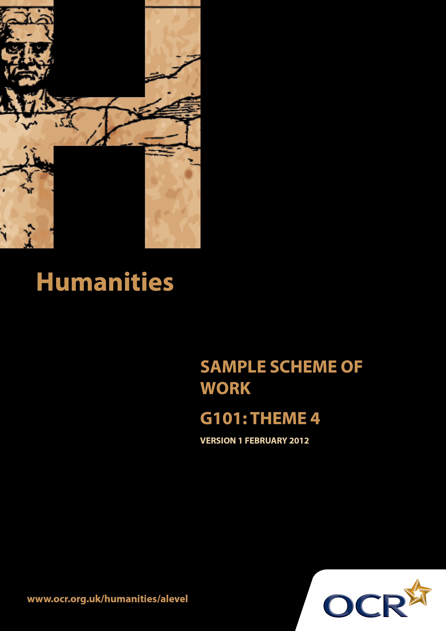
TWENTY FIRST CENTURY SCIENCE SUITE
SCHEMES OF WORK AND LESSON PLANS
B1: You and your genes
VERSION 1.1 JULY 2011
Introduction
OCR involves teachers in the development of new support materials to capture current teaching practices tailored to our new specifications. These support materials are designed to inspire teachers and facilitate different ideas and teaching practices. Each Scheme of Work is provided in Word format – so that you can use it as a foundation to build upon and amend the content to suit your teaching style and students’ needs.
The Scheme of Work provides examples of how to teach this unit and the teaching hours are suggestions only. Some or all of it may be applicable to your teaching.
The Specification is the document on which assessment is based and specifies what content and skills need to be covered in delivering the course. At all times, therefore, this Support Material booklet should be read in conjunction with the Specification. If clarification on a particular point is sought then that clarification should be found in the Specification itself.
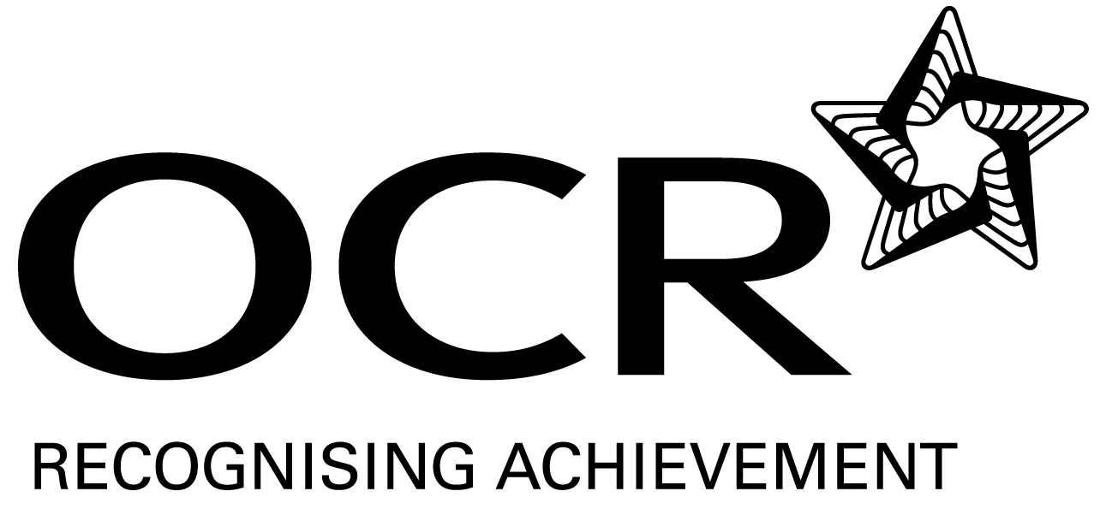
Sample Scheme of Work
GCE Humanities
G101: Human Society and the natural world. Theme 4: Sustainability

Suggested Teaching Time: 15 Hours

Aims of the whole unit

This unit is about the way human society and the natural world inter-relate. It explores: changes that human society has made to the natural world; ways that environment has influenced man; attempts to recognise the importance of the natural world and to act appropriately in order to retain the natural heritage.

Content of this theme

The latter part of the 20thcentury and the early years of the 21 ^{st} century have seen increased understanding of global changes in the natural environment with rapid technological changes, for example in global communications, making a significant contribution to this. This has led to research, international protocols, financial incentives and controls in attempts to manage the situation, with sustainability frequently cited as the desired outcome. International co-operation alongside recognition of differences (related to development, wealth, society and culture) has been challenging. However sustainable initiatives at a local scale continue to grow.

Teaching this unit

Conceptually this unit is based on an understanding of changes taking place through a period of time. It also involves some degree of spatial awareness with studies ranging in scale from local to global. There are links between this unit and unit G102 which will need to be made apparent to candidates to promote coherence in learning.

The unit will particularly develop skills 3, 4, 5, 6, 7 and 8 listed on page 4. As assessment will be through questions based on previously unseen sources, it will be especially important for candidates to become confident in analysing and evaluating source material in the light of subject specific knowledge.

The function of expanded content

The specification is arranged around key ideas which appear in the ‘Key concepts, ideas and terms’ column. This gives the emphasis and focus of what candidates need to learn. The expanded content is designed to provide material suitable for teaching the concepts, and it also forms the context in which the concepts will be examined.

Topic outline | Suggested teaching and homework activities | Suggested resources | Points to note
Introduction to the Theme  Sustainable Development and Inter-generational justice  Sustainable development | Students could be provided with the essential information relevant to this unit/theme. This could include a brief summary of the strands within the theme, an overview of assessment, homework requirements and a reading list (if required).  Brainstorm the terms ‘sustainability’ and ‘sustainable development’ and discuss/exchange ideas. Categorise ideas to ensure students have an understanding of economic, social, environmental and political issues and goals – create a Venn diagram to demonstrate the connections and issues.  Understanding of ‘sustainable development’ could also be achieved through the examination of a variety of images: deforestation, afforestation, conservation, degradation, open cast quarrying/mining sites, reclamation, renewable energy (solar, wind turbines) recycling vs landfill sites, food resources etc. | Definition source; International Institute of Sustainable Development  www.iisd.org  Youtube clips e.g. ‘sustainability song’, ‘sustainability explained through animation’.  Source images from Google images. | Teachers will need to explain the focus of study as acquiring skills. The skills development document gives more guidance on teaching this area. Although acquiring knowledge and understanding of content is essential, the focus of the examination will be on applying skills to unseen material within the contextual area rather than demonstrating familiarity with the specific resources identified in this scheme of work.  Sustainable development is development that meets the needs of the present without compromising the ability of future generations to meet their own needs.
Intergenerational justice  - heritage  - inheritance | Students to research the Brundtland Report 1987 ’Our Common Future’ – how and why was it set up? What are the key issues, goals and strategies?  Focus on equity and justice within and between generations. Take quotes from the UN source to critically analyse and interpret.  Students could conceptualise (through images/prose/concept map) what the world would be like for future generations if we continue if meet the goals of the Brundtland Report compared to if we do not meet the goals.  The Brundtland report laid down the ground rules for the 1992 Earth Summit in Rio de Janeiro and the UN Commission on Sustainable Development. Complete a factual report: Where?, When?, What?, How? | Brundtland Report: www.un.org  Access quotes:  www.un-documents.net click on part 1: ‘Common concerns’, section 2: ‘Towards Sustainable Development’, ii: Equity and the common interest.  Rio Earth Summit: www.earthsummit.info/ | Intergenerational justice is the concept of fairness between children, youths, adults and seniors in terms of their use and abuse of the world’s resources.  Resources such as the quality and diversity of the environment which do not ‘belong’ to any generation but are to be use and preserved for all future generations.  1992 Earth Summit was a meeting of UN Governments to rethink development and halt the destruction of irreplaceable natural resources and pollution of the planet.

Topic outline | Suggested teaching and homework activities | Suggested resources | Points to note
The Moral dilemma | The potential conflict between sustainability and economic development (plus an acceptable standard of living).  Students assess the views of environmentalist Bill McKribben (Youtube interview or quotes from his books) and compare with their own views, to understand the impact economic development has had on the planet and the subsequent need for sustainability.  Consider and debate whether LEDCs should abide by the UN sustainability goals and strategies but would this be at the detriment to their economic development?  Outline this moral dilemma through tourism (the main income for many LEDC economies) in a country such as Kenya: compare and contrast the cultural conflicts, environmental damage, use of resources such as water and population exploitation. This could be completed through research and role play to debate and draw conclusions. | Bill McKibben discussion regarding the issues facing the world due to increasing carbon emissions: www.youtube.com ‘350.0rg’s Bill McKibben on David Letterman’.  Bill McKibben (2011) ‘Making Life on a Tough New Planet’ publisher: St. Martin’s Griffin  Bill McKibben (2003) ‘ Worried, Us?’ in Granta 83 The Overhanging World p8-12.  Tourism conflicts: www.tourismconcern.org.uk | Sustainability recognises that the three ‘pillars’: the economy, society and the environment, are interconnected. Its goal is to enable all people throughout the world to satisfy their basic needs and enjoy a better quality of life without compromising the quality of life of future generations.

Topic outline | Suggested teaching and homework activities | Suggested resources | Points to note
Demands of the economy, society and the environment must be balanced against each other. | Brainstorm the factors that affect sustainability .e.g. population growth compared with the available resources, the level of development (GNP, GDP, Birth rate, Death Rate), urbanisation, industrialisation.  Introduce the Millennium Development Goals (MDG) set by world leaders in 2000. Understand what they are and how they try to balance the demands of society, development and the environment.  Students need to compare the level of development of at least two contrasting countries: Choose one MEDC(e.g. UK, USA, Japan) and one LEDC (e.g. Kenya, Mexico, Philippines) – extend by introducing NICs and BRICs (e.g. Brazil, Russia, India, China as quickly emerging and growing economies) and use development indicator statistics from a variety of sources to build up a fact file of data for each country to assess their level of development. Look at data trends, anomalies, and similarities. Evaluate the source provenance (official statistics?, date?, validity, reliability, utility)  Investigate population size and growth of the UK in the 19th century compared with the 21st Century – create a story board or cartoon of the growth rates and reasons for these.  Contrast the farming industry in the UK with Stalin’s collectivism of agriculture in Russia in 1928. Evaluate the success of collectivism.  Students could complete research from newspaper articles regarding the impacts of the UK’s population recently reaching 70 million.  Measures of economic success and how they are defined, such as GNP and GDP may no longer be as useful as measures related to environmental targets. Research alternative development measures that are used such as the Human Development Index (HDI), Environmental Sustainability Index (ESI). Carbon footprints. | Millennium Development Goals:  www.un.org/millenniumgoals/  Schools’ Atlas have good statistical pages in them.  The World Bank  http://data.worldbank.org/indicator  British Population animation:  www.bbc.co.uk/history  Collectivism: www.historylearningsite.co.uk  Guardian: ‘UK population growth to 70m challenged’ (Oct 2009)  www.guardian.co.uk  Human Development Indicators  http://hdrstats.undp.org | Millennium Development Goals were adopted by world leaders in the year 2000 and set to be achieved by 2015, the MDG provide numerical benchmarks for tackling poverty. Goal 7 is to ensure environmental sustainability.  Link to Theme 1  Stalin wanted Russia to be self sufficient. He introduced collectivism so that peasant farmers had to produce food not just for themselves, but also for the workers in factories. To do this 25 million individually owned farms were joined to form ‘collectives’, large farms that would use science and technology to increase food production.  Human Development Index (HDI) combines the indicators of life expectancy, educational attainment and income to form one composite measure of development.

Topic outline | Suggested teaching and homework activities | Suggested resources | Points to note
Environmental cost versus material benefits. | Students to research a case study example to link the demands of development, society and environment. Examples could include the impacts and conflicts of either: diamond mining in Congo, deforestation in the Amazon or Coral reef destruction.  Students are to present their findings to the rest of the group in an innovative way using film, ICT, report, animation. | Geo files.  Threats to coral reefs:  www.coral.org | Environmental Sustainability Index (ESI) tracks 21 elements of environmental sustainability covering natural resources, pollution levels, environmental management and society’s capacity to improve its environmental performance over time.

Topic outline | Suggested teaching and homework activities | Suggested resources | Points to note
Human society may have to rethink its needs by looking at consumerism, well-being and sustainability in the long and short term.  Consumerism  Wellbeing / quality of life | Introduce by having a variety of images that represent ‘consumerism’ e.g. shopping malls, high streets, cash tills, gadgets, technology, chain shops, multinational giants, prices, money, rubbish tips, recycling, litter etc. Students need to link these images and write a statement regarding consumerism, development and sustainability.  Students to be presented with a variety of scenarios of individuals from around the world (different affluence, culture, location, background story, family, material possession). Who has the best quality of life? Why? Discuss.  Read the article ‘The Economist Intelligence Unit’s Quality of Life Index’. Define the term ‘Quality of life’ can it really be measured or is it subjective? Which countries have the best Quality of Life Index? Do you agree with the list? Examine the methods of collecting this data and its reliability.  Introduce the term ‘shopoclaypse’ and watch the video / clip of Reverend Billy.  Discuss whether consumerism is an addiction? Students need to make connections to their own standards of living and habits.  Discuss the article ‘Consumerism and Affluenza – How Society Shapes our Thinking of Happiness’. Are there any truths in this theory?  What impacts are consumerism and the desire to improve wellbeing/quality of life in order to have even basic human rights such as food and clean water, having on the environment? Students to choose one of the issues below and research data to represent the opposing views / arguments: | Consumerism: Good graphs and quotes on www.globalissues.org  Sustainable products and consumers:  www.defra.gov.uk/environment  Article: The Economist Intelligence Unit Quality of Life Index  www.economist.com  2010 Quality of Life Index: 194 countries ranked:  http://internationalliving.com  Shopocalypse: www.revbilly.com  ‘What would Jesus buy?’ by Rev. Billy and the Church of Stop Shopping video www.youtube.com  Article ‘Consumerism and Affluenza – How Society Shapes our Thinking of Happiness’ (March 2010 by Steve Nguyen): www.workplacepsychology.net | Consumerism is the increasing desire to purchase goods and services by individuals. In doing so it expands the economy but can be at the detriment of the environment.  Shopocalypse is the proposed end of the world through rampant and pervasive shopping.  Affluenza is from the words ‘affluence’ (wealth) and influenza (flu). It explains the problems that occur when individuals are in pursuit of wealth and material possessions at the expense of other sources of happiness.

Topic outline | Suggested teaching and homework activities | Suggested resources | Points to note
 | Food: research could investigate: the percentage income different countries spend on food, food miles (justification / need for transporting large distances), demand for seasonal and exotic foods, imports vs local sources, factory farming, GM foods, animal welfare, vegetarianism/veganism.  Conservation of wildlife habitats: Is it right or wrong if it has negative impacts on food production / protection of property. Case study examples: Wetland protection vs drainage for farmland or coastal protection vs protection of property.  Biofuels: the use of food growing land or ecosystems for ‘green; uses such as palm oil (Malaysia). | The Percentage of income spent on food: ‘Clouds, clocks and sitting at tables’: www.jdasovic.com  Food miles: www.climatechoices.org.uk  www.i-sis.org.uk  www.indepenent.co.uk (article: The true Cost of Putting Food on Your Plate)  www.guardian.co.uk (article: How the Myth of Food Miles Hurts the Planet)  Wetland and Wild Fowl Trust:  www.wwt.org.uk  Article: ‘Palm oil: the Biofuel of the futures driving an  ecological disaster now’ (2007): www.guardian.co.uk

Topic outline | Suggested teaching and homework activities | Suggested resources | Points to note
Sustainability at different scales  Carbon emissions | Students measure their carbon footprint using an online calculator.  Mind map how their carbon footprint could be reduced further at a variety of scales of intervention: what could be done in the home, at work, by local councils, by government and intergovernmental.  Examine and make links to the targets set and responses of governments to the UN’s Kyoto Protocol (1997) and Copenhagen Climate Change Agreement (2009).  Investigate legislation such as carbon trading, carbon emissions and carbon offsetting.  In response to reducing emissions the UK government have introduced a variety of transport initiatives such as tram lines in cities such as Sheffield, Manchester, London Congestion charging and the UK network of electric car charging points. Assess the benefits and problems of one of these initiatives. | Footprint calculator (WWF): http://footprint.wwf.org.uk  Carbon emission reduction target:  www.decc.gov.uk  Kyoto Protocol: www.unfccc.int/kyoto  Article: Q&A: The Copenhagen Climate Summit (21/12/09): www.bbc.co.uk
Population change | The impact of fast population growth on sustainable development means there are too many people and this puts pressure on resources and the environment.  Examine and identify trends and reasons for the population growth rates of a selection of countries.  Case study research of one country to exemplify the problems and solutions of  ‘Overpopulation’ (e.g.China, India) and ‘Underpopulation’ (e.g. Australia, Canada, Singapore). | Population growth data:  http://data.worldbank.org/indicator  Overpopulation: www.overpopulation.org

Topic outline | Suggested teaching and homework activities | Suggested resources | Points to note
Waste disposal and recycling | Understand the different ways that waste in the UK can be disposed of: landfill, Incineration, recycling plants, council tips, fly tipping, littering.  Produce a flow diagram of directives, facts and figures and penalties on waste management in the UK. Start with EU legislation on waste, the UK Government (Defra), Local Councils (choose your local council) and Individuals. Use a variety of sources to build up this information.  Investigate a local land fill site and recycling plant to compare government targets with actual waste disposal figures – to what extent is there a difference? How could this be overcome?  What do the student households do? Students could conduct a questionnaire/survey of local opinion of waste generated, recycling, collection and disposal.  To extend compare the UK’s waste disposal management systems and data with that of another EU country (Germany) or Japan which has high level of recycling. | EU directive on waste management in the environment section of:  http://europa.eu/legislation_summaries  Waste and recycling (UK): www.defra.gov.uk/environment/waste  Landfill sites and tax:  www.environment-agency.gov.uk

Topic outline | Suggested teaching and homework activities | Suggested resources | Points to note
Environmental citizenship | Students need to understand the variety of ways that individuals can be involved in sustainability in their local area.  Students could complete this task as a mini local research project either as individuals or in small groups. Primary research could be collected through a local visit, photos, guest speakers or a virtual fieldtrip. Secondary data would include assessing Local Agenda 21 legislation, the Code for Sustainable Homes, The Sustainable Communities Act as well as investigating local sustainable development initiatives from your local council website, leaflets or newspapers.  Alternatively students could research one local aspect and present it to the rest of the group to help build up an understanding of local initiatives. Based on your locality include a selection from the following three concepts:  1. Local sustainable initiatives: school based activities/building design, changes in park design and activities, local community /neighbourhood garden use schemes  2. Sustainable food supplies: farmers markets, city farms, guerrilla gardening, school vegetable gardens, access to allotments  3. Sustainable energy: off-grid energy supplies (solar and wind power), zero carbon housing designs.  Through the data research, consider the positive and negative issues of each type of local initiative, but also the validity and reliability of the data. Interpret qualitative and quantitative data from official sources such as council websites Students need to assess and evaluate the local sustainable initiatives/ programmes and draw conclusions between them. To extend this project (homework), students could compare and contrast the sustainability of their local area with another locality. | Code for Sustainable homes:  www.nhbc.co.uk  Legislation and policy:  www.energysavingtrust.org.uk  Sustainable Communities Act: (download publication guide from www.communities.gov.uk  Guerrilla gardening:  www.guerrillagardening.org  Local councils:  www.direct.gov.uk  Search for local city farms:  www.farmgarden.org.uk  Zero carbon homes:  www.zerocarbonhub.org

