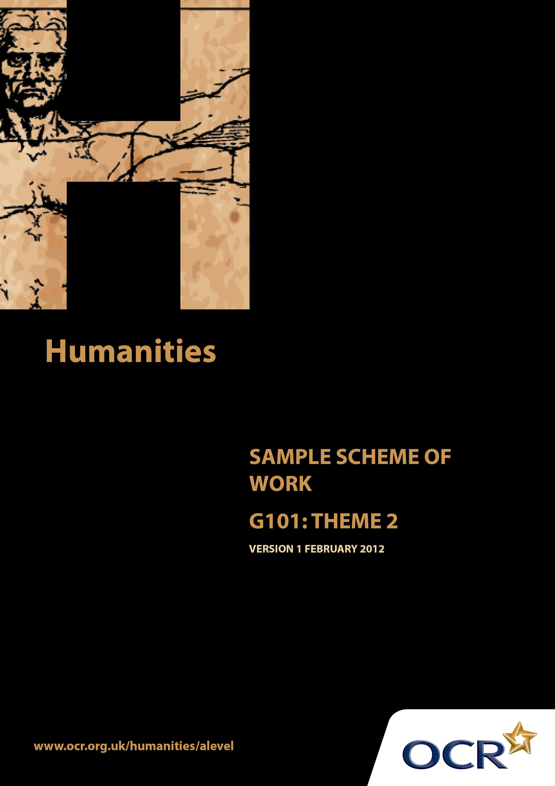
TWENTY FIRST CENTURY SCIENCE SUITE
SCHEMES OF WORK AND LESSON PLANS
B1: You and your genes
VERSION 1.1 JULY 2011
Introduction
OCR involves teachers in the development of new support materials to capture current teaching practices tailored to our new specifications. These support materials are designed to inspire teachers and facilitate different ideas and teaching practices. Each Scheme of Work is provided in Word format – so that you can use it as a foundation to build upon and amend the content to suit your teaching style and students’ needs.
The Scheme of Work provides examples of how to teach this unit and the teaching hours are suggestions only. Some or all of it may be applicable to your teaching.
The Specification is the document on which assessment is based and specifies what content and skills need to be covered in delivering the course. At all times, therefore, this Support Material booklet should be read in conjunction with the Specification. If clarification on a particular point is sought then that clarification should be found in the Specification itself.

Sample Scheme of Work
GCE Humanities
G101: Human Society and the natural world. Theme 2: Contact with Nature and the Aesthetic response to the Natural World
Suggested Teaching Time: 15 Hours

Aims of the whole unit

This unit is about the way human society and the natural world inter-relate. It explores: changes that human society has made to the natural world; ways that environment has influenced man; attempts to recognise the importance of the natural world and to act appropriately in order to retain the natural heritage.

Content of this theme
The unit has an historical dimension starting in the late 18th century with the Industrial Revolution in Britain. Industrialisation followed similar patterns in other countries during the 19thand 20 ^{th} centuries. ‘Industrialisation […] shifted people away from working the land in agricultural settings and urbanisation […] led to larger human settlements that generated living environments largely divorced from natural things’. Anthony Giddens (2009) Sociology Polity p.157.

In parallel with this is the aesthetic response to the changed relationship between human society and the natural environment. The recognition of the natural world and its importance is reflected in artistic works and different lifestyles. Different perspectives on human society and the natural world include religious teachings with an eco-centric focus and the importance of the natural world in both practical and aesthetic terms.

Teaching this unit

Conceptually this unit is based on an understanding of changes taking place through a period of time. It also involves some degree of spatial awareness with studies ranging in scale from local to global. There are links between this unit and unit G102 which will need to be made apparent to candidates to promote coherence in learning. A wide range of skills will be needed to study this unit. The unit will particularly develop skills 3, 4, 5, 6, 7 and 8 listed on page 7 of the specification. As assessment will be through questions based on previously unseen sources, it will be especially important for candidates to become confident in analysing and evaluating source material in the light of subject specific knowledge.

The function of expanded content

The specification is arranged around key ideas which appear in the ‘Key concepts, ideas and terms’ column. This gives the emphasis and focus of what candidates need to learn. The expanded content is designed to provide material suitable for teaching the concepts, and it also forms the context in which the concepts will be examined. This is the content on which this scheme of work is based.

Topic outline | Suggested teaching and homework activities | Suggested resources | Points to note
Introduction to the theme | Students could be provided with the essential information relevant to this unit/theme. This could include a brief summary of the strands within the theme, an overview of assessment, homework requirements and a reading list (if required). |  | Teachers will need to explain the focus of study as acquiring skills. The skills development document gives more guidance on teaching this area. Although acquiring knowledge and understanding of content is essential, the focus of the examination will be on applying skills to unseen material within the contextual area rather than demonstrating familiarity with the specific resources identified in this scheme of work.  It is hoped that much of the teaching of this theme can be done through sources.
The effect of industrialisation and urbanisation in terms of everyday contact with nature  Industrialisation and urbanisation has led to many people being estranged from natural cycles. | Introductory activity: Students research the various strategies employed for managing daylight and their effect such as Daylight Saving time, Time Zones, management of global activities such as stock markets, identical exams taken in different time zones, school terms being agricultural in origin.  Students work in pairs/small groups researching how and why daylight is managed. | http://services.parliament.uk/bills/2010-11/daylightsaving.html  This site will develop as it refers to a live Parliamentary process on Daylight Saving. Worth checking regularly.  “Saving the Daylight” by David Prerau is a useful book for this – accessible and gives the history/philosophy of daylight saving.  http://en.wikipedia.org/wiki/Daylight_saving_time_by_country  Wikipedia, so use with caution. Mainly factual but may not be up to date or verified. Candidates are likely to access this first, so teachers are advised to be familiar with it!

Topic outline | Suggested teaching and homework activities | Suggested resources | Points to note
Effect of separation from nature  Changes in food and diet  Continuing human need for space/countryside | This could be developed into research by students on the effects of our separation from nature/how the natural world determines our responses. Possible areas  - community activities/religious festivals linked to the natural world/seasonal cycles  - how diet has changed with industrialisation  - growing your own food v purchasing in markets or shops, availability of seasonal items such as fruit all year round  Students could then be divided into small groups and asked to prepare a short presentation or wall display on their given area of separation.  Starter activity – brainstorm what links we have with the natural world/how it is integrated into our lives. Map these on a flipchart/whiteboard.  Consider holidays, allotments, second homes, popularity of rural activities despite the sometimes physical challenge, Arts and Crafts Movement, TV programmes such as Escape to the Country, alternative lifestyles such as travellers, communes, kibbutzes, creation of green spaces in town planning, roof gardens in cities, constant conflict between development for economic benefits and need for green spaces to benefit the environment.  using sources they have researched to support their conclusion. | http://www.answers.com/topic/agriculture-since-the-industrial-revolution  Accessible source outlining how industrialisation impacts on diet.  http://www.cbc.ca/news/health/story/2005/02/11/diet-aboriginal050211.html  Topical item relating diet to type 2 diabetes in Aboriginal people.  DVDs/Book of the “Victorian Farm” series might be useful for showing how diet has changed in 100-150 years.  Old cookery books/household management texts (eg. Mrs Beeton) can show how food preparation has changed. (e.g. Jugged Hare, how to clean a rabbit etc)  Two resources on estrangement from nature and industrialisation.  http://faculty.frostburg.edu/phil/forum/Marx.htm  Has some political content, but also some valid philosophy which is worth debating.  www.human-nature.com/rmyoung/papers/pap103h.html  This online paper helps to balance out the above material  http://www.artscrafts.org.uk/index.html  Home page of the Arts and Crafts Movement’s website. Has a useful timeline of key dates in the movement.  http://designmuseum.org/design/art-and-craft-movement  Also a useful and accessible source on the same movement.  “The Tent, the Bucket and Me” by Emma Kennedy has some entertaining material on camping holidays. Select carefully, the language can be colourful. | Singapore is a useful location to consider for green spaces in an urban area as there is limited land
Topic outline | Suggested teaching and homework activities | Suggested resources | Points to note
Extended essay writing. :“How important do you consider nature to be in your society?”
Length to be determined by teachers. Students should make reference to what they consider to be their ‘society’ – may be determined by their ethnicity, religion, nationality, life experiences. Examples should be explored fully as part of their argument,

Topic outline | Suggested teaching and homework activities | Suggested resources | Points to note
How the natural world and people’s relationship with it is understood and expressed  The value of the natural world as a source of emotional and spiritual fulfilment  The power of the natural world to inspire artistic creativity in a range of expressive forms. | Starter activity – produce a range of different dictionaries/thesauri, and collate on a flipchart/board all the various synonyms of ‘aesthetic’. Ask students to map these to find an appropriate and helpful definition of the word which can take their studies forward.  As an introduction to the topic, ask candidates to source three items from the Arts, Media and Literature which express qualities of the natural world that people value.  Candidates should explain, either verbally or in writing, what are the emotional, spiritual and aesthetic qualities explored in these items, and how they have been expressed by the artist. The sourcing is best set as a preparatory homework.  Students could research different belief systems and how the natural world is viewed by participants e.g. Maori, Aboriginal, Native Americans as well as major religions – Islam, Christianity, Buddhism etc – and the Romantic Movement.  Using art/artefacts/images relating to one or two belief systems, create a short leaflet/booklet explaining the emotional, spiritual and aesthetic significance of these.  The specification has a great deal of expanded content which outlines the sorts of creative work which can be studied, and teachers should start this part of the theme by defining with students what ‘creative work’ covers.  A good starter activity could be to present students with a range of sources (poems, extracts from books, photos/paintings) and ask them to choose three. They then have five minutes to note down what ideas they contain. Each candidate then explains these to the class and comments on how they connect or contradict each other. | Dictionaries, thesauri, flipchart/whiteboard.  http://www.contempaesthetics.org/newvolume/pages/article.php?articleID=581  A challenging source providing a functional model of the aesthetic response – helpful for teachers rather than candidates.  The Aesthetic Appreciation of Nature: Malcolm Budd . Oxford Scholarship Online (2003).  http://www.maori.info/  http://www.aucklandmuseum.com/?t=81  http://www.religioustolerance.org/nataspir.htm  The above websites have some useful images on Aboriginal culture and beliefs, as well as images, which candidates could access for this activity.  http://www.eeo.ed.ac.uk/homes/rgroves/bradypub1.pdf  Useful paper on why we value the natural world. Reasonably accessible and worth working through with students.  http://philpapers.org/browse/aesthetics-of-nature  Bibliography of relevant sources  http://beta.wosu.org/classical101/vaughan-williams-and-music-of-peace/  Brief and accessible article with video clip of pastoral music

Topic outline | Suggested teaching and homework activities | Suggested resources | Points to note
 | To familiarise students with particular works and make connections between them:  Teachers of this theme could prepare in advance a collection of small cards on which there is a representation or title of a creative work.  A)Colour code these into Art/Media/Music/Literature.  Divide them into piles. Students pick one from each pile and then research the possible links between them.  B) Use the same colour cards. Structure the cards more tightly, allocating them into ‘families’ of four, one from each type of creative work. Students then play Happy Families with these, the aim of which is to collect four linked cards. | http://www.crossref-it.info/articles/190/Pastoral-poetry-in-brief  Useful site with brief definitions of relevant topics such as pastoral poetry, romantic movement. Candidates could use this to compile their own glossary of terminology.  http://www.enotes.com/william-wordsworth-and-samuel-taylor-coleridge-criticism/lyrical-ballads-william-wordsworth-and-samuel  Accessible site outlining the Lake Poets and their lyrical ballads.  http://academic.brooklyn.cuny.edu/english/melani/cs6/rom.html  Good introduction to the Romantic Movement.  http://www.philosopher.org.uk/rom.htm  Accessible site containing details of relevant philosophies.  http://www.enotes.com/pastoral-literature-english-renaissance-criticism/pastoral-literature-english-renaissance  Information on Pastoral poetry.  http://www.archive.org/details/feelingfornatur02bryagoog  Link to an online book, relating to nature in pastoral poetry. Helpful for teachers unfamiliar with literary criticism.  http://onlinebooks.library.upenn.edu/webbin/book/browse?type=lcsubc&key=Pastoral%20poetry%2C%20English  Online books site – searchable. Some works relating to pastoral poetry are available here. (search site using ‘pastoral’ as search term.)

Topic outline | Suggested teaching and homework activities | Suggested resources | Points to note
Creative works as sources of evidence  Religious beliefs and spiritual ideas that describe human society’s relationship with and understanding of the natural world | How reliable creative works are as sources of evidence.  Students undertake a comparison between Penshurst Place and its representation is literary works. The website is useful for this. Key questions are:  - How accurate is the presentation compared with the reality?  - What are the differences and similarities?  - How do these relate to the purpose/attitude/values of the author of the work?  Similar activities could be done with other locations such as Lake District/Wordsworth.  Similar activities could be done using paintings (e.g Pre-Raphaelites), particularly paintings of real people, events and places (e.g. paintings of great events in history)  Ideas and beliefs which explain the importance of the natural world. The various philosophies put forward to explain our responsibility for our environment.  Students could consider:  - The role of art (particularly visual art) in various major religions e.g. Islamic beliefs about representations of the natural world/living beings, and religious teachings about the environment as gift from God.  - Non-religious philosophies such as conservation ethics, deep ecology, Gaia hypothesis, | http://www.penshurstplace.com/page/3053/Literary-Links-to-Penshurst-Place  http://www.preraphaelites.org/  And when did you last see your father? The Victorian Painter and British History  Roy Strong pub. Thames and Hudson  http://www.iep.utm.edu/  General philosophy internet resource.  http://www.deepecology.org/index.htm  http://www.gaiatheory.org/  Gaia: The practical science of planetary medicine James Lovelock pub Quality Paperbacks Direct

Topic outline |  | Suggested teaching and homework activities | Suggested resources | Points to note
This topic provides a good opportunity to invite outside speakers to the school to explain the work they do (Groundwork trust, Greenpeace, local conservation groups).

Following presentation by outside speaker there can be a class debate with a conservation theme. There are likely to be plenty of valid and topical issues which can be used as a basis for this – High Speed rail link, wind farms, recycling, many of which link to other areas of the course and could be used to introduce another unit.

Different philosophies could be presented by students through powerpoint presentations, wall displays, leaflets. In centres where there are younger pupils, leaflets which are aimed at a particular age group could be produced.

At the end of this theme, students could be provided with revision exercises in the form of examination-type source-based questions.

Students could devise their own source based questions, and give them to other students to do.

